Requirements
You will need a machine with Vista Ultimate Edition on it, and a USB flash drive, and a floppy disk. BitLocker is not available in the Home editions or in Business Edition.
Starting Your Vista Ultimate Machine
- Start the machine and boot to Vista Ultimate Edition. Log in with any account that has Administrator privileges, such as the Student account. If a password is required, try P@ssw0rd
Checking Windows Activation Status
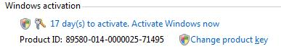
- Click Start, right-click Computer, and click Properties. Scroll to the bottom of the System window to see your Windows activation status, as shown to the right on this page. See how many days you have left to activate Windows.
If You Have More Than Seven Days Left, Skip to the Next Section
- Don’t do this step unless your activation is about to expire! You can only rearm the trial period three times, so if you do it when it’s not necessary, you could cause the Vista Ultimate installation to expire before the semester ends. However, if you have seven days or fewer left to activate Windows, do this:
  - Press the Logo key, type in CMD and press Shift+Ctrl+Enter. In the "User account control" box, click Continue.
  - Type in this command, and press the Enter key:
slmgr.vbs -rearm
  - Restart your machine. Check the Windows activation status again—you should now have 30 days left to activate.
Obtaining the BitLocker Drive Preparation Tool
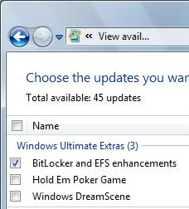
- Press the Logo key, and type in BIT
- If the Search finds "BitLocker Drive Preparation Tool", skip to the next section, “Using the BitLocker Drive Preparation Tool”. If your computer does not find it, do these steps to install it:
  - Click Start, "All Programs", "Windows Update". In the right pane of Windows Update, under the "There are Windows Ultimate Extras available for download" message, click "View available Extras".
  - In the "View available updates" box, check "BitLocker and EFS Enhancements", as shown to the right on this page. Clear all the other check boxes.

  - Click the Install button. In the "User Account Control" box, press Alt+C or click Continue. Wait while the update downloads and installs. When the process is finished, you should see a message saying "The updates were successfully installed".
Using the BitLocker Drive Preparation Tool
- Press the Logo key, and type in BIT
- When the Search finds "BitLocker Drive Preparation Tool", use the down-arrow as needed to highlight it and press the Enter key. In the "User Account Control" box, press Alt+C or click Continue.
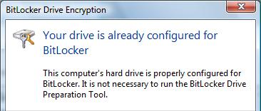
- A license agreement appears. Click the "I Accept" button.
- You may see a message saying "Your drive is already configured for BitLocker", as shown to the right on this page. If you do not, follow the steps in the wizard to adjust your hard disk partitions as required for BitLocker. Click Close.
Adjusting Group Policy to Allow BitLocker Without a Trusted Platform Module
- BitLocker is intended to be used on special motherboards with a Trusted Platform Module (TPM) chip, but we don't have machines like that. So we'll need to allow BitLocker to use a USB flash drive instead.
- Press the Logo key, type in this command, and press Enter:
gpedit.msc
- In the "User Account Control" box, press Alt+C or click Continue.
- In the "Group Policy Object Editor" console tree, in the "Local Computer Policy" section, expand "Administrative Templates". Expand "Windows Components", and then click "BitLocker Drive Encryption", as shown below on this page.
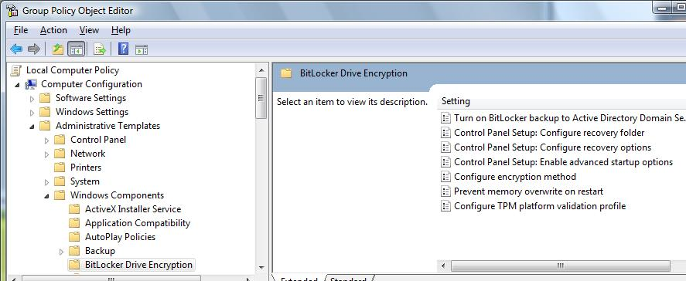

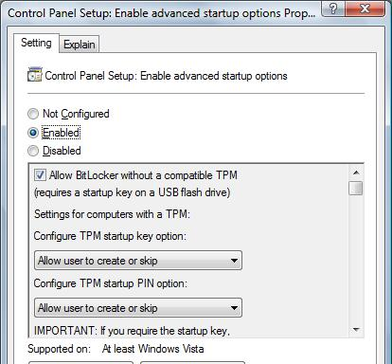
- In the right pane of "Group Policy Object Editor", double-click "Control Panel Setup: Enable Advanced Startup Options".
- In the "Control Panel Setup: Enable Advanced Startup Options" box, click the Enabled button, as shown to the right on this page. This will allow you to use a USB key instead of a TPM chip. Click OK.
- Close the "Group Policy Object Editor" window.
- Although the Group Policy has been changed, it may not take effect immediately. To force it to take effect, do these steps:
- Press the Logo key, type in this command, and press Enter:
gpupdate.exe /force
Activating BitLocker Drive Encryption
- Click Start, "Control Panel". If Control Panel is in "Classic View", click "Control Panel Home". Click Security.
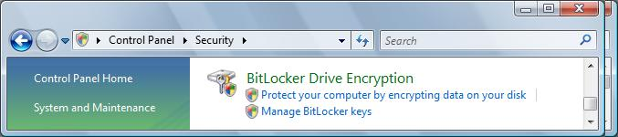
- In the "BitLocker Drive Encryption" section, click "Protect your computer by encrypting data on your disk", as shown below on this page.

- In the "User Account Control" box, press Alt+C or click Continue.
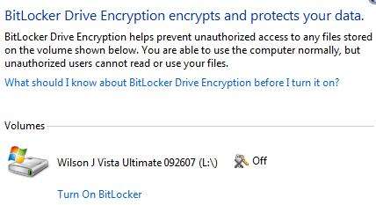
- The next screen should show your Vista Ultimate volume, with the word Off next to it, as shown to the right on this page. Click "Turn on BitLocker".

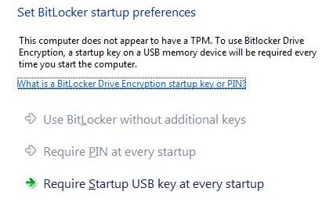
- In the "Set BitLocker startup preferences" screen, the first two options are grayed out because our computers do not have a TPM, as shown to the right on this page. Click "Require Startup USB key at every startup".

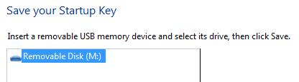
- Insert a USB flash drive. When it appears in the box, as shown to the right on this page, click Save.

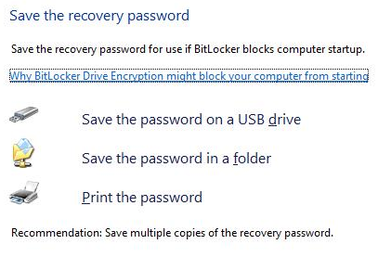
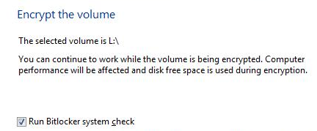
- In the "Save the recovery password" screen, as shown to the right on this page, click "Save the password on a USB drive". In the next box, click Save.
- In the "Save the recovery password" screen, click Next.

- In the "Encrypt the volume" box, accept the default selection of "Run BitLocker system check" and click Continue.
- In the "Computer must be restarted" box, click "Restart Later".

Viewing the BitLocker Encryption Files
- Click Start, Computer. In the "Devices with Removable Storage" section, double-click your USB drive.
- In the Windows Explorer window, click Organize, "Folder and Search Options". In the "Folder Options" box, on the View tab, ensure that these settings are correct, and then click OK:
  - "Show hidden files and folders" should be checked
  - "Hide extensions for known types" should not be checked
  - "Hide protected operating system files (Recommended)" should not be checked
- In the Windows Explorer window showing the files on your USB drive, click the drop-down arrow next to the word "Views" and click Details. Click the "Date modified" heading to bring the most recently modified files to the top of the screen.

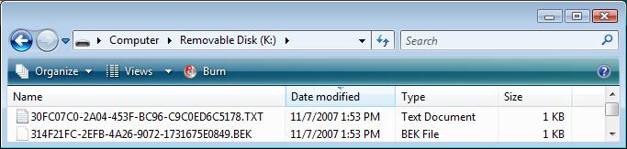
- You should see two files that were recently created, as shown below on this page. They both have names that are just scrambled letters and numbers. One is a "Text Document" and the other is a "BEK File".

Viewing the 48-Digit BitLocker Recovery Password
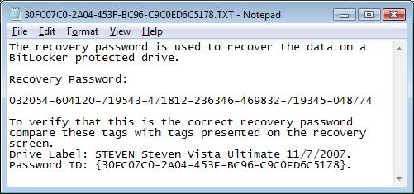
- Double-click the "Text Document" file. You should see a 48-digit "Recovery Password", as shown to the right on this page.

Saving the Screen Image
- Make sure the 48-digit "Recovery Password" is visible.
- Press the PrintScrn key in the upper-right portion of the keyboard. That will copy the whole desktop to the clipboard.
- Click Start, All Programs, Accessories, Paint. In the untitled - Paint window, select Edit, Paste from the menu bar. The window image appears in the Paint window.
- In the untitled - Paint window, click File, Save. Save the document in the My Pictures folder (or any other place you wish, such as a floppy disk) with the filename Your Name Proj X4a. Select a Save as type of JPEG.

Copying the Bitlocker Encryption Key to a Floppy Disk
- The BitLocker encryption key is intended to be stored on a USB drive, but for some reason it cannot be read properly on the machines in S214. I suspect it has something to do with our BIOS. But there is a simple workaround we can use—copying the key to a floppy disk. (Thanks to Kirk Yang for finding this!)
- Label a floppy disk with your machine number. Insert the floppy disk in the drive.
- In the Windows Explorer window showing the files on your USB drive, right-click the "BEK File" and click "Send To…", "Floppy Disk Drive". If you see a box saying "You need to format the disk in drive A: before you can use it", do this:
  - Verify that there is no important data on the disk and click "Format disk".
  - In the "Format Floppy Disk Drive (A:)" box, check the "Quick Format" box and click Start.
  - In the box saying "WARNING: Formatting will erase ALL data…", click OK.
  - In the box saying "Format Complete.", click OK.
  - In the "Format Floppy Disk Drive (A:)" box, click Close.
Viewing the BEK File on the Floppy Disk
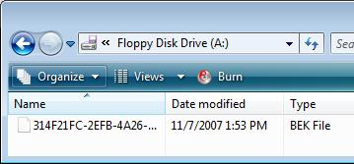
- Click Start, Computer. Double-click "Floppy Disk Drive (A:)".
- You should see the BEK File on the floppy disk, as shown to the right on this page.
Restarting your Machine
- Remove the floppy disk. Eject the USB drive and remove it. Restart your Vista machine.
- When you see the operating system selection menu, insert the floppy disk, select your installation of Vista Ultimate, and press the Enter key.
- Log in as usual.
Observing the BitLocker Encryption Status
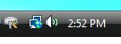
- Your machine should now be encrypting your drive. In the lower right corner of your screen, near the clock, you should see a BitLocker icon, as shown to the right on this page.
BitLocker Icon
- Right-click the BitLocker icon and click Status.

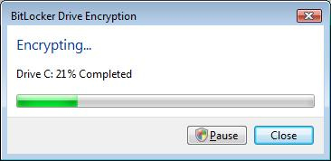

- You should see a "BitLocker Drive Encryption" box, as shown to the right on this page. It doesn't matter what % is completed.

Saving the Screen Image
- Make sure the "BitLocker Drive Encryption" box is visible.
- Press the PrintScrn key in the upper-right portion of the keyboard. That will copy the whole desktop to the clipboard.
- Click Start, All Programs, Accessories, Paint. In the untitled - Paint window, select Edit, Paste from the menu bar. The window image appears in the Paint window.
- In the untitled - Paint window, click File, Save. Save the document in the My Pictures folder (or any other place you wish, such as a floppy disk) with the filename Your Name Proj X4b. Select a Save as type of JPEG.

Turning in your Project—Include the BEK File and the Station Number
- Email the JPEG images to me as attachments to a single email message. If you did this project in S214, attach the BEK file to the email as well, and tell me which station you did the project on, so that I can start them if the BitLocker key is lost. Send the message to: cnit.335@gmail.com with a subject line of "Proj X4 From Your Name", replacing Your Name with your own first and last name. Send a Cc to yourself.

Sources:
http://support.microsoft.com/kb/930063
http://www.microsoft.com/technet/technetmag/issues/2007/06/BitLocker/

Last Modified 11-8-07 8 am

