Requirements
You will need a Vista machine (any edition). The system drive must have at least 2 GB free space.
Starting Your Vista Machine
- Start the machine and boot to Vista. Log in as usual. If a password is required, try P@ssw0rd
Downloading the Speedtest Batch File
- Open a Web browser and go to samsclass.info
- Click the "CNIT 335" link. Click Projects. Scroll down to " Project X5: Testing Speed of File Copies ". Right click the "Speedtest Batch File" link and select "Save Target As…". Save the file on your desktop.
Creating the Speedtest Folder
- Right click an empty portion of your desktop and click New, Folder. Name the folder Speedtest-YourName. Replace YourName with your own name.
- Drag the Speedtest.bat file into the Speedtest-YourName folder.
- Double-click the Speedtest-YourName folder.
Running the Speed Test Without Compression or Encryption
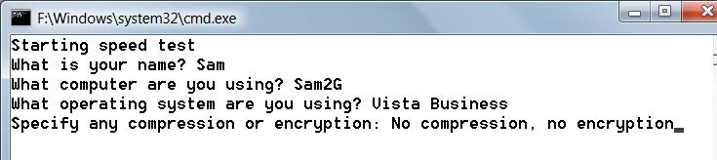
- In the Speedtest-YourName window, double-click the Speedtest.bat file.
- A Command Prompt window opens as shown below on this page. Type in answers to the four questions, giving your name and computer information, not using the exact examples shown below. Press the Enter key after each answer.

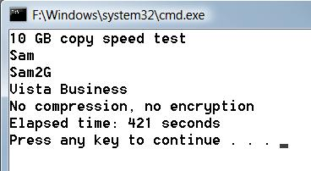
- This will run a little script that creates a 1 GB file and copies it ten times, then deletes it. The purpose of this is to see how long your machine takes to perform the copies. It should take 5-10 minutes.
- When the script finishes, you should see the result, showing how many seconds it took, as shown to the right on this page. If you see no time value, or a negative value, look in the results.txt file to find the time and send in that image instead.

Saving the Screen Image
- Press the PrintScrn key in the upper-right portion of the keyboard. That will copy the whole desktop to the clipboard.
- Click Start, All Programs, Accessories, Paint. In the untitled - Paint window, select Edit, Paste from the menu bar. The window image appears in the Paint window.
- In the untitled - Paint window, click File, Save. Save the document in the My Pictures folder (or any other place you wish, such as a floppy disk) with the filename Your Name Proj X5a. Select a Save as type of JPEG.
Compressing the Speedtest Folder
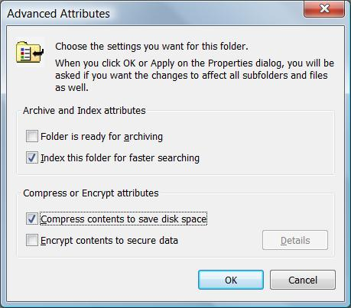
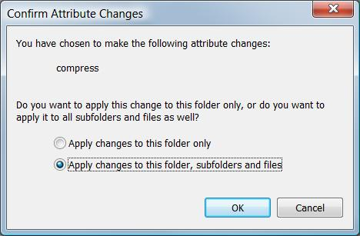
- On your desktop, right click the Speedtest-YourName folder. In the context menu, click Properties.
- In the "Speedtest-YourName Properties" box, on the General tab, click the Advanced button.
- In the "Advanced Attributes" box, check the "Compress contents to save disk space" box, as shown to the right on this page. Click the OK button.
- In the "Speedtest-YourName Properties" box, click the OK button.
- In the "Confirm Attribute Changes" box, accept the default selection of "Apply changes to this folder, subfolders, and files", as shown to the right on this page. Click the OK button.
- Double-click the Speedtest-YourName folder.
- Notice that the filenames in this folder appear in blue letters. If they are not blue, repeat the steps in this section to make sure the folder is really compressed.
Running the Speed Test With Compression
- In the Speedtest-YourName window, double-click the Speedtest.bat file.
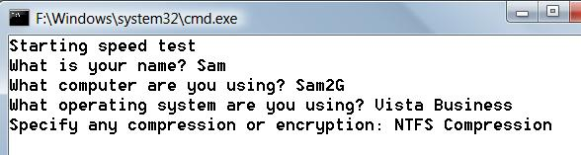
- A Command Prompt window opens as shown below on this page. Type in answers to the four questions, giving your name and computer information, not using the exact examples shown below. Be sure to enter the "NTFS Compression" information. Press the Enter key after each answer.
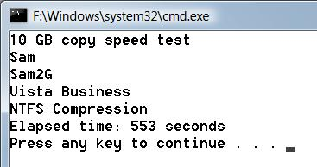
- When the script finishes, you should see the result, showing how many seconds it took, as shown to the right on this page. Your times may be different from my example, but the copy should take longer than it did with no compression and no encryption. If you see no time value, or a negative value, look in the results.txt file to find the time and send in that image instead.
Encrypting the Speedtest Folder
- On your desktop, right click the Speedtest-YourName folder. In the context menu, click Properties.
- In the "Speedtest-YourName Properties" box, on the General tab, click the Advanced button.
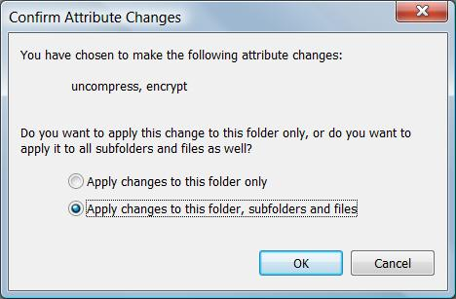
- In the "Advanced Attributes" box, check the "Encrypt contents to secure data" box. Click the OK button.
- In the "Speedtest-YourName Properties" box, click the OK button.
- In the "Confirm Attribute Changes" box, accept the default selection of "Apply changes to this folder, subfolders, and files", as shown to the right on this page. Click the OK button.
- Double-click the Speedtest-YourName folder.
- Notice that the filenames in this folder appear in green letters. If they are not green, repeat the steps in this section to make sure the folder is really encrypted.
Running the Speed Test With Encryption
- In the Speedtest-YourName window, double-click the Speedtest.bat file.
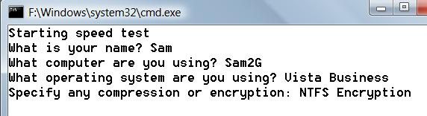
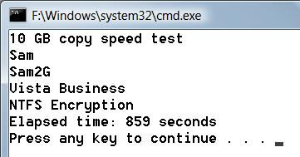
- A Command Prompt window opens as shown below on this page. Type in answers to the four questions, giving your name and computer information, not using the exact examples shown below. Be sure to enter the "NTFS Encryption" information. Press the Enter key after each answer.
- When the script finishes, you should see the result, showing how many seconds it took, as shown to the right on this page. Your times may be different from my example, but the copy should take longer than it did with no compression and no encryption. If you see no time value, or a negative value, look in the results.txt file to find the time and send in that image instead.

Turning in your Project
- Email the JPEG images to me as attachments to a single email message. Send the message to: cnit.335@gmail.com with a subject line of "Proj X5 From Your Name", replacing Your Name with your own first and last name. Send a Cc to yourself.

Last Modified 12-12-07

