Starting Your Machine in Vista
- Restart the machine and boot to Vista. Log in as usual.
Putting the Intel NIC Driver on the VMs Drive
- Press the Windows logo key, next to the Ctrl key at the lower left of your keyboard. Don't touch the mouse. Type this into the Search box, and then press the Enter key:
\\192.168.1.3
If you are asked for a login name and password, use the name CNIT with no password. If the connection cannot be established, ensure that the "Laraine" server is turned on.
- In the Network ► 192.168.1.3 window, double-click the CNIT335 folder to open it.
- Right-click the IntelNICDriver folder and click Copy.
- Click Start, Computer.
- In the Computer ► window, double-click the VMs drive to open it.
- In the Computer ► VMs window, double-click the Install folder to open it.
- In the Computer ► VMs ► Install window, look to see if there is already a folder named "". If there is, some other student already copied the NIC driver, so you can skip to the next section: "Booting from the Longhorn DVD". If the folder is not there, right-click a blank portion of the folder and click Paste.
Putting the Clamwin and Firefox Installers on the VMs Drive
- Repeat the same process to move the two folders Clamwin and Firefox from the server to the VMs drive.
Booting from the Longhorn Beta DVD
- Insert the Longhorn DVD. There are some of them in the translucent plastic box in the closet—the lab monitor should be able to get you one.
- Restart your machine. When you see the message "Press any key to boot from CD or DVD", press the Enter key.
- When you see the "Install Windows" box, accept the default "Language to install","Time and currency format", and "Keyboard or input method" settings and click Next.
- In the next screen, click "Install now".
- The next screen asks for a product key. Clear the "Automatically activate Windows when I'm online" box, leave the product key blank, and click Next.
- When a box pops up asking "Do you want to enter your product key now?" box, click No.
- The next screen asks you to select the edition of Windows that you purchased. There are six options: three normal server installations, and thee CORE versions. Choose any one of the first three, but make a note of which one you chose. If you aren't sure, I recommend choosing "Windows Longhorn SERVERENTERPRISE". Check the "I have selected the edition of Windows that I purchased" box and click Next.
The three CORE versions are interesting, but very hard to use, because CORE is a stripped-down server with no graphical user interface. I will write a different project installing the CORE versions.
- Check the “I accept the license terms” box and click Next.
- Click Custom (advanced).
Choosing the Installation Partition
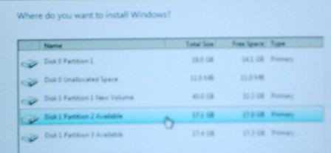
- Find a partition marked Available as shown to the right on this page and click on it. Note the Disk number and Partition number you chose. In the figure to the right on this page, “Disk 1 Partition 2” is selected.
- After you have clicked an available partition, click Next.
- Now wait – it will take a while to copy the files. Your computer will restart one or more times. When it restarts, don't touch the keyboard—just let it boot from the default hard disk partition. When I did it, it took about 20 minutes.
Server Configuration
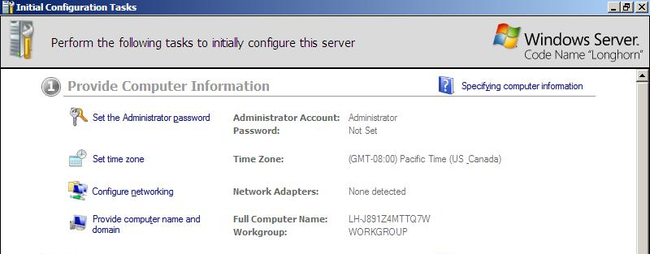
- When Longhorn is installed, you should see a window saying "Perform the following tasks to initially configure this server", as shown below on this page.

Setting the Administrator Password
- Click "Set the administrator password". Enter P@ssw0rd in both password boxes and click OK.
Installing the Network Adapter Driver
- Click Start, Computer. Double-click the VMs drive to open it. Double-click the Install folder to open it. Double-click the IntelNICDriver folder to open it.
- Double-click the PROVISTA32 file to start the installer. Follow the on-screen prompts to install the driver with the default selections.
Installing Clamwin Antivirus
- Click Start, Computer. Double-click the VMs drive to open it. Double-click the Install folder to open it. Double-click the Clamwin folder to open it.
- Double-click the clamwin setup file. Follow the on-screen prompts to install Clamwin antivirus with the default selections.
Installing Firefox
- Click Start, Computer. Double-click the VMs drive to open it. Double-click the Install folder to open it. Double-click the Firefox folder to open it.
- Double-click the Firefox setup file. Follow the on-screen prompts to install Firefox with the default selections.

Determining the System Drive Letter
- Click Start. In the Search box, type in CMD. Press the Enter key. A Command Prompt window opens.
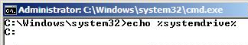
- Type this command into the Command Prompt window, then press the Enter key.:
echo %systemdrive%
The response should tell you your Longhorn drive letter. It is usually C:.

Changing the System Drive Label
- Click Start, Computer. Find your system drive in the list—it should be labeled “Available (F:)”, showing your actual drive letter instead of F:. You need to change this name, so that later students in the lab don’t see your Longhorn partition as “Available” and install Longhorn again on the same partition.
- Right-click your system drive icon and click Rename. Type in a new name of "Your Name Longhorn" and press the Enter key.

Changing the Operating System Label
- Click Start. In the Search box, type in CMD. Press Shift+Ctrl+Enter. In the "User account control" box, click Continue.
- An Administrator Command Prompt window opens, as shown below on this page. Look at the title bar of this window and make sure the first word you see is Administrator. If you don't see the word "Administrator" there, you cannot use BCDedit or other administrative commands. This is a new Vista feature which is confusing at first—there are two types of command prompt windows: Standard and Administrator.

Changing the Operating System Label with BCDEDIT
- Type this command into the Administrator Command Prompt window, then press the Enter key.:
bcdedit /set description "Your Name Server 2008" {current}
Replace Your Name with your own name. If you see a message saying "The boot configuration data store could not be opened. Access is denied.", you aren't in an Administrator Command Prompt window. Close the window and carefully repeat step the " Changing the Operating System Label " steps above.
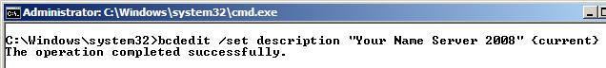

Creating a Student Account
- Click Start, "Control Panel". In the "User Accounts" section, click "Manage another account".
- In the "Choose the account you would like to change" screen, click "Create a new account".
- In the "Name the account and choose the account type" screen, enter a name of Student, click "Administrator", and click "Create a new account". Your screen should now look like the image below.
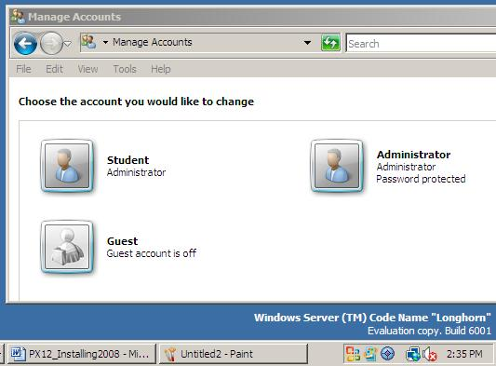

Saving the Screen Image
- Press the PrintScrn key in the upper-right portion of the keyboard. That will copy the whole desktop to the clipboard.
- Click Start, All Programs, Accessories, Paint. In the untitled - Paint window, select Edit, Paste from the menu bar. The window image appears in the Paint window.
- In the untitled - Paint window, click File, Save. Save the document in the My Pictures folder (or any other place you wish, such as a floppy disk) with the filename Your Name Proj X7. Select a Save as type of JPEG.

Turning in your Project
- Open Internet Explorer, and use it to email the JPEG image to me as an email attachment. Send the message to: cnit.335@gmail.com with a subject line of "Proj X7 From Your Name", replacing Your Name with your own first and last name. Send a Cc to yourself.

Activating Windows
- The Windows Server 2008 you have installed will only work for 30 days. If you want it to work longer than that, you can use the slmgr –rearm command to add 30 days up to three times. You may be able to get a free product key from Microsoft, depending on which version you have and when you try to get it. Ask your instructor for the latest information.

Last Modified12-12-07 10

