Starting Your Windows 2008 Server Machine
- You must have a working domain controller before you can do this project. You can either do projects X6 and X7 to make your own, or use a domain controller that another student made previously.
- Start the domain controller and log in as Administrator with a password of P@ssw0rd
Finding the Domain Controller's IP Address
- On the domain controller, click Start. In the Search box, enter CMD and press the Enter key.
- In the Command Prompt window, enter this command and then press the Enter key:

IP: _____________________
IPCONFIG
- Find your IP address and write it in the box to the right on this page. It should start with 192.168.1.

Starting a Vista Machine
- Leave the Windows Server 2008 domain controller running. Go to another machine in the room and boot it to Vista. Log in with as Student. Don't use any other account, because the login name must match the Student account you created on the domain controller.

Creating a Restore Point on the Vista Machine
- On the Vista machine, click Start, right-click Computer, and click Properties. In the left pane, click "System Protection". In the "User Account Control" box, click Continue.
- In the "System Properties" box, on the "System Protection" tab, click the Create button.
- In the "Create a restore point" box, enter a name of "Before joining a domain" and click the Create button.
- A box appears saying "The restore point was created successfully". Click OK.
- Close all windows.

Adding a DNS Server
- On the Vista machine, click Start, right-click Network, and click Properties. In "Network and Sharing Center", on the left side, click "Manage Network Connections".
- In "Network Connections", right-click "Local Area Connection" and click Properties. In the "User Account Control" box, click Continue.
- In "Local Area Connection Properties", click "Internet Protocol Version 4 (TCP/IPv4)". Click the Properties button.

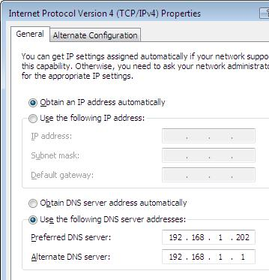
- In the "Internet Protocol Version 4 (TCP/IPv4) Properties" box, click the "Use the following DNS server addresses" button. In the "Preferred DNS Server" box, enter the "IP Address" you wrote in the box on the first page of these instructions. In the "Alternate DNS Server" box, type in 192.168.1.1
- In the "Internet Protocol Version 4 (TCP/IPv4) Properties" box, click the OK button.
- In "Local Area Connection Properties, click the Close button.

Adding the Vista Computer to Your Domain
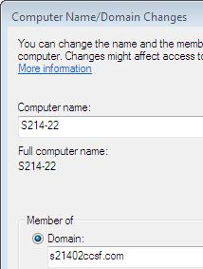
- On the Vista machine, click Start, right-click Computer, and click Properties. In the left pane, click "Advanced System Settings". In the "User Account Control" box, click Continue.
- In the "System Properties" box, click the "Computer Name" tab. Click the Change button.
- In the "Computer Name/Domain Changes" box, click the Domain radio button. In the box, type in your domain name as you wrote in the box on a previous page of these instructions, as shown to the right on this page. Do not use the exact domain name shown in the figure, unless your domain controller is really on station S214-02. Click OK.
- In the "Computer Name/Domain Changes" box, enter a user name of Administrator and a password of P@ssw0rd
- In the "Computer Name/Domain Changes" box, click OK.
- A box pops up saying "Welcome to the yourdomain domain.". Click OK.
- A box pops up saying "You must restart your computer…". Click OK.
- Close all windows and restart your computer. Boot it to the same Vista operating system you used before.

Logging in to Your Domain
- The logon process is different now. You must first press Ctrl+Alt+Delete, and your name will show up as S214-nn\Student with your Vista machine's number instead of nn. Press Enter to log in with no password.
- Click Start, right-click Computer, and click Properties. In the "Computer name, domain, and workgroup settings" section, the Domain: entry should show your domain name, as shown below on this page.
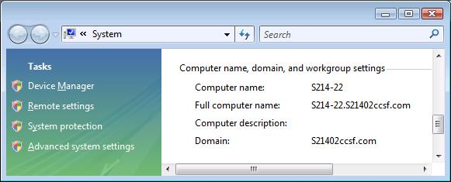

Saving the Screen Image
- Press the PrintScrn key in the upper-right portion of the keyboard. That will copy the whole desktop to the clipboard.
- Click Start, All Programs, Accessories, Paint. In the untitled - Paint window, select Edit, Paste from the menu bar. The window image appears in the Paint window.
- In the untitled - Paint window, click File, Save. Save the document in the My Pictures folder (or any other place you wish, such as a floppy disk) with the filename Your Name Proj X9. Select a Save as type of JPEG.

Turning in your Project
- Open Internet Explorer, and use it to email the JPEG image to me as an email attachment. Send the message to: cnit.335@gmail.com with a subject line of "Proj X9 From Your Name", replacing Your Name with your own first and last name. Send a Cc to yourself.

Restoring the Vista Machine
- Press the Windows logo key, next to the Ctrl key at the lower left of your keyboard. Don't touch the mouse. Type this into the Search box:
restore
- "System Restore" should appear in the Programs list. If it's not already highlighted, press the down-arrow as needed to highlight it. Then press the Enter key.
- In the "User Account Control" box, click Continue.

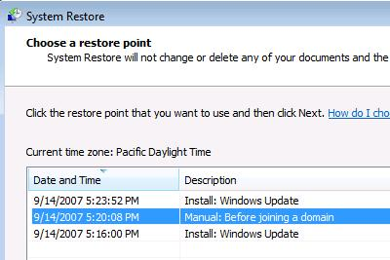
- In the "Restore system files and settings" box, click "Choose a different restore point" and click Next.
- In the "Choose a restore point" box, click "Manual: Before joining a domain", as shown to the right on this page, and click Next.
- In the "Confirm your restore point" box, click Finish.
- In the "System Restore" box, click Yes.
- After a few seconds, your machine will display a large "Please wait…" message, and then it will restart. Choose the same operating system as before when it restarts!
- Verify that you see the same choices as before, a student's name and a Student account. You should not have to press Ctrl+Alt+Delete to log in anymore, because the machine is no longer a domain member.

Last Modified: 12-12-07

