What You Will Need
- A wireless router
- A Vista computer (any version) with a wireless NIC to be the Wireless Client
- A Vista computer (any version) to be the Wired Client
- An Ethernet patch cord to connect the wired client.

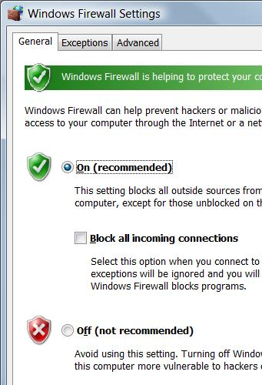
Setting Your Machines to Answer PINGs
- If things go smoothly, you won't need to PING machines during this project. But usually something goes wrong, and you will find it helpful to use PINGs to test the network. Windows Firewall blocks PINGs by default, so the first thing is to change that.

Using "Windows Firewall" to Turn On the Firewall
- Press the Logo key, and type in FIRE
- When the Search finds "Windows Firewall", use the down-arrow as needed to highlight it and press the Enter key.
- In the "Windows Firewall" box, click the "Change settings" link. In the "User Account Control" box, press Alt+C or click Continue.
- In the "Windows Firewall Settings" box, make sure the "On (recommended)" radio button is selected, and that the "Block all incoming connections" box is clear, as shown to the right on this page. Click OK.

Using "Windows Firewall with Advanced Security" to Allow PINGs
- Press the Logo key, and type in FIRE
- When the Search finds "Windows Firewall with Advanced Security", use the down-arrow as needed to highlight it and press the Enter key. In the "User Account Control" box, press Alt+C or click Continue.
- In the left pane of the "Windows Firewall with Advanced Security" window, click "Inbound Rules". Wait until the large middle pane fills with entries.
- Maximize the "Windows Firewall with Advanced Security" window.

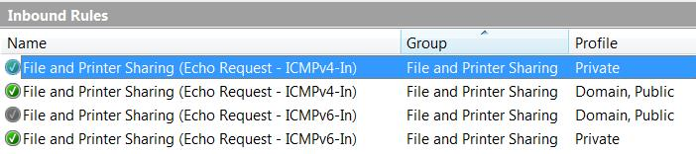
- In the middle pane of the "Windows Firewall with Advanced Security" window, drag the right edge of the "Name" header to the right so you can see long names. Then scroll down, find the "File and Printer Sharing (Echo Request – ICMPv4-In)" item, for the Private profile, as shown below on this page, and double-click it.

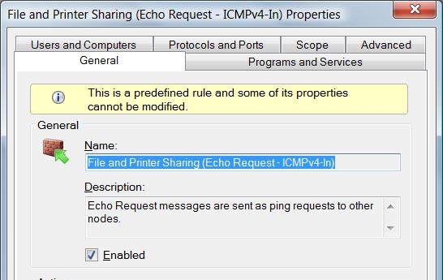
- In the "File and Printer Sharing (Echo Request – ICMPv4-In) Properties" box, make sure the Enabled box is checked, as shown to the right on this page. Click OK.
- Close the "Windows Firewall with Advanced Security" window.

Choose Your Wireless Router
- There are three types of Wireless Routers available: Linksys, D-Link, and Belkin. Choose one and use the corresponding instructions below to set up a secure Wireless Local Area Network (WLAN).

Making a Secure WLAN with the Linksys Wireless Router

Restoring the Wireless Router to Factory Default Settings
- Get the blue Linksys BEFW11S4 router from the closet. Plug in the power cord. Do not plug in any Ethernet cables yet.
- Press the little red RESET button on the back and hold it in for ten seconds. This resets the router back to its factory default settings.

Connecting a “Wired Client” Computer to the Router
- Choose one computer to be the Wired Client. Boot it up to Vista.
- Disconnect the blue Ethernet cable from the back of the Wired Client. Take another cable and connect the Wired Client to port 1 on the router. Check the front panel of the router: the light under number 1 should light up, but the Internet light should be dark.
- On the Wired Client, click Start, type in this command and press the Enter key:
CMD
- On the Wired Client, in the "Command Prompt" window, click Start, type in this command, All Programs, Accessories, Command Prompt. Type in this command and press the Enter key:
IPCONFIG /ALL
Under one of the the “Ethernet adapter” headings, you should see a line showing “Dhcp Enabled . . Yes” and an IP address starting with 192.168.1, as shown below. This indicates that the router is providing an IP address to the wired client computer. There are other network adapters present with other IP addresses, but one of them should start with 192.168.1. If you don’t have an IP address like that, restart the Wired Client computer.

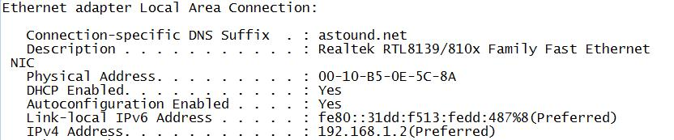

- On the Wired Client, in the Command Prompt window, type in this command and press the Enter key.
PING 192.168.1.1
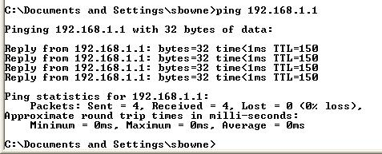
You should see the front panel lights on the router blink. In the “Command Prompt” window, you should see “Reply” lines, as shown to the right on this page. The Wired Client is now connected to the router as a client.

Changing the Subnet on the Router
- The LAN in S214 uses the 192.168.1.0 subnet, which is the same as the default subnet for the Linksys router. The router won’t be able to connect to the LAN in S214 to get to the Internet unless it uses a different subnet for its clients, so we need to change the router to a different subnet.
- On the Wired Client. open Firefox and type this address: 192.168.1.1
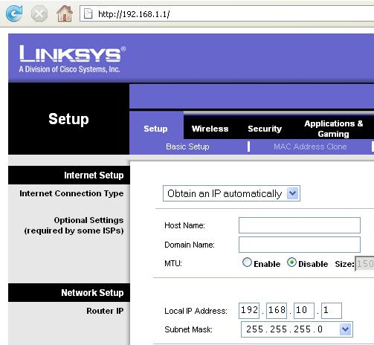
- Press the Enter key. A box pops up asking for a user name and password. Leave the User Name blank and enter a password of admin
- Click OK. A Linksys page should appear as shown to the right on this page.
- In the Linksys page, on the Setup tab, change the Local IP Address to 192.168.10.1, as shown to the right on this page.

- Scroll to the bottom of the page and click the Save Settings button.
- A popup box appears saying “Next time, login the router with the new IP address”. Click OK.
- Now that the router has a new address, the Wired Client needs a new IP address too to connect to it. To force the wired client to get a new IP address from the router, unplug the network cable from port 1 on the router, wait a couple of seconds, and plug it in again.
- On the Wired Client , in the Command Prompt window, type in this command and press the Enter key.
IPCONFIG /ALL
You should see an IP address starting with 192.168.10. If you don’t have an IP address like that, restart the Wired Client computer.
- On the Wired Client, in the Command Prompt window, type in this command and press the Enter key.
PING 192.168.10.1
You should see the front panel lights on the router blink, and you should see replies . The Wired Client is now connected to the router again as a client.

Setting the SSID and Channel on the Wireless Router
- Make up a new SSID to be your network’s name. Write it in the box to the right on this page.

SSID: _______________________

Channel: 1

- On the Wired Client. open Firefox and type this address: 192.168.10.1
- Press the Enter key. A box pops up asking for a user name and password. Leave the User Name blank and enter a password of admin
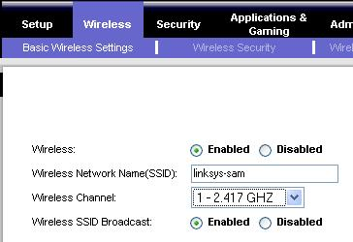
- A Linksys page should appear.
- In the Linksys page, click the Wireless tab. Click the blue “Basic Wireless Settings” tab. In the “Wireless” line, click Enabled. Enter your SSID in the “Wireless Network Name(SSID):” box, as shown to the right on this page.
- Select a “Wireless Channel” of “1 – 2.417 GHZ”, as shown to the right on this page. At the bottom of the page, click “Save settings”.

Changing the Router’s Password
- Make up a password for your router. Write it in the box to the right on this page.

Password: _______________________
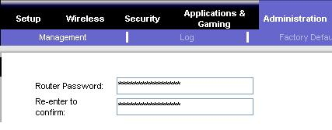
- On the Wired Client, in the Linksys page, click the Administration tab. Click the blue “Management” tab. Type your new password into the “Router Password” box and also into the “Re-enter to confirm” box, as shown to the right on this page. At the bottom of the page, click “Save settings”.
- A box pops up asking for a user name and password. Leave the User Name blank and enter the new password you selected. The Linksys page should open again.

Setting WPA Security on the Wireless Router

WPA Key: ________________________
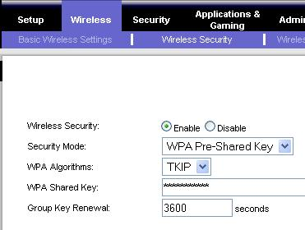
- Make up WPA key and write it in the box to the right on this page. Your key should be at least 8 letters long, and should not be a word found in a dictionary.
- On the Wired Client, in the Linksys page, click the Wireless tab.
- In the “Wireless Security” line, click Enable.
- In the “Security Mode” line, select “WPA Pre-Shared Key”.
- In the “WPA Shared Key” line, enter your WPA key.
- At the bottom of the page, click “Save settings”. When a Firefox box pops up asking “Do you want Firefox to remember this password?”, Click “Never for this site”.

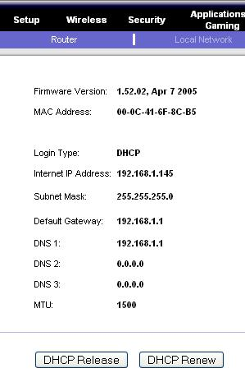
Connecting the Router to the Room’s LAN
- Find the blue cable attached to the wall that used to be plugged into the Wired Client. Plug it into the WAN port on the router. The Internet front panel light should come on.
- On the Wired Client, in the Linksys page, at the upper right, click the Status tab. At the bottom of the screen, click the “DHCP Renew” button. The router should now show an “Internet IP Address” starting with 192.168.1 as shown to the right on this page. If it does not, click the the “DHCP Renew” button again.
- On the Wired Client, in the Command Prompt window, type in this command and press the Enter key.
PING YAHOO.COM
You should see replies, and you should see the front panel lights on the router blink. The Wired Client is now connected to the Internet through the router.

Skip ahead to the “Connecting a “Wireless Client” to the Wireless Router” section.

Making a Secure WLAN with the Belkin Wireless Router

Restoring the Wireless Router to Factory Default Settings
- Get the gray Belkin router from the closet. Plug in the power cord. Do not plug in any Ethernet cables yet.
- Use a pin or paper clip to press the little RESET button on the back and hold it in for ten seconds. This resets the router back to its factory default settings.

Connecting a “Wired Client” Computer to the Router
- Choose one computer to be the Wired Client. Disconnect the blue Ethernet cable from the back of the Wired Client. Take another cable and connect the Wired Client to port 1 on the router. Check the front panel of the router: the light under number 1 should light up, but the WAN light should be dark.
- On the Wired Client, click Start, type in this command and press the Enter key:
CMD
- On the Wired Client, in the "Command Prompt" window, click Start, type in this command, All Programs, Accessories, Command Prompt. Type in this command and press the Enter key:
IPCONFIG /ALL

Under one of the the “Ethernet adapter” headings, you should see a line showing “Dhcp Enabled . . Yes” and an IP address starting with 192.168.2, as shown below. This indicates that the router is providing an IP address to the wired client computer. There are other network adapters present with other IP addresses, but one of them should start with 192.168.2. If you don’t have an IP address like that, restart the Wired Client computer.
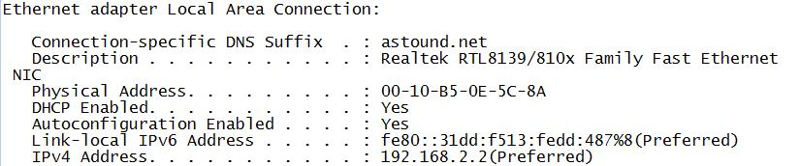
- On the Wired Client, in the Command Prompt window, type in this command and press the Enter key.
PING 192.168.2.1
You should see replies, and you should see the front panel lights on the router blink. The Wired Client is now connected to the router as a client.

Setting the SSID and Channel on the Wireless Router
- Make up a new SSID to be your network’s name. Write it in the box to the right on this page. Don't use any spaces in the SSID.

SSID: _______________________

Channel: 11

- On the Wired Client. open a browser and go to this address: 192.168.2.1
- A Belkin page opens. In the upper right, click the “Login” button.
- A Login screen appears. Leave the Password box empty and click the Submit button. If the browser displays a “Security Warning” box, click Continue.
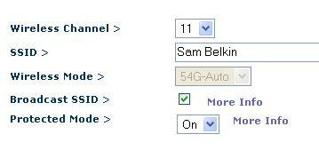
- On the left side of the screen, click “Channel and SSID”.
- In the “Wireless > Channel and SSID” page, enter your SSID in the SSID box.
- Select a “Wireless Channel” of “11”, as shown to the right on this page. At the bottom of the page, click “Apply Changes”.

Changing the Router’s Password
- Make up a password for your router. Write it in the box to the right on this page.

Password: _______________________
- On the Wired Client, in the Belkin page, scroll down to the bottom of the left pane and click “System settings”.
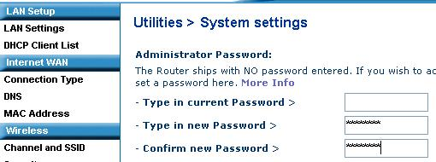
- In the “Utilities > System settings” page, type your new password into the “Type in new Password” box and also into the “Confirm new Password” box, as shown to the right on this page. At the bottom of the page, click “Apply changes”.

Setting WPA Security on the Wireless Router

WPA Key: ________________________
- Make up WPA key and write it in the box to the right on this page. Your key should be at least 8 letters long, and should not be a word found in a dictionary.
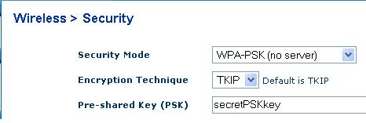
- In the left pane, in the Wireless section, click Security. In the “Security Mode” box, select “WPA-PSK (no server)”. Enter the WPA Key you wrote in the box on this page into the “Pre-shared Key (PSK)” field, as shown to the right on this page. At the bottom of the page, click “Apply Changes”.

Connecting the Router to the Room’s LAN
- Find the blue cable attached to the wall that used to be plugged into the Wired Client. Plug it into the “Connection to Modem” port on the router. The WAN front panel light should come on.
- On the Wired Client, a browser should still be open, showing address 192.168.2.1
- In the Belkin page, on the left side, in the “Internet WAN” section, click “Connection Type”.
- In the “WAN > Connection Type” screen, accept the default selection of Dynamic and click the Next button.
- In the “WAN > Connection Type > Dynamic IP” screen, leave the “Host Name” box empty and click the “Apply Changes” button.
- On the Wired Client, in the Command Prompt window, type in this command and press the Enter key.
PING YAHOO.COM
You should see replies, and you should see the front panel lights on the router blink. The Wired Client is now connected to the Internet through the router.

Skip ahead to the “Connecting a “Wireless Client” to the Wireless Router” section.

Making a Secure WLAN with the D-Link Wireless Router

Restoring the Wireless Router to Factory Default Settings
- Get the gray D-Link router from the closet. Plug in the power cord. Do not plug in any Ethernet cables yet.
- Use a pin or paper clip to press the little RESET button on the back and hold it in for ten seconds. This resets the router back to its factory default settings.

Connecting a “Wired Client” Computer to the Router
- Choose one computer to be the Wired Client. Disconnect the blue Ethernet cable from the back of the Wired Client. Take another cable and connect the Wired Client to port 1 on the router. Check the front panel of the router: the light under number 1 should light up, but the WAN light should be dark.
- On the Wired Client, click Start, type in this command and press the Enter key:
CMD
- On the Wired Client, in the "Command Prompt" window, click Start, type in this command, All Programs, Accessories, Command Prompt. Type in this command and press the Enter key:
IPCONFIG /ALL
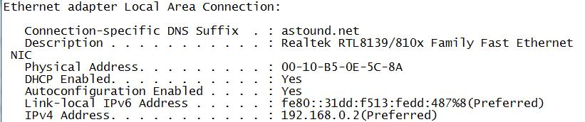
Under one of the the “Ethernet adapter” headings, you should see a line showing “Dhcp Enabled . . Yes” and an IP address starting with 192.168.0, as shown below. This indicates that the router is providing an IP address to the wired client computer. There are other network adapters present with other IP addresses, but one of them should start with 192.168.0. If you don’t have an IP address like that, restart the Wired Client computer.
- On the Wired Client, in the Command Prompt window, type in this command and press the Enter key.
PING 192.168.0.1
You should see replies, and you should see the front panel lights on the router blink. The Wired Client is now connected to the router as a client.

Setting the SSID and Channel on the Wireless Router

SSID: _______________________

Channel: 6

- Make up a new SSID to be your network’s name. Write it in the box to the right on this page.
- On the Wired Client. open a browser and go to this address: 192.168.0.1

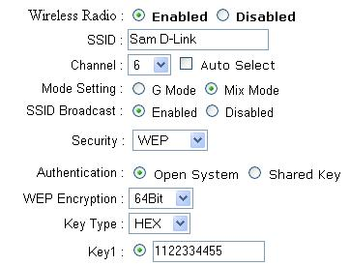
- A box pops up asking for a user name and password. Enter a user name of admin and leave the password blank. Click the OK button.
- On the left side of the screen, click “Wireless”.
- Enter your SSID in the SSID box, as shown to the right on this page.
- Select a “Wireless Channel” of “6”, as shown to the right on this page.

Setting WPA Security on the Wireless Router

WPA Key: ________________________
- Make up WPA key and write it in the box to the right on this page. Your key should be at least 8 letters long, and should not be a word found in a dictionary.
- In the “Security:” box, select “WPA”.
- In the “PSK / EAP:” line, select “PSK” (Pre-Shared Key).
- Enter your WPA key into the “Passphrase” box, and also into the “Confirmed Passphrase” box.
- At the bottom of the page, click “Apply”. When you see a message saying “The device is restarting”, wait a few seconds and then click the Continue button. The D-Link page should re-appear.

Changing the Router’s Password
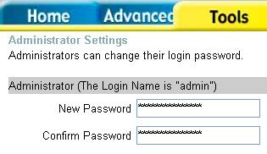
- Make up a password for your router. Write it in the box to the right on this page.

Password: _______________________
- On the Wired Client, in the D-Link page, click the Tools tab. In the “Administrator” section, type your new password into the “New Password” box and also into the “Confirm Password” box, as shown to the right on this page. At the bottom of the page, click “Apply”. When you see the “Settings saved” message, click the Continue button.
- A box pops up asking for a user name and password. Enter a User Name of admin and enter the new password you selected. Click OK. The D-Link page should open again.

Connecting the Router to the Room’s LAN
- Find the blue cable attached to the wall that used to be plugged into the Wired Client. Plug it into the “WAN” port on the router. The WAN front panel light should come on.
- On the Wired Client, a browser should still be open, showing the D-Link page.
- On the Wired Client, in the Command Prompt window, type in this command and press the Enter key.
PING YAHOO.COM
You should see replies, and you should see the front panel lights on the router blink. The Wired Client is now connected to the Internet through the router.

Skip ahead to the “Connecting a “Wireless Client” to the Wireless Router” section.

Connecting a “Wireless Client” to the Wireless Router
- Find a machine with a wireless NIC to use as the “Wireless Client” computer. Do not use S214-13 for this role. Machines S214-15, 16, and 17 have wireless NICs, and there are also USB wireless NICs available that can be attached to other stations.
- Boot your wireless client to Vista. Insert your NIC if necessary, and install the drivers. Letting Vista find the drivers over the Internet should work for all the NICs your instructor has provided.

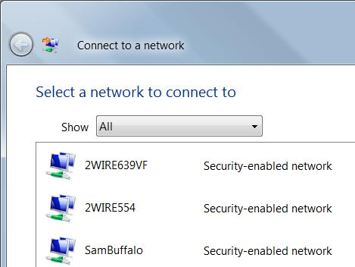
- In the lower right of the desktop, find the Network Connection icon, as shown to the right on this page. It shows two computers and a globe. Right-click that icon and click “Connect to a network”.
- You should see a list of networks as shown to the right on this page. Find your SSID in the list and click it once to select it. Click the Connect button.
- A box pops up asking you to "Type in the network security key or passphrase". Enter the WPA Key you wrote in the box on a previous page of these instruction and click Connect.
- You should see this message “Successfully connected to YourSSID”. Click the Close. Button.
- A box pops up asking you to "Select a location for the ' YourSSID ' network". Click Work. In the "User Account Control" box, press Alt+C or click Continue.
- You should see this message “Successfully set network settings”. Click the Close. Button.

Capturing the Screen Image
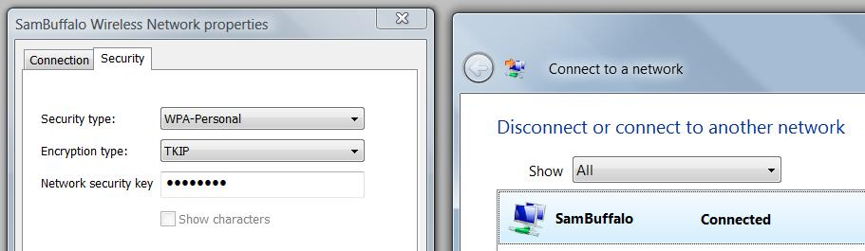
- The "Connect to a network" box should now show your SSID at the top of the list, marked Connected. Double-click on that line to open the "YourSSID Wireless Network properties" box, as shown below on this page. In the example below, the SSID is "SamBuffalo"—your SSID will be different.

- In the "YourSSID Wireless Network properties" box, click the Security tab. Verify that it shows a "Security type" of "WPA-Personal".
- Drag the "YourSSID Wireless Network properties" box to the side, so that both it and the "Connect to a network" box are clearly visible.
- Press the PrntScn key to copy whole screen to the clipboard. Open Paint and paste in the image. Save it as a JPEG, with the filename Your Name Proj 14.
Turning in your Project
- Email the JPEG image to me as an attachment. Send the message to cnit.335@gmail.com with a subject line of Proj 14 From Your Name. Send a Cc to yourself.
Last modified 3-10-08

