What You Will Need
- Two Vista computers (any version) on a Local Area Network

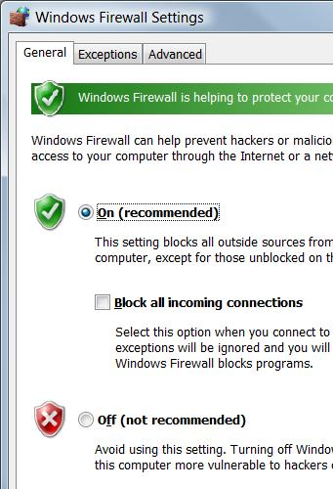
Setting Your Machines to Answer ICMPv4 and ICMPv6 PINGs—Do This on Each Machine
- Windows Firewall blocks PINGs by default, but we really need PINGs for this project. So set all the machines you plan to use to answer both ICMPv4 and ICMPv6 Pings, with the procedure below.

Ensuring that Windows Firewall is On
- Press the Logo key, and type in FIRE
- When the Search finds "Windows Firewall", use the down-arrow as needed to highlight it and press the Enter key.
- In the "Windows Firewall" box, click the "Change settings" link. In the "User Account Control" box, press Alt+C or click Continue.
- In the "Windows Firewall Settings" box, make sure the "On (recommended)" radio button is selected, and that the "Block all incoming connections" box is clear, as shown to the right on this page. Click OK.

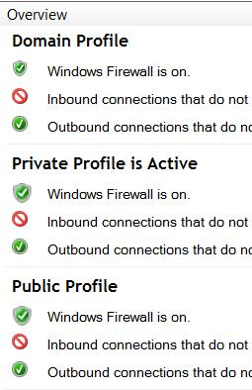
Using "Windows Firewall with Advanced Security" to Allow IPv4 and IPv6 PINGs
- Press the Logo key, and type in FIRE
- When the Search finds "Windows Firewall with Advanced Security", use the down-arrow as needed to highlight it and press the Enter key. In the "User Account Control" box, press Alt+C or click Continue.
- Look in the center pane. You should see three profiles, labeled "Domain Profile", "Private Profile", and "Public Profile", as shown to the right on this page. One of them is marked Active—in the example to the right, it's the Private profile. Write down the active profile in the box below on this page.

Active Profile: ________________________

- In the left pane of the "Windows Firewall with Advanced Security" window, click "Inbound Rules". Wait until the large middle pane fills with entries.
- Maximize the "Windows Firewall with Advanced Security" window.
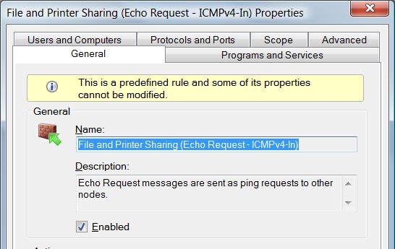
- In the middle pane of the "Windows Firewall with Advanced Security" window, drag the right edge of the "Name" header to the right so you can see long names. Then scroll down, find the "File and Printer Sharing (Echo Request – ICMPv4-In)" item, for the active profile (the one you wrote down in the box on the previous page), and double-click it.
- In the "File and Printer Sharing (Echo Request – ICMPv4-In) Properties" box, make sure the Enabled box is checked, as shown to the right on this page. Click OK.
- Repeat the process for the "File and Printer Sharing (Echo Request – ICMPv6-In)" item, for the active profile.
- Your "Inbound Rules" should now show both "File and Printer Sharing (Echo Request – ICMPv4-In)" and "File and Printer Sharing (Echo Request – ICMPv6-In)" with green check marks, as shown below on this page.
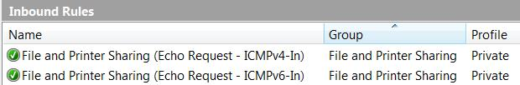

- Close the "Windows Firewall with Advanced Security" window.
- Repeat the whole process for all the machines you plan to use in this project.

Finding your IP Addresses--Do This on Each Machine
- Find your computer's name on the front panel, which will be something like "S214-01". Write it in the box below on this page.
- Click Start, type in this command and press the Enter key:
CMD
- In the "Command Prompt" window, type in this command and press the Enter key:
IPCONFIG /ALL
Under one of the the “Ethernet adapter” headings, you should see a line showing “Dhcp Enabled . . Yes” and an IP address starting with 192.168.1, as shown below. This indicates that the router is providing an IP address to the wired client computer. There are other network adapters present with other IP addresses, but one of them should start with 192.168.1. If you don’t have an IP address like that, restart the computer.

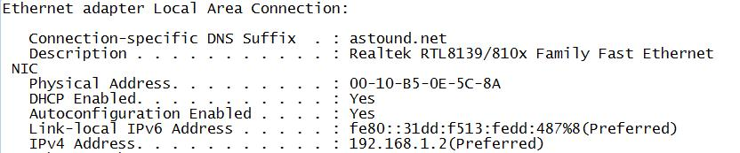
- Write down both the "Link-local IPv6 Address" and the "IPv4 Address" in the chart below. Notice that the IPv6 addresses start with fe80:: and end with a % sign and a suffix. The fe80:: is the prefix for automatically generated private IP addresses, and are analogous to the 169.254 IPv4 addresses automatically assigned when no DHCP server is present. The % sign indicates the Zone ID, which is a number assigned to the interface by Vista. For more details, see the references at the end of this project.

Computer Name: ________________________________________________________________

IPv6 Address: ________________________________________________________________

IPv4 Address: ________________________________________________________________

Using PING (ICMPv4)—Do this on One Machine
- Click Start, type in this command and press the Enter key:
CMD
- In the "Command Prompt" window, type in this command and press the Enter key:
PING IPv4-Address
Replace IPv4-Address with the other computer's IPv4 address, which will be something like 192.168.1.14. You should see replies as shown below on this page.
F:\Users\Sam>ping 192.168.1.14

Pinging 192.168.1.14 with 32 bytes of data:

Reply from 192.168.1.14: bytes=32 time<1ms TTL=128
Reply from 192.168.1.14: bytes=32 time<1ms TTL=128
Reply from 192.168.1.14: bytes=32 time<1ms TTL=128
Reply from 192.168.1.14: bytes=32 time<1ms TTL=128

Using PING (ICMPv6)—Do this on One Machine
- Click Start, type in this command and press the Enter key:
CMD
- In the "Command Prompt" window, type in this command and press the Enter key:
PING IPv6-Address
Replace IPv6-Address with the other computer's IPv6 address, which will be something like fe80::31dd:f513:fedd:487%8. You should see replies as shown below on this page.
F:\Users\Sam>ping fe80::31dd:f513:fedd:487%8

Pinging fe80::31dd:f513:fedd:487%8 from fe80::24ac:ad2:f2d:b63%8 with 32 bytes of data:

Reply from fe80::31dd:f513:fedd:487%8: time<1ms
Reply from fe80::31dd:f513:fedd:487%8: time<1ms
Reply from fe80::31dd:f513:fedd:487%8: time<1ms
Reply from fe80::31dd:f513:fedd:487%8: time<1ms

Capturing the Screen Image
- Make sure that the Reply lines to the ICMPv6 PING command are visible, as shown at the bottom of the previous page.
- Press the PrntScn key to copy whole screen to the clipboard. Open Paint and paste in the image. Save it as a JPEG, with the filename Your Name Proj 15a.
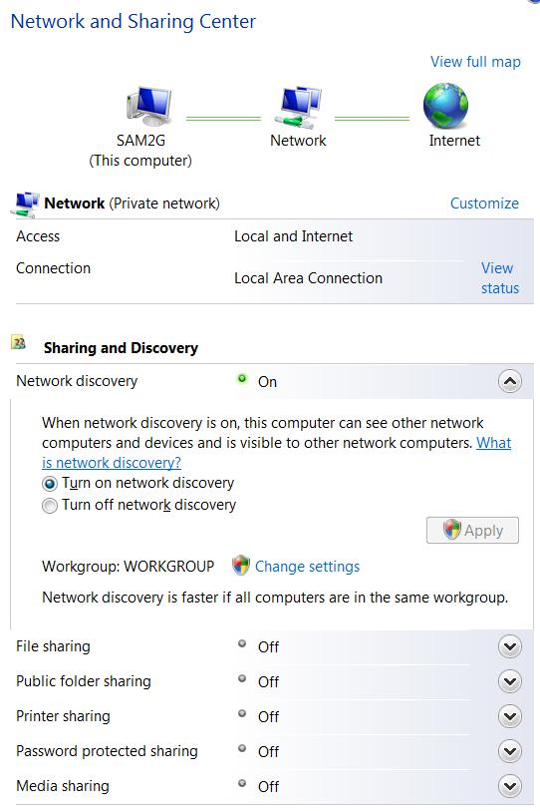
Configuring Public Folder Sharing—Do this on Both Machines
- Click Start, Network. In the Network window, click "Network and Sharing Center".
- In the "Sharing and Discovery" section, in the "Network discovery" line, click the 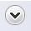 symbol. The section expands. Click the "Turn on network discovery" radio button, as shown to the right on this page. If the Apply button is not grayed out, click it, and in the "User Account Control" box, press Alt+C or click Continue.
- In the "File sharing" line, click the symbol. Click the "Turn on file sharing" radio button. If the Apply button is not grayed out, click it, and in the "User Account Control" box, press Alt+C or click Continue.
- In the "Public folder sharing" line, click the symbol. Click the "Turn on sharing so anyone with network access can open, change, and create files" radio button. If the Apply button is not grayed out, click it, and in the "User Account Control" box, press Alt+C or click Continue.
- Note: This is not the most secure way to share files. But it's the easiest way to do it in the lab, because the machines don't all have the same account names and passwords.
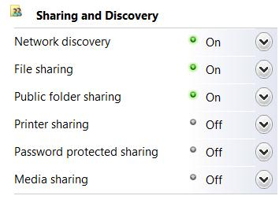
- In the same manner, ensure that the last three items are all turned off: "Printer sharing", "Password protected sharing", and "Media sharing".
- Click all the symbols, to collapse all the items. Your "Sharing and Discovery" section should now look like the example shown to the right on this page, with the first three items On and the last three Off.

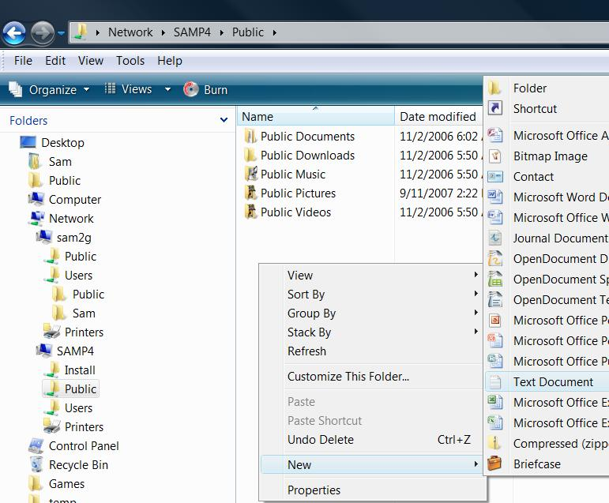
Opening a Shared Folder—Do this on One Machine
- Click Start, Network. In the right pane of the Network window, find your other machine's name and double-click it. Double-click the Public folder.
- Right click a blank portion of the Public window and select New, "Text Document", as shown to the right on this page.
- A new document should appear in the Public folder. This shows that you have the sharing properly configured, so that you can create a file on the other machine.

Opening Local Area Connections Properties
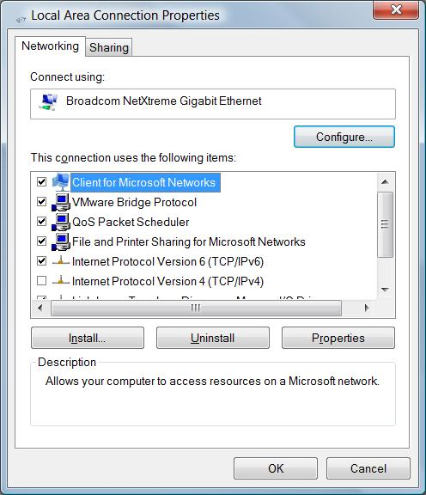
- Click Start, Network. In the Network window, click "Network and Sharing Center".
- In the "Network and Sharing Center" window, in the left pane, click "Manage network connections".
- In the "Control Panel ► Network Connections" window, right click "Local Area Connection" and click Properties. In the "User Account Control" box, press Alt+C or click Continue.
- In the "Local Area Connection Properties" box, clear the "Internet Protocol Version 4 (TCP/IPv4)" check box, as shown to the right on this page.

Capturing the Screen Image
- Make sure that the "Local Area Connection Properties" box is visible, with the "Internet Protocol Version 4 (TCP/IPv4)" check box cleared, as shown above on this page.
- Press the PrntScn key to copy whole screen to the clipboard. Open Paint and paste in the image. Save it as a JPEG, with the filename Your Name Proj 15b.
Turning Off IPv4
- In the "Local Area Connection Properties" box, click the OK button.
Networking With IPv6
- Find the Public window, showing the shared folder on the other machine. Right-click "New Text Document" and click Delete. In the "Delete File" box, click Yes. The file deletes properly, showing that you are still connected to the other machine, even without IPv4.
- Open a Web browser and try to do a Google search. You can't use the Internet, because our ISP does not yet support IPv6.
Turning IPv4 On Again
- Click Start, Network. In the Network window, click "Network and Sharing Center".
- In the "Network and Sharing Center" window, in the left pane, click "Manage network connections".
- In the "Control Panel ► Network Connections" window, right click "Local Area Connection" and click Properties. In the "User Account Control" box, press Alt+C or click Continue.
- In the "Local Area Connection Properties" box, check the "Internet Protocol Version 4 (TCP/IPv4)" check box. Click the OK button.
- Open a Web browser and try to access your Email. The Internet connection should work now.
Turning in your Project
- Email the JPEG images to me as attachments. Send the message to cnit.335@gmail.com with a subject line of Proj 15 From Your Name. Send a Cc to yourself.

References
http://www.microsoft.com/technet/network/ipv6/ipv6faq.mspx
http://technet.microsoft.com/en-us/network/bb530961.aspx

Last modified 10-2-07

