What You Will Need
- A wireless router that supports uPNP (most modern ones do)
- A Vista computer (any version) with a wireless NIC to be the Vista Expert Machine
- A Vista computer (any version) to be the Vista Novice Machine
- A Windows XP computer (any version) to be the XP Novice Machine
You will need your instructor to turn the firewall off on this machine
- Three Ethernet patch cords

Restoring the Router to Factory Default Settings
- Get a router from the closet. Plug in the power cord. Do not plug in any Ethernet cables yet.
- With a paper clip, press the little RESET button and hold it in for ten seconds. This resets the router back to its factory default settings.

Connecting the Router
- Choose a computer to be the Vista Novice Machine. Disconnect its blue Ethernet cable from the back and plug that cable into the WAN port of the router. Use a patch cord to connect the Vista Novice Machine to port 1 on the router, as shown below.
WAN port
to Internet
Router

Testing the Router
- On the Vista Novice Machine, open Internet Explorer (NOT Firefox) and go to this page (link Ch 9e on my CNIT 335 Web page):
http://www.microsoft.com/windows/using/tools/igd/default.mspx
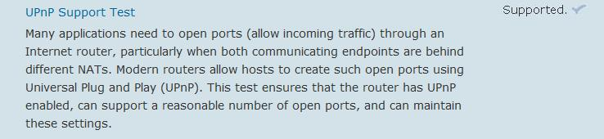
- The "Internet Connectivity Evaluation Tool" page should open. Accept the agreement and run the tests—you will have to allow an ActiveX control and approve two User Account Control requests. Your router should show a result of Supported for the "UPnP Support Test", as shown below. If it does not, try turning on the UPnP support in the router configuration pages, or use a different router. In S214, the Belkin routers will pass after you turn on UPnP in the Advanced page of the settings, but the D-Link router doesn't pass.
Vista Novice Machine

Assembling Your LAN
- Leave the Vista Expert Machine connected to the S214 LAN as it is.
- Unplug the blue network cables from both the Vista Novice Machine and the XP Novice Machine.
- Plug the blue network cable that used to go to the Vista Novice Machine into the WAN port on the router.
- Connect the both the Vista Novice Machine and the XP Novice Machine to the router with Ethernet patch cords. Your final network should match the diagram below.

WAN port
to Internet
XP Novice Machine
Vista Novice Machine
Router

Adjusting the DHCP Address Range (Only Necessary for the Linksys Routers)
- If you are using a Linksys router, you will need to adjust the address range so that it does not conflict with the S214 LAN. If you are using a Belkin or D-Link router, leave the address range at the default and skip to the "Testing the Internet Connections" section of these instructions.
- On the XP Novice Machine, open Firefox and type this address: 192.168.1.1
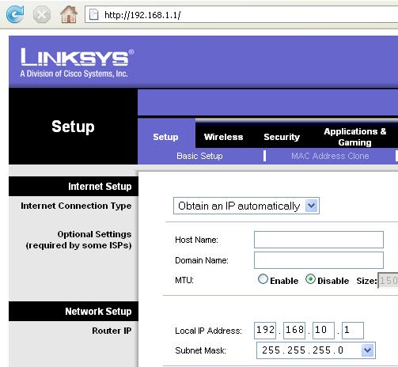
- Press the Enter key. A box pops up asking for a user name and password. Leave the User Name blank and enter a password of admin
- Click OK. A Linksys page should appear as shown to the right on this page.
- In the Linksys page, on the Setup tab, change the Local IP Address to 192.168.10.1, as shown to the right on this page.
- Scroll to the bottom of the page and click the Save Settings button.
- A popup box appears saying “Next time, login the router with the new IP address”. Click OK.
- Now that the router has a new address, the XP Novice Machine and the Vista Novice Machine need a new IP addresses. To force them to get new IP addresses, unplug the patch cords from the router, wait a couple of seconds, and plug them in again.

Testing the Internet Connections
- Open a browser on each machine and make sure they can all reach the Internet. If they cannot, here are some likely problems:
  - The Win XP machine may not be set for automatic addressing.
    - To test that, click Start, Run. In the Run box, type in CMD and press the Enter key.
    - In the "Command Prompt" window, type in IPCONFIG and press the Enter key.
    - Look for the section that shows information about the Ethernet adapter that is connected to the router (it should be the "Intel(R) PRO/100 VE", as shown below). Look at the "Autoconfiguration Enabled" line—it should show Yes. If it does not, you need to ask your instructor to log in as an Administrator and adjust it.
Ethernet adapter Local Area Connection 2:

Connection-specific DNS Suffix . : Belkin
Description . . . . . . . . . . . : Intel(R) PRO/100 VE Network Connection
Physical Address. . . . . . . . . : 00-0C-F1-6E-D0-10
Dhcp Enabled. . . . . . . . . . . : Yes
Autoconfiguration Enabled . . . . : Yes
IP Address. . . . . . . . . . . . : 192.168.2.4
Subnet Mask . . . . . . . . . . . : 255.255.255.0
Default Gateway . . . . . . . . . : 192.168.2.1
DHCP Server . . . . . . . . . . . : 192.168.2.1
DNS Servers . . . . . . . . . . . : 192.168.2.1

  - The router might be handing out DHCP addresses in the same subnet as the classroom. In that case you will have to log in to the router and reconfigure the address range, as explained on a previous page of these instructions. In S214, this will only happen with the Linksys routers.

Turning Off the Firewall on the Vista Expert Machine
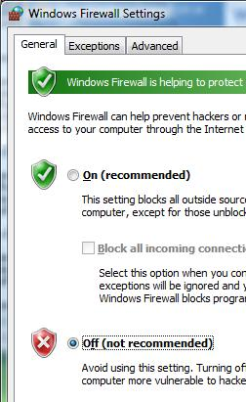
- On the Vista Expert Machine, press the Logo key, and type in FIRE
- When the Search finds "Windows Firewall", use the down-arrow as needed to highlight it and press the Enter key.
- In the "Windows Firewall" box, click the "Change settings" link. In the "User Account Control" box, press Alt+C or click Continue.
- In the "Windows Firewall Settings" box, make sure the "Off (not recommended)" radio button is selected, as shown to the right on this page. Click OK.

Turning Off the Firewall on the Vista Novice Machine
- Use the same procedure to turn off the firewall on the Vista Novice Machine.

Enabling Pings on the XP Novice Machine (You will need your instructor to do this)
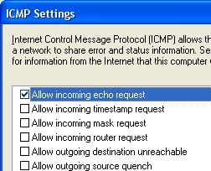
- Your instructor will have to log in as an administrator to do this. If you are working at home, follow these steps while logged in with an Administrative account:
  - Click Start, "Control Panel".
  - If necessary, click "Switch to classic view". Double-click "Windows Firewall".
  - Make sure the "On (recommended)" radio button is selected, but that the "Block all incoming connections" box is clear.
  - Click the Advanced tab. In the ICMP section, click the Settings button.
  - In the "ICMP Settings" box, check the "Allow incoming echo request" item, as shown to the right on this page. Click OK.
  - In the "Windows Firewall" box, click OK.

Requesting Remote Assistance from the XP Novice Machine
- On the XP Novice Machine, click Start "Help and Support".
- In the "Ask for assistance" section, click "Invite a friend to connect to your computer with Remote Assistance".
- In the "Remote Assistance" screen, click "Invite someone to help you".
- In the "Remote Assistance" screen, at the bottom, click "Save invitation as a file (Advanced)".
- In the "Remote Assistance – Save Invitation" screen, at the bottom, click Continue.
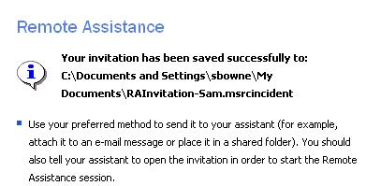
- In the "Remote Assistance – Save Invitation" screen, type in a password of P@ssw0rd in both boxes and click "Save Invitation". Save the file on your desktop with a name of RAInvitation-yournameXP.msrcincident, replacing yourname with your name.
- You should see a message saying "your invitation has been saved successfully" as shown to the right on this page. Leave that message open on the screen—don't close it.

Offering Assistance From the Vista Expert Machine
- Transfer the RAInvitation-yournameXP.msrcincident file to the Vista Expert Machine, using e-mail, a floppy disk, a USB memory stick, , or any other convenient technique.
- On the Vista Expert Machine, double-click the RAInvitation-yournameXP.msrcincident file.
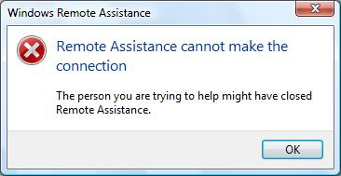
- A box pops up, asking you to "Type the password to connect to the remote computer". Type in P@ssw0rd and click OK.
- A "Windows Remote Assistance" screen opens, with a "Attempting to connect" message in the left corner. After a few seconds, a box pops up saying "Remote Assistance cannot make the connection", as shown to the right on this page.

Capturing the Screen Image
- On the Vista Expert Machine, press the PrntScn key to copy whole screen to the clipboard. Open Paint and paste in the image. Save it as a JPEG, with the filename Your Name Proj 16a.

Finding IP Addresses
- On the Vista Novice Machine, press the Logo key, type in CMD, and press Enter.
- In the "Command Prompt" window, type in IPCONFIG and press Enter.
- Find the IP address of your Local Area Connection. It should start with 192.168, as shown below. Write it under the Vista Novice Machine on the diagram at the bottom of this page.
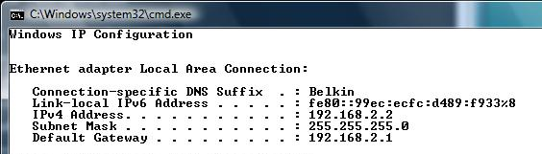

- Repeat the same process on the Vista Expert Machine to find its IP address. It should start with 192.168. Write it under the Vista Expert Machine on the diagram at the bottom of this page.
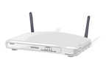
- Repeat the same process on the XP Novice Machine to find its IP address. It should start with 192.168. Write it under the XP Novice Machine on the diagram at the bottom of this page.
XP Novice Machine

IP: _____________________
Vista Novice Machine

IP: _____________________
Vista Expert Machine

IP: _____________________
Gateway
to Internet

Pinging the XP Novice Machine from the Vista Novice Machine
- On the Vista Novice Machine, press the Logo key, type in CMD, and press Enter.
- In the "Command Prompt" window, type in the following command and press Enter.
PING XP-Novice-Machine-IP
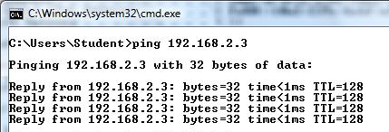
Replacing XP-Novice-Machine-IP with the IP address you wrote under the "XP Novice Machine" on the previous page.
- You should see Reply lines, as shown to the right on this page. The PINGs get through, because both the Vista Novice Machine and the XP Novice Machine are on the same subnet—connected as clients to the same router.

Pinging the Vista Expert Machine from the Vista Novice Machine
- On the Vista Novice Machine, press the Logo key, type in CMD, and press Enter.
- In the "Command Prompt" window, type in the following command and press Enter.
PING Vista-Expert-Machine-IP
Replacing Vista-Expert-Machine-IP with the IP address you wrote under the "XP Novice Machine" on the previous page.
- You should see Reply lines. The PINGs get through, because the traffic is recognized by the router as not on the local subnet, and passed out the WAN port to the room's LAN. And the Vista Expert Machine is found on the room's LAN.

Pinging the XP Novice Machine from the Vista Expert Machine
- On the Vista Expert Machine, press the Logo key, type in CMD, and press Enter.
- In the "Command Prompt" window, type in the following command and press Enter.
PING Vista-Novice-Machine-IP
Replacing Vista-Novice-Machine-IP with the IP address you wrote under the "XP Novice Machine" on the previous page.
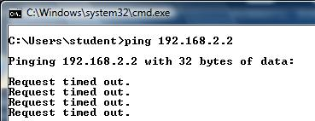
- You should see Reply lines. The PINGs do not get through, because the traffic is recognized by the room's router as not on the local subnet, and passed out the WAN port to the Internet. And the XP Novice Machine is not there! It's on the other side of the router you added, and your PINGs cannot get through.

Understanding Why Remote Assistance Failed
- You cannot PING the XP Novice Machine from the Vista Expert Machine, because it's on the other side of a router that is performing Network Address Translation. The same thing is true of Remote Assistance traffic. When you double-click the invitation on the Vista Expert Machine, it tries to contact the XP Novice Machine, but the packets are lost. In order for Remote Assistance to work with Windows XP, you need to configure "Port Forwarding" on the router.

Requesting Remote Assistance from the Vista Novice Machine
- On the Vista Novice Machine, press the Logo key, and type in REM
- When the Search finds "Windows Remote Assistance", use the down-arrow as needed to highlight it and press the Enter key.
- In the "Do you want to ask for or offer help?" screen, click "Invite someone you trust to help you".
- In the "How do you want to invite someone to help you" screen, click "Save this invitation as a file".
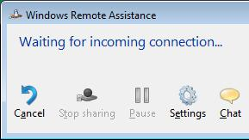
- In the "Enter a path and file name" box, leave the path unchanged, but change the file name to RAInvitation-yournameV.msrcincident, replacing yourname with your name.
- Type in a password of P@ssw0rd in both password boxes and click Finish.
- The RAInvitation-yournameV.msrcincident file should appear on your desktop, and you should see a box saying "Waiting for incoming connection", as shown to the right on this page. Leave that message open on the screen—don't close it.

Transferring the Invitation File to the Vista Expert Machine
- Transfer the RAInvitation-yournameV.msrcincident file to the Vista Expert Machine, using e-mail, a floppy disk, a USB memory stick, , or any other convenient technique.
- On the Vista Expert Machine, close all windows.
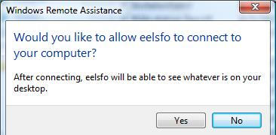
- On the Vista Expert Machine, double-click the RAInvitation-yournameV.msrcincident file.
- A box pops up, asking you to "Type the password to connect to the remote computer". Type in P@ssw0rd and click OK.
- A "Windows Remote Assistance" screen opens, with a "Attempting to connect" message in the left corner.

- Look on the Vista Novice Machine. A box should pop up asking "Would you like to allow machinename to connect to your computer?", as shown to the right on this page. Click Yes.
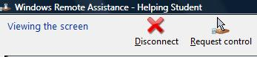
- On the Vista Expert Machine, You should see a "Windows Remote Assistance – Helping" window, with a "" message in the upper left corner, as shown to the right on this page.

Capturing the Screen Image
- On the Vista Expert Machine, press the PrntScn key to copy whole screen to the clipboard. Open Paint and paste in the image. Save it as a JPEG, with the filename Your Name Proj 16b.
Turning in your Project
- Email the JPEG images to me as attachments. Send the message to cnit.335@gmail.com with a subject line of Proj 16 From Your Name. Send a Cc to yourself.

Understanding Why Remote Assistance Succeeded
- You cannot PING the Vista Novice Machine from the Vista Expert Machine, because it's on the other side of a router that is performing Network Address Translation. But you can send Remote Assistance traffic through because Vista automatically configures the router for port forwarding by using Universal Plug and Play (UPNP).
- It's not part of this project, but if you want to see the ports that are forwarded, download UPNPPW from this website (Link Ch 9f on my Web page):
http://www.upnpworks.alcidelic.com/downloads.html
- Once you download and unzip UPNPPW, run it with this command line:
UPNPPW –list
You will see the port-forwarding list, as shown below, forwarding port 3389 (remote Assistance) and some other ports to high-numbered external ports on the router.
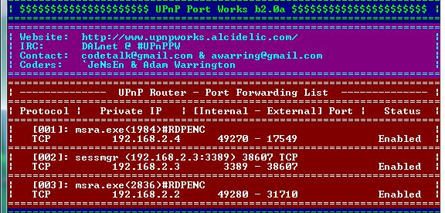

Last modified
10-10-07

