What You Will Need
- Two Vista computers (any version) on a Local Area Network (LAN)

Choosing Two Machines
- Find two Vista machines to use. Choose one to be the "File Server". The other one will be the "Client Machine".

Creating a "Wally" Account on the File Server
- Log in to the "File Server" with any account that has Administrative privileges.
- Press the Windows logo key, next to the Ctrl key at the lower left of your keyboard. Don't touch the mouse. Type this into the Search box:
use
- "User Accounts" should appear in the Programs list. If it's not already highlighted, press the down-arrow as needed to highlight it. Then press the Enter key.
- The "Control Panel ► User Accounts" window should open, with the title "Make changes to your user account". Click "Manage another account". In the "User Account Control" box, press Alt+C or click Continue.
- In the window titled "Choose the account you would like to change", at the bottom, click "Create a new account".
- Enter a name of Wally, accept the default selection of "Standard User", and click the "Create Account" button.
- In the window titled "Choose the account you would like to change", click the Wally icon.
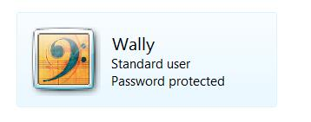
- In the window titled "Make changes to Wally's account", click "Create a password".
- In the window titled "Create a password for Wally's account", enter a password of password2 in both password boxes and click "Create password".
- You should see a Wally icon, labeled "Standard User" and "Password Protected", as shown to the right on this page.

Deleting the "Sally" Account on the File Server
- In the "Control Panel ► User Accounts ► Change an Account" window, click "Manage another account". Look for an account named Sally. If there is one, follow these steps to delete it:
  - Click the Sally icon to select it.
  - Click "Delete the account".
  - Click "Delete Files".
  - Click "Delete Account".

Sharing the Public Folder on the File Server
- On the "File Server", press the Windows logo key, next to the Ctrl key at the lower left of your keyboard. Don't touch the mouse. Type this into the Search box:
net
- "Network and Sharing Center" should appear in the Programs list. If it's not already highlighted, press the down-arrow as needed to highlight it. Then press the Enter key.
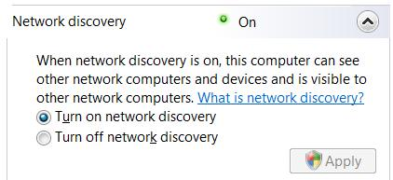
- In the "Sharing and Discovery" section, click the down-arrow to the right of "Network discovery". Ensure that the "Turn on network discovery" button is selected, as shown to the right on this page. If you made any change, click the Apply button. In the "User Account Control" box, press Alt+C or click Continue.
- Use the same procedure to make these adjustments:
- File sharing: On
- Public folder sharing: On so anyone with network access can open files
- Printer sharing: Off
- Password protected sharing: On
- Media sharing: Off
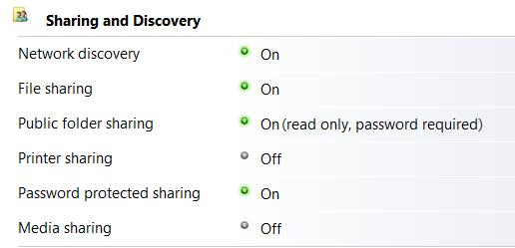
- Your "Sharing and Discovery" section should now look like the example shown to the right on this page:

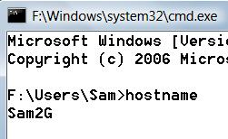
Finding your Computer Name on the File Server
- On the "File Server", press the Windows logo key, next to the Ctrl key at the lower left of your keyboard. Don't touch the mouse. Type this into the Search box, and then press Enter:
cmd
- In the Command Prompt window, type in this command and press Enter:

Computer Name: _____________________
hostname
- Your computer's name should appear, as shown above on this page. In my example, the hostname is Sam2G—your hostname will be different. Write your computer's name in the box above on this page.

Creating a "Sally" Account on the Client Machine
- On the "Client Machine", log in with an account that has Administrative privileges.
- Press the Windows logo key, next to the Ctrl key at the lower left of your keyboard. Don't touch the mouse. Type this into the Search box:
use
- "User Accounts" should appear in the Programs list. If it's not already highlighted, press the down-arrow as needed to highlight it. Then press the Enter key.
- The "Control Panel ► User Accounts" window should open, with the title "Make changes to your user account". Click "Manage another account". In the "User Account Control" box, press Alt+C or click Continue.
- In the window titled "Choose the account you would like to change", at the bottom, click "Create a new account".
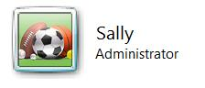
- Enter a name of Sally. Click the "Administrator" button. Click the "Create Account" button.
- You should see a Sally icon, labeled "Administrator", as shown to the right on this page. Close the "Control Panel ► User Accounts ► Change an Account" window.

Clearing the Stored Logon Passwords on the Client Machine
- On the "Client Machine", log off and log in again as Sally.
- Press the Windows logo key, next to the Ctrl key at the lower left of your keyboard. Don't touch the mouse. Type this into the Search box:
use
- "User Accounts" should appear in the Programs list. If it's not already highlighted, press the down-arrow as needed to highlight it. Then press the Enter key.
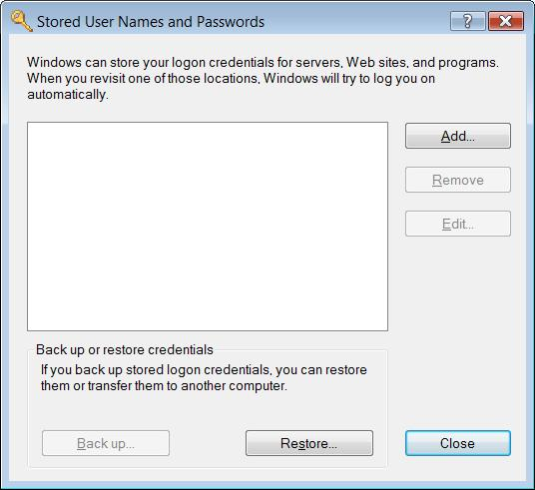
- The "Control Panel ► User Accounts" window should open, with the title "Make changes to your user account". On the left side, click "Manage your network passwords".
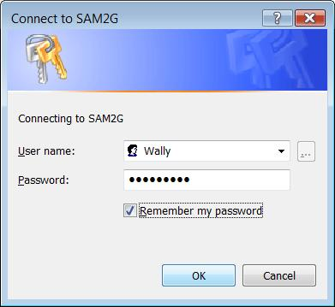
- The "Stored User Names and Passwords" box should be empty, as shown to the right on this page. If any accounts appear, highlight them and remove them. Click the Close button.
- Close the "Control Panel ► User Accounts" window.

Opening the Public Folder from the Client Machine
- On the "Client Machine", click Start, Network. Find the Computer Name you wrote in the box on the previous page and double-click it.
- In the "Connect to" box, enter a User name of Wally and a Password of password2. Check the "Remember my password" box, as shown to the right on this page, and click OK.
- On the "Client Machine", a "Network ► Computer Name ►Public ►" window opens, as shown on the next page.

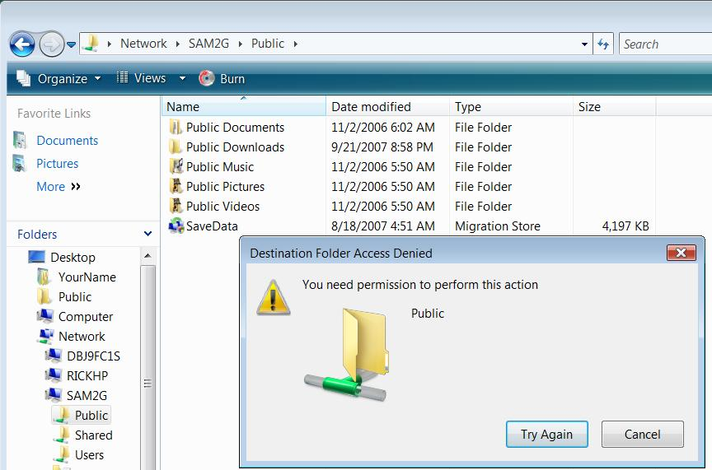
Trying to Create a Document from the Client Machine
- In the "Network ► Computer Name ►Public ►" window, right-click an empty portion of the lower right pane and click New, "Text Document". You should see a box appear saying "You need permission to perform this action", as shown below on this page.

Capturing the Screen Image
- Press the PrntScn key to copy whole screen to the clipboard. Open Paint and paste in the image. Save it as a JPEG, with the filename Your Name Proj 17a.
Turning in your Project
- Email the JPEG image to me as an attachment. Send the message to cnit.335@gmail.com with a subject line of Proj 17 From Your Name. Send a Cc to yourself.

Last modified 10-10-07

