What You Will Need
- Two Vista computers (any version) on a Local Area Network (LAN)

Choosing Two Machines
- Find two Vista machines to use. Choose one to be the "File Server". The other one will be the "Client Machine".

Checking to See if a "Wally" Account Exists on the File Server
- Log in to the "File Server" with any account that has Administrative privileges.
- On the "File Server", press the Windows logo key, next to the Ctrl key at the lower left of your keyboard. Type this into the Search box, and then press Shift+Ctrl+Enter:
cmd
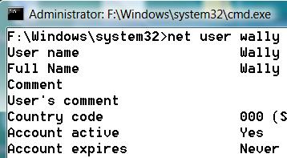
In the "User Account Control" box, press Alt+C or click Continue. Look at the upper left of the window and make sure the word Administrator appears there, as shown to the right on this page.
- In the Command Prompt window, type in this command and press Enter:
net user wally
- If a "Wally" account exists, you will see a "User name" of "Wally" on the next line, as shown above on this page, followed by a lot of other information about the Wally account. If the account exists, follow the process below to delete it. If you see a message saying "The user name could not be found", that means the Wally account does not exist. Skip to the 'Creating a "Wally" Account on the File Server' section below.

Deleting the "Wally" Account on the File Server
- On the "File Server", in the Command Prompt window, type in this command and press Enter:
net user wally /delete
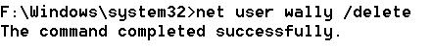
- You should see a message saying "The command completed successfully" as shown to the right on this page. If you see a message saying "System error 5 has occurred", that means you have a regular Command Prompt window open instead of an Administrator Command Prompt window—return to step 3 above.

Creating a "Wally" Account on the File Server
- On the "File Server", in the Command Prompt window, type in this command and press Enter:
net user wally password2 /add
- This command creates a user account with a name of Wally and a password of password2. You should see a message saying "The command completed successfully" as shown below on this page.

Sharing the Public Folder on the File Server
- On the "File Server", in the Command Prompt window, type in this command and press Enter:
net share public2=%systemdrive%\users\public
- You should see a message saying"public2 was shared successfully" as shown below on this page.

Viewing the Shared Folders on the File Server
- On the "File Server", in the Command Prompt window, type in this command and press Enter:
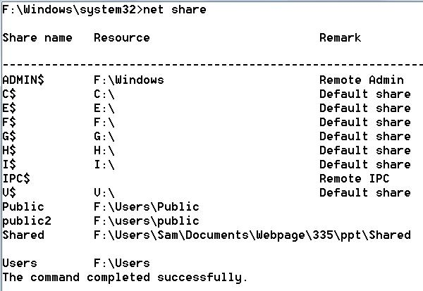
net share
- You should see a list of shared folders, including one named public2, as shown to the right on this page.

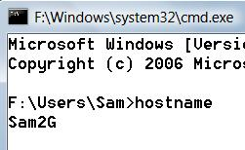
Finding your Computer Name on the File Server
- On the "File Server", in the Command Prompt window, type in this command and press Enter:
hostname
- Your computer's name should appear, as shown above on this page. In my example, the hostname is Sam2G—your hostname will be different. Write your computer's name in the box to the right on this page.

Computer Name: _____________________

Connecting to the Public2 Share from the Client Machine
- On the "Client Machine ", in the Command Prompt window, type in this command and press Enter:
net use \\computer-name\public2 /user:wally password2
Replace computer-name with the computer name you wrote in a box on a previous page of these instructions.
- This command connects to the shared folder, authenticating you as Sally with the password password2. You should see a message saying "The command completed successfully" as shown below on this page.

Attempting to Create a File in the Public2 Share from the Client Machine
- On the "Client Machine ", in the Command Prompt window, type in this command and press Enter:
echo "Hi" > \\computer-name\public2\test.txt
Replace computer-name with the computer name you wrote in a box on a previous page of these instructions.
- This command attempts to put the text "Hi" into a new file named test.txt in the shared folder. You should see a message saying "Access is denied" as shown below on this page, because the sharing read-only.

Viewing a Directory of the Public2 Share from the Client Machine
- On the "Client Machine ", in the Command Prompt window, type in this command and press Enter:
dir \\computer-name\public2
Replace computer-name with the computer name you wrote in a box on a previous page of these instructions.
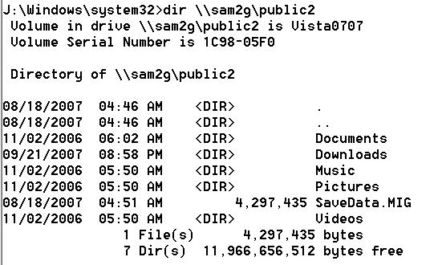
- This command lists the files and folders in the Public2 share, as shown to the right on this page. Your file and folder names will be different.

Capturing the Screen Image
- Press the PrntScn key to copy whole screen to the clipboard. Open Paint and paste in the image. Save it as a JPEG, with the filename Your Name Proj X3.
Turning in your Project
- Email the JPEG image to me as an attachment. Send the message to cnit.335@gmail.com with a subject line of Proj X3 From Your Name. Send a Cc to yourself.

References
Net User:
http://technet2.microsoft.com/windowsserver2008/en/library/8935e4a8-3624-46a1-b47a-c7735802b4561033.mspx?mfr=true
(Link Ch 11b on my CNIT 335 Web page)
Net Group:
http://technet2.microsoft.com/windowsserver2008/en/library/5be322dc-e214-4ab2-a319-e89e3d4806941033.mspx?mfr=true
(Link Ch 11c on my CNIT 335 Web page)

Last modified 10-10-07

