Windows 7 Versions and Installation (not in textbook)

CNIT 335 or CNIT 345?

CNIT 335 was Vista Tech Support

But Vista is a dead duck

We will not cover Vista at all in this class—only Windows 7

BUT CNIT 345: Windows 7 Tech Support won’t be officially offered till Spring 2010

Your options:

Enroll this semester and get credit for CNIT 335

Sit in this semester, do all the work, and enroll in CNIT 345 next semester to get credit

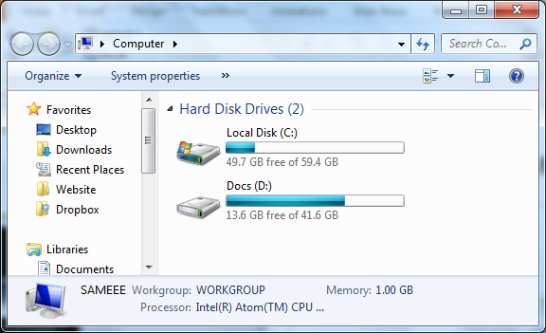
Wait till next semester to take CNIT 345

Disk Partitions

Hard disks are large—often 320 GB or more

It is a good practice to divide the hard disk into several separate portions called partitions

Each partition typically appears in the Computer window with a different drive letter

Installation Options

Clean install

Start with an empty hard disk or partition

You will get the most stable install this way

BUT: you will need to install all your applications and migrate over your documents and settings

Windows Easy Transfer may help

Upgrade

From Windows Vista SP1 or SP2 to Windows7

Keeps installed programs, settings, and documents

You cannot upgrade Win XP to Windows 7

See link Ch0a on my Web page

samsclass.info, click “CNIT 345”

Installation Boot Options

Single-boot

Windows 7 as the only operating system on the computer

This is the normal situation

Dual-boot or multi-boot

Two or more operating systems (OSs) on the same computer

Each OS is on its own disk or partition

Each time the machine starts up, the user chooses the OS to boot to

This is what we will do in the S214 lab

Hardware Requirements

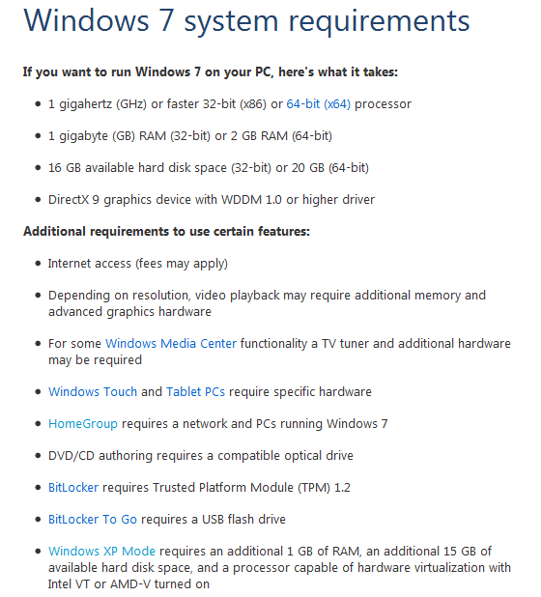

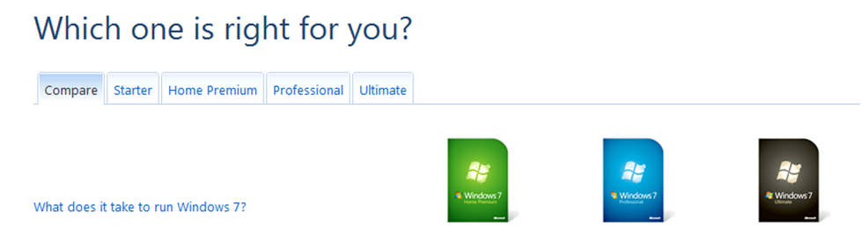
Windows 7 Versions

Windows 7 Versions

Starter

Home Premium

Professional

Ultimate

See link Ch 0b

Starter

Intended for developing countries, not the USA

Home Premium

Intended for home users

Professional

Everything in Home Premium plus business features like Domain Join

Ultimate

Everything in Professional plus advanced business technology like BitLocker, BranchCache, and AppLocker

Common Features
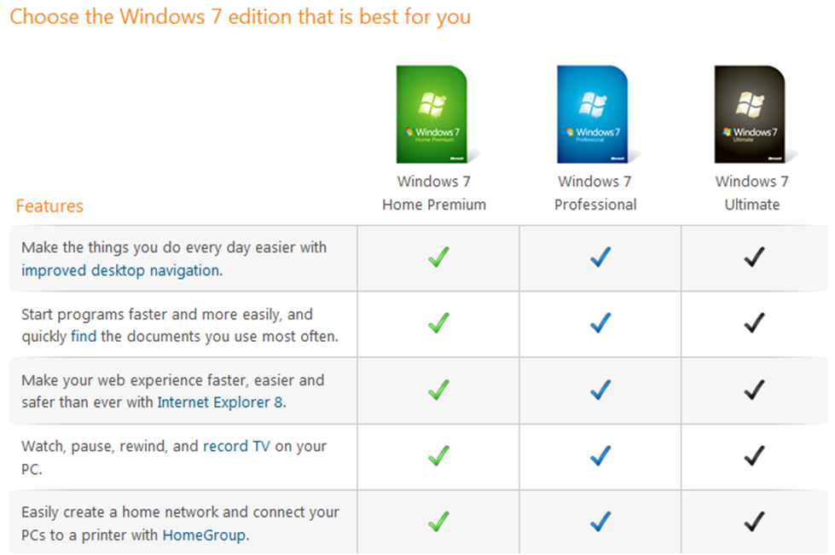

Differences
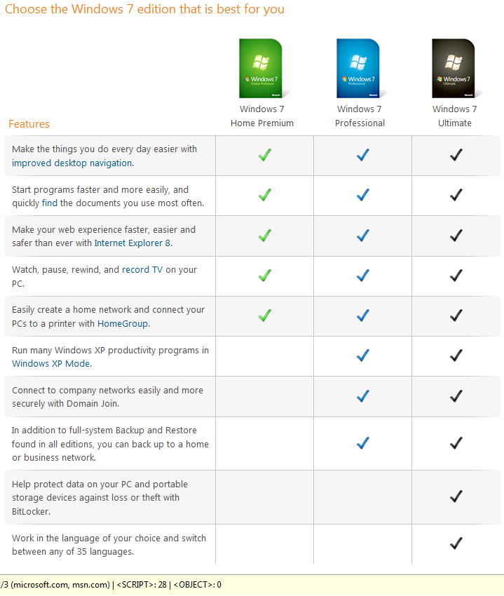

HomeGroups

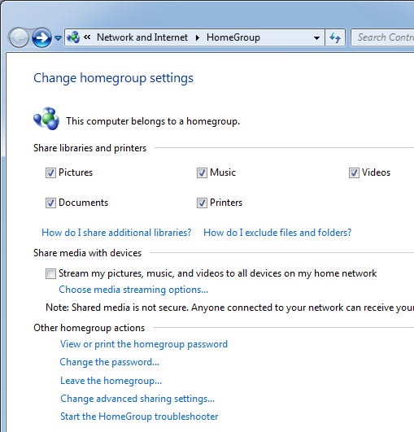
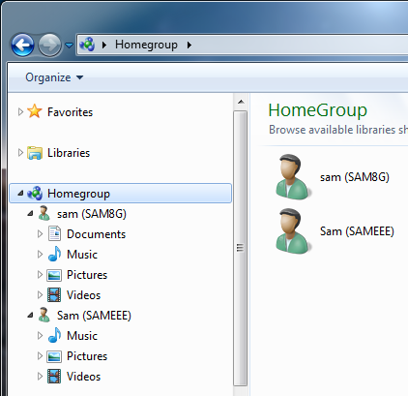
Easy, secure file-sharing

Only for Home networks

Protected by a password

Windows XP Mode

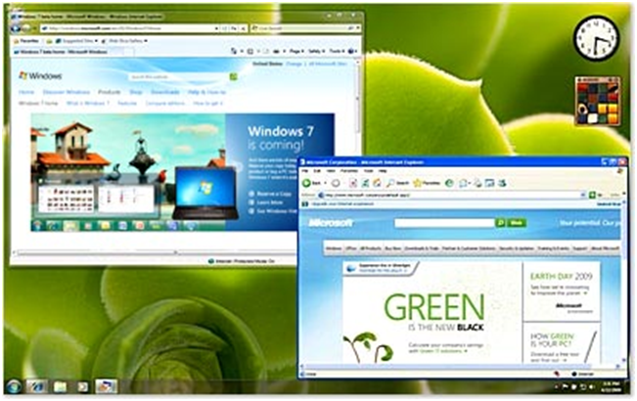
Runs Windows XP in a virtual machine

Only available in Windows 7 Professional and Ultimate

Software opens in a window without a visible Win XP desktop

BUT it requires Intel's Virtual Technology (VT)

Only the latest machines have it, and only some of the new Sony VAIOs

Link Ch 0f

Security of Windows XP and Vista

Windows XP

42% of attacks came through Microsoft software

Vista

6% of attacks came through Microsoft software

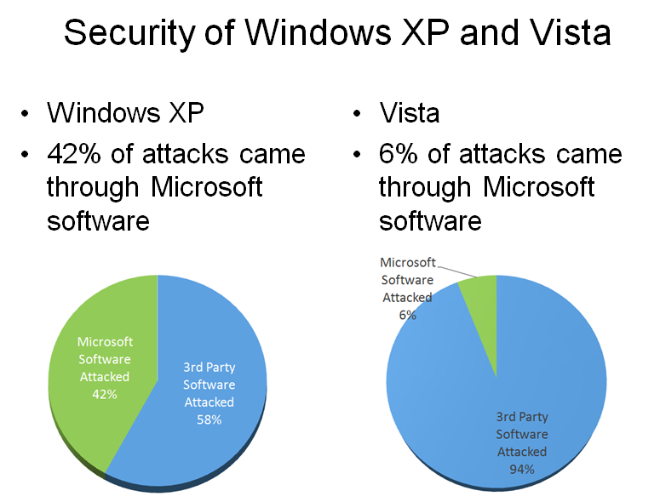
Using Windows XP Mode Wisely

Do Web browsing and run most applications on Windows 7

Use Windows XP Mode only for legacy applications that requires it

This will be much more secure than running Windows XP only

Link Ch 0g

Security of Various Windows Versions

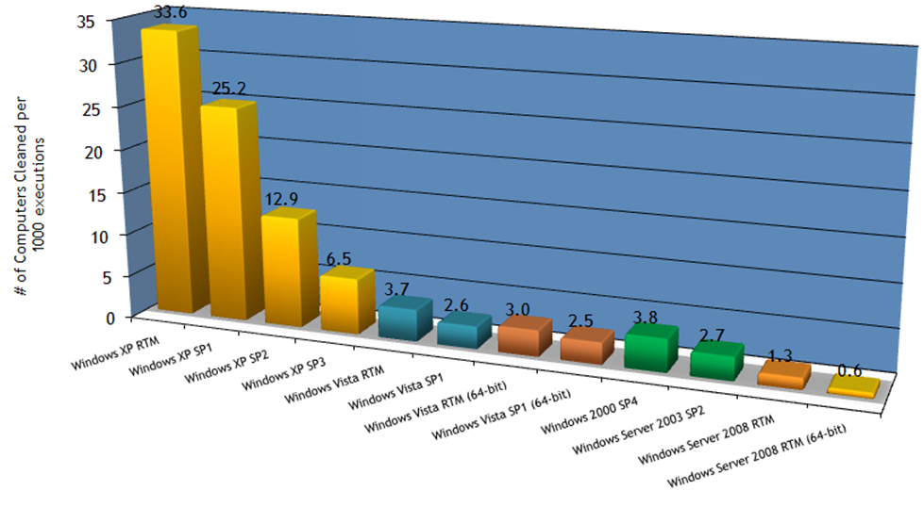

Domain Join

Intended for businesses

Requires a domain controller running Windows 2008 Server or earlier Windows Server versions

Provides a central point of administration, making the network more secure and scalable

Only Windows 7 Professional and Ultimate can join domains

Backup

All versions of Windows 7 provide image-based full system backup

But only Windows 7 Business and Ultimate can back up to a network server

Windows 7 BitLocker

Encrypts the whole hard drive

Requires the user to supply a startup PIN or USB flash drive that contains keying material before the computer will boot

Protected from Stanford’s “cold boot” attack that can break through Vista’s BitLocker

See link Ch 0h

Windows 7 Enterprise

Not available in retail stores

Only sold to "Microsoft Software Assurance customers"

Several new features not included in the Business or Home Premium versions

Link Ch 0i

Windows 7 Enterprise

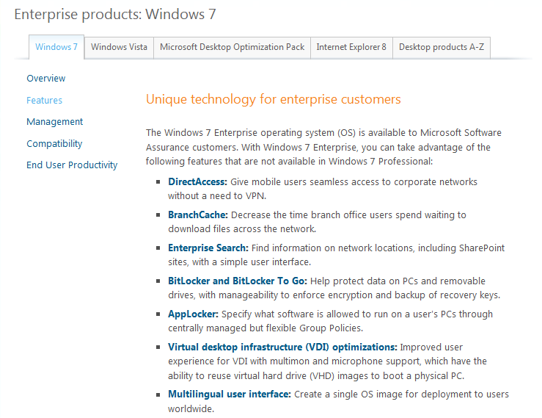

New Features

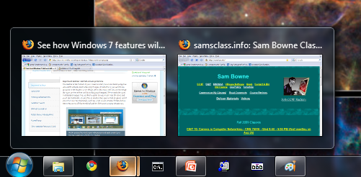
New Taskbar

Larger icons

Hover to see thumbnail images of windows

Drag items to the taskbar to dock them

Drag icons to rearrange them

Full-Screen Preview

Hover over a window's thumbnail to see it in preview mode

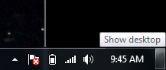
Hover over the rectangle at the right end of the taskbar to preview the Desktop

Jump Lists

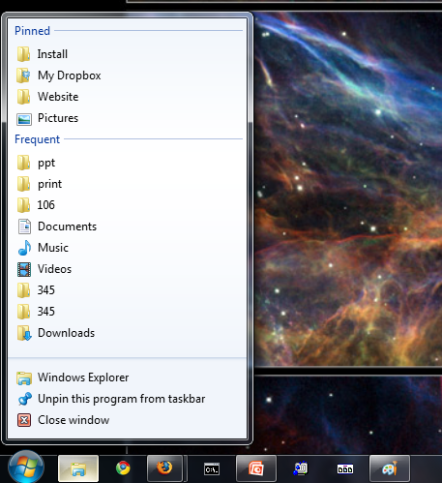
You can pin items to each Taskbar button

Makes the tasks you do most often easier to launch

New Window Controls

Drag a window to the top of the screen to maximize it

Drag it to left or right edge to make it fill half the desktop

Aero Shake

Shake a window to close all other windows

Shake it again to restore them

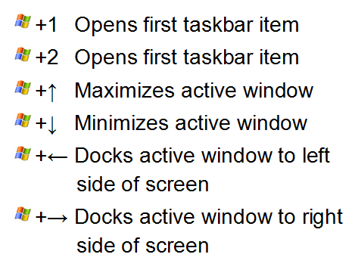

Shortcut Keys

Libraries

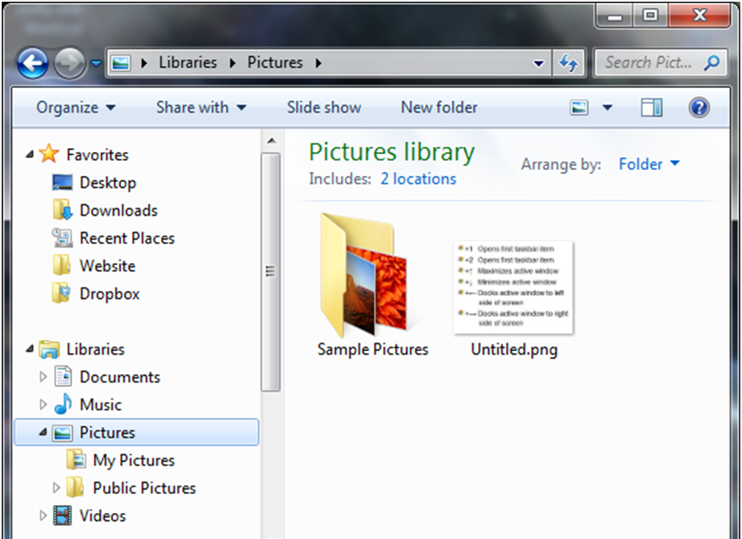
Gathers files from several folders together

To customize the folder list, click the blue "2 locations" link

Working in the S214 Lab

Hackers in S214

“Ethical Hacking” students are stealing passwords and doing many other sneaky and surprising things in S214

Don’t use those machines to send personal email, shop online, or for any other personal purpose

Everything on those machines is subject to arbitrary hackation

If you are delayed on a project because another student wipes out your machine, let me know and I can give you more time

Emailing from S214

To turn in projects from S214

Make a new Gmail account

Use a password you never use anywhere else

Set the account to forward mail to your normal email

That way you can send email safely from the hacking lab, and also read the replies my grader sends you conveniently

Another option: Save your images on a USB memory stick and email them from home
Ch 1: Customizing Windows Explorer

Returning Menus

The File, Edit, Save… menus are hidden

To see them, press Alt

Or Organize, Folder and Search Options, View, Always Show Menus

Turn on File Extensions

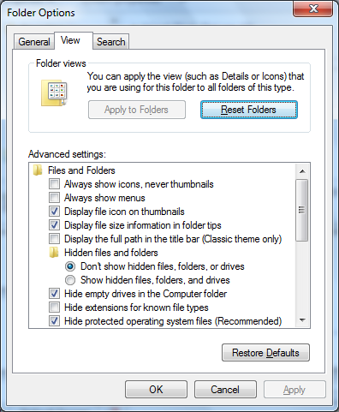
Organize, Folder and Search Options, View, clear the "Hide extensions for known file types" box

Now file names show extensions like .png

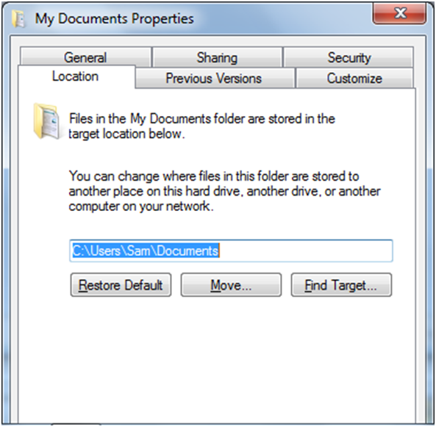

Moving User Folders

Best practice: Store documents and the operating system on separate partitions

That simplifies maintenance tasks:

Backing up documents

Reinstalling the operating system

Upgrading the operating system to a new version

BUT: People naturally save files in their "Documents" folder or on the desktop

C:\Users\Username

Moving User Folders

To move the Documents folder to another location:

Create the folder you want to use, such as D:\Username\Documents

Click Start, right-click the username folder, click Properties

Change the Location

Note: the steps on page 19 don't work—I cannot move the whole %userprofile% folder
Ch 2: Customizing Internet Explorer

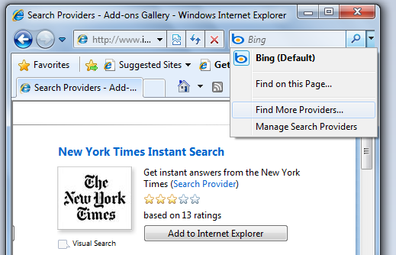
Adding More Search Engines

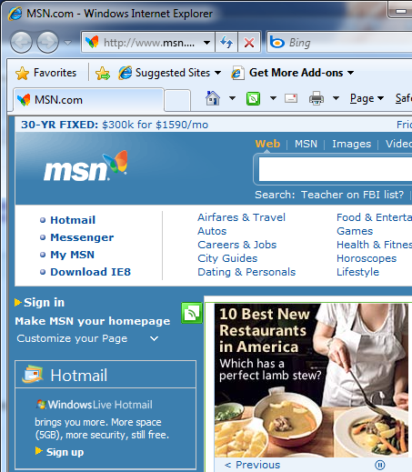

Web Slices

Shows as a green square symbol

Allows you to subscribe to that information like an RSS Feed

(not in book)
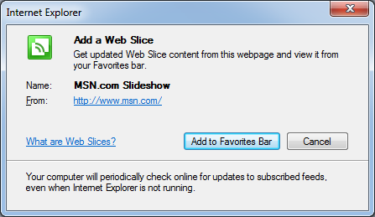

Caret Browsing

Click Page, Caret Browsing

Adds a Microsoft-Word style "Caret" mark to the Web page so you can select text with the keyboard

Shift+Arrow-key selects text

Shift+Ctrl+Right-arrow selects a word at a time

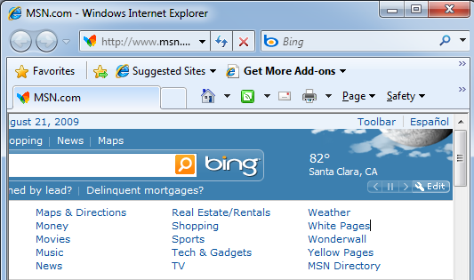

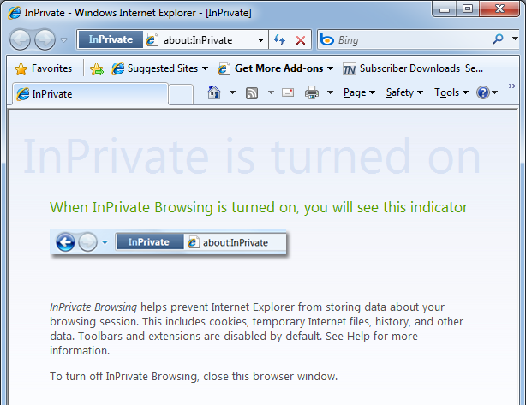

InPrivate Browsing

Click Safety, InPrivate Browsing

Prevents IE from storing data about pages you view

(not in book)

Security of Internet Explorer

A recent study showed Internet Explorer to be the best at blocking social-engineering websites

Websites that try to trick a user into clicking on a link

BUT Microsoft paid for the study…

Link Ch 2a

Other security options will be the topic of a later chapter

Most experts still regard Internet Explorer as dangerously insecure

Web criminals use Firefox (link Ch 2b)

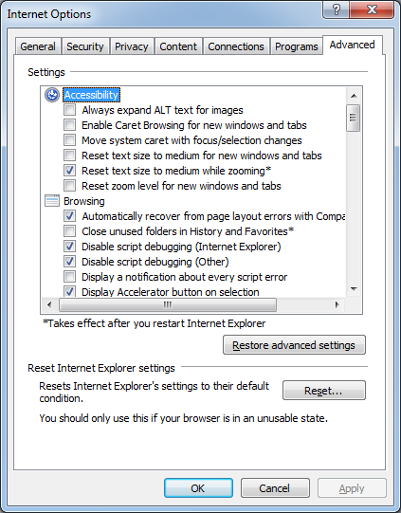
Advanced Options

Click Tools, Internet Options, Advanced tab

Many adjustments can be made

Internet Explorer's Accelerators

Highlight text on a page

A blue "Accelerator" button appears

Click it to see actions you can do with the text

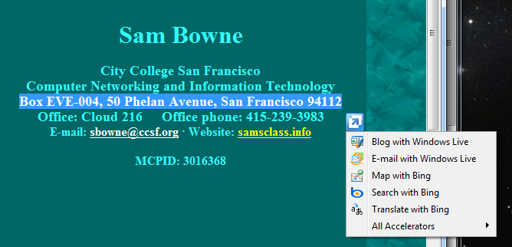
(not in book)

Last modified 8-20-09

