Ch 3: Understanding File Types

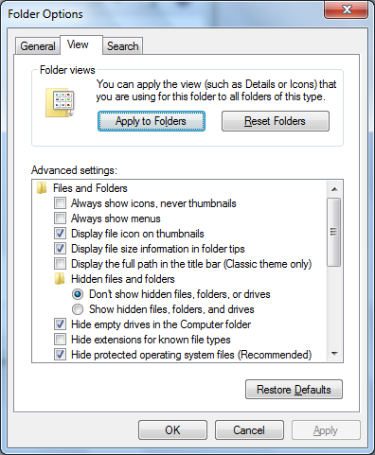
File Types and File Extensions

File extensions are hidden by default

This prevents people from changing them

It's difficult to tell files with similar names apart

Turn on File Extensions in Folder Options

File Types and the Registry

Start, REGEDIT

HKEY_CLASSES_ROOT

First section

More than 400 file extension subkeys

Second section

File types that are associated with the extensions
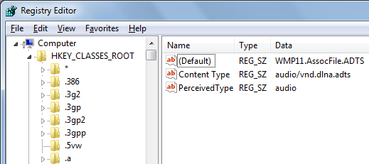

The Structure of HKEY_CLASSES_ROOT

In first section,

Default value is the name of the extension's associated file type subkey in the second section of HKEY_CLASSES_ROOT

In second section

Default value is a description of the file type

DefaultIcon subkey defines its icon

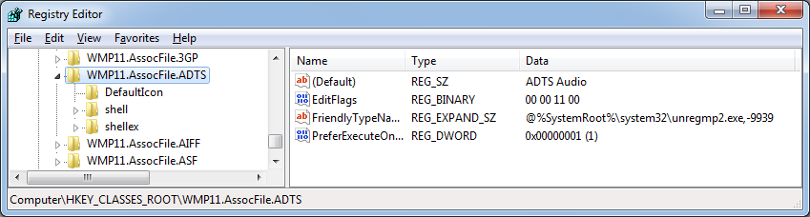
Shell subkey determines actions that can be performed with this filetype, such as Open and Print

Backing Up the Registry

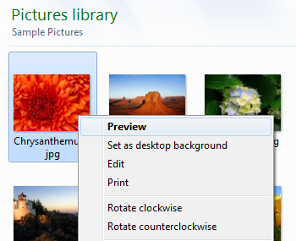
(Not in this chapter, but important to know now)

Creating a System Restore Point

Regedit is dangerous! You can damage your operating system easily.

Back up the registry first with this process:

Click Start, type in RESTORE

Click "Create a Restore Point"

Click "Create"

Changing the Default Action

When you right-click a file, one of the context menu items is bold

That's the Default action—the effect of a double-click

This can be adjusted in the Registry (although it's not as simple as the book makes it sound)

Associating an Extension with a Different Application

Suppose your images are all opening in a new graphics program you loaded, but you want them to open in some other program

You can do this in three ways

Right-click, Open With

Task Pane (also called Command Bar) (see next slide)

Set Associations: Start, ASSOC, click "Change the file type associated with a file extension"

Task Pane (also called Command Bar)
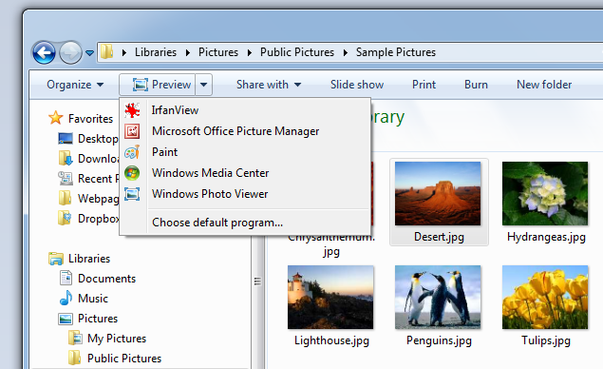

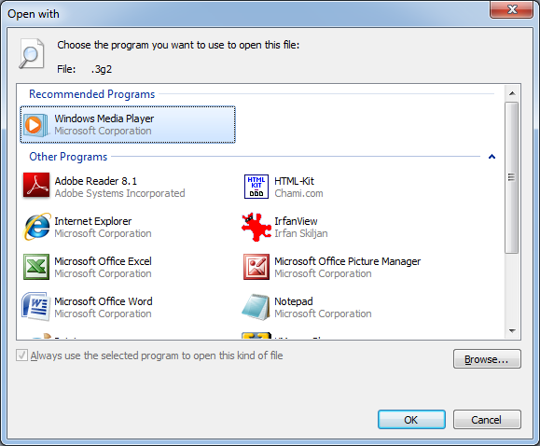
Open With

All three methods bring you here:

Use the little down-arrow button to fill the lower pane

Use the Browse button if the program you want is not visible

Check the "Always use the selected program to open this kind of file" box

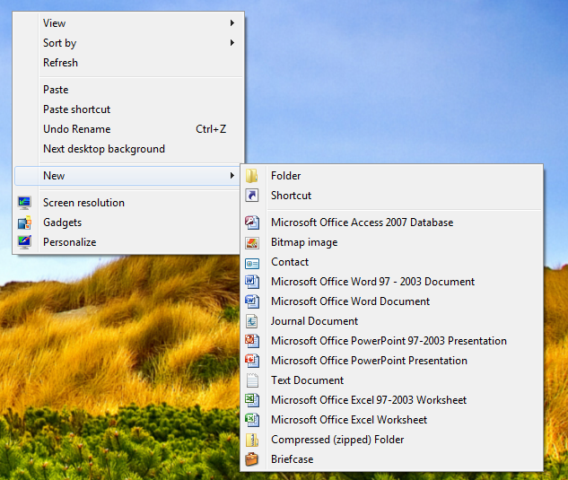
Customizing the "New" Menu

Right-click the desktop, New

ShellNew

The ShellNew subkey controls the New menu behavior. There are four options:

NullFile makes an empty file

Directory makes a folder

Command executes a command

Data inserts data into the new file
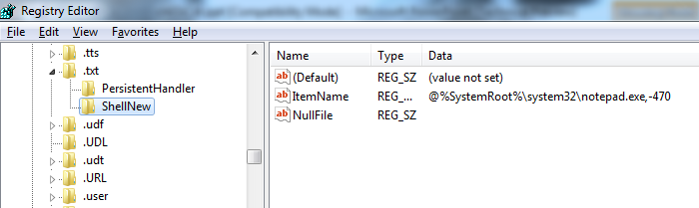

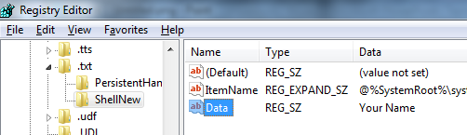

How to Start Text Files With Data in Them

Ch 4: Customizing Startup and Shutdown

Boot Configuration Data (BCD)

BCD replaced the earlier boot.ini file used by Windows XP and earlier versions, because:

BCD works on both BIOS-based and the newer EFI-based machines

EFI (Extensible Firmware Interface) is a replacement for BIOS, developed by Intel (link Ch 4a)

It supports boot applications that run during boot time, like Windows Boot Manager, Windows OS Loader, and Windows Memory Tester (links Ch 4b, 4c)

Boot options can be configured with scripts

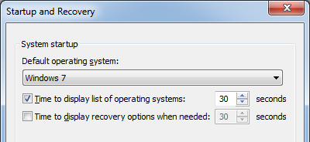
Four Ways to Modify BCD Store

Startup and Recovery

System Configuration

BCDEDIT

BCD WMI

Startup and Recovery

Start, right-click Computer, Properties, Advanced System Settings

In the Startup and Recovery section, click Settings

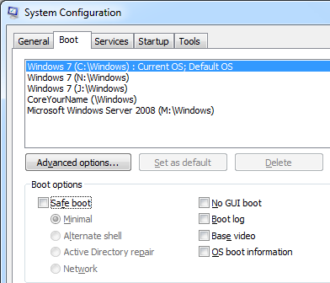
You can change default OS here, or display time, but not the name of a boot menu item

System Configuration

Start, MSCONFIG, Boot tab

You can select Safe Boot features here

Safe Boot Options

Minimal: Same as "Safe Mode"—bare minimum device drivers

Minimal (Alternate Shell)—Safe Mode and also no GUI—Command Prompt only

Other shells besides cmd.exe can be specified in the Registry (see p. 67 of textbook)

Active Directory Repair—only applies to domain controllers, not Windows 7

Network—Safe Mode With Networking

Safe Boot Options

No GUI Boot—doesn't display graphical progress bar during boot, but does boot the Windows GUI later

Boot Log—records bootup process to ntbtlog.txt in %systemroot%

Base Video—VGA Mode (640x480)

OS Boot Information—Displays detailed information about each driver that loads

Advanced Options

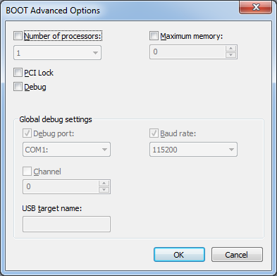
Esoteric tasks like debugging the Kernel

Rarely useful

BCDEDIT

GUIDs

Each item in the BCD store is labelled by either its:

GUID (Globally Unique Identifier) like

598a979b-a877-11dd-86d7-d18166c96a92

Or

Well-known Identifier

bootmgr

ntldr

current

default
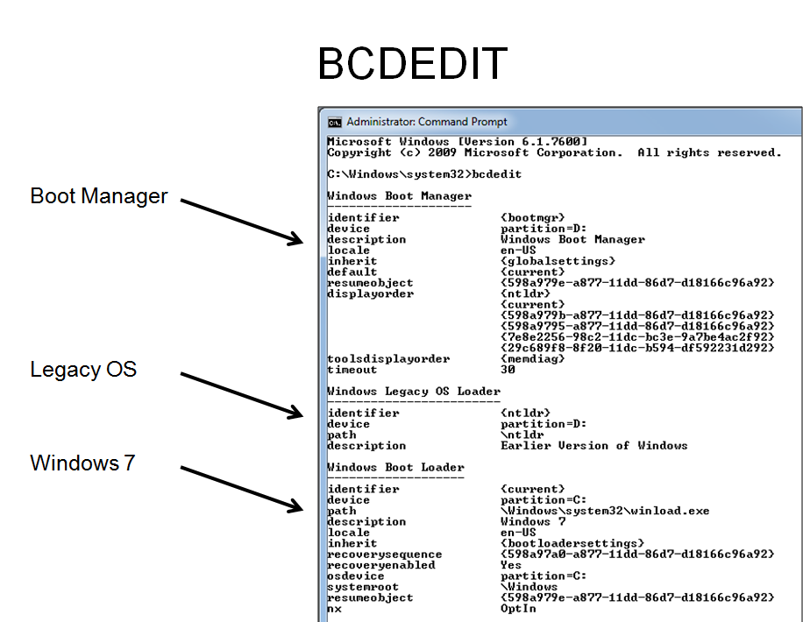

Backing Up the BCD Store

Backing up the BCD Store

bcdedit /export c:\bcd_backup

Restore it with

bcdedit /import c:\bcd_backup

Renaming an Entry

bcdedit /set {ntldr} description "Windows XP Pro"

Advanced Boot Options Press F8 during boot
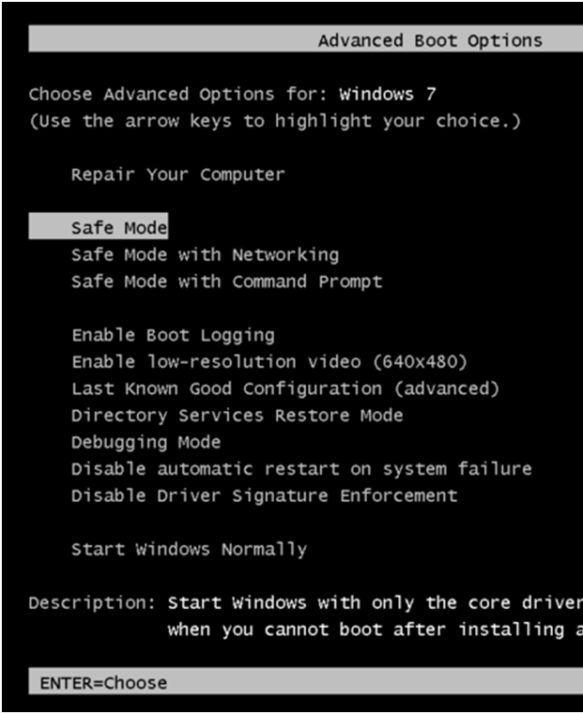

New Items

Most of these are the same as the MSCONFIG Safe Boot options, except:

Repair Your Computer—opens System Recovery Options, which can be used to do a System Restore, Restore from a system image, and more

Last Known Good Configuration—restores a small portion of the Registry to a previously saved version

Disable Automatic Restart on System Failure—to stop repeated crashes

Disable Driver Signature Enforcement—Prevent Windows 7 64-bit from requiring signed drivers (link Ch 4d)

Customizing Logons and Power Options

Local Users and Groups

A handy way to control user accounts

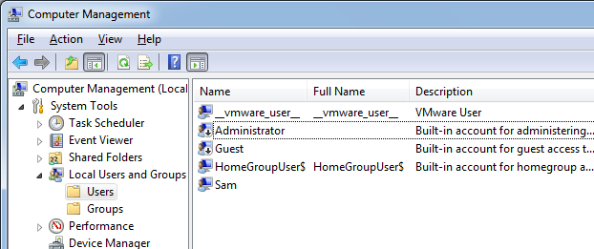
Start, right-click Computer, Manage

Expand the Local Users and Groups plug-in

Click the Users folder

Enabling the Administrator Account

In the Local Users and Groups plug-in, in the Users folder, right-click Administrator, Properties

Enable it here

It's most efficient to just use the command line to manage accounts

Net user
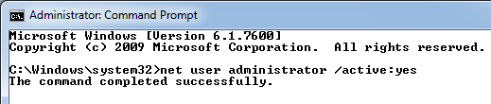

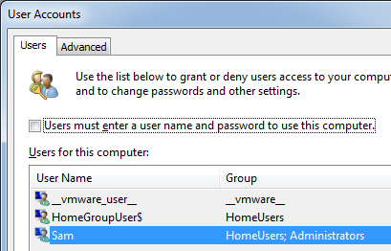

Automatic Logon

Start, CMD, Shift+Ctrl+Enter

In Administrator Command Prompt: control userpasswords2, Enter

Clear the "Users must enter a user name and password to use this computer" box

On Users tab, click desired account

Click OK and enter the password

Issues With Automatic Logon

It's obviously insecure, especially on a laptop

You can't launch userpasswords2 from the Search box anymore, so the first step on page 79 doesn't work anymore

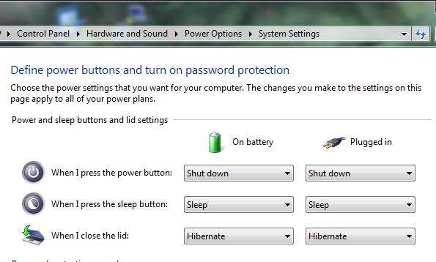
If the account has a password, when the screen saver comes on, it may require the password anyway to recover

So it would be best to use an account with no password to automatically logon

Power Options for Notebooks

Click Start, type power options, Enter

Click "Choose what the power buttons do"

Ch 5: Customizing the Start Menu and Taskbar
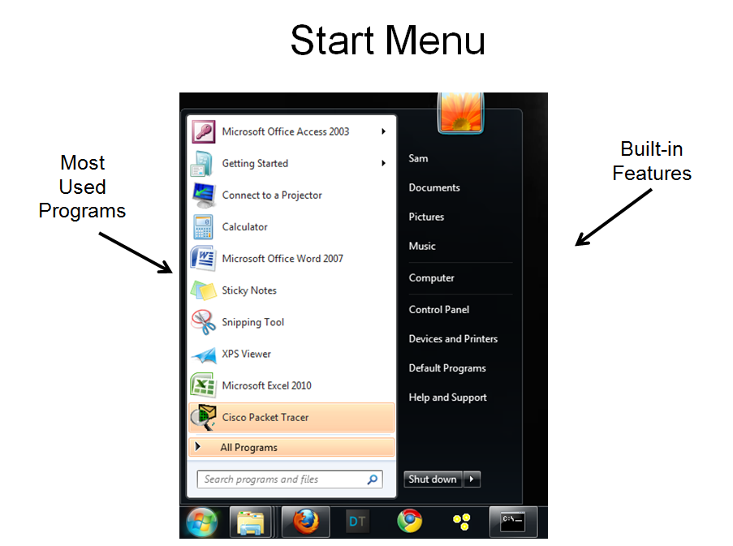

Customizing the Start Menu

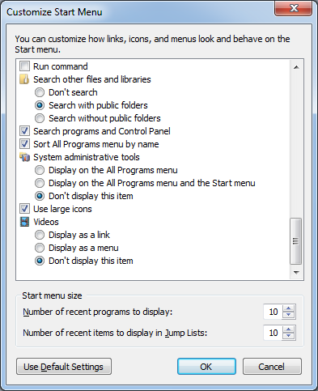
Right-click Start button, Properties, Customize

Adjust the "Number of recent programs to display" at the bottom

Clear the "Use large icons" box if you want to fit more items on the list

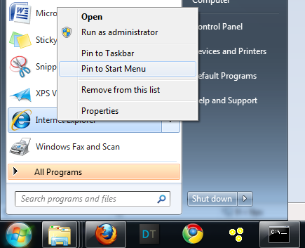

Pinned Items

Right-click Start menu items, "Pin to Taskbar"

Puts them at the top of the menu

Customizing the Taskbar

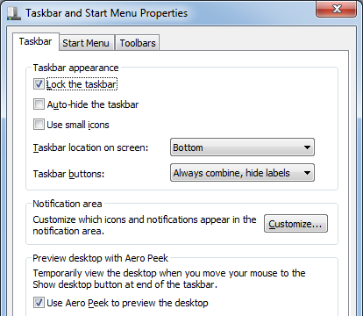
Right-click taskbar, Properties

Lock, Auto-hide, and Use small icons are all worth experimenting with

Taskbar location on screen (a good alternative to dragging the Taskbar)

Taskbar Buttons

Control combination

Pinning a Program to the Taskbar

Drag an icon to the Taskbar and drop it there

To remove it, right-click the item, and Unpin it

Jump List

Right-click menu of a Taskbar button to see the 10 most recently-used documents or destinations

You can also pin items here, and adjust the number of items shown (see page 101 of the textbook)

Using the Logo Key

Launch Taskbar Items with Logo+a digit
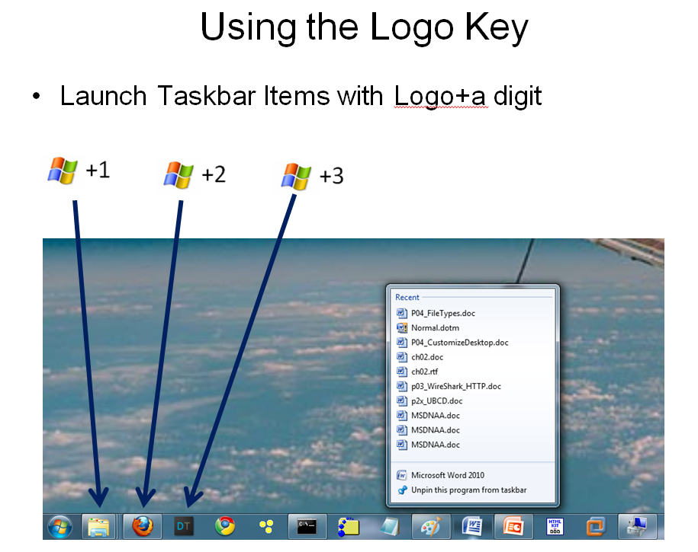

Notification Area

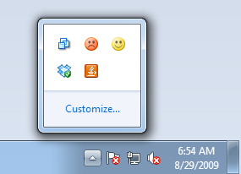
On lower right of desktop

Click up-arrow to see hidden items

Click Customize… for more options

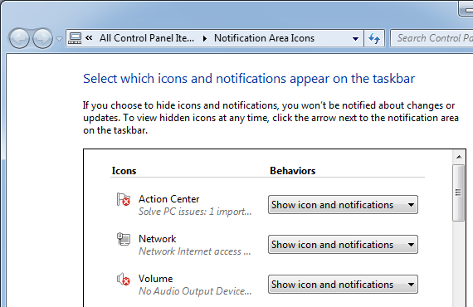

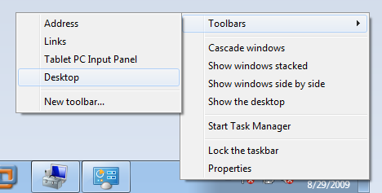

Taskbar Toolbars

Right-click Taskbar

Point to Toolbars

Activate the toolbars you want

Desktop toolbar may be useful if you keep things on the Desktop

Last modified 8-29-09

