Chapter 6: Tuning Windows 7's Performance
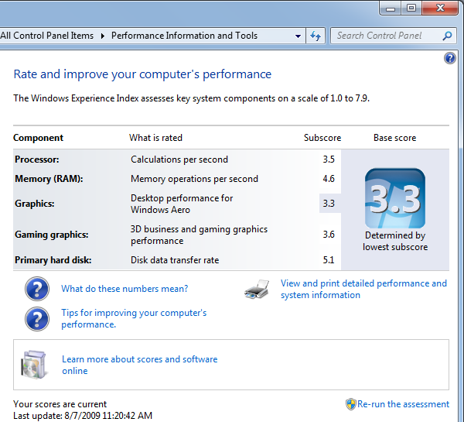
Monitoring Performance

Performance Rating

Windows 7 adjusts itself to match the ability of the hardware

Aero Theme v. Windows Basic

Gaming features

TV recording

Video playback

WinSAT: Windows System Assessment Tool

Start, PERF

Click "Performance Information and Tools"

Scores range from 1.0-7.9

Higher is better

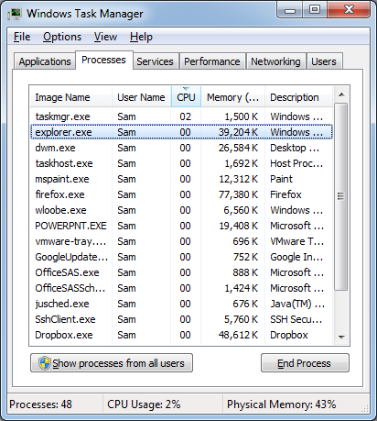

Task Manager

Ctrl+Shift+Esc or Ctrl+Alt+Delete

Processes tab shows CPU and RAM each process is using

CPU stuck at 100% or Memory constantly increasing indicates a problem

You can terminate processes here

Task Manager

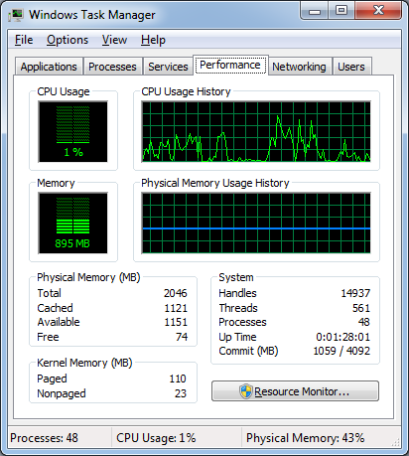
Performance tab

Physical Memory

Total: Amount of RAM installed

Cached: Contains recently used programs and documents, can be used for applications if necessary

Available: Physical RAM that is not being used

Free: Portion of the cache that does not contain useful information

These numbers are inaccurate and don't add up correctly (see links Ch 6a & 6b)

Kernel Memory

Paged: Mapped to virtual memory

Nonpaged: Must be in physical RAM only

System

Handles: objects (pointers) used by all processes

Threads: Components of processes that operate independently

Processes: Number of items in the Processes tab

Up Time

Commit (MB): Minimum and Maximum Page File size

Page File

When RAM is unavailable, Windows puts data on the hard disk in the Page File

Also called virtual memory

Virtual memory is much slower than RAM

Computers that use too much virtual memory run slowly and need more RAM

Signs of Inadequate RAM

Physical Memory Free is small, approaching zero

System is starving for RAM

Physical Memory Cached much less than half of Physical Memory Total

System will be somewhat slow, because Windows cannot use as much cache as it should

Resource Monitor

Start, MONITOR

Click "Resource Monitor"

Overview tab

Four categories of metrics: CPU, Disk, Network, Memory

Expand category sections with the little down-arrow in the bottom section
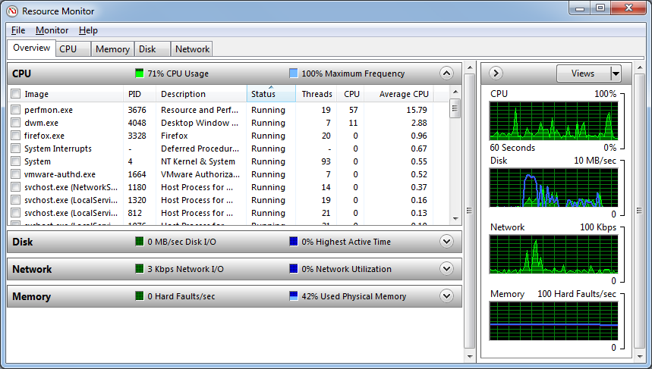
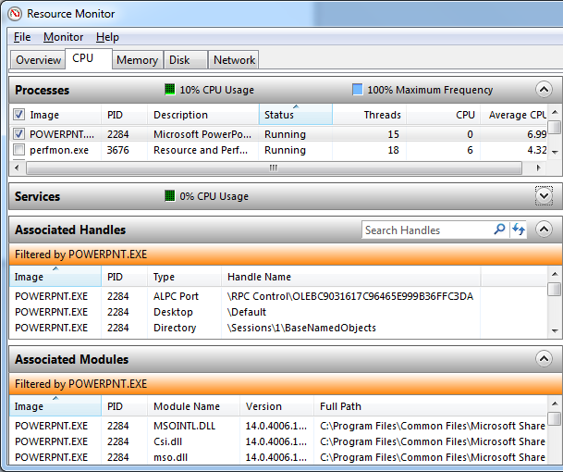

Resource Monitor

CPU tab

Shows handles and modules for each process

Resource Monitor

Memory tab

Details for each process

Very clear summary at the bottom

Hard Faults occur when the computer cannot find data in the RAM cache and must use virtual memory
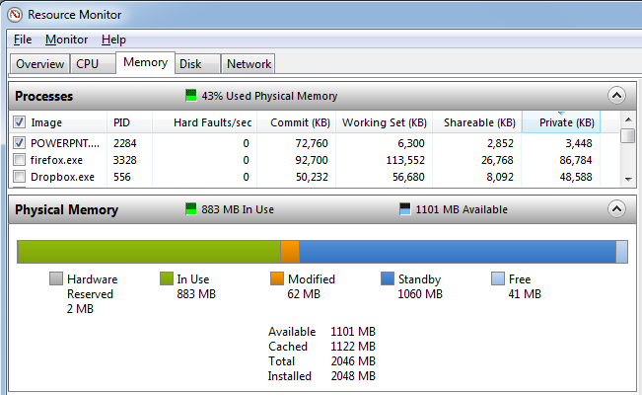

Resource Monitor

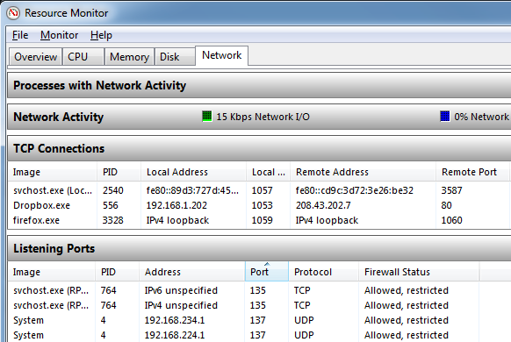
Disk tab

Details about disk usage by each process

Resource Monitor

Network tab

Lists TCP Connections and Listening Ports!

Performance Monitor

Start, PERFORMANCE

Click "Performance Monitor"

Baffling complexity

Not required for desktop support

Useful for servers

Optimizing Startup

Ways to Speed Up Startup

Skip BIOS Checks

Reduce OS Choices Menu Timeout

Start, MSCONFIG, Boot tab

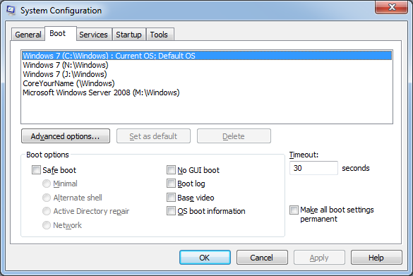
Use "No GUI Boot"

But it will hide some Blue Screen errors

Ways to Speed Up Startup

Upgrade Device Drivers

Use Automatic Logon

Bad for security

Configure Prefetcher

Optimizing Applications

Ways to Speed Up Applications

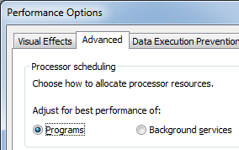
Add more RAM

Get a faster hard drive

Adjust Prefetching to preload applications

Update Device Drivers

Giving Priority to Programs

Start, ADVANCED SYSTEM

Click "View advanced system Settings"

In Performance group, click Settings

Click Advanced tab

Programs is the default setting

Ways to Speed Up Applications

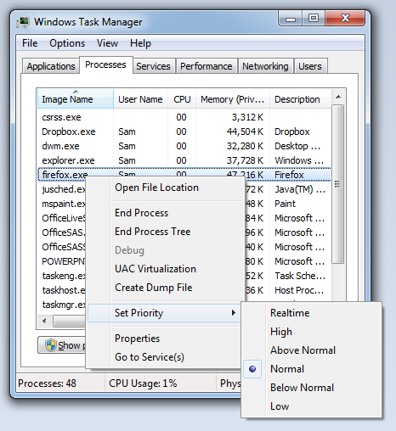
Give it more priority in Task Manager

Right-click process

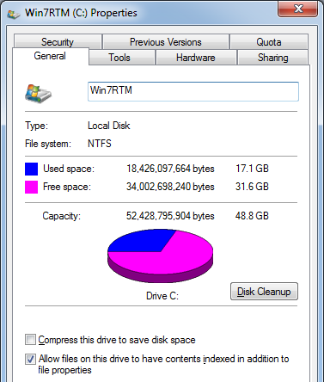
Optimizing the Hard Disk

Hard Drive Performance Specifications

Hard Drive Speed

Revolutions per minute

7,200 rpm is common, 10,000 rpm is available

Hard Drive Cache

8 to 16 MB is common, 32 MB is better

Time Specifications

Seek Time

Most commonly quoted; lower is better

Latency

Write time

Read time

Hard Drive Maintenance

Keep empty space on the drive

Clean off unneeded files

Uninstall programs you don't need

Check Disk for Errors

Defragment disk

Disable Compression and Encryption

Turn off Content Indexing

Making Hard Drives Faster: Exotic Ideas

Use Write Caching

On by default anyway

Use NTFS file system, not FAT16 or FAT32

Turn off 8.3 Filename Creation

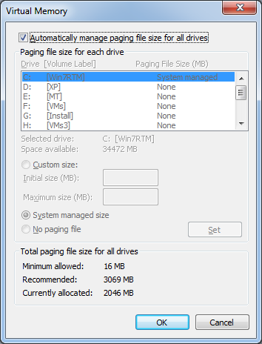
Disable Last Access Timestamp
Optimizing Virtual Memory

Ways to Speed Up Virtual Memory

Virtual memory uses a hard disk file to store temporary data when RAM is full

Also called "Paging"

Adjusting the Page File

Start, ADVANCED SYSTEM

Click "View advanced system Settings"

In Performance group, click Settings

Click Advanced tab

Click Change…

Ways to Speed Up Virtual Memory

Use the fastest physical disk for the Page file

Use the disk with the most free space for the Page file

Helpful because the Page file can automatically grow

Split the Page file across multiple physical disks

Chapter 7: Maintaining Your Windows 7 System

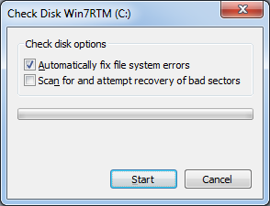
Checking the Hard Disk for Errors

In Hard Drive Properties

Tools Tab, "Check Now"

Can take a long time

Checking Disk Free Space

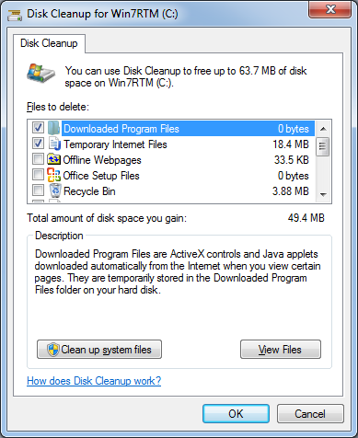
Computer window in Details view shows free space

Disk Cleanup

Start, CLEAN

Click "Disk Cleanup"

Defragmenting Your Hard Disk

Defragmenting a disk arranges the files on it neatly

Makes read and write faster

Does NOT create more free space

Windows 7 defragments disks automatically

You shouldn't have to defragment manually

Preparing for Trouble

System Restore automatically creates restore points for you, that contain the Registry, installed program files, and crucial system files

Every 24 hours

Before installing modern applications, patches, unsigned device drivers

Before restoring backed-up files

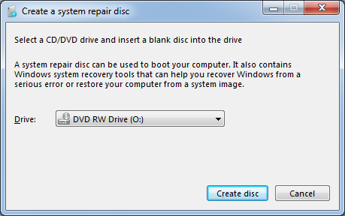
Before reverting to a previous configuration using System Restore

Creating a System Repair Disc

Start, REPAIR

Click "Create a System Repair disc"

Useful if you don't have a Windows 7 Install disc

Backing Up Your Files

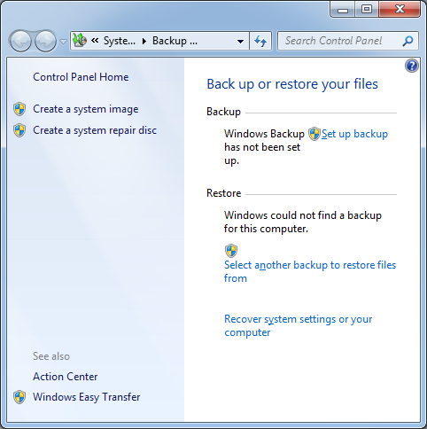
Start, BACKUP

Click "Backup and Restore"

Use "Set up backup" to schedule regular document backups

Use "Create a system image" to back up the System drive

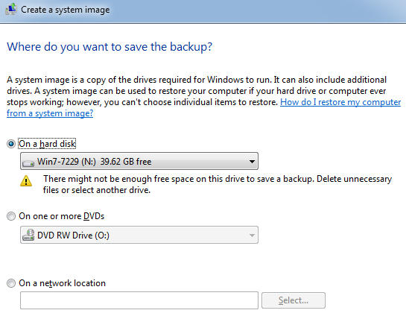

Create a System Image

Store the backup on:

Hard disk

DVDs

Network

Restoring From a System Image

If Windows 7 is still running

Open Recovery in Control Panel

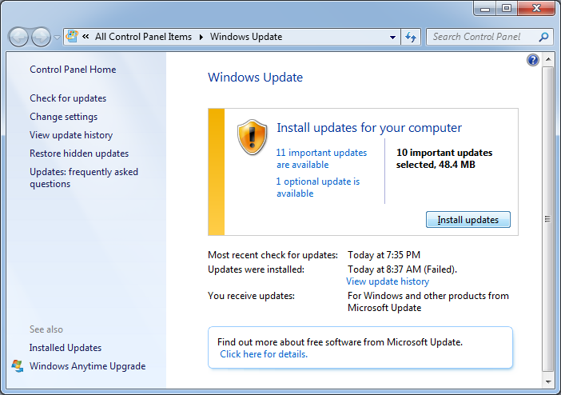
Click "Advanced Recovery Methods"

If the boot loader still works

Press F8 during startup

In Advanced Boot Options, select "Repair your computer"

Boot from a Windows 7 install disc or a system repair disc

Click "Repair your computer"

Updates and Patches

Click Start, UPDATE

Click "Windows Update"

Reading Event Viewer Logs

Start, EVE

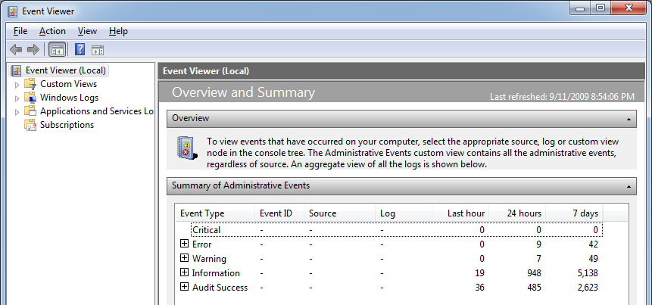
Click "Event Viewer"

View, Customize, clear "Action Pane"

Last modified 9-11-09

