Ch 8: Controlling Windows 7 with Control Panel

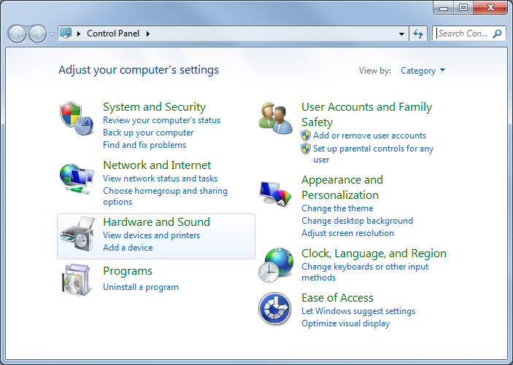
The Control Panel Window

Category View

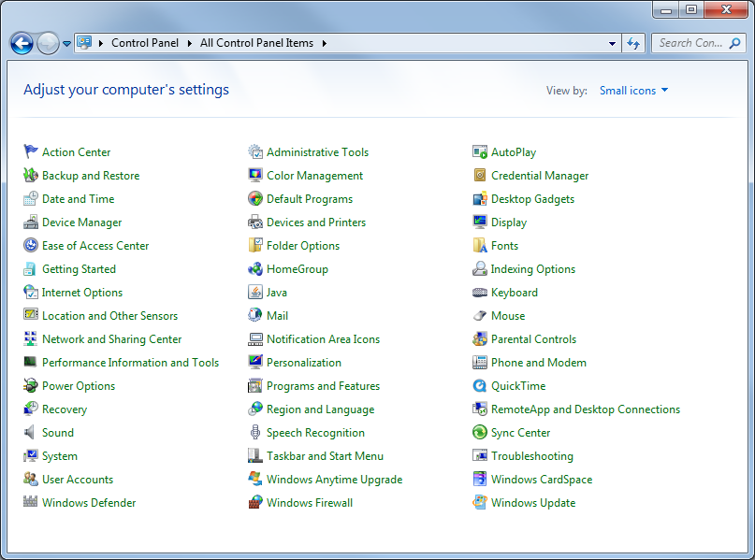

Small icons View

New Control Panel Items

Action Center

Administrative Tools

Component Services

Biometric Devices

Only if you have fingerprint readers, etc.

Credential Manager

Desktop Gadgets

Devices and Printers

Display

Getting Started

HomeGroup

Location and Other Sensors

Such as GPS devices, if you have them

Notification Area Icons

Recovery

System Restore and system image recovery

RemoteApp and Desktop Connections

Lets you connect to a remote application server

Troubleshooting

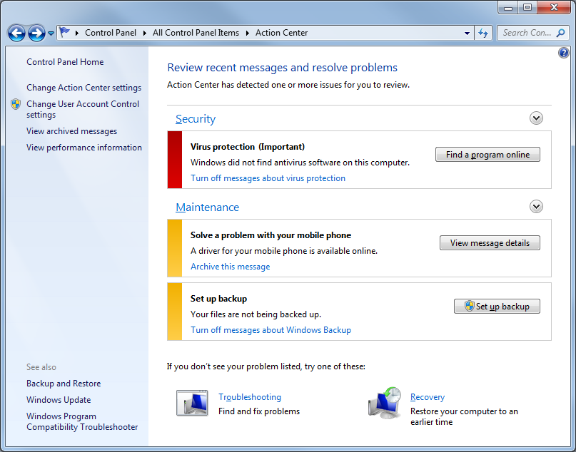
Action Center

Helpful and easily customized

Alerts show in Notification Area

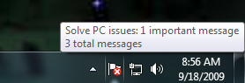

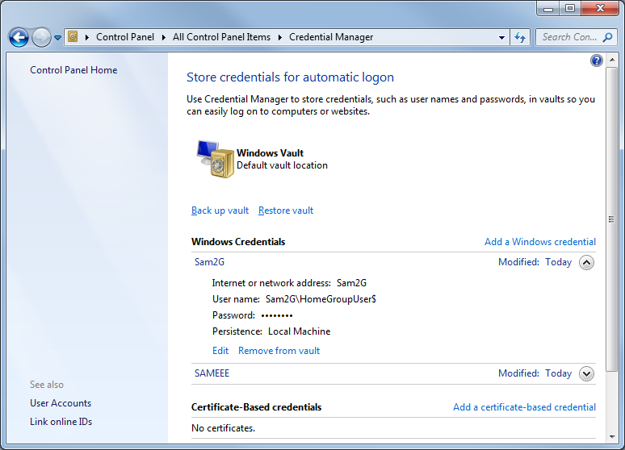

Credential Manager

Much enhanced from earlier versions

Desktop Gadgets

Vista’s Sidebar is gone

Getting Started

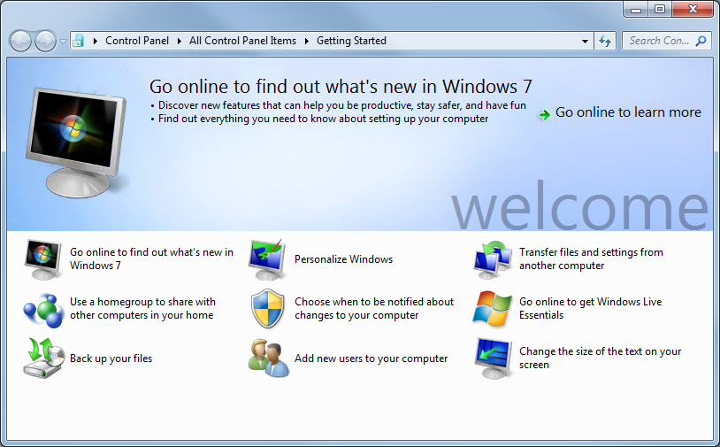
Replaces Vista’s Welcome Center

Also appears near the top of the Start menu

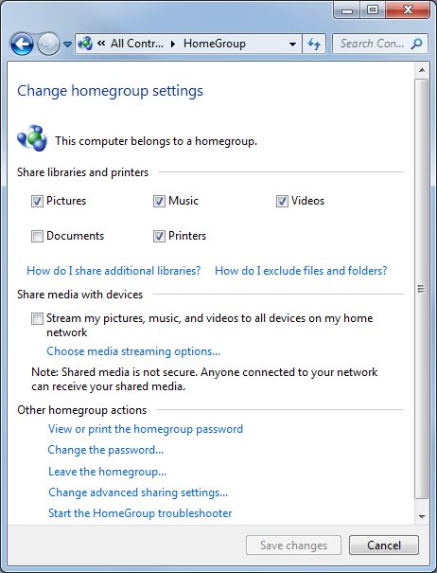

HomeGroup

Easy and secure file sharing at home

Password-protected

Only on Home networks, not Work or Public
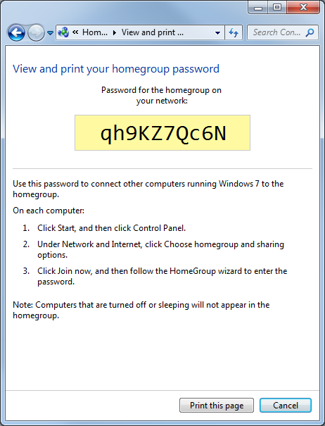

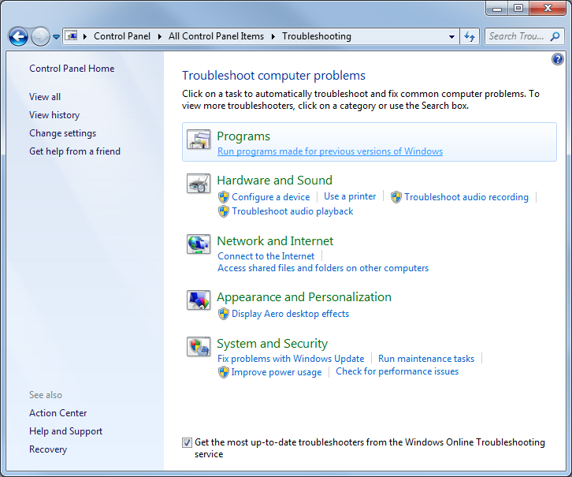
Troubleshooting

Very handy

Fixed Aero on my Eee

Launching Control Panel Items from the Command Line

Folder Options

control folders

Network Connections

control npca.cpl

Or

control netconnections

Windows Firewall

control firewall.cpl

User Accounts

control nusrmgr.cpl

Or

control userpasswords

Alternate User Accounts box with Advanced tab

control userpasswords2

Limiting Control Panel with Group Policy

Start, gpedit.msc
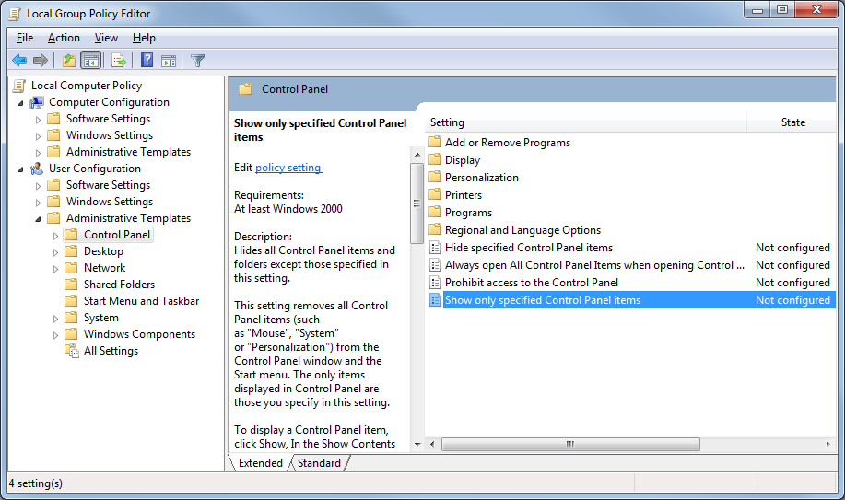
Ch 9: Policing Windows 7 with Group Policies

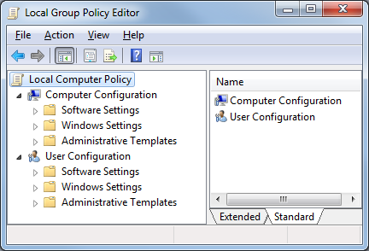
Group Policies

Control Windows in great detail

Push policies to many machines

Set a Restore point before making major changes

Editions

Local Group Policy Editor is not available on Starter or Home Premium versions of Windows 7 (link Ch 9a)

But you can make the same changes with Regedit

Details can be downloaded from Microsoft (link Ch 9b)

Working with Group Policies

Left pane

Computer Configuration

Settings apply to all users

Take effect before a user logs on

Left pane

User Configuration

Settings apply to the current user only

Take effect after that user logs on

Right pane shows the actual policies

Configuring a Policy

Three states: Not Configured, Enabled, or Disabled

Supported on: shows Windows versions

Some policies have more choices
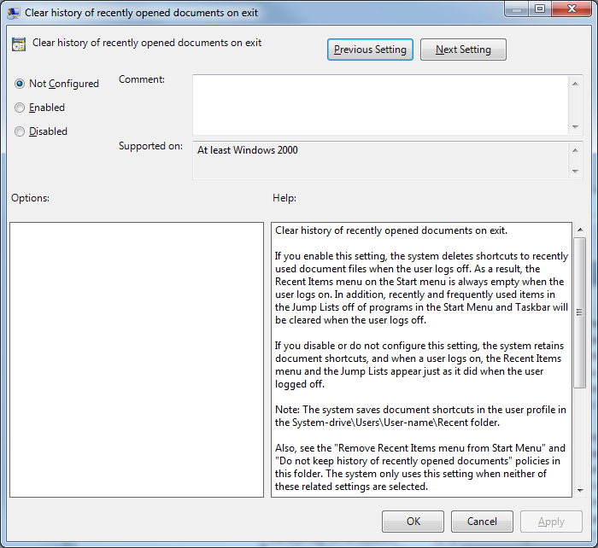

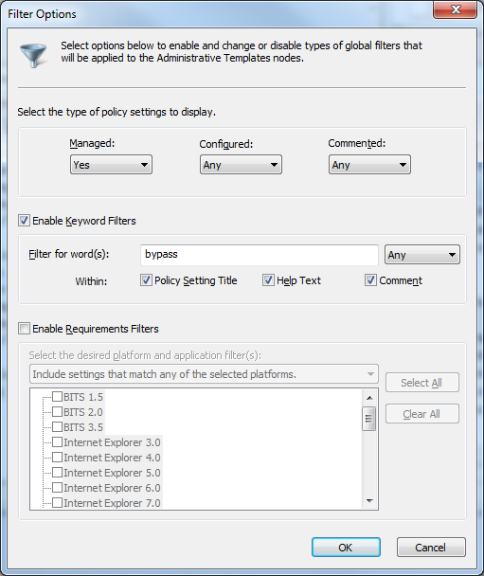
Filtering Policies

Use the “All Settings” branch of the appropriate Administrative Templates item

Action, Filter Options

Helps to find specific policies

Group Policy Examples

Customizing the Windows Security Window

It appears when you press Ctrl+Alt+Delete

Customizing Open and Save As dialog boxes

Increasing the Size of the Recent Documents List

Enabling the Shutdown Event Tracker

See project 2x (extra credit)

Ch 10: Customizing the Microsoft Management Console

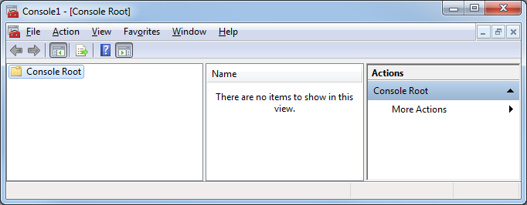
Microsoft Management Console

Start, MMC, Enter

It’s an empty container at first

Add Snap-ins to use it

Snap-ins

Microsoft Common Console Documents

.msc files

Demo

Start, gpedit.msc

Open Task Manager

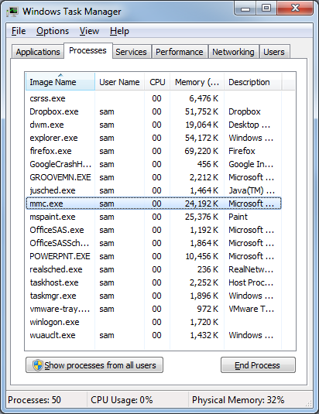
On Applications tab, right-click “Local Group Policy Editor”, and click “Go To Process”

The Process is mmc

Many familiar tools are snap-ins

Computer Management

Device Manager

Event Viewer

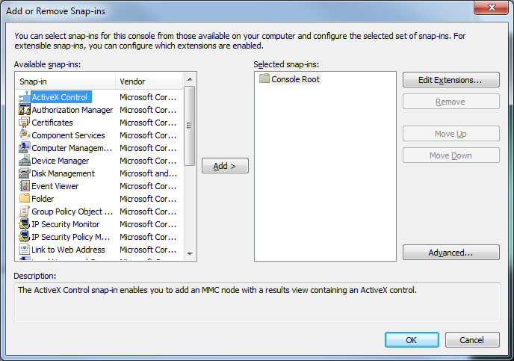

Demonstration: Custom Snap-in

Add snap-ins

Save the console in C:\Windows\System32

It now appears in the Start button's Search menu

See project 10

Last modified 9-18-09

