Ch 11: Controlling Services

Services

A service is a specialized program that performs a function to support other programs

Many services operate at a very low level

Interacting directly with hardware

Need to run even when no user is logged on

Run with the System account (which has elevated privileges)

Using the Services Console

A MMC snap-in

In Computer Management

Or SERVICES.MSC at a command prompt

Over 150 services installed in Windows 7
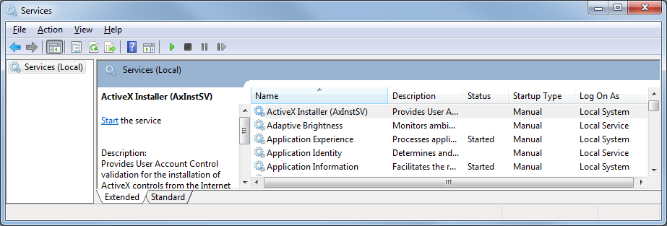

Actions on Services

Start, stop, pause, resume, or restart

Pausing and resuming is less drastic than stopping and restarting

May avoid cancelling jobs in process

Essential services start automatically

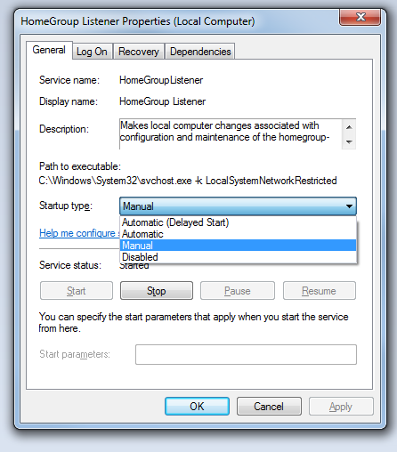
Some others must be manually started or stopped

Usually because of an error

Service General Properties

Startup Types

Automatic (Delayed Start)

Starts shortly after the computer starts

Automatic

Starts when the computer starts

Manual

Doesn't start automatically at startup, starts when needed

Disabled

Can't be started

Essential Services

Cannot be stopped

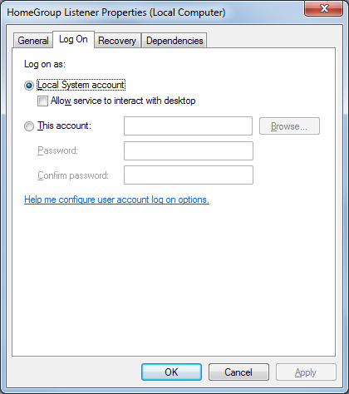
Stop button grayed out

Examples:

Group Policy Client

Plug and Play

Remote Procedure Call (RPC)

Security Accounts Managet (SAM)

Service Log On Properties

Most Services run as "Local System Account"

Log On As A Service (not in textbook)

The logon account must have the "Log On As A Service" right

Start, SEC

Local Security Policy

Local Policies

User Rights Assignment

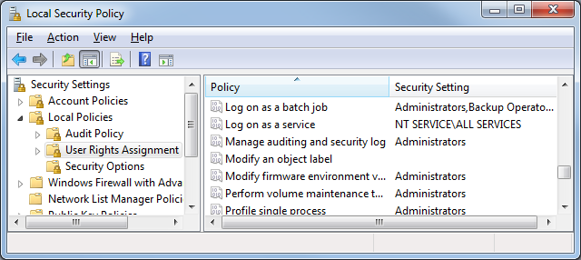

Service Recovery Properties

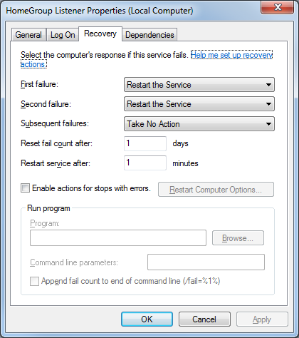
When it fails

Take No Action

Restart The Service

Run A Program

Restart The Computer

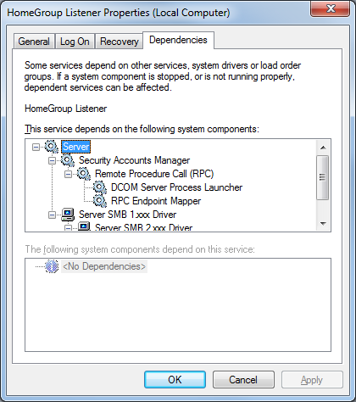

Dependencies

If you stop a service upon which others are dependent, Windows also stops those services

But if you start a service that depends on other services, Windows may not start the others

Managing Services from a Command Prompt

net start Lists running services

net start "service" Starts "service"

net stop "service" Stops "service"

net pause "service" Pauses "service"

net continue "service" Resumes paused "service"

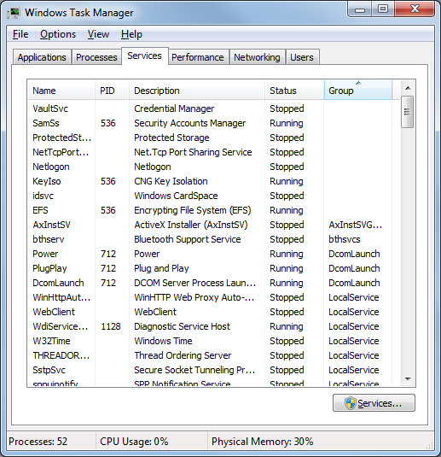
Managing Services from Task Manager

Not in textbook

Demo: Process Explorer (not in book)

Download Process Explorer v11.33

Link Ch 10a

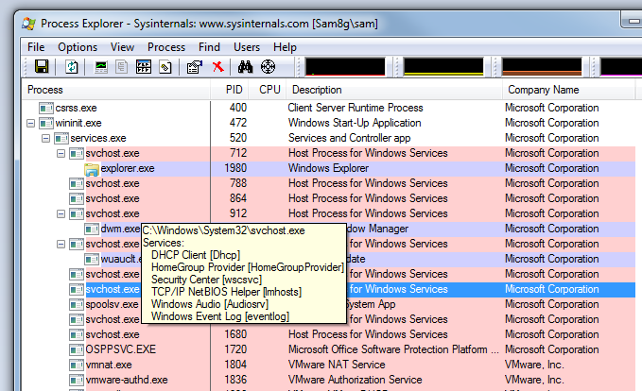

I Skipped These Sections

Controlling Services With a Script

Disable Services for Faster Performance

Make Windows Shut Down Services Faster

Reset a Broken Service
Ch 12: Registry

Editing the Registry is Dangerous

A bad manual change can crash your system

Normally you use Control Panel to update the registry to avoid such disasters

The Registry Includes

Information about all installed hardware

Resources used by devices

List of device drivers to load at startup

Settings Windows 7 uses internally

File type associations

Backgrounds, color schemes

Customization of the Start Menu and Taskbar

The Registry Includes

Internet and network connections and passwords

Settings for applications like Windows Explorer and Internet Explorer

Settings and customization for third-party applications

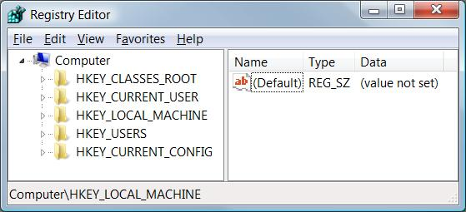
Understanding the Structure of the Registry

The registry consists of five root keys

HKEY_CLASSES_ROOT

HKEY_CURRENT_USER

HKEY_LOCAL_MACHINE

HKEY_USERS

HKEY_CURRENT_CONFIG

Or HKCR, HKCU, HKLM, HKU, and HKCC

Subkeys

Root keys (sometimes called predefined keys), contain subkeys

Subkeys look like folders in Regedit

HKCU has these top-level subkeys: AppEvents, Console, Control Panel, …

A root key and its subkeys form a path

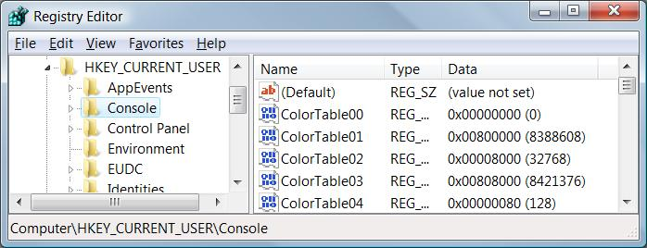
HKCU\Console

Values

Every Subkey contains at least one value

But it may show (value not set)

The default value (often undefined)

Values have name, data type, and data

Root Keys

HKEY_CLASSES_ROOT

Data relating filename extensions to associated programs

HKEY_CURRENT_USER

Settings that apply to the currently logged-on user

Group policies from HKEY_USERS\sid

sid is a Security Identifier, a unique number for each user

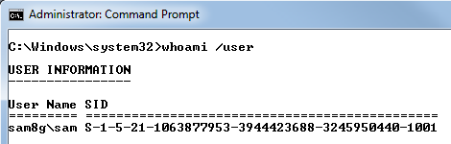
The user's %userprofile%\ntuser.dat file

Finding a SID From a Command Prompt (not in textbook)

Finding SIDs in the Registry
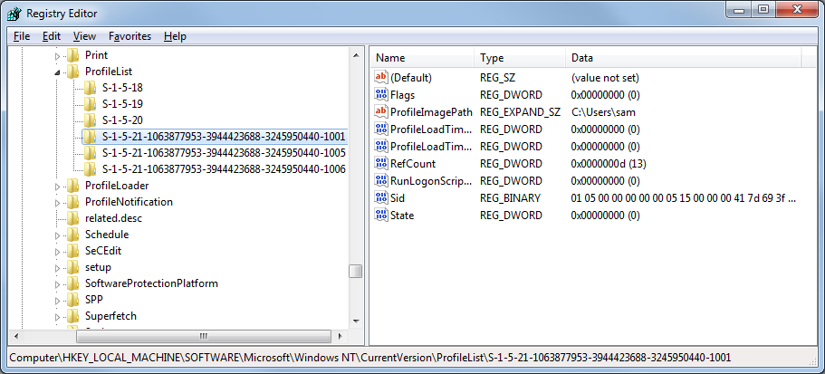

Root Keys

HKEY_LOCAL_MACHINE

Non-user-specific configuration data

HKEY_USERS

Similar to HKEY_CURRENT_USER, for all users

HKEY_CURRENT_CONFIG

Settings for the current hardware profile

Hives

A key with all its subkeys and values is called a hive

The registry is stored on disk as several separate hive files

Hive files are read into memory when the operating system starts (or when a new user logs on)

HiveList

HKLM\System\CurrentControlSet\Control\HiveList
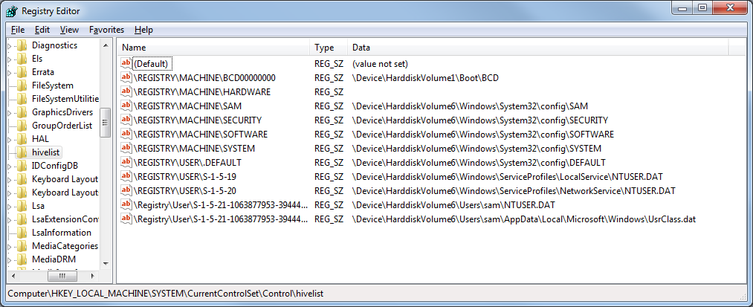

Avoiding Registry Mishaps

Registry Editor changes the registry immediately

No Undo command


No File, Save command

Backing Up Before You Edit

Registry Editor's File, Export

Registry Hive format is recommended for backups

Because it restores the entire hive exactly

BUT if you restore it to the wrong key, it does a lot of damage

.reg Files

You can export a registry key in Registration Files format

Creates a .reg file

Can be edited in notepad

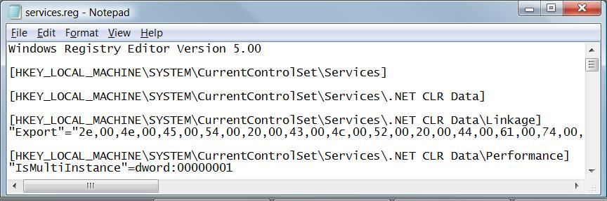
Right-click, Merge to insert values into registry

HKLM\System\CurrentControlSet

This hive is so important, Windows backs it up

To restore this hive, press F8 during bootup and use "Last Known Good Configuration"

Finding Registry Changes

Export all or part of the Registry as a .REG file

Make the changes you are interested in, such as in Group Policy

Export the Registry again

Compare the files with this command

FC /U pre-edit.reg post-edit.reg > reg-changes.reg

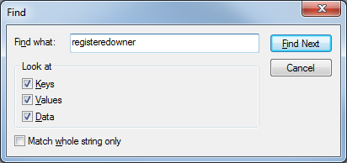
Finding Registry Values

In Regedit, click Edit, Find

Useful to find leftover keys from an application that doesn't uninstall correctly

Last modified 9-25-09

