Controlling Windows 7 from the Command Line

Administrator Command Prompt

Start, CMD, Enter

Normal (low-privilege) Command Prompt

Start, CMD, Shift+Ctrl+Enter

Administrator Command Prompt

SET

Displays Environment Variables

Navigation

CD

Shows the current working directory

CD foo

Changes the working directory to foo

CD ..

Moves to the parent of the current working directory

D:

Changes the working drive to D:

Tab Completion

To refer to a file or folder in the current directory, type the first one or more letters and press Tab

If you see the wrong name, keep pressing Tab

Delete

DEL foo

Deletes file foo

Does not put it in the recycle bin!

External and Internal Commands

External commands exist as separate files

Chkdsk

Defrag

Xcopy

Internal commands are part of the CMD shell

DIR

CD

CLS

Running Internal Commands

Two methods

Type command at a Command Prompt

Use CMD to launch the command

CMD /C IPCONFIG /RENEW

Runs IPCONFIG /RENEW and then closes the Command Prompt window

CMD /K IPCONFIG /RENEW

Runs IPCONFIG /RENEW and leaves the Command Prompt window open

Running External Commands

Three methods

Type command at a Command Prompt

Use CMD to launch the command

Launch command from Windows Explorer with the GUI

Demo: CMD Commands in the Run Box

Logo+R opens the Run box

Working with Long Filenames

Use quotes around the names

Copy "Fiscal Year 2009.doc" "Fiscal Year 2010.doc"

Copy path from Windows Explorer and paste into the Command Prompt window

Add frequently used folders to the PATH environment variable

Editing the PATH from the Command Line

SET PATH

Shows current value of all environment variables starting with PATH

SET PATH=string

Sets PATH to string (don't use quotes around string) \

SET PATH=%PATH%string

Appends string to PATH

Editing the PATH from the GUI

Start, right-click Computer, Properties, Advanced System Settings, on the Advanced tab, click the "Environment Variables" button.

Copy-and-Paste in the Command Prompt

Right-click, MARK

Drag through text with left mouse button down

Enter to copy it

Paste into Notepad to remove line breaks

DOSKEY

Up-arrow

Recalls previous command in buffer

Down-arrow

Recall next command in the buffer

F8

Recall a command that begins with the characters you typed

F7 Displays Entire Command Buffer

Multiple Commands on a Single Line

Use && characters between them

Editing Command Lines

Left arrow or Right arrow

Move one character to the left or right

Ctrl+Left arrow or Ctrl+Right arrow

Move one word to the left or right

Home

Move to start of line

End

Move to end of line

Output Redirection

Standard Input: Keyboard

Standard Output: Monitor

DIR > foo

Puts a directory into a file named foo, emptying any previous contents of foo

DIR >> foo

Appends a directory to a file named foo, after any previous contents of foo

Input Redirection

DATE

Waits for user input

DATE < enter.txt

Gets the input from then file enter.txt instead

This makes it possible to automate tasks that are written to expect keyboard input

Piping Commands

Use the | character (Shift+Backslash) to "pipe" the output from one command into another command

IPCONFIG | MORE

This prevents IPCONFIG from scrolling off the screen before you can read it

DIR | SORT

Sorts a directory by date

Echo and Pipe

You can use Echo to pipe a response into a command that would otherwise be interactive

ECHO. | TIME

Sends "Enter" to the TIME command

Echo and Output Redirection

ECHO "Hi"

Displays "Hi" on the standard output (console)

ECHO "Hi" > foo

Puts "Hi" into file foo, emptying it first

ECHO "Hi" >> foo

Appends "Hi" to the end of foo
Batch File Basics

Simple Batch File

Use Notepad to make a text file containing command-line commands

Saved with a filename ending in .bat

Normally every command is echoed as it executes

Preventing Command Echoes

@ECHO OFF

Stops command echoes
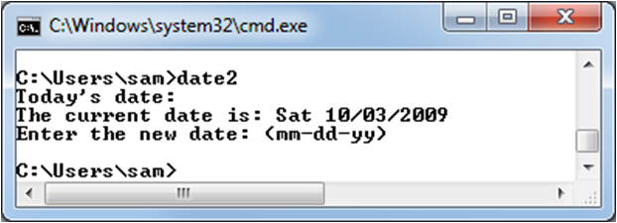

PAUSE

PAUSE waits for the user to press a key

User can press Ctrl+C to stop the batch file
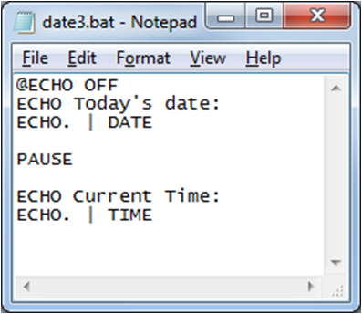
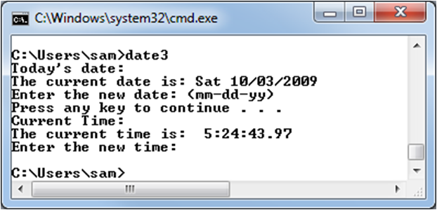

Parameters

When you execute a batch file, you can add up to nine parameters after the batch file name

They are referenced in the script as %1, %2, etc.
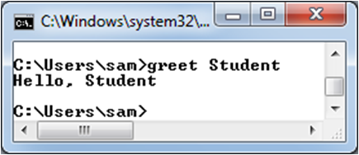
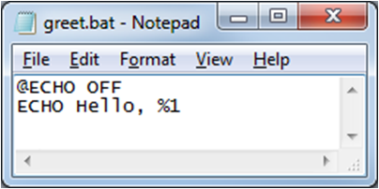

FOR Looping

FOR %%parameter in (set) DO command

parameter can be any single letter

set lists the choices, separated by spaces, commas, or semicolons

Command can be any command, often including %%parameter

FOR Example
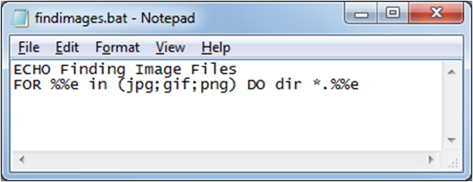

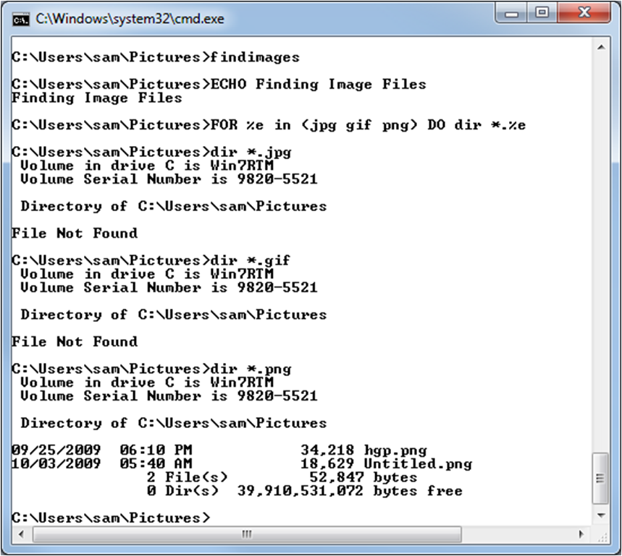

GOTO: Jumping to a Line in a Batch File

:Label

Labels a line

GOTO Label

Goes to that line
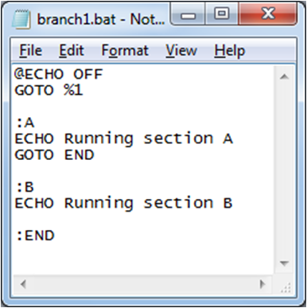
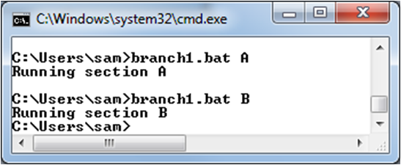

IF: Making Decisions

IF condition command

condition evaluates to yes or no
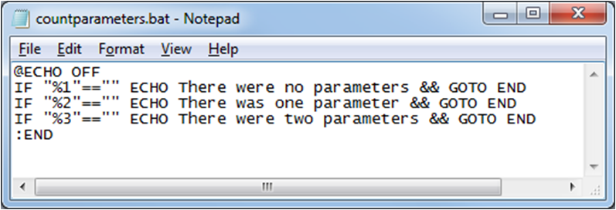

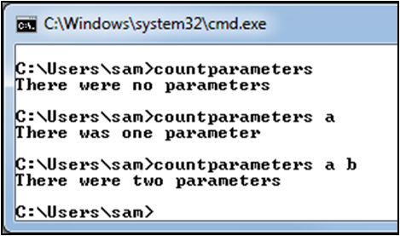

Working with the Command-Line Tools

Disk Management

CHKDSK Checks a volume for errors

CONVERT Converts a FAT volume to NTFS

DEFRAG Defragments a volume

DISKPART Manages disk partitions

FORMAT Formats a volume

File and Folder Management

ATTRIB Displays or changes attributes

CD Changes working directory

COPY Copies a file or folder

DEL Deletes a file or folder

DIR Directory listing

FIND Finds a string in a file

MKDIR Makes a folder

MOVE Moves a file or folder

REN Renames a file or folder

RMDIR Deletes a folder

SORT Sorts a file and displays the results

WHERE Finds a file

XCOPY Copies a file, has more options
than COPY

System Management Tools

BCDEDIT Configure Boot Manager

DATE Display or set system date

REG Read or write to the Registry

SHUTDOWN Shut down the computer

SYSTEMINFO Display system information

TIME Display or set system time

WHOAMI Information about current user

WMIC Windows Management
Instrumentation

Command Line Kung Fu

A weblog from experts in the Windows, Linux, and OS X command-line (link Ch 13a)

Very interesting tricks

Finding large files (#4)

Using WMIC to find installed patches (#16)

Ping sweep from the command line with a FOR loop (#6)

Last modified 10-3-09

