Ch 14 Securing Windows 7

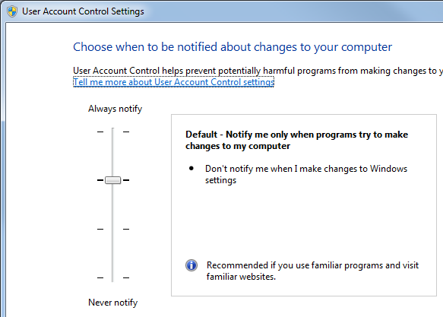
User Account Control

Leave User Account Control Turned On

Highest setting is like Vista

Second-highest is default

Basic Precautions

Be Paranoid

Assume people will attack you and your computer

Mistrust email attachments and links

Keep to Yourself

Don't reveal personal information online

Test the Firewall

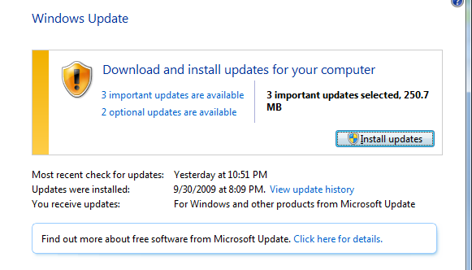
To test from the outside, use grc.com's Shields UP!

From your LAN, use nmap

Your router has a firewall, too--using both is safest

Updates

Patch Tuesday is the second Tuesday of each month, the day on which Microsoft releases security patches

Next week it's the largest patch ever--13 flaws

Link Ch 14a

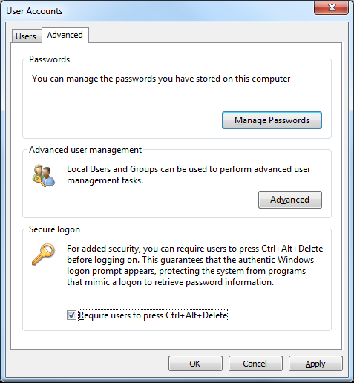
Lock Your Computer

Press Logo+L to lock manually

Set screen saver to display logon screen

Logo, SCREEN, click "Screen Saver"

Requiring Ctrl+Alt+Delete

Logo+R to open Run box

CONTROL USERPASSWORDS2

Windows Defender

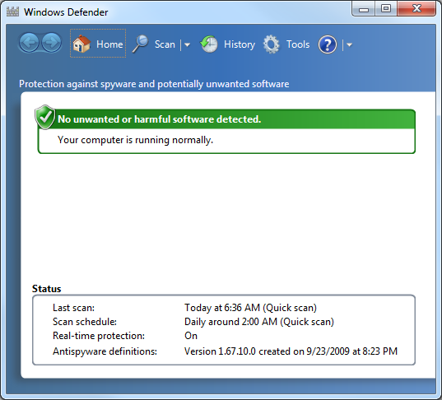
Home button shows a summary of your protection status

Scan scans now

Full scan may take 30 minutes or more

History shows previous scans

Options configures real-time protection and scans

Spynet sends information to Microsoft (on by default)

Making Sure the Administrator Account is Disabled

Start, SECPOL.MSC

Local Policies

Security Options

First item

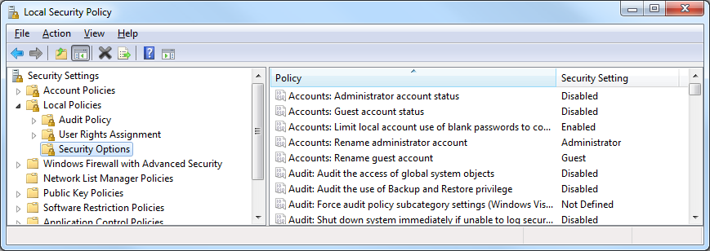
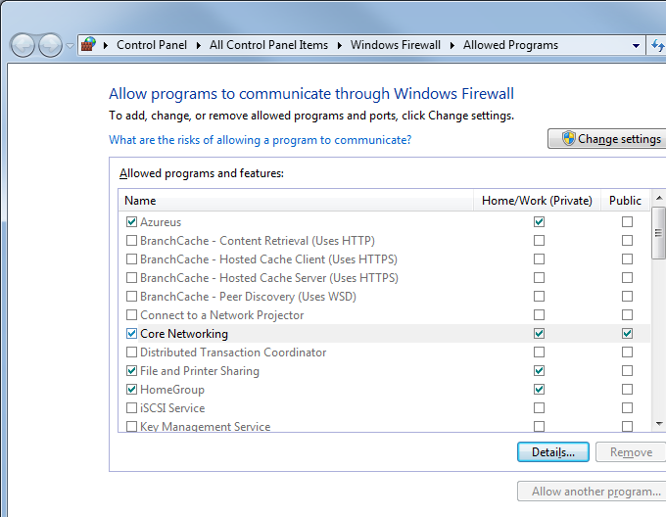

Firewall Exceptions

Start, FIRE, "Allow a program through Windows Firewall"

Security Alerts

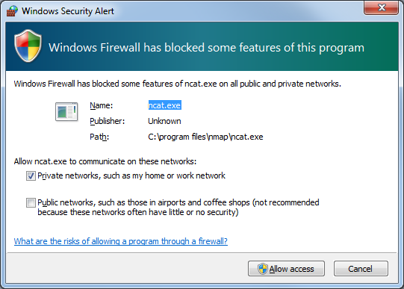
The first time a program tries to listen for incoming connections, this box pops up

The choice made here is saved in the "Allowed Programs" list

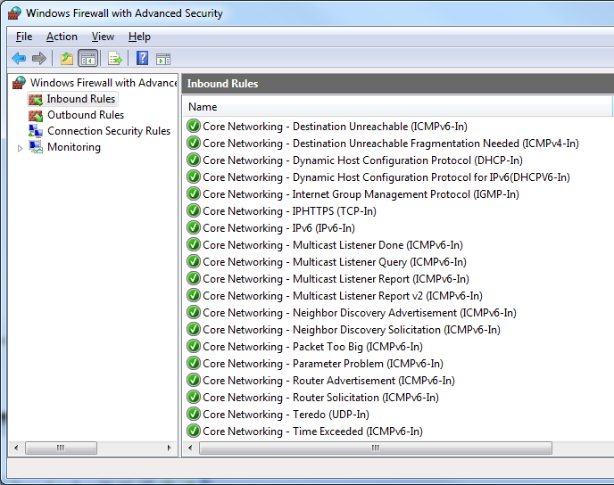
Core Networking

Allowed by default

Ch 15:Configuring Internet Explorer Security

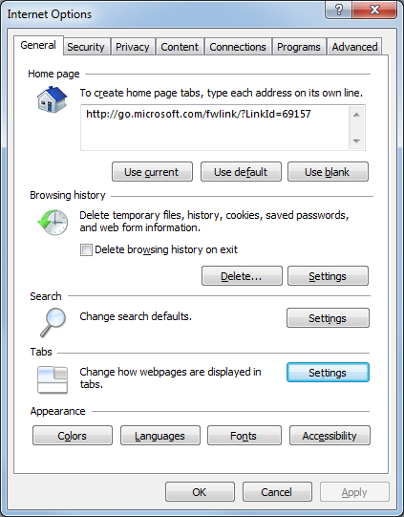
Private Data Stored by Internet Explorer

Temporary Internet Files

Cookies

History

Form Data

Passwords

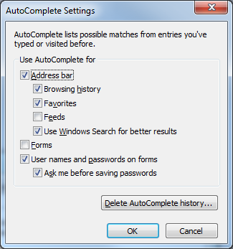

AutoComplete

In Internet Options, on the Content tab, in the AutoComplete section, click the Options button

Passwords are stored with encryption in the Registry

Experts recommend not using IE's password storage

Deleting Saved Data

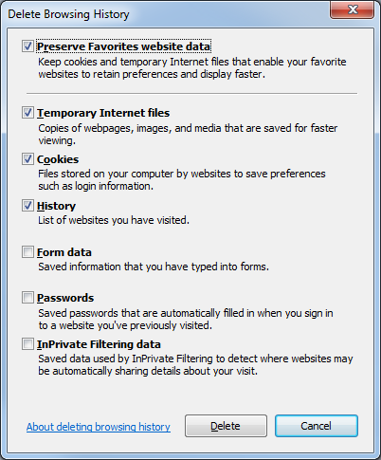
In IE, press Ctrl+Shift+Delete

Types of Cookies

Temporary cookie

Deleted when IE closes

Persistent cookie

Kept until it expires

First-party cookie

Set by the website you are viewing

Third-part cookie

Set by some other website, such as DoubleClick

Cookie Risks

Cookies might store Personally Identifiable Information

Name, email address, SSN, etc.

Third-party cookies spy on your Web activities to target ads

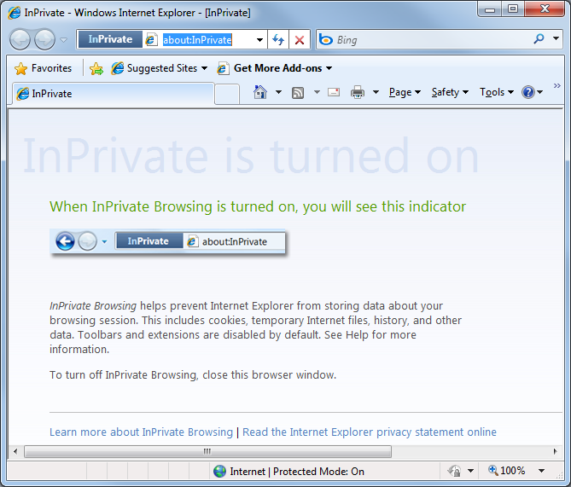

InPrivate Browsing

In IE, press Shift+Ctrl+P

No data is saved while InPrivate browsing is on

InPrivate Filtering

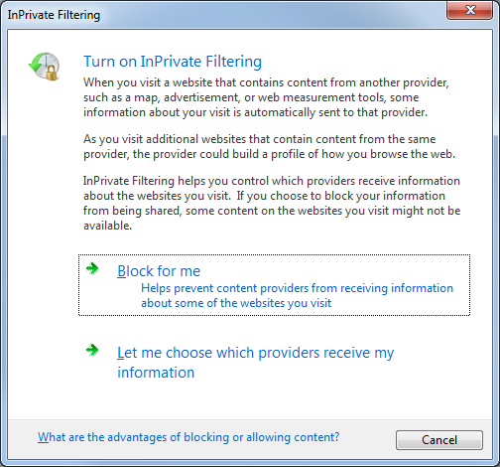
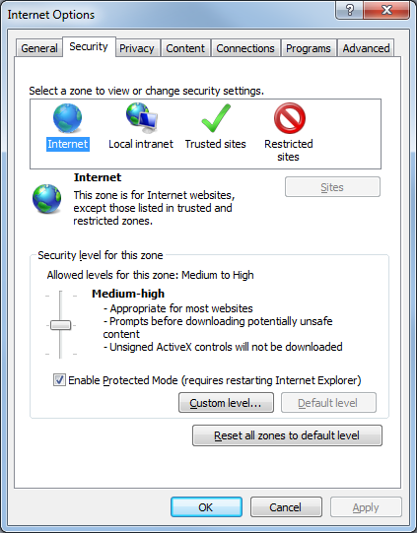
In IE, Shift+Ctrl+F

Pop-Up Blocker

In IE, Tools, Pop-up Blocker

Security Zones

Local Intranet

IP address in your subnet

Internet

All other addresses

Trusted & Restricted

Empty by default

Add sites of your choosing

Local Intranet Zone

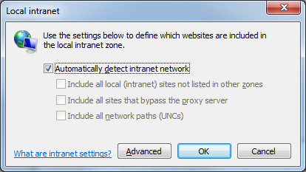
In Internet Options, on the Security tab, click "Local Intranet" and then click Sites

UNCs look like this:

\\server\resource

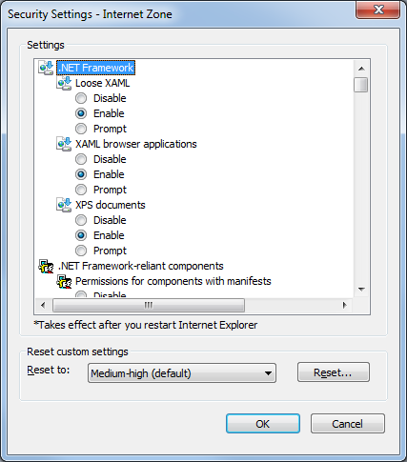

Custom Level

In Internet Options, on the Security tab, click a Zone and then click "Custom level…" button

Many, many settings available

Protected Mode

In Protected Mode, IE runs with low privileges, and cannot

Install software

Add shortcuts to the Startup folder

Change its own Home Page or Search settings

IE can only save data to Temporary Internet Files

If it wants to save data elsewhere, it must ask your permission

Phishing

Phishing is making a fake site that looks like a real one, such as paypal.com

Emails or IMs trick victims into logging in on the fake page

Sometimes you can identify the fake sites from the URL, links, source code, images, or the https:// in the URL

None of those are 100% trustworthy, not even https

SmartScreen Filter

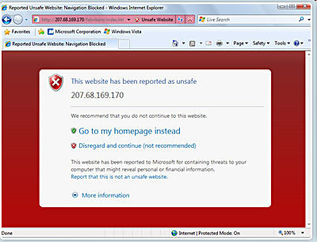
Analyzes a site to look for suspicious content

Checks a global database of known phishing sites

Flags suspicious sites with big red border

IE is the Safest Browser?

One study showed IE as much safer than other browsers

But Microsoft paid for it (link Ch 15c)

Managing Add-Ons

In IE, Tools, Manage Add-ons

Internet Explorer (No Add-ons)

Alternate shortcut to launch IE without add-ons

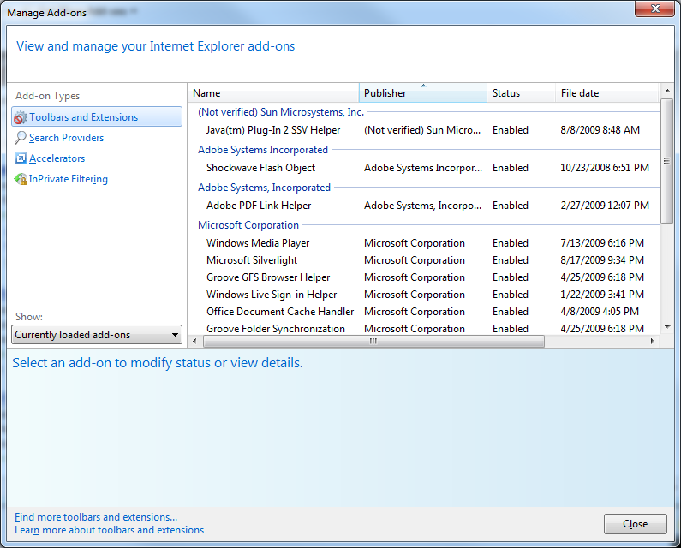
Useful when a computer is infected with malware

Advanced Security Options
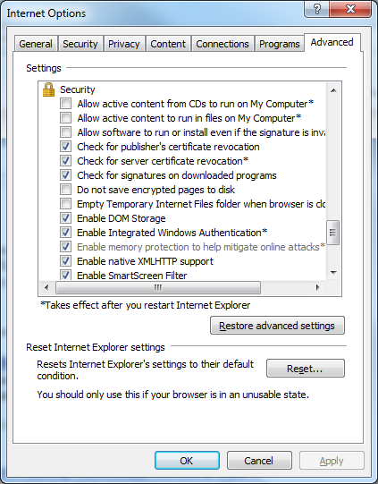

Ch 16: Implementing Email Security

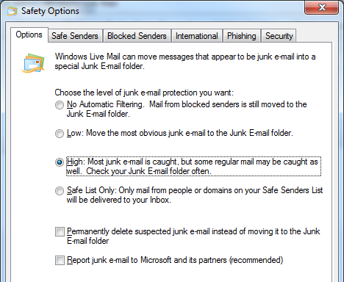
Windows Live Mail

Windows 7 does not include an email client by default

You need to add "Windows Live Essentials"

Email Virus Safety

Don't open unexpected attachments

Don't view junk mail with the Preview pane open

Use an antivirus program that scans email

Windows Mail Safety Options

Alt+M, Safety Options

Junk Mail Filtering

Safe & Blocked Senders

International settings

Phishing protection

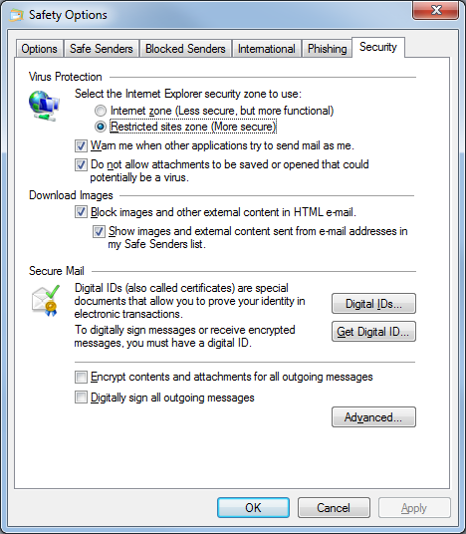
Restricted Sites

Prevents scripting

Do not allow attachments to be saved that could potentially be a virus

Blocks .exe and .mdb files and many others

To get past it, zip the files

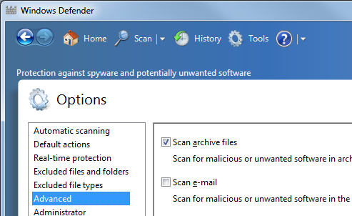

Setting Windows Defender to Scan Email

In Windows Defender, Tools, Options

Scan e-mail

Web Bugs

Images used to detect when you read the mail

The "Block Images" option protects you from this

Encrypted Email

For real safety, encrypt your email

But the people you send mail to must also use encrypted email

Last modified 10-9-09

