Ch 17: Securing the File System

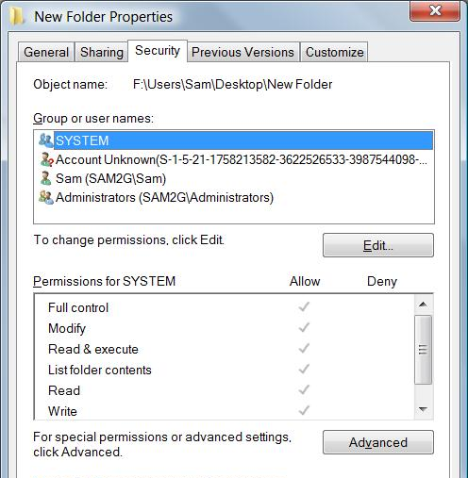
Three Ways to Protect Files

Controlling Access with NTFS Permissions

With NTFS permissions, you can:

Control access to any file or folder on any NTFS-formatted volume

Allow different types of access for different users or groups

Applying Advanced Security Settings

Right-click file or folder

Properties

Security tab

This is the Access Control List

Editing Permissions

Click Edit in an object's Properties to change permissions

Permissions
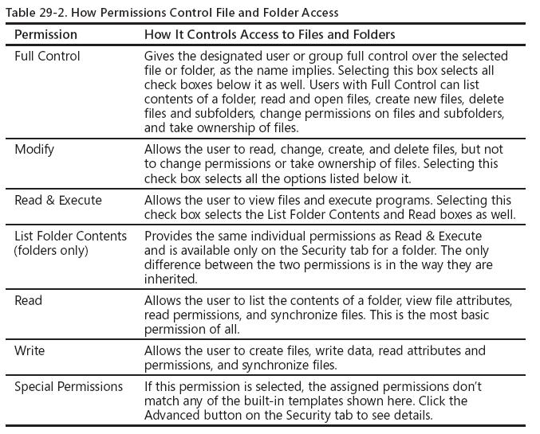

Be careful with the Deny box

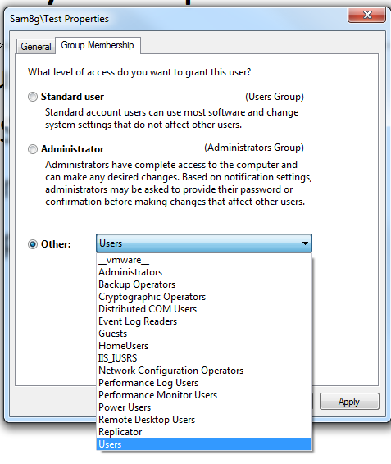
Deny permissions take precedence over Allow permissions

It's safer to just Allow, or nor Allow, permissions

There is an exception to this rule: an explicit Allow can take precedence over an inherited Deny

Security Groups

Logo+R to open Run box

CONTROL USERPASSWORDS2

Click a user, Properties

Group Membership tab

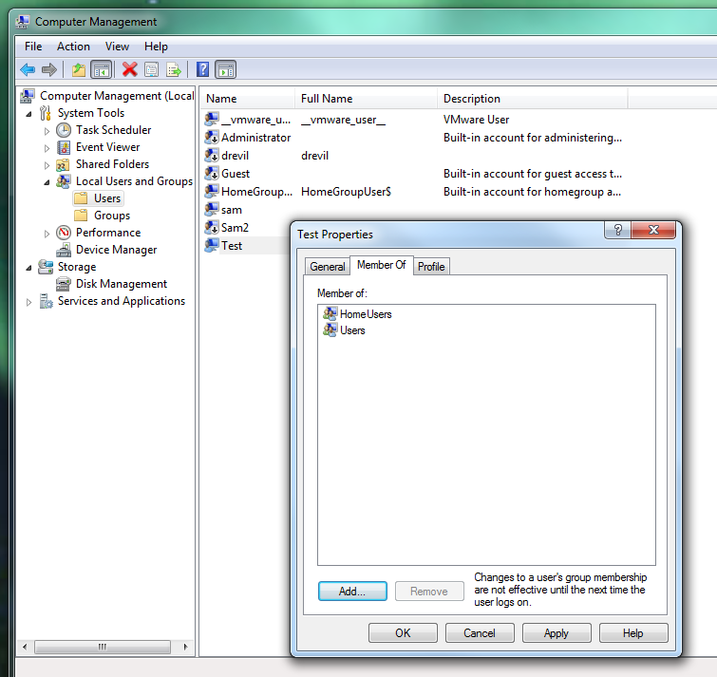

Assigning a User to Multiple Security Groups

Use the "Local Users and Groups" snap-in in Computer Management

Using Special Permissions

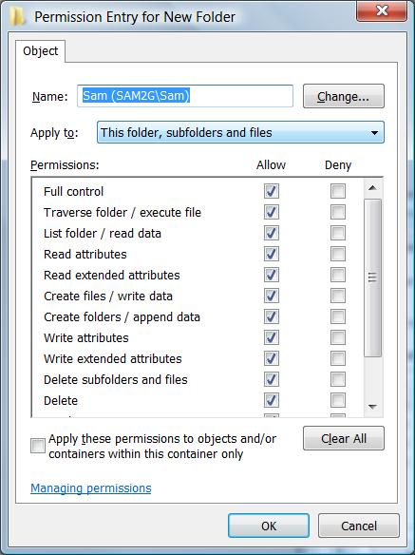
Click Advanced on the Security tab, click Edit, select a user or group name, click Edit

Special Permissions

Leave Special Permissions Alone

The basic permissions like Full Control, Modify, etc. are almost always complex enough for any purpose

Don't adjust the special permissions unless you really need to
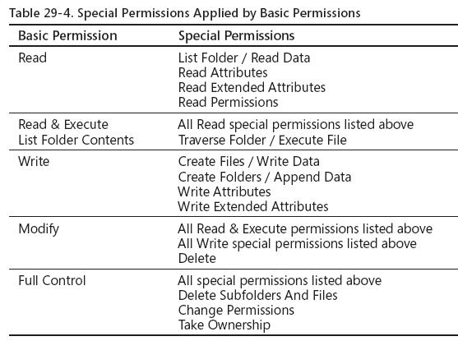

Ownership and Inheritance: Not in Textbook

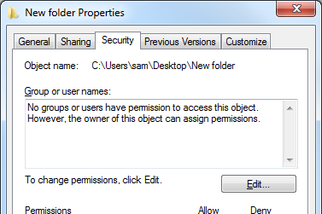
Discretionary Access Control

In Windows 7, the owner of a file or folder (typically the person who creates the file) has the right to allow or deny access to that resource

In addition, members of the Administrators group and other authorized users can grant or deny permissions

Demonstration of Ownership

Create a folder, so you are the owner

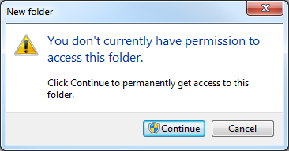
Click Advanced button, then Change Permissions, and clear "Include heritable permissions" check box

Remove all permissions

You cannot open the folder, but you can still change the permissions because you are the owner

Automated Permission and Ownership Changes

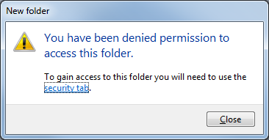
Windows 7 will automatically change permissions for you, if you are an Administrator

It will even guide you through the process of Taking Ownership

Applying Permissions to Subfolders Through Inheritance

Files and subfolders inherit permissions from a parent folder

Right-click the folder icon, Properties, Security tab, Advanced button

Applying Permissions to Subfolders Through Inheritance

To block inheritance

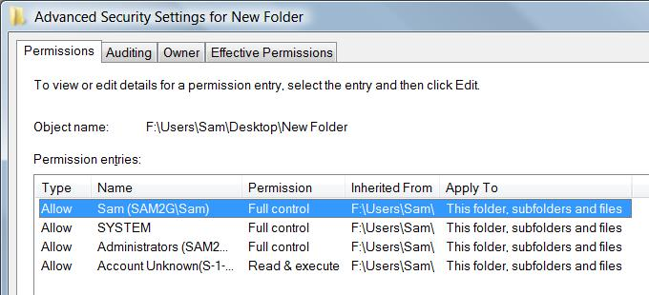
Click Edit

Uncheck "Include Inheritable Permissions From This Object’s Parent"

Choose Copy or Remove

Taking or Assigning Ownership of Files and Folders

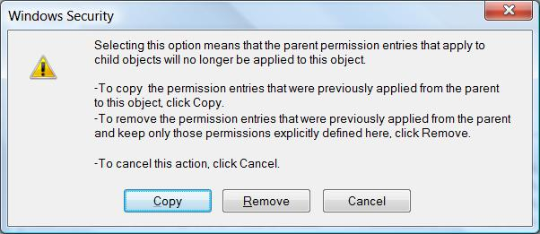
When you create a file or folder on an NTFS drive, you become its owner

Owner can allow or deny permissions

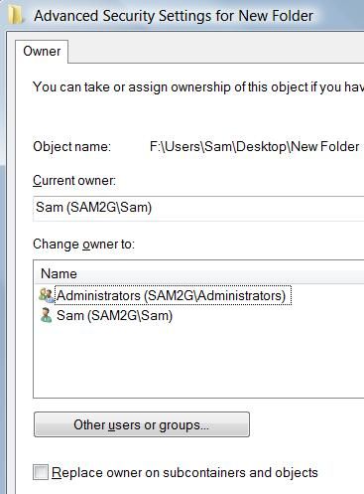
Any member of the Administrators group can take or give ownership of any file or folder

How to Take or Assign Ownership of Files and Folders

Right-click, Properties

Security tab, Advanced

Owner tab, Edit

Encrypting Files and Folders

Logon Passwords are Not Enough

If a computer is stolen, or booted from a CD, the data can be copied from the hard drive without using any logon password

NTFS permissions don't protect the data from this attack

Encryption is an essential defense, especially for laptops

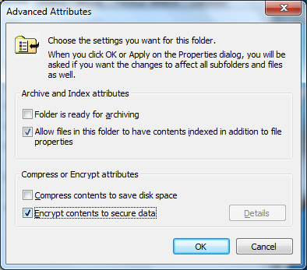
Encrypting File System

In file or folder Properties, click the Advanced button

This encryption is only available on NTFS volumes

Converting FAT32 to NTFS

You can convert a FAT32 volume to NTFS from an Administrator Command prompt

CONVERT d: /FS:NTFS

d: is the drive letter of the volume to convert

Data is preserved in the conversion process

There is no way to convert from NFTS to FAT, however

Except by erasing all data and reformatting the partition

Encryption Key

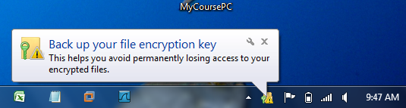
When you first encrypt a file or folder, Windows will create an encryption key

You will be prompted to back up the key

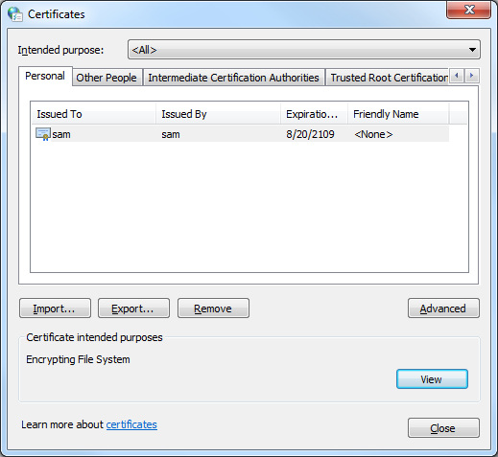
If you lose the key, your encrypted files will be unreadable

Exporting your Encryption Key

It is saved as a PFX file

Viewing Your Encryption Keys

In Internet Options, on the Content tab, click the Certificates button

Green Names

Encrypted files and folders show up in green font

Except on the Desktop

Best practice: encrypt whole folders, not files

For security, encrypt your whole profile folder:

C:\Users\Yourname

Because programs often make temporary copies of documents in other folders

Encrypting a Disk with BitLocker

Encrypting Folders is Not Enough

The operating system makes copies of your data

Page file

Hibernation file

It also has information that can compromise your EFS-encrypted files

Password hashes

LM Secrets

Stored Internet Explorer passwords

For real safety, encrypt the whole hard disk

Trusted Platform Module (TPM)

BitLocker encrypts the whole hard disk

It stores the encryption key in the TPM

If your computer doesn't have a TPM, you can store the key on a USB flash drive or floppy disk

But BitLocker is not available in Windows 7 Business Edition

You need Corporate or Ultimate Edition

BitLocker To Go Video

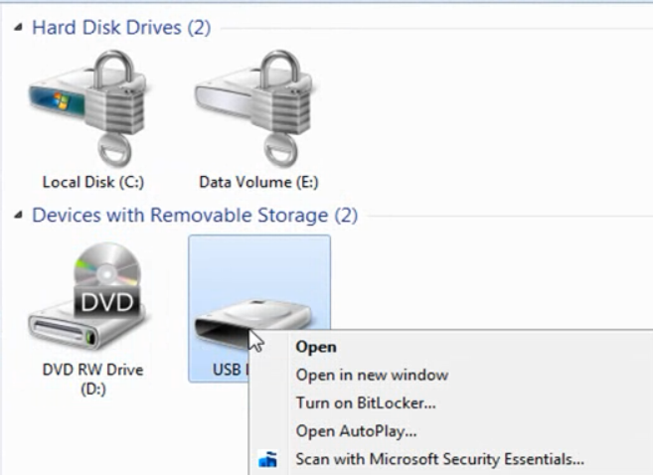
Link Ch 17a

Ch 18: Setting Up User Security

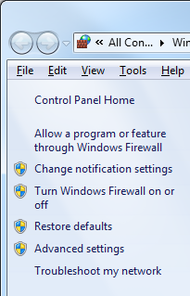
Protecting Users From Each Other on a Shared Machine

Create an account for each user

Remove unused accounts

Limit the number of administrators

Rename the Administrator account

Put all other accounts in the Users group

Use strong passwords on every account

Set screen saver to resume to the Welcome screen

Lock your computer

Use disk quotas

User Account Control (UAC)

Users in the Administrators group have two tokens

A low-privilege token that is used normally

A high-privilege token that is used only after elevation through the User Account Control process

Shield Icon

The shield icon indicates administrative acts that will require elevation

Elevation does not always require the user to click (unlike Vista)
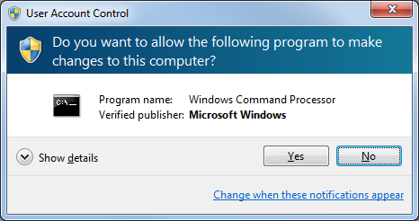

UAC Prompt

Secure Desktop

The whole desktop turns gray

Only the UAC prompt is active

This prevents "Clickjacking"--tricking the user into approving an elevation while showing other choices on the screen

File and Registry Virtualization

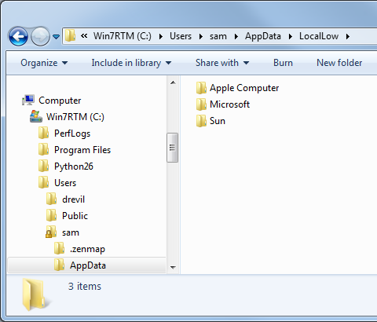
A Standard user can install software

But he or she cannot change the contents of %SystemRoot%, %ProgramFiles%, or the Registry

Virtual changes are made in the user's profile folder, and they only affect that user

IE's Protected Mode works the same way

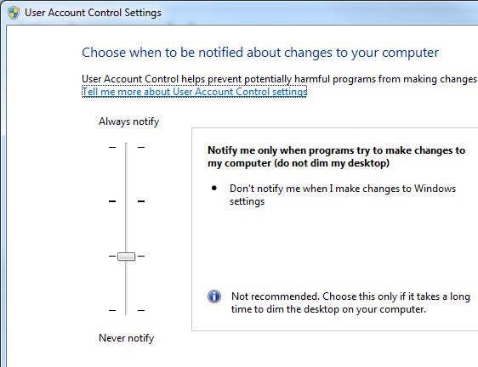

Configuring User Account Control

UAC Policies

Start, SECPOL.MSC

UIAccess- accessibility applications for disabled persons
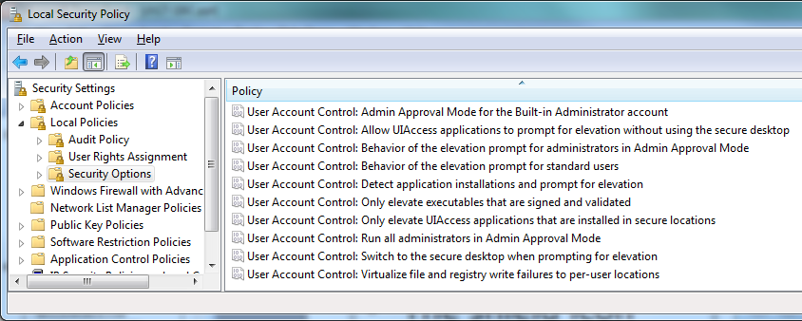

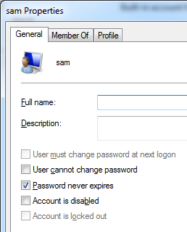

Account Password Options

In Computer Management, open Local Users and Groups, open Users, and double-click a user

Password Policies

Start, SECPOL.MSC

Security Settings, Account Policies, Password Policies

Double-click an item to see explanation
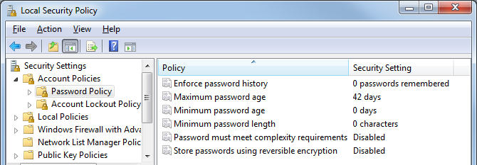

Recovering From a Forgotten Password

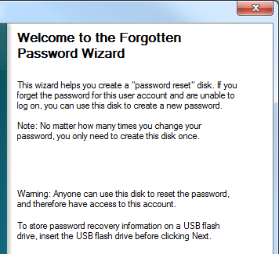
Password Hint (in User Accounts)

Password Reset Disk

In the real world: Ultimate Boot CD!

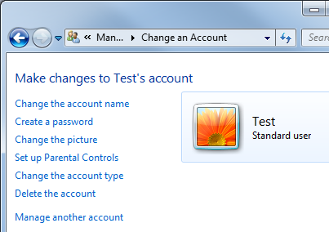

Managing User Accounts

Start, User, click "User Accounts"

Manage another account

Click the account name

Note: "Guest Mode" mentioned on page 385 in the book was removed from Windows 7 RTM

Account Policies

Here you can rename the Administrator Account
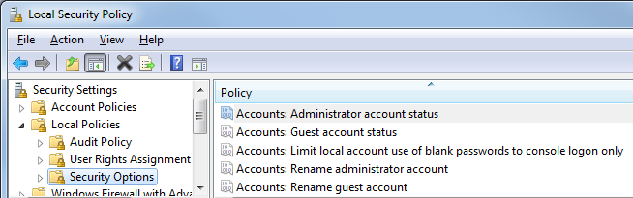

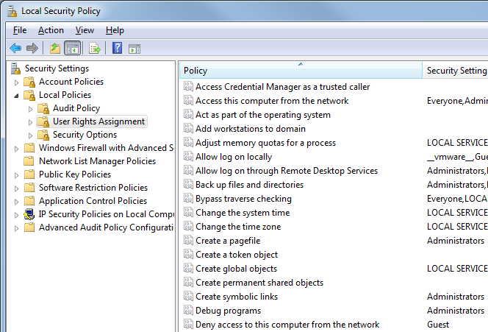
User Rights Assignment

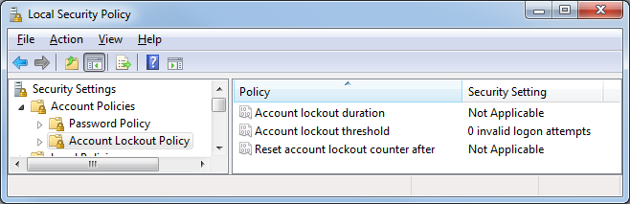
Account Lockout Policies

Managing Users and Groups from the Command Line

NET USER username password /ADD

NET USER username password /DELETE

There are options to set password expiration, home directory, etc.

NET LOCALGROUP groupname username /ADD

NET LOCALGROUP groupname username /DELETE

Parental Controls
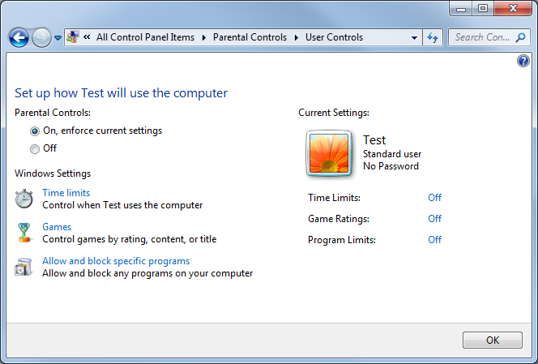

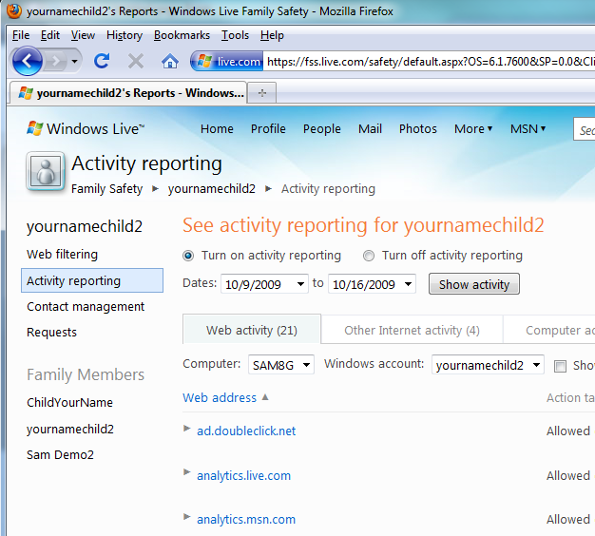

Family Safety

Part of Windows Live

Disk Quotas

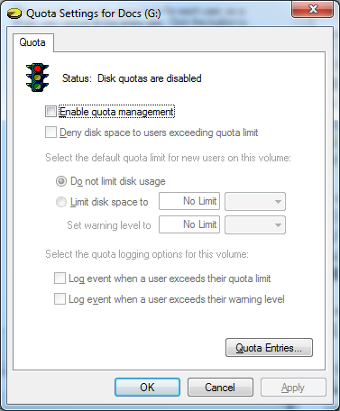
In a disk's Properties sheet, click the Quotas tab

Last modified 10-16-09

