Ch 19: Implementing Network Security

Network and Sharing Center

Network discovery

File and printer sharing

Public folder sharing

Media streaming

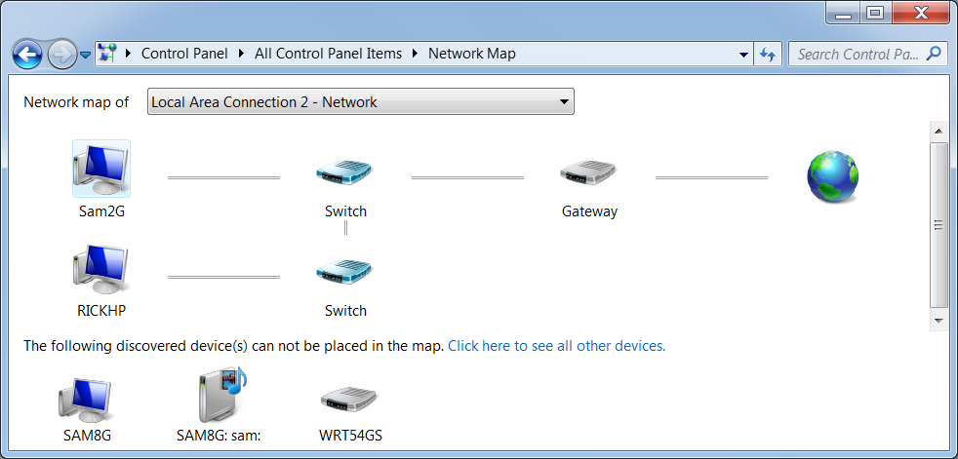
File sharing connections

Send authentication credentials with 128-bit encryption or older, less secure methods

Password protected sharing

HomeGroup connections

Network Discovery

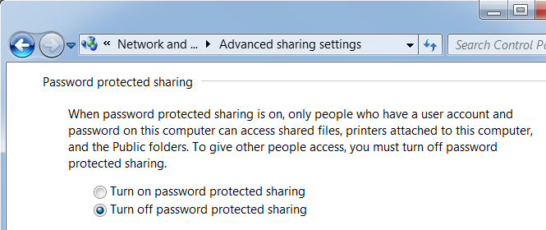
Used to draw the Network Map, in Network and Sharing Center

Password-Protected Sharing

This makes sharing very inconvenient

Each person who accesses a shared resource needs an account on the server

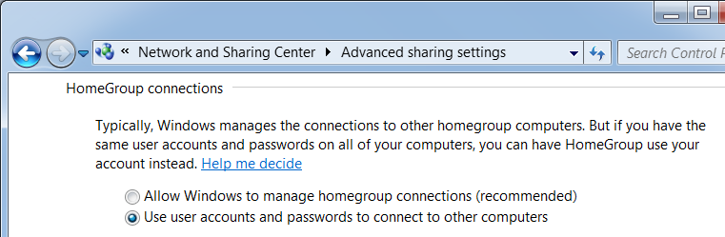

HomeGroup Connections

By default, Windows uses the HomeGroupUser$ account to

Sharing Wizard

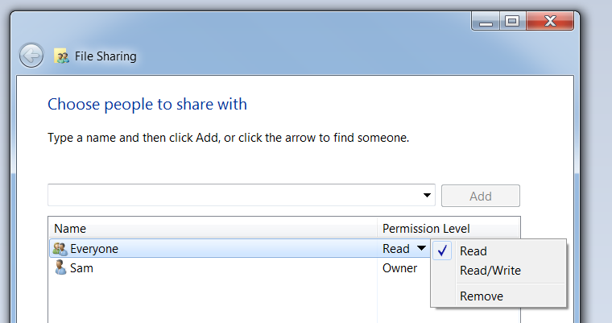
Right-click a folder, Share with…, Specific people

Simplifies sharing

Deactivating the Sharing Wizard

Uncheck it in Folder Options

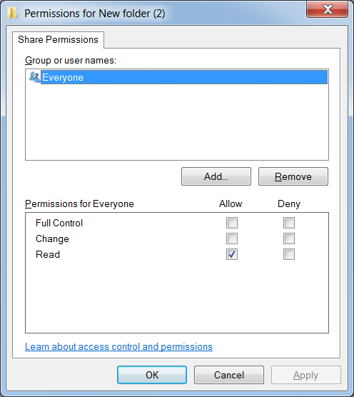
Advanced Sharing

In a folder’s properties, on the Sharing tab, click "Advanced sharing", check "Share this folder", click Properties

Error in book: this is possible with the Sharing Wizard activated

Sharing and NTFS Permissions Work Together

Share permissions are required to connect to a resource over the network

NTFS permissions apply to both local and remote users

NTFS permissions are a more powerful security barrier in most cases

Example

Share permissions on a folder

Sam has Full Control

Everyone has Read

NTFS Permissions

Sam has Read

Everyone has Full Control

Sam has Read whether he connects locally or remotely

Other users have Full Control locally, but Read remotely

Administrative Shares

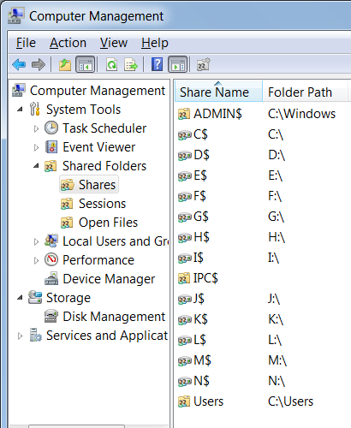
Windows shares the root of each drive

It also makes ADMIN$ for remote administration and IPC$ for inter-process communication

You can hack the Registry to remove the Administrative Shares, but some Windows features require them

Hidden Shares

The $ sign makes the Administrative Shares hidden--they won't appear in Windows Explorer on a remote machine

You can put a $ at the end of your own shared folders to hide them

This is not very secure--Linux can still see them

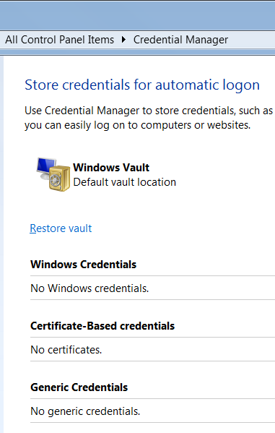

Credential Manager

Delete credentials you don't need

Restricting Logon Hours

From an Administrative Command Prompt

net user username /time:M-F,8am-5pm

For more, see link Ch 19a

Forcing Logoff when Logon Hours Expore

In Local Security Policies (Start, SECPOL.MSC)

Network security: Force logoff when logon hours expire
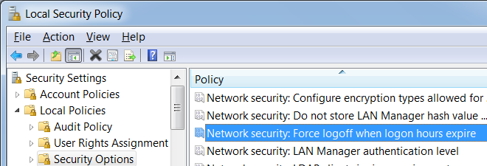

Ch 20: Wireless Network Security

Configuring Wireless Routers

Sat. Nov 7, Noon

This semester's wardrive (20 pts extra credit)

Meet in S214

Bring whatever you have

Cars

Laptops

Antennas

Nothing at all

We'll drive around for an hour, then meet for lunch and compile the data

Netgear WGR614 (v7)

Popular, low-cost access point

Four switch ports, routing capabilities

Supports 802.11b, 802.11g transmission

Configuration steps on other small wireless connectivity devices

Differ somewhat

Follow similar process, modify same variables

Router Passwords

If you don't have the password

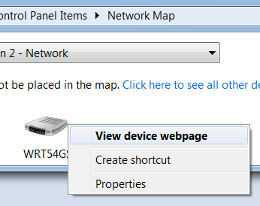
Hold down the reset switch for 10 seconds to restore router to factory defaults

Sometimes you need to power cycle the router with the button down

Find the default password online

routerpasswords.com

Don't trust home router security much

"Router Hacking Contest" at link Ch 20b

Opening a Router's Configuration Page from the Network Map

Right-click device

View Device Webpage

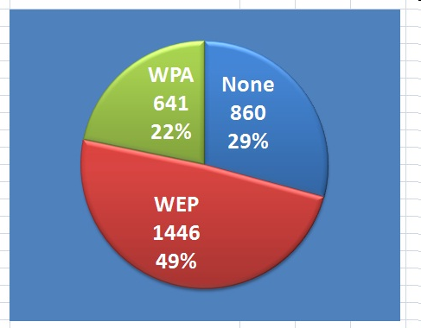
But it couldn't find my AT&T device at 192.168.1.254

Wireless Encryption

We wardrive San Francisco every semester

Most wireless networks are insecure

WPA v. WEP

Open networks let anyone connect

WEP is the older encryption technique, easily broken in a few minutes with the right network card

WPA is much safer. Just don't use a dictionary word as the passphrase.

WPA-2 is even safer than WPA

MAC Address Filtering

Used on the CCSF Wi-Fi network

www.ccsf.edu/wifi

This is a very weak security measure

Easily defeated, because MAC addresses are not concealed at all

Use Cain to read all the MAC addresses on the network now

Adjust network card properties to impersonate anyone you like

This is, of course, dishonest and possibly illegal

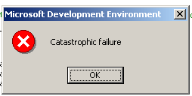
Ch 21: Troubleshooting and Recovering from Problems

Error Messages

Google the exact text of the message you got

Sometimes they aren't very helpful

Links Ch 21a, 21b

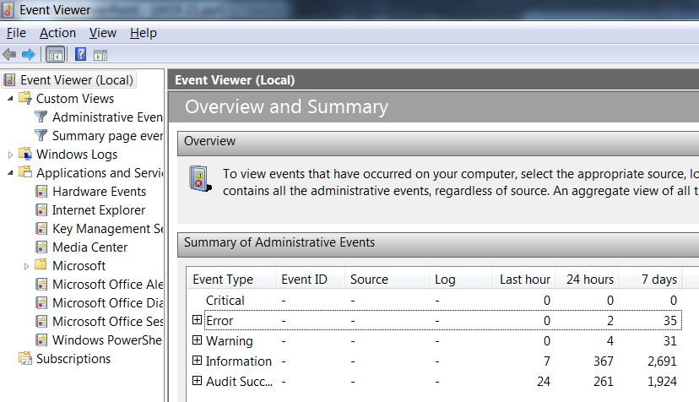
Event Viewer
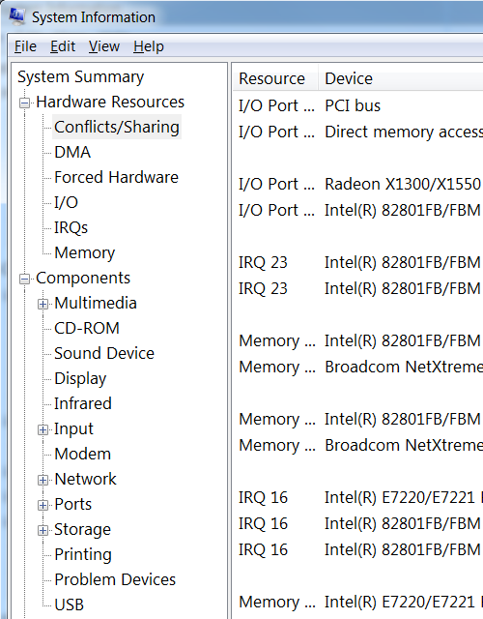

System Information

Start, MSINFO32

Useful items

Conflicts/Sharing

Problem Devices

Automatic Restart

Blue screen errors don't last long by default, because Windows automatically restarts

To adjust that

Start

Systempropertiesadvanced

In "Startup and Redovery" section, click Settings

Debugging Information

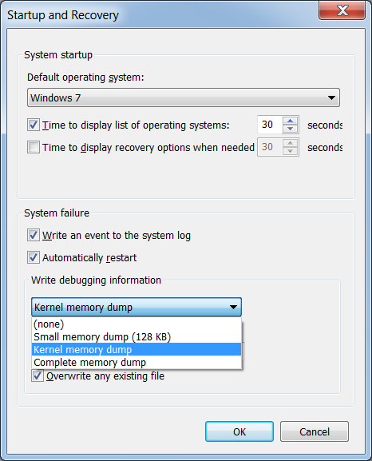
Small memory dump

Includes the stop error and its description, running device drivers, and the processor state

Kernel memory dump

Only the Kernel (1/3 the size of RAM)

Complete memory dump

All of the RAM (2 GB on my machine)

Repairing Applications

In Programs and Features

You can repair or uninstall/reinstall

Recent Changes to Investigate

Did you recently

Edit the registry

Change Windows settings

Change application settings

Install a new program

Install a new device

Install an unsigned driver

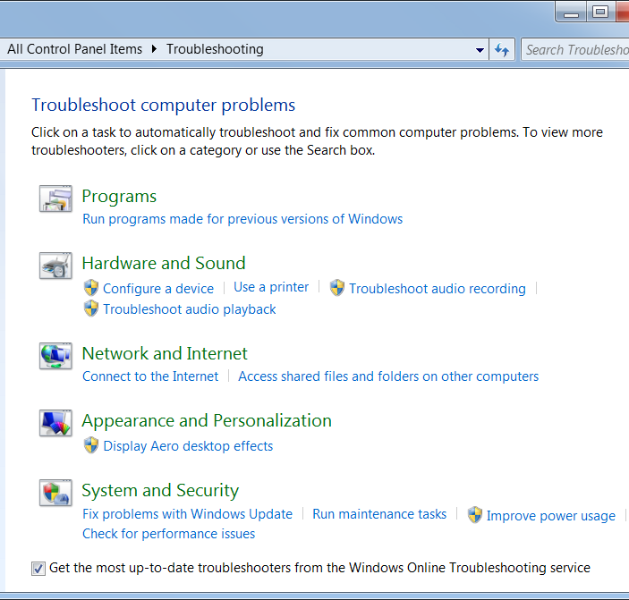
Apply a Windows update

These can all cause problems

Troubleshooters

Disk Diagnostics

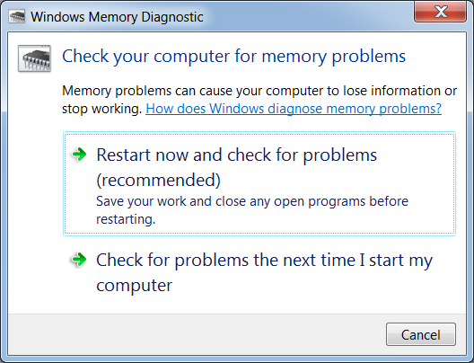
Self-Monitoring, Analysis, and Reporting Technology (SMART)

Measures the health of a hard disk

Spin-up time

Drive temperature

Error rates, etc.

Windows 7 will automatically alert you if it detects a problem

Memory Diagnostic

Problem Reporting in Action Center

Windows checks for a solution to any problem

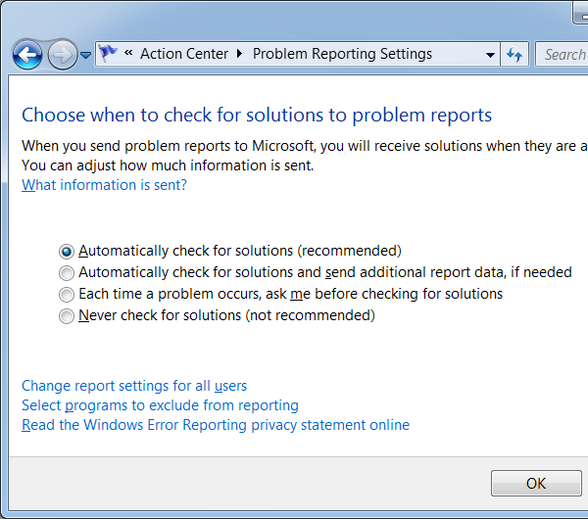
Asks for permission to send information back to Microsoft

Online Resources

Microsoft Product Support

support.microsoft.com (link Ch 21d)

General help

Microsoft Knowledge Base

Specific, detailed, problem solutions (link Ch 21e)

Technet

Technet.microsoft.com

For IT Professionals (link Ch 21f)

Online Resources

Windows Update

Microsoft Security

microsoft.com/security (link Ch 21g)

Vendor websites

Windows 7 Newsgroups

Recovering from a Problem

Last Known Good Configuration

Press F8 during startup

Only helps with driver problems, a weak solution

System Restore

Very powerful and easy

Can be undone

Often the best option
Last modified 10-23-09

