Ch 22 Troubleshooting Devices

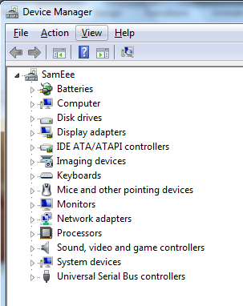
Device Manager

Your first stop to solve device problems

Other Views

Device by Connection

Shows what bus devices are connected to

Resources by Type

DMA, IO, IRQ, and Memory

Resources by Connection

Show Hidden Devices
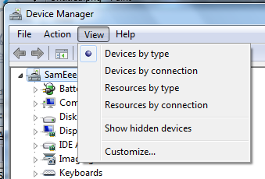
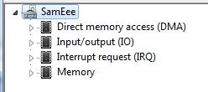

Device Properties

General tab

Shows if the device is working properly

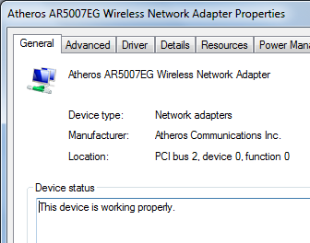
Driver tab

Update or roll back driver

Resource

Memory, IRQ, etc.

Show Hidden Devices

Shows

Non-Plug and Play devices

IPv6 virtual network adapters

Nonpresent devices

Devices that were installed, but not attached now

Also called "ghosted"

Showing Ghosted Devices

In a Command Prompt window

set devmgr_show_nonpresent_devices=1

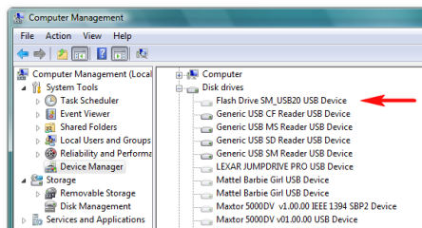
devmgmt.msc

Ghosted devices appear with faded icons

See link Ch 22a

Windows Update and Drivers

Start, systempropertieshardware, Enter

Click Device Installation Settings

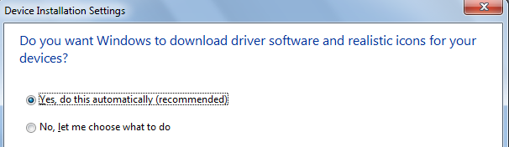
If you don't let Windows install drivers automatically, you will have to get drivers from the manufacturers yourself

Note: the 3rd option shown on page 465 has vanished

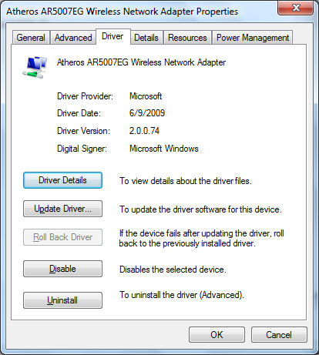
Updating and Rolling Back Drivers

Windows caches the last used driver

Rolling back a driver is less drastic than using System Restore

Unsigned Device Drivers

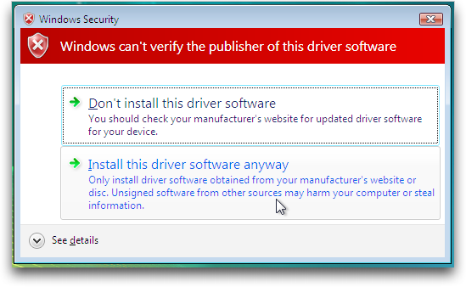
Windows 7 will complain if a driver is not signed

Without a signature, Windows cannot be sure the driver is intact—it may have been altered

There is no way to know who made the driver

Windows Logo Program

The best way to ensure that a driver will work


Drivers are thoroughly tested by Windows Hardware Quality Labs (WHQL)

Links Ch 22c, d

Signing Drivers

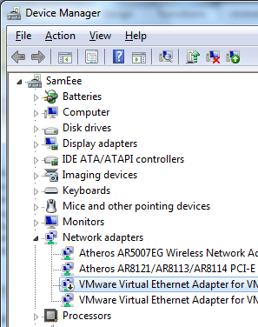
A driver can also be signed using a digital certificate purchased from a Certificate Authority

Or even self-signed for testing purposes

Link Ch 22d

Configuring Windows to Ignore Unsigned Drivers

Windows 7 64-bit requires signed drivers

See link Ch 22d

There is a Group Policy setting to ignore unsigned drivers, but it only works in Win Server 2003 and earlier versions (see link Ch 22e)

There is another command-line trick to disable driver signature enforcement in Windows 7

See link Ch 22f

Icons in Device Manager

Icons will display an error symbol in Device Manager if a device is misconfigured or disabled

Troubleshooting Device Driver Problems

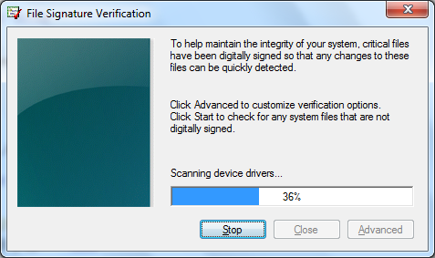
Reinstall the driver

Upgrade to a signed driver

Disable a device

Use the Signature Verification tool (sigverif)

Get driver from manufacturer

Use Windows Update

Roll back a driver

Ch 23 Troubleshooting Startup

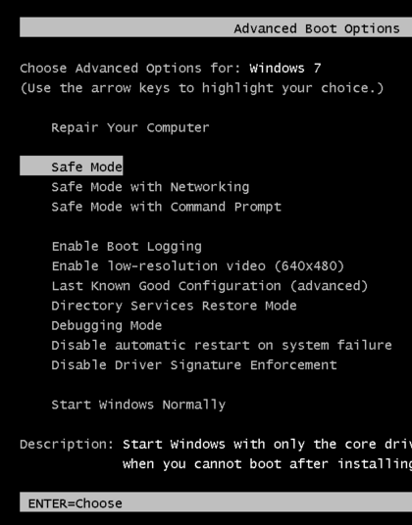
Simple Fixes

Power off and power on again

Check BIOS settings

Disconnect unnecessary devices

Check power light--it could be the power supply

Advanced Boot Options Press F8 during boot

If Windows 7 Won't Start in Safe Mode

Virus infection

Run antivirus software

Incorrect BIOS settings, or dead CMOS battery

Hardware conflict

Only with legacy devices

SCSI device causes SCSI BIOS initialization to halt

Remove devices from the SCSI chain

System Recovery Options

Press F8 during system startup, and select "Repair Your Computer" -- No DVD needed!

Link Ch 23a

Startup Repair automatically fixes many startup problems

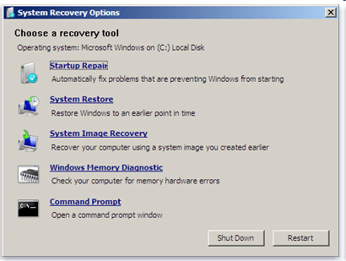
System Restore same as usual

System Recovery Options

System Image Recovery

Uses a system image backup file (if you have one) to completely restore the system

Windows Memory Diagnostic

Tests RAM

Command Prompt

You are "SYSTEM"--more powerful than the administrator

Try echo %username%

If you Cannot Boot from the Hard Drive

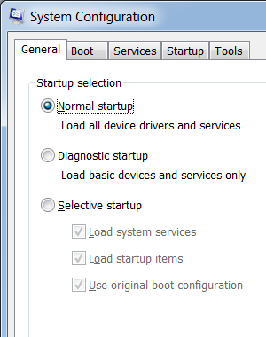
Boot from the Windows 7 installation DVD

Choose "Repair Your Computer"

System Recovery Options runs (no need to log in)

Troubleshooting Startup with the System Configuration Utility

Start, MSCONFIG, General tab

Normal Startup

Diagnostic Startup

Same as clearing all three Selective Startup boxes and doing a Selective Startup

Load system services

See Services tab

Load startup items

See Startup tab

Use original boot configuration

Used to test a problem after you have isolated and possibly solved it
Ch 24 Troubleshooting Networking

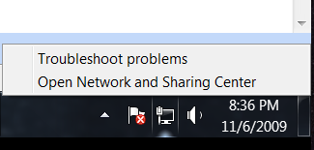
Repairing a Network Connection

Right-click Network icon in the Notification Area, Troubleshoot Problems

Network Diagnostics Framework opens

Tries a series of troubleshooters

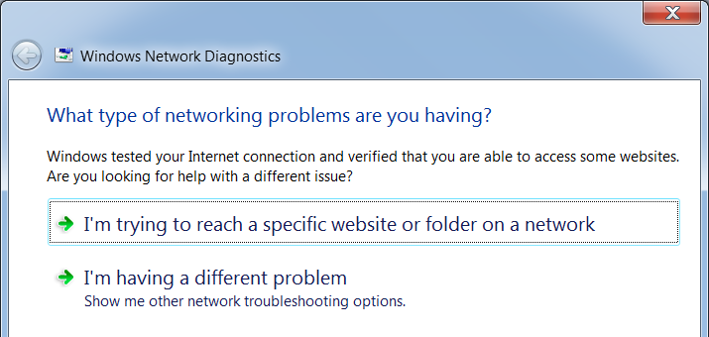

Connection Icons

Wired with Internet Access



Connected, with an error

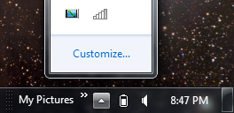
Wireless connection with Internet access

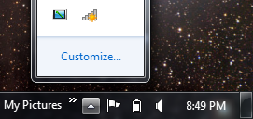

Wireless network, not connected

General Solutions to Network Problems

Enable network discovery

Close all programs, Log off, restart, or power cycle computer

Power cycle router and modem

Check physical connections, power switches, etc.

Use Action Center

Use Last Known Good Configuration or System Restore

Reset router to factory default settings

Upgrade router's firmware
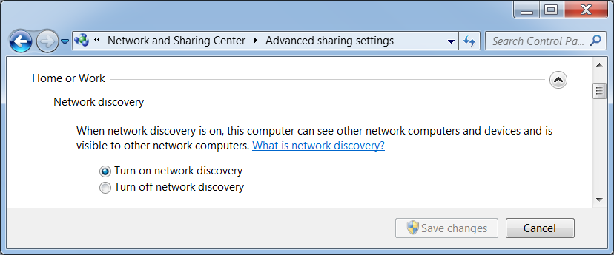

Turning on Network Discovery

In Network and Sharing Center, click Advanced sharing settings

Upgrading Router Firmware
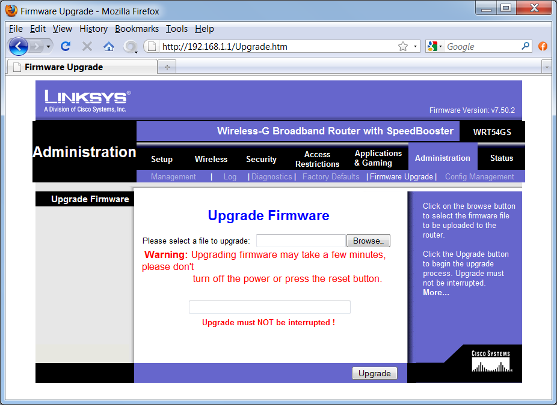

Troubleshooting from the Command Line--Favorites

IPCONFIG | MORE

Shows TCP/IP settings

IPCONFIG /RELEASE and then IPCONFIG /RENEW

Gets a new address from DHCP

PING

Tests connection to a specified server

NSLOOKUP

Test DNS resolution

NETSTAT

Current network connections

Troubleshooting from the Command Line--Less Common Tools

ARP -A

Shows the current Address Resolution Protocol cache, linking IP addresses to MAC addresses

ARP -D

Clears the cache

NBTSTAT -R

Clears the NetBIOS cache (used for file and printer sharing in older Windows versions)

IPCONFIG /FLUSHDNS

Clears the DNS cache

TRACERT

Shows all the routers used to reach a remote host

ROUTE PRINT

Shows the routing table

Troubleshooting Cables

Damaged cables or connectors

Tight bends or crimps can degrade signal

Electromagnetic interference from fluorescent lights, motors, etc.

Troubleshooting the NIC

Look in Device Manager--make sure NIC is correctly recognized

Update or reinstall the NIC driver

Open case and re-seat the NIC

Disable the motherboard NIC

Replace the NIC

Troubleshoot Wireless Network Problems

Use the Windows 7 Network Diagnostics

Reboot and power cycle the access point

Check connections--power, network cable, antenna

Move the antenna for better line-of-sight

Check your computer's WLAN switch--it may be turned off (airplane mode)

Check for radio interference from other devices-- move interfering devices

Troubleshoot Wireless Network Problems

Change the channel

Shorten the range--move the access point closer, or boost access point power

Add another access point closer, bridged with power line networking

Check compatibility

802.11a,b,g,n

Reset the router to factory defaults

Last modified 11-6-09

