Warning

I have added quite a bit to these notes that is not in the chapter

Study the notes for the quiz in addition to the chapter
Setting Up a Peer-to-Peer Network (Workgroup)

Network Basics

Network Interface Card (NIC)

Router or switch

DHCP server (usually the router)

Ethernet cables

WAN connection to Internet

Computer name

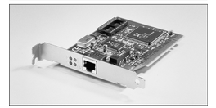
Workgroup name (unimportant in Windows 7)

Workgroup

This chapter is discussing a workgroup, not a domain

Recommended for 10 or fewer computers

No domain controller required

Capabilities of a Small Network

Shared storage

Shared printers

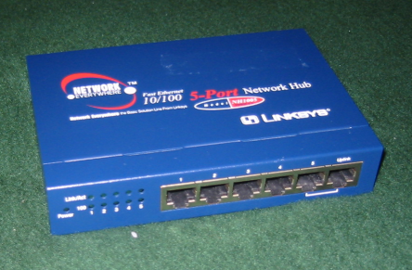
Shared internet connection

Network adapters

Each computer needs an adapter (also called a network interface card, or NIC)

Network adapters can be internal (usually installed in a PCI slot) or external (typically connected to a USB port)

Ethernet is the most popular by far

Pic from Network+ Guide to Networks, Second Edition by Tamara Dean

Hubs

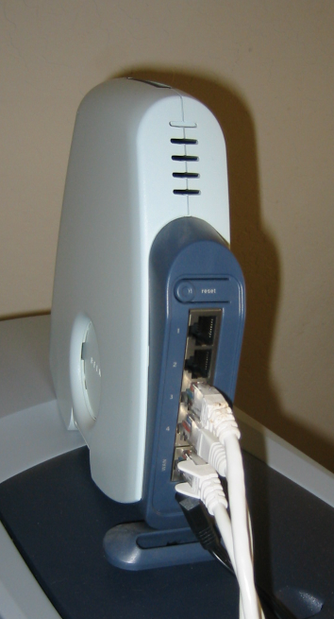
A hub or switch can be used to connect the computers in an Ethernet network

To connect two computers, you can use a crossover cable and no hub

Router

You can also use a router or residential gateway, which typically adds network address translation (NAT) capabilities and security features

Wireless Network Access Point

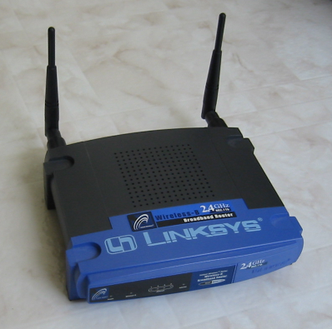
On wireless networks, a wireless access point handles these duties

Cables

On an Ethernet network, eight-wire Category 5 patch cable with RJ-45 connectors on each end

Installing and Configuring Network Adapters

Happens automatically for Plug and Play adapters

Ethernet, Wireless, or Phone Line?

Three popular technologies

Ethernet/Fast Ethernet/Gigabit Ethernet

10, 100 or 1000 Megabits per second

Wireless

IEEE 802.11b, also known as Wi-Fi -- 11 megabits per second

IEEE 802.11g or 802.1a -- 54 Mbps

IEEE 802.11n (draft) – 300 Mbps claimed

Ethernet, Wireless, or Phone Line?

Phone Line

Uses normal phone lines, no hub or router

Home Phoneline Networking Alliance (HomePNA) -- 10 megabits per second

HomePNA 3 claims 128 megabits per second

Making Connections: Cables and Hubs

Place the hub in a central location

The segment length (distance between furthest points) should not exceed 100 meters (328.1 feet)

All the ports are the same on a hub, except the uplink port

Uplink ports are used to expand a network’s capacity by connecting two hubs

The uplink port achieves the same purpose as a crossover cable

In addition to (or in place of) a hub, your network may use a router, switch, or residential gateway

Often used to share a fast Internet connection

If you plan to use Internet Connection Sharing and you have an external DSL or cable modem, you’ll need to install two network adapters in the computer with the shared Internet connection

Typical Network

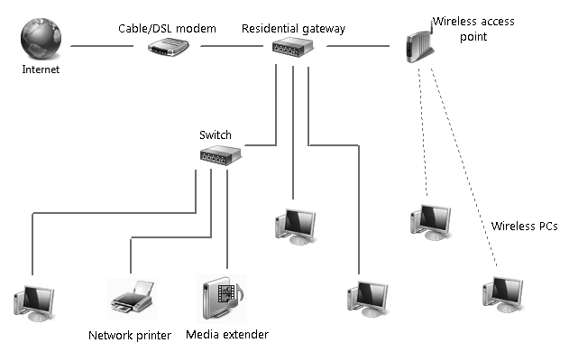
The gateway often includes the switch and the wireless access point

Computer Name and Workgroup

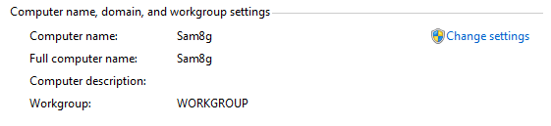
Start, right-click Computer, Properties

Understanding Security for Wireless Networks

Risks:

Theft of service

Denial of service

Overwhelming your connection with traffic

Privacy violations

Listening to traffic through your connection

Theft or destruction of data

Entering shared folders

Network takeover

Installing a Trojan to allow remote control of your systems

Wireless Security Options

Wired Equivalent Privacy (WEP)

Old and broken, has mathematical flaws

Hackers can break into a WEP network easily

Wi-Fi Protected Access (WPA)

Much safer than WEP

Uses a pre-shared key from 8 to 63 bytes long

Wi-Fi Protected Access 2 (WPA2)

Strongest protection

Open Wi-Fi Network

If you just buy Wi-Fi devices and turn them on, you get an "open" network

Completely insecure

Anyone nearby can use it

Convenient, but risky

Security at the Wi-Fi Access Point

Change the administrator password to a non-default value

Use a non-default network name (SSID)

Disable remote administration

Upgrade the firmware

Restrict access to computers with known MAC addresses

Use virtual private networks for wireless connections

RADIUS

On larger networks with one or more domain servers available

Set up a Remote Authentication Dial-In User Service (RADIUS) server

This allows the most secure option of all: 802 1x authentication

In addition, consider enabling Internet Protocol Security (IPsec)

Connecting to a Hidden Network

Some wireless networks don’t broadcast their SSID

This does not make your network more secure, because the SSID is still sent in the data packets and hackers can easily capture it

You can still connect, by entering the SSID manually (see pages 468-469 in the textbook)

Sharing an Internet Connection

To share an Internet connection safely on a small network, you have two options:

Install a router or residential gateway

The simplest and most secure method

Use Internet Connection Sharing (ICS)

Uses a Windows computer as a router

Rarely done these days, nearly obsolete

Virtual Router

New feature in Windows 7

Requires Windows 7-Certified Driver for your wireless NIC

Link Ch 25a
Working with Windows 7's Basic Network Tools

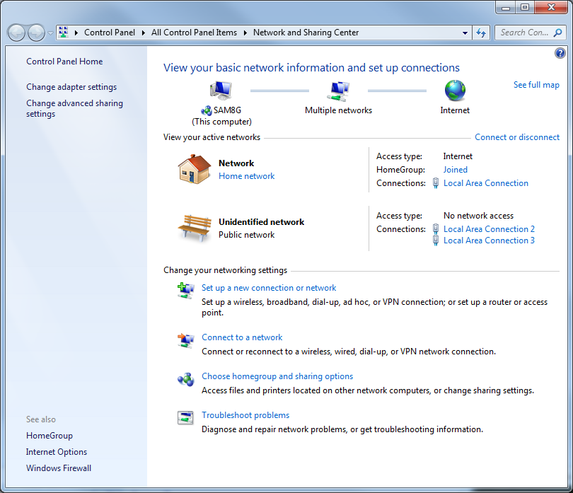
Network and Sharing Center

Map (at top)

View your active networks

Change your networking settings

Tasks (on left)

HomeGroup
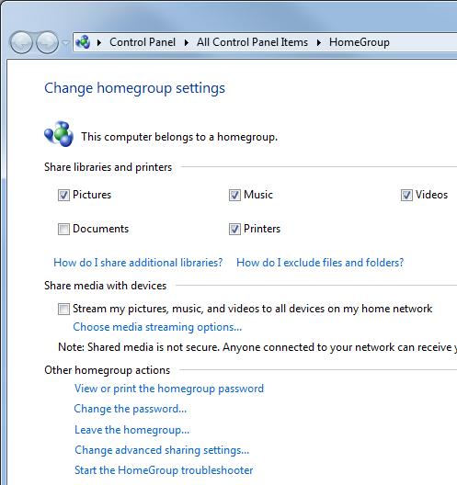
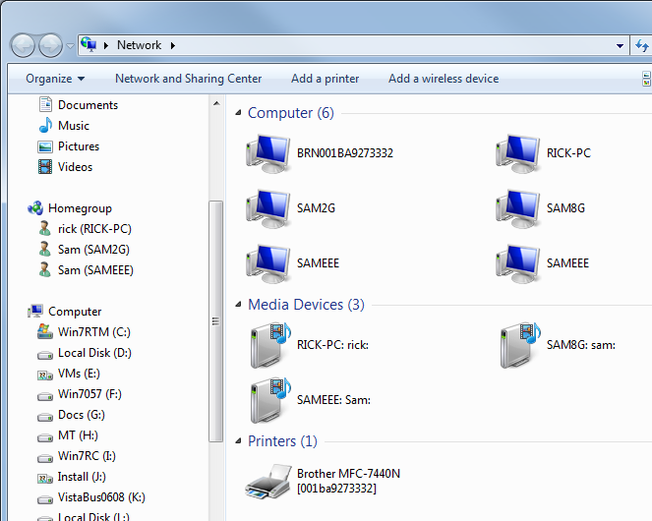

Viewing Network Computers and Devices

Start, Network

Details View

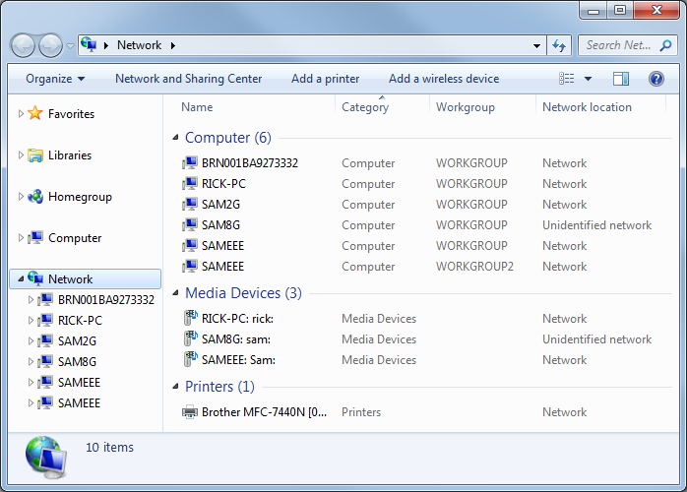
Media Devices include Windows 7 computers sharing media

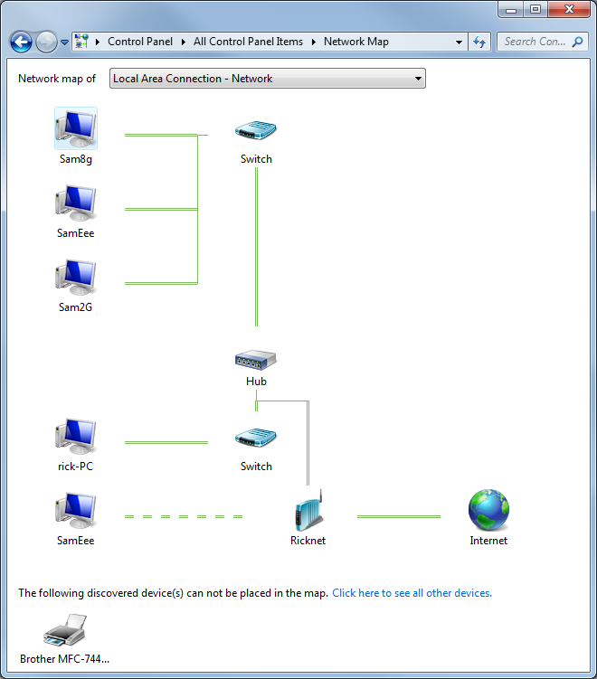
Network Map

Uses "Link Layer Topology Discovery" protocol

Viewing Network Status

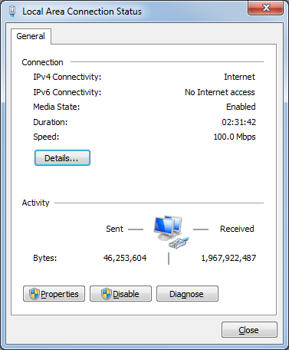
In "Network and Sharing Center", in the "View your active networks" section, click a link on the right side (usually named "Local Area Connection" )

Viewing Network Status Details

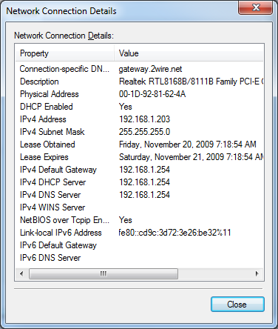
Click "Details" button

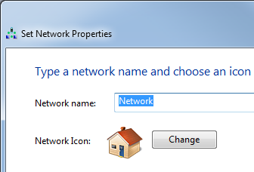

Customizing Your Network

In "Network and Sharing Center", in the "View your active networks" section:

Click icon to change network name or icon

Click blue "Home Network" or "Work Network" to change network location

Managing Network Connections

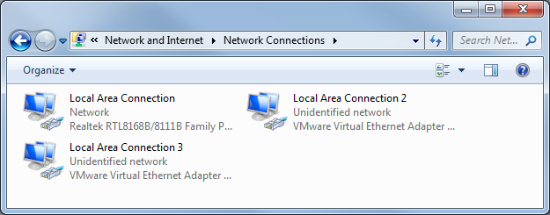
In "Network and Sharing Center", click "Change Adapter Settings"

Network Connection Properties

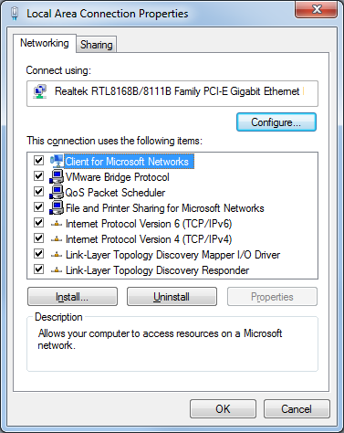
Right-click a connection, Properties

Notice IPv6 and LLTD

LLTD Mapper draws the map

LLTP Responder sends data to the mapper

You can disable these items by clearing the check mark

IP Settings (at bottom right of this page)

In "Local Area Connection Properties", double-click "Internet Protocol Version 4 (TCP/IPv4)"

Network Connection Components

Client For Microsoft Networks

Allows you to connect to Windows computers

QoS Packet Scheduler

Quality Of Service – will be important when we switch to Internet Protocol version 6 (IPv6)

File And Printer Sharing For Microsoft Networks

Allows your computer to be a file or print server

Internet Protocol Version 6 (TCP/IPv6)

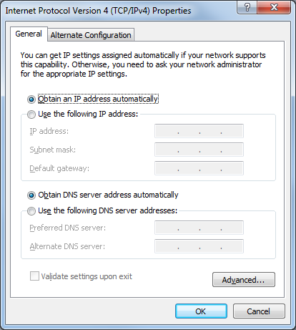
The new Internet protocol, not widely used in the USA yet

Internet Protocol Version 4 (TCP/IPv4)

The primary Internet protocol in current use

Link-Layer Topology Discovery Mapper I/O Driver

Used to create the network map

Link-Layer Topology Discovery Responder

Also used to create the network map

IP Addresses

On a TCP/IPv4 network, every computer has a unique IP address

Four 8-bit numbers

(In decimal format, a number between 0 and 255)

Separated by periods

Example: 147.144.1.2

TCP/IP configuration has three additional settings:

Subnet Mask

Default Gateway

DNS Server

Subnet Mask, Default Gateway, DNS Server

Subnet mask

Tells the network how to distinguish between IP addresses that are part of the same network and those that belong to other networks.

Default Gateway

A computer that can send packets outside the local network

Domain Name System (DNS) Servers

Computers that translate domain names (such as www.microsoft.com) into IP addresses

Methods For Assigning IP Addresses

Dynamic Host Configuration Protocol (DHCP)

The most common method

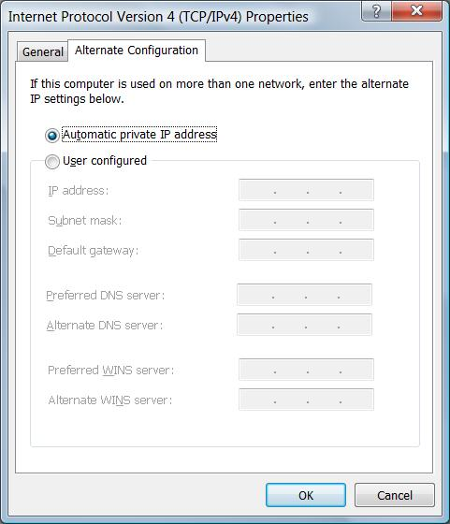
IP configuration is set automatically by the server

Automatic Private IP Addressing (APIPA)

If DHCP fails, the machines make up their own addresses starting with 169.254.

Static IP Addressing

Administrator must manually type in the IP address for each machine

Servers typically use static IP addresses

Requires more administrative effort and not commonly used for workstations anymore

Alternate IP Configuration

You set the address used if DHCP fails

Useful for a laptop that travels between two different LANs

Start, Network

Click "Network and Sharing Center"

Click "Manage Network Connections"

Right-click a connection, Properties

Click "Internet Protocol Version 4 (TCP/IPv4)", Properties

Sleep Mode

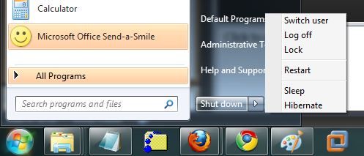
A sleeping computer uses very little power, just enough to maintain data in RAM

But to wake it, you normally need to use the keyboard, mouse, or power button

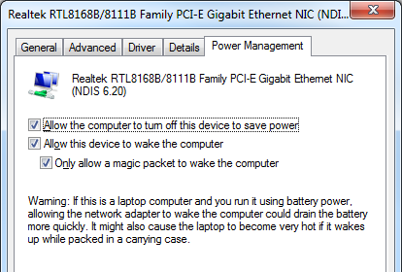

Using a Network Connection to Wake a Sleeping Computer

In "Network Connection Properties", click Configure

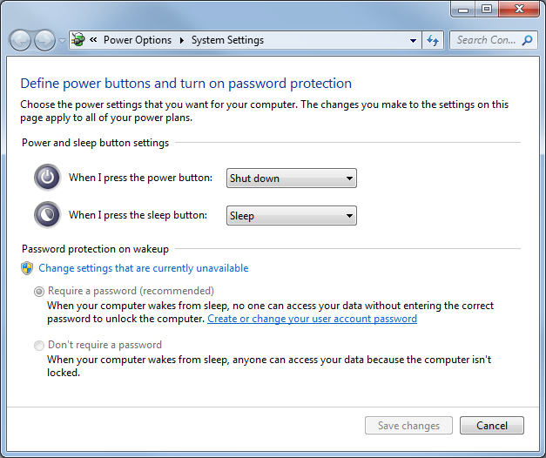

Disabling Password Requirement on Wakeup

Start, type in WAKE, click "Require a password when the computer wakes"

Convenient but insecure

Generating the Magic Packet

Link Ch 25b

Managing Wireless Network Connections

From "Network and Sharing Center", click "Manage Wireless Networks".

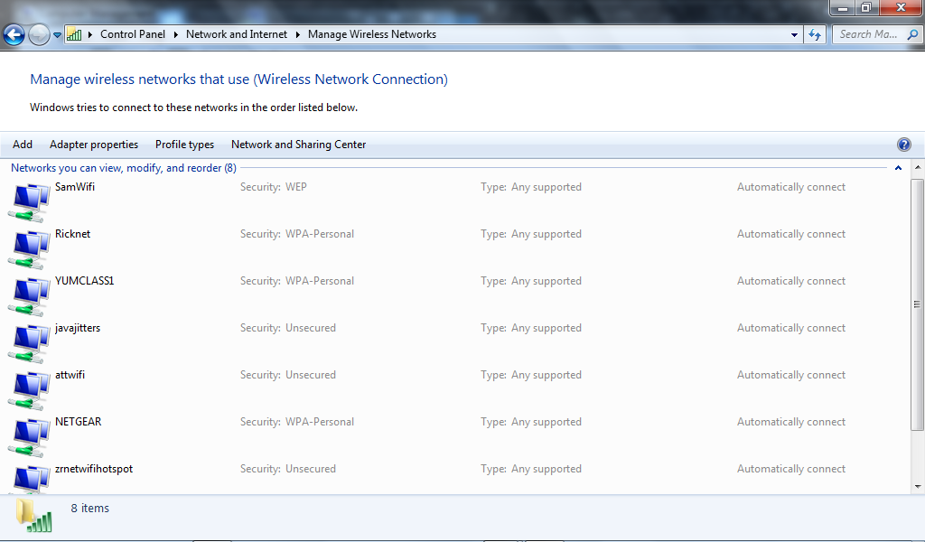

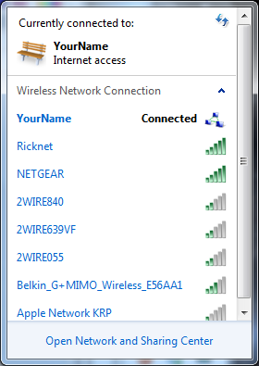
Sharing an Internet Connection with an Ad Hoc Wireless Network

Connects computers to one another through the wireless NICs without a router

This is easy and works with all the hardware have tested

It's one of the Projects

Last modified 11-20-09

