Ch 26: Accessing and Using Your Network

Accessing Shared Network Resources

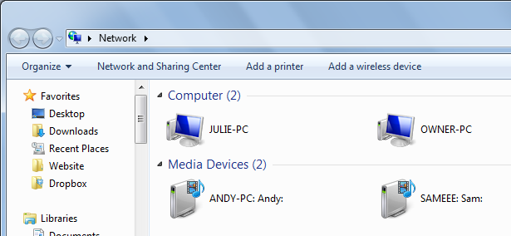
Network Window

Start, Network

Shows devices on your network

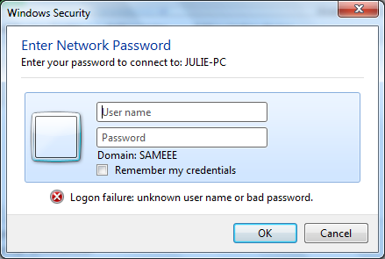

Viewing a Computer's Shared Resources

If the computer has password-protected sharing enabled, and your stored network credentials are not accepted, you see the "Enter Network Password" box

Shared Resources

Breadcrumb trail address: ▶ Network ▶ SAMEEE

Click address bar to see UNC path: \\SAMEEE
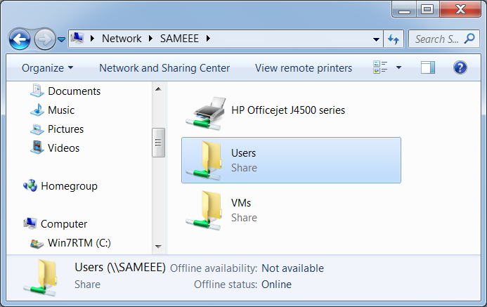

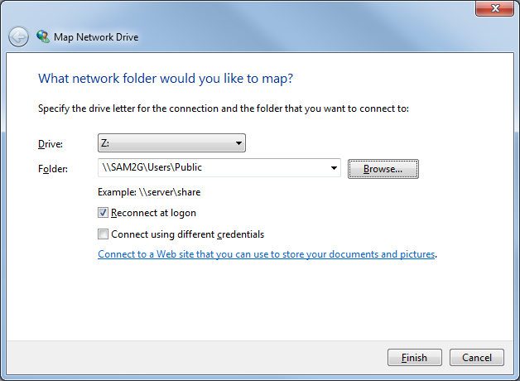
Mapping a Network Folder to a Drive Letter

Mapping a Network Folder to a Local Drive Letter

Start, right-click Computer, Map Network Drive

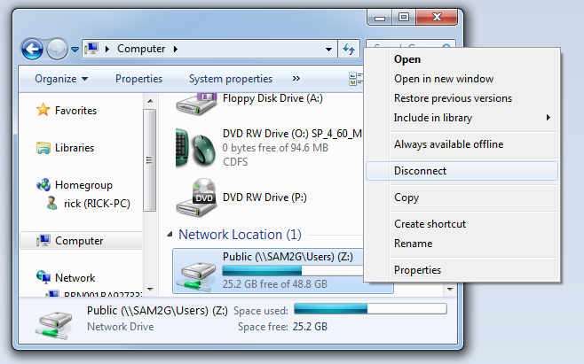

Disconnecting a Mapped Network Folder

In the Computer window, right-click the drive, Disconnect

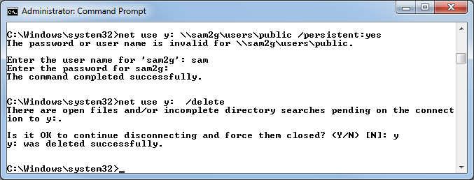
Mapping (and Deleting) Network Folder at the Command Line

Creating a Network Location for a Remote Folder

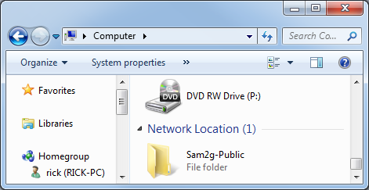
Creating a Network Location for a Remote Folder

In the Computer window, right-click empty space, click "Add a Network Location"

Go through the wizard

Adds the folder to the Computer window without assigning a drive letter

Accessing a Shared Printer

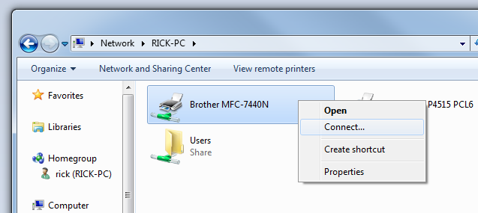
Accessing a Shared Printer

In Network window, open print server. Right-click printer, Connect…

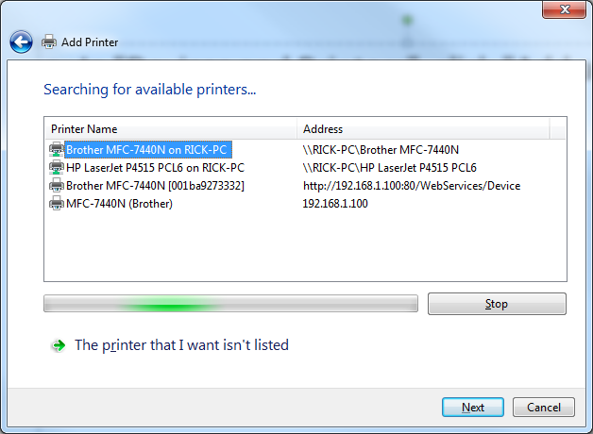

Add Printer Wizard

In "Devices and Printers", click "Add a Printer" button

Sharing Resources with the Network

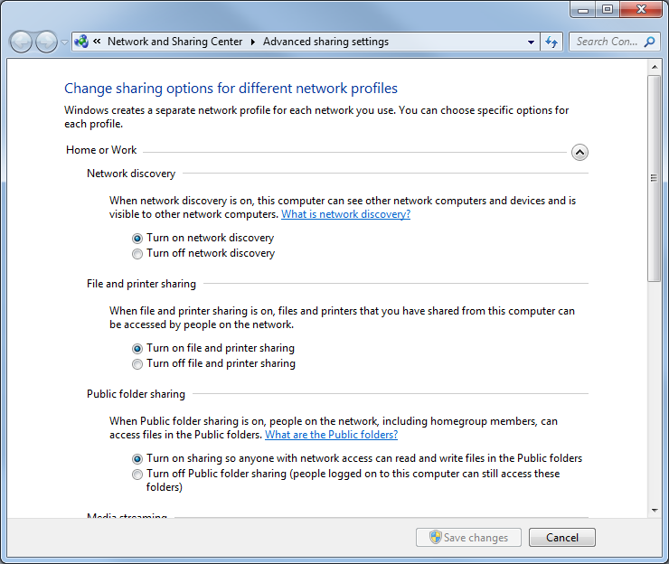
Sharing Resources with the Network

Start, SHARING, click "Manage advanced sharing settings"

Creating User Accounts for Sharing

If you use HomeGroup, or don't use password protected sharing, you don't need to have local accounts for the users sharing your resources

If you choose to require accounts, they must not have blank passwords

Monitoring Your Shared Resources

Shared Folders in Computer Management

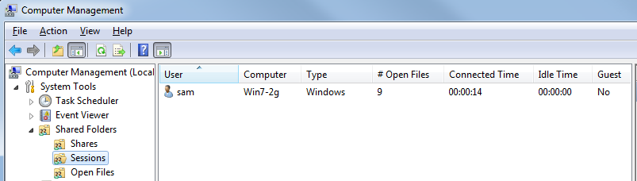
You can also view open files, and disconnect users

Working with Network Files Offline

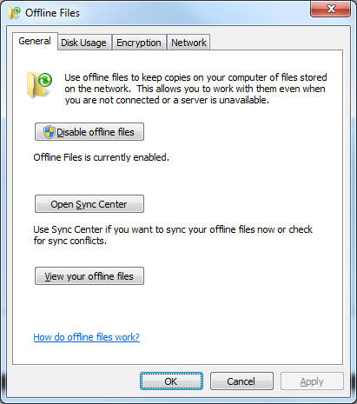
Working with Network Files Offline

Offline Files is only included in Windows 7 Professional, Enterprise, or Ultimate

Start, OFFLINE, "Manage offline files"

Offline Files is enabled by default

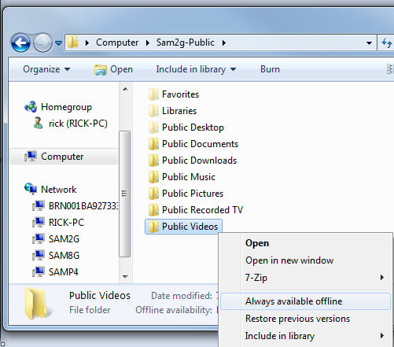

Making a File or Folder Available for Offline Use

In Windows Explorer, right-click file or folder, click "Always available offline"

The "Always Available Offline" box appears as Windows synchronizes the file
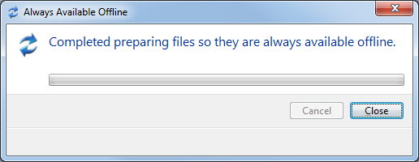

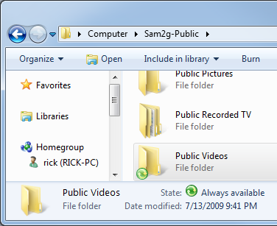
"Sync Center" icon

This green mark indicates objects that are available offline

Status at bottom shows "Always available"

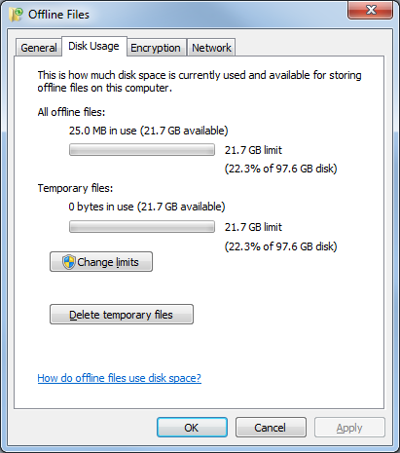

Changing the Amount of Disk Space Used by Offline Files

In "Manage offline files"

You can also encrypt offline files here

Prohibiting a Network Folder from Being Made Available Offline

You might want to prevent the slow synchronization, or prevent copies of the file being taken out of the building

This can be adjusted in Group Policy, as well as many other settings of Offline Files
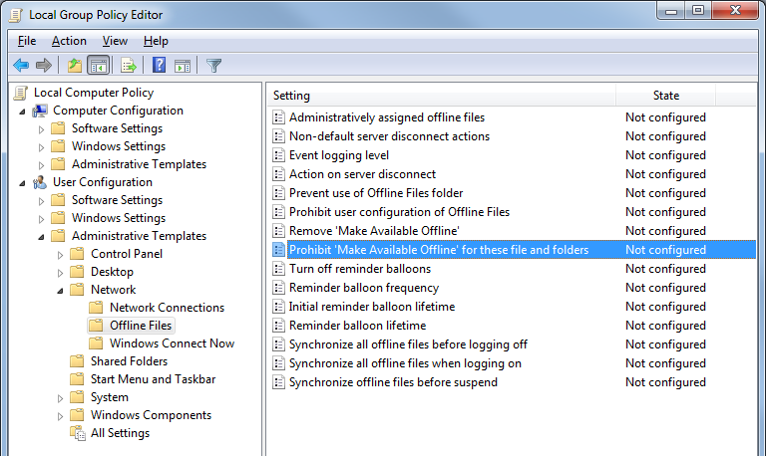

Sync Center

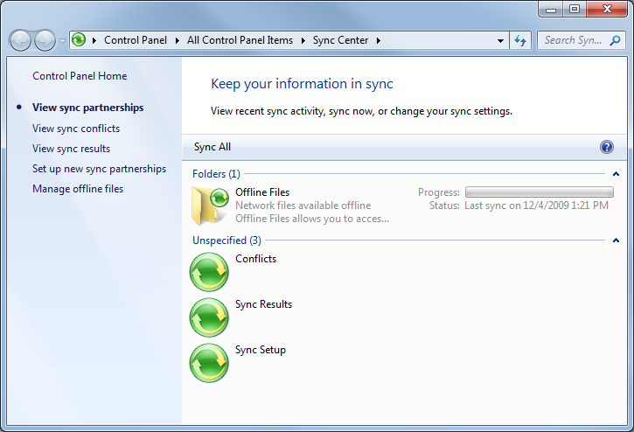
Start, SYNC

You can open your offline files here

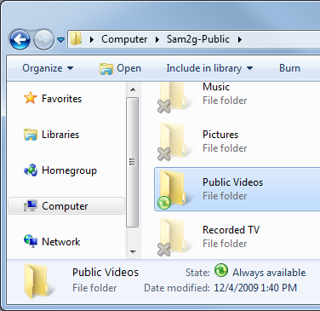

Leaving a Folder Open

If you leave the network share open when you disconnect, the offline files remain available

Synchronizing Your Offline Files

Files should synchronize when you reconnect to the network

You can control synchronization in Sync Center

Offline Files Bugs

It refused to synchronize in my tests, happily keeping different versions of a text file on the client and server.

It's supposed to detect such conflicts and warn you about them, but it did not.

Ch 27: Making Remote Network Connections

Setting Up the Remote Computer as a Host

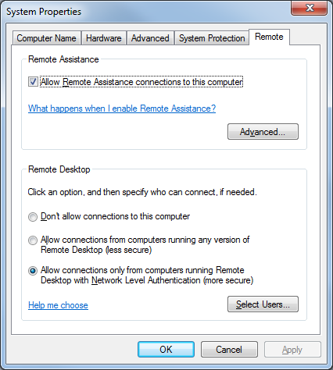
Versions

Only Windows 7 Business, Enterprise, and Ultimate can act as the Remote Computer

The Remote Computer is the one that is controlled by another computer

The Client Computer can use any version of Win XP, Vista, or Windows 7

Setting Up User Accounts on the Host

Only accounts with passwords can be used to connect

These accounts in can make Remote Desktop Connections

Accounts in the Administrators group

Other accounts added to the Remote Desktop Users group

The currently logged-in user is not necessarily allowed in, the book is wrong on page 586 at the bottom

Activating Remote Desktop

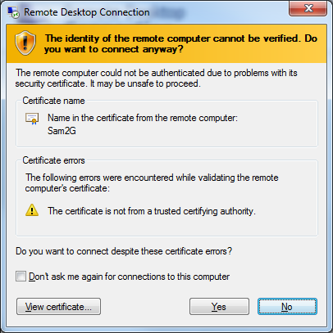
Start, right-click Computer, Advanced System Properties, Remote tab

The less secure option allows Win XP clients

Win XP Home clients will need to download the client from Microsoft

The last option is best for Win 7 and Vista clients

Standby and Hibernate

You must disable these for the computer to answer Remote Desktop connection requests

Use Power Options in Control Panel
Connecting to the Remote Desktop

Making a Basic Connection

Start, Remote, "Remote Desktop Connection"

The first time you connect, you need to approve a certificate identifying the host

Log in with an account that is in the Remote Desktop Users group on the host machine

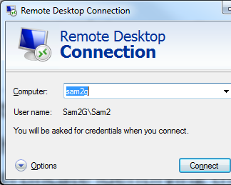

User Logoff

If someone is using the computer, they will be logged off

The other person has 30 seconds to stop the remote session

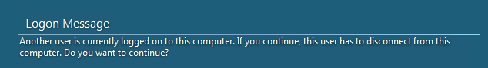
If you want two people to share the same machine, you need Remote Assistance, not Remote Desktop

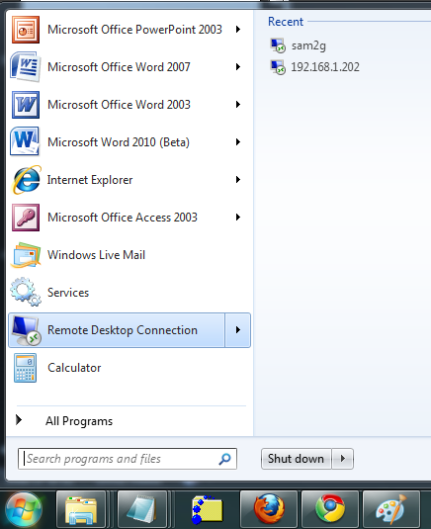
Jump Lists

Recent connections are available in a jump list from the Remote Desktop Connection icon

Making an Advanced Connection

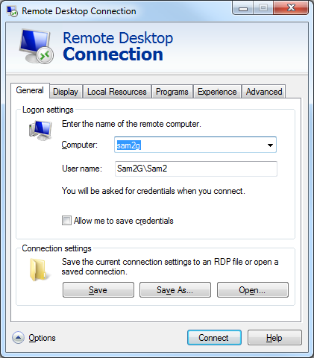
Click the Options arrow to see these tabs

These settings allow you to customize your experience to suit your hardware and network speed

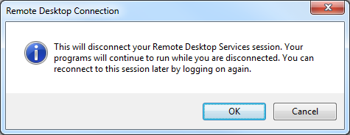
Disconnecting from the Remote Desktop

Start, Log Off stops your session and exits

Closing the Remote Desktop Connection window by clicking the X leaves your programs and windows open on the host

Connecting to the Remote Desktop via the Internet

Security Measures

Allowing remote desktop from the Internet is obviously risky

Use strong passwords

Change the listening port

Registry adjustment, see link Ch 27c

Configure Windows Firewall to allow the new port through

Port Forwarding

Generally you need to configure port forwarding on your router for any server on your network, including Remote Desktop

That's the only way unexpected requests for service can find your computer

Using Dynamic DNS to Access your Network

Dynamic DNS

These services will find your machine's IP address even if it changes, and point a DNS name to iy

DynDNS.org

Tzo.com

No-ip.com

Dlinkdns.com
Using Virtual Private Network Connections

Encryption and Remote Desktop

In Group Policy, go to Computer Configuration - Administrative Templates - Windows Components - Terminal Services - Encryption and Security.
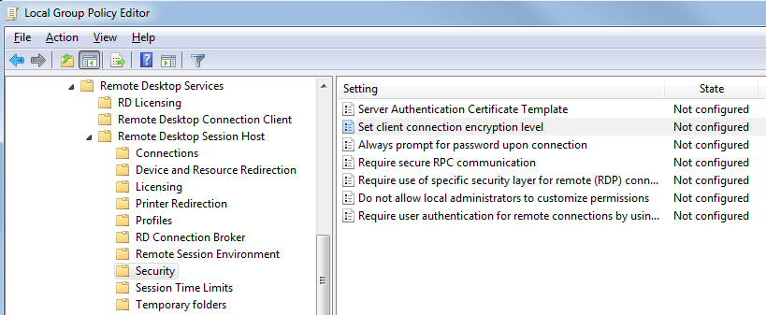

Encryption is Optional in Remote Desktop

By default, it used High security (128-bit AES), but that can be set lower, to dangerously low levels like 56-bit DES.

Using a Virtual Private Network is a far more secure way to use Remote Desktop

And it frees you from the need to configure port forwarding

PPTP and IPSec

PPTP (Point to Point Tunneling Protocol) is older and less secure

IPSec (IP Security) is newer and more secure

Last modified 12-4-09

