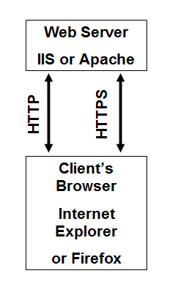
Understanding Internet Information Services

Web Servers

The two main Web servers are Apache (Open source) and IIS (Microsoft)

Image from netcraft.com

Versions

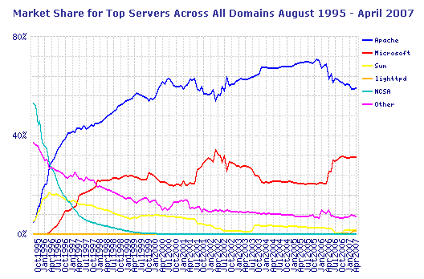
Windows 7 Professional, Enterprise, and Ultimate include IIS 7.5

Windows 7 Home Premium offers a limited version of IIS

Missing features include WebDAV and Windows authentication (in a domain)

Link Ch 28b

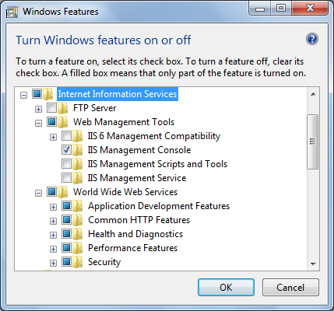
Installing Internet Information Services

Use "Windows Features"

Web Management Tools

IIS Management Service (lets you administer your Web site from another computer)

World Wide Web Services

Application Development Features (used to build and test Web applications)

Use "Windows Features"

Security

Basic Authentication (lets you password-protect portions of your Web site)
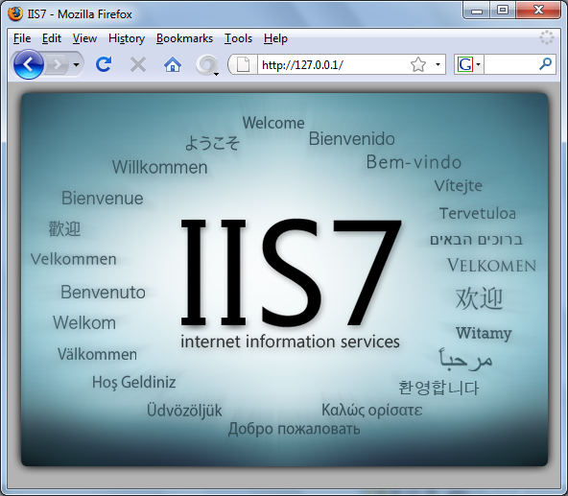
Accessing Your Website

Viewing your Website

Use any of these URLs:

From the Web server

http://127.0.0.1

http://localhost

From any computer connected to the Web server

http://IP-Address

Replace IP-Address with your IP address

http://Computername

Replace Computername with your computer's name

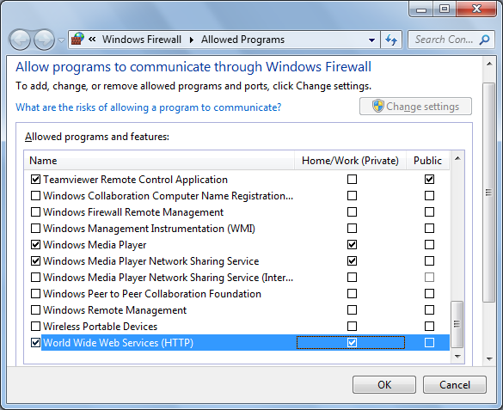

Creating a Windows Firewall Exception for the Web Server

Start, FIREWALL, "Allow a program through Windows Firewall"

Change Settings

Check "World Wide Web Service (HTTP)"

Accessing your Website over the Internet

You will need a public IP address

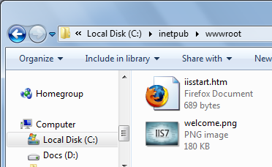
Or a forwarded port on a router with a public IP address

If you want a domain name, like foo.com, you will need to purchase it and assign it to your IP address
Understanding the Default Website

Viewing the Default Website Folder

C:\Inetpub\wwwroot

Viewing the Default Website with IIS Manager

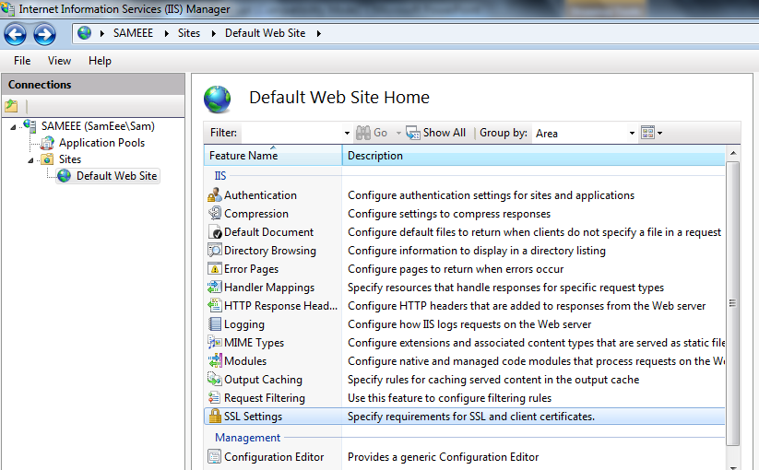
Start, IIS, "Internet Information Services (IIS) Manager"
Adding Folders and Files to the Default Website

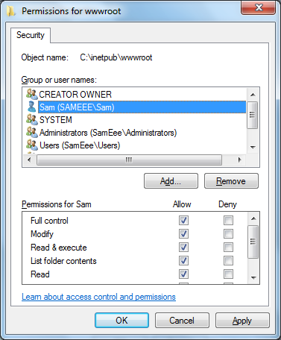
Setting Permissions on the Default Website Folder

You need to give yourself Full Control of the wwwroot folder

Otherwise you'll need to elevate permissions to create or edit anything on your Website

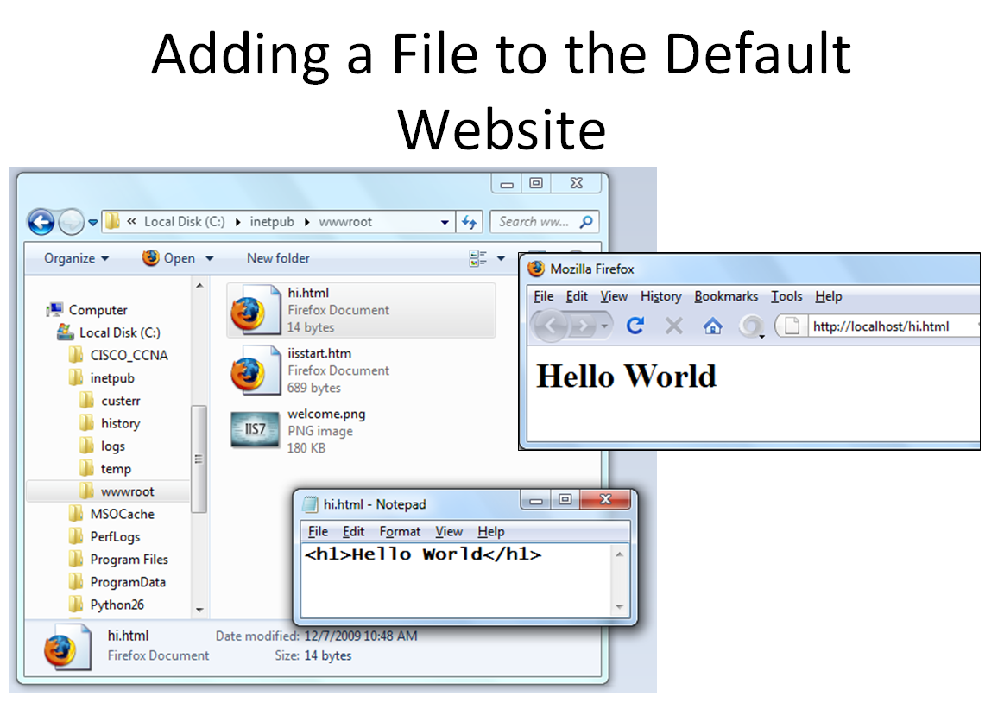

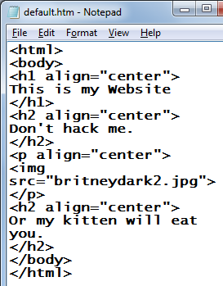


Changing the Default Website Home Page

Put a file in the wwwrooot folder with one of these names:

Default.htm

Default.asp

Index.htm

Index.html

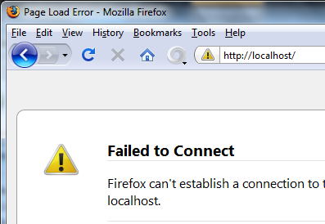
Controlling and Customizing Your Website

Stopping Your Website

In IIS Manager, select website, in Action Pane, click Stop

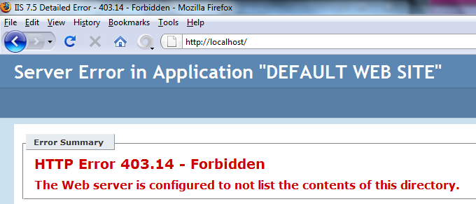

Working Without a Default Document

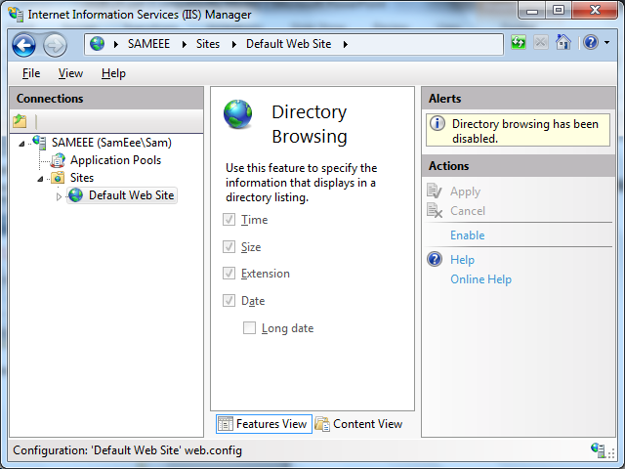

Enabling Directory Browsing

In IIS Manager, in Features view, click "Directory Browsing"

In the Action pane, click Enable

Not recommended

A large security risk

Private documents on the Web server may be visible

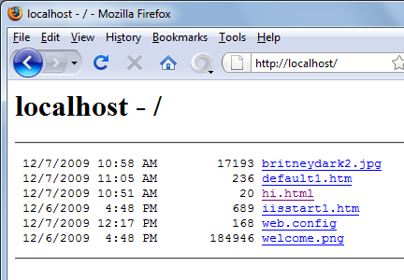

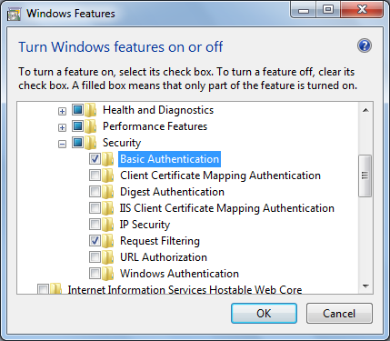

Installing Basic Authentication

By default, IIS includes the "Authentication" module, but no actual authentication modules, so it can't be used

Disabling Anonymous Access

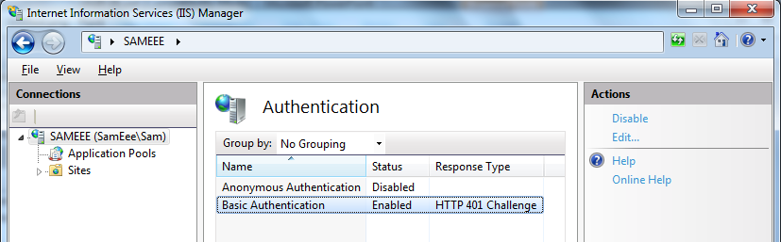
In IIS Manager, in disable "Anonymous Authentication", and enable "Basic Authentication"

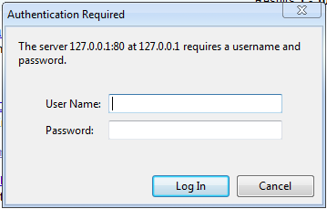

Basic Authentication

The name and password you use here must match a login account on the Windows 7 Web server

Basic Authentication is Insecure

It transmits unencrypted base64-encoded passwords across the network

Easily sniffed with Wireshark

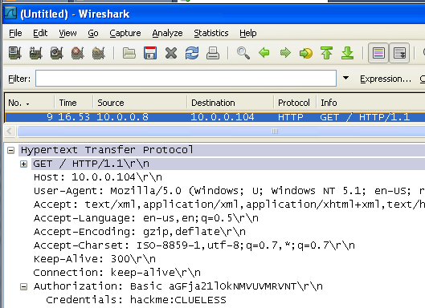

Last modified 12-11-09

