Ch 1: What’s New in Windows 7

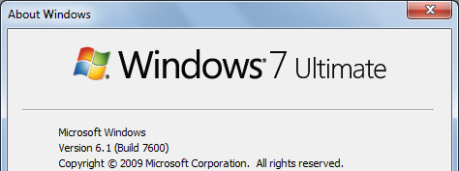
Based on Vista

Start, WINVER

Windows 7 is actually Windows NT 6.1

An incremental upgrade from Vista (NT 6.0)

Likely to be popular and enduring, like Windows XP (NT 5.1)

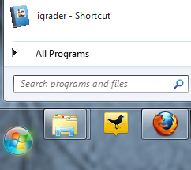

Changes from Windows XP

Big Changes from Windows XP

Integrated search, in Start menu, in Windows Explorer, and in Control Panel

New diagnostic and monitoring tools

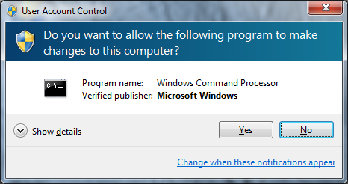

User Account Control

Asks for confirmation of risky actions

Makes you much safer

Much less annoying than in Vista

Elevated Command Prompt

Start, CMD, Enter

Low-privilege command prompt
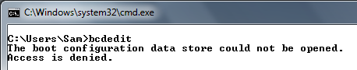

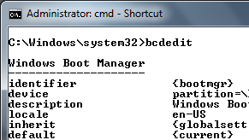

Start, CMD, Shift+Ctrl+Enter

Administrator Command Prompt

The Missing Pieces

No Email Client is included in Windows 7

Outlook Express is gone

You can download Windows Live Mail as a free addition

Antivirus not included

But Microsoft Security Essentials is a free download

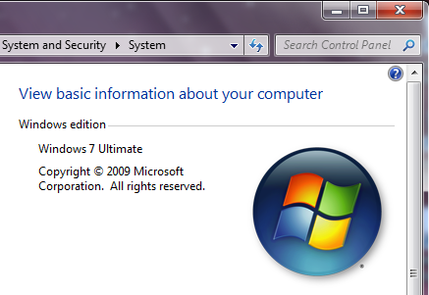
Windows 7 Versions

What Version Do You Have?

Logo+Break

Windows 7 Versions

Starter

Home Premium

Professional

Ultimate

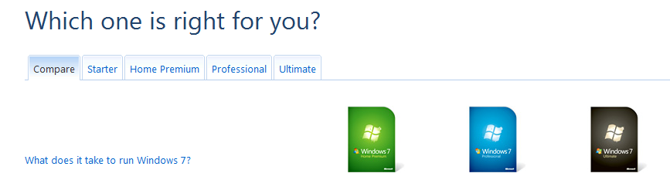
See link Ch 0b

Windows 7 Versions

Starter

Intended for netbooks, most limited version

Home Premium

Intended for home users

Professional

Everything in Home Premium plus business features like Domain Join

Ultimate and Enterprise

Everything in Professional plus advanced business technology like BitLocker, BranchCache, and AppLocker

Common Features
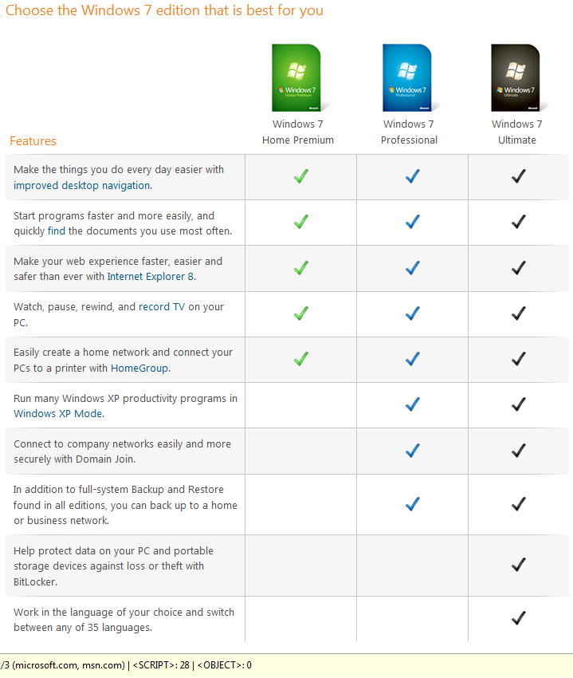

Differences

Domain Join

Intended for businesses

Requires a domain controller running Windows 2008 Server or earlier Windows Server versions

Provides a central point of administration, making the network more secure and scalable

Only Windows 7 Professional and higher (Enterprise and Ultimate) can join domains

Backup

All versions of Windows 7 provide image-based full system backup

But only Windows 7 Professional and Ultimate can back up to a network server

Windows 7 BitLocker

Encrypts the whole hard drive

Requires the user to supply a startup PIN or USB flash drive that contains keying material before the computer will boot

Protected from Stanford’s “cold boot” attack that can break through Vista’s BitLocker

See link Ch 0h

Windows 7 Enterprise

Not available in retail stores

Only sold to "Microsoft Software Assurance customers"

Several new features not included in the Professional or Home Premium versions

Link Ch 0i

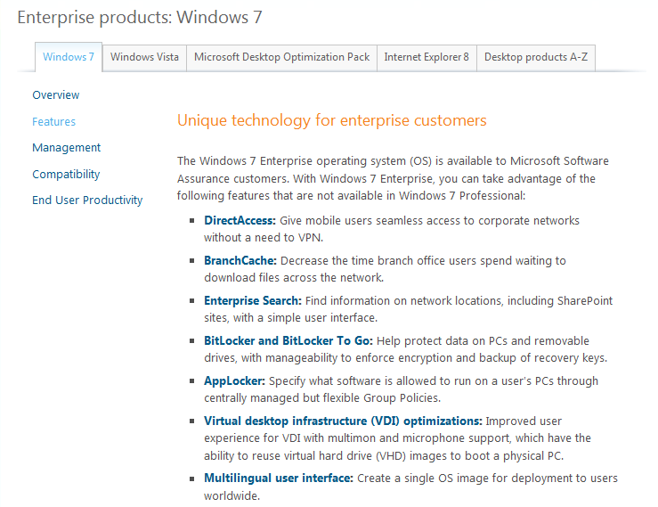
Windows 7 Enterprise

Obscure Versions

Windows 7 Home Basic

No Aero graphics or Media Center

Intended for developing countries, not sold in the USA

N and K versions

Special versions sold in Europe and Korea

Windows Media Player removed to comply with legal requirements

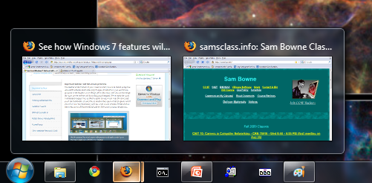
Adjusting to the Windows 7 Interface

New Taskbar

Larger icons

Hover to see thumbnail images of windows

Drag items to the taskbar to dock them

Drag icons to rearrange them

Full-Screen Preview

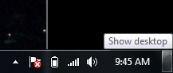
Hover over a window's thumbnail to see it in preview mode

Hover over the rectangle at the right end of the taskbar to preview the Desktop

Jump Lists

You can pin items to each Taskbar button

Makes the tasks you do most often easier to launch

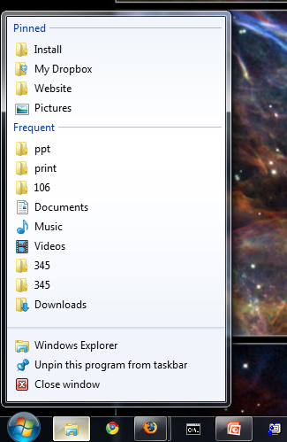
New Window Controls

Drag a window to the top of the screen to maximize it

Drag it to left or right edge to make it fill half the desktop

Aero Shake

Shake a window to close all other windows

Shake it again to restore them

Shortcut Keys
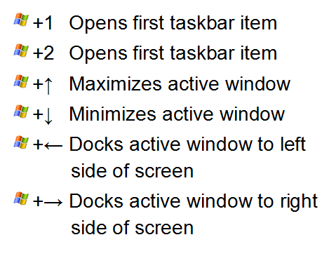

Personalization

Right-click desktop, Personalize

Desktop background slide show

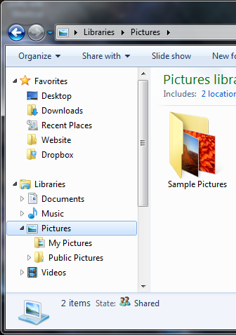
Libraries

Gathers files from several folders together

To customize the folder list, click the blue "2 locations" link

Saving, Sharing, and Playing Digital Media

Windows Media Player

Supports more file types, including H.264 and AVC

Can stream music between devices on a Windows network
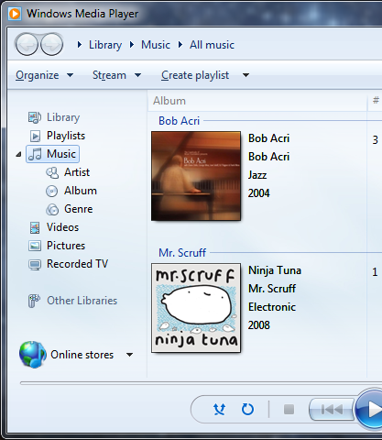

Windows Media Center

Can be operated with a remote control

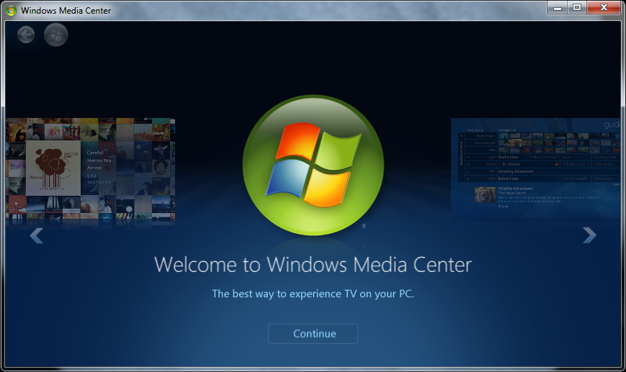
Can record television from a TV tuner

Networking in New Ways

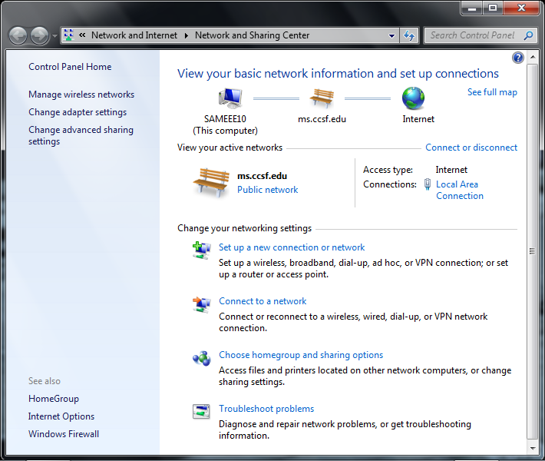
Network and Sharing Center

Central panel for common networking tasks

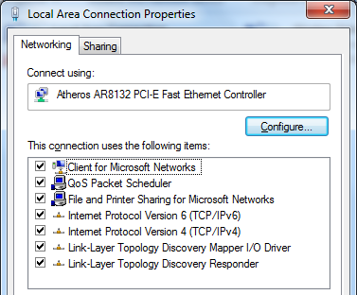

New Protocols

IPv6 preferred to IPv4

Used for LAN connections

Not yet in common use for Internet connections in the USA

Link-Layer Topology Discovery

Used to create the Network Map

HomeGroups

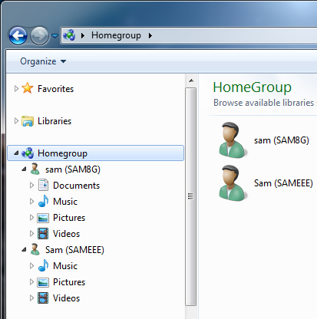
Easy, secure file-sharing

Only for Home networks

Protected by a password

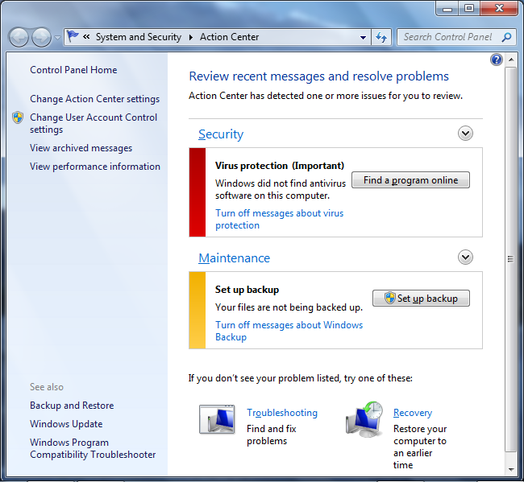
Keeping Your PC Speedy and Safe

Action Center

Alerts you of security and maintenance problems and guides you through solutions

Reliability Monitor

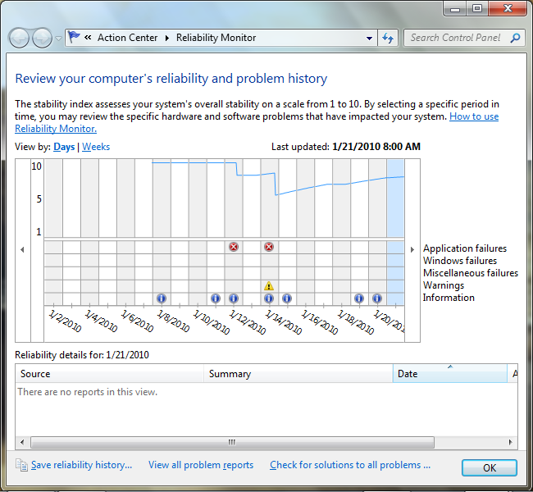
Displays a convenient log of important events

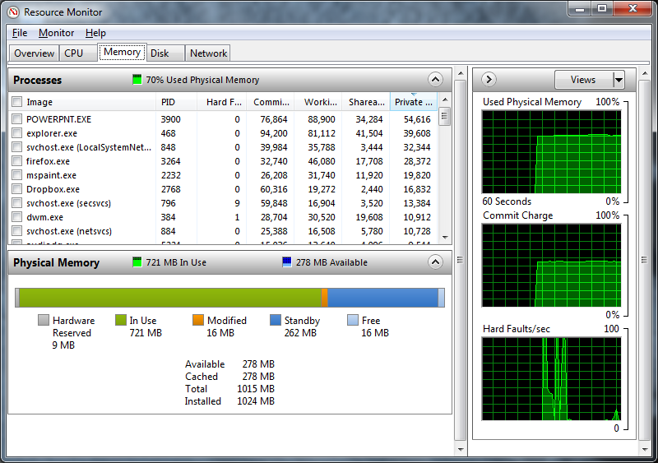

Resource Monitor

Detailed performance information

Ch 2: Installing and Configuring Windows 7

Image-based Installation

Very different from the Windows XP Installer

Essentially the same as the Vista installer

Faster and more reliable than the Windows XP installation process, especially for upgrades

What's in Your Edition?

All the tools and techniques in this chapter are available in all versions of Windows 7

Original Equipment Manufacturers (OEMs) may remove features or change default settings

Before You Start

Windows 7 Upgrade Advisor

Scans your computer to identify hardware and software issues that might interfere with an upgrade to Windows 7

Link Ch 2a

Dynamic Updates

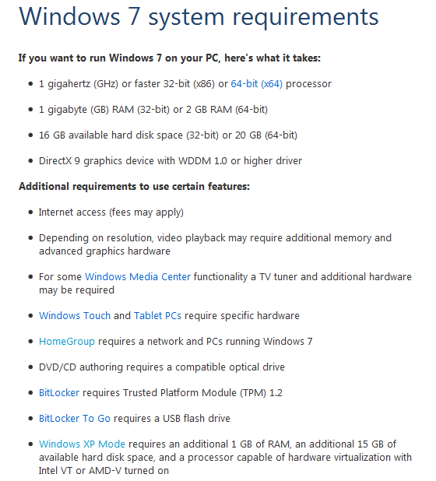
When you upgrade, use this option to include updates during installation, which increases your chance of a successful upgrade

Hardware Requirements

Link Ch 2b

Signed Drivers

Windows 7 64-bit requires all device drivers to be signed

This can be a major annoyance if you use cheap hardware with unsigned drivers

There is no good way around this, as far as I know

See link Ch 2c

Avoiding Software Compatibility Problems

Disable or uninstall these programs before an upgrade

Antivirus and antispyware

Software firewalls and other security programs

Programs that burn CDs and DVDs

Disk-partitioning utilities and other low-level system maintenance programs

Backing Up Data and Settings

Before you upgrade, back up your data and settings

NOTE

The Windows XP backup creates files that cannot be opened by the Windows 7 backup utility

Use Norton Ghost or Acronis TrueImage instead

Setting Up Windows 7

Which Windows 7 Edition?

Retail DVDs include these editions:

Home Premium

Professional

Ultimate

Home Basic

Starter

You can install any version for a 30-day trial

Custom Install or Upgrade?

Custom install is a clean install

You need to reinstall programs and transfer files and settings from your old computer

The most stable and reliable method

Upgrade

Keeps your programs, settings, and files from the previous system

Less stable and reliable

Only possible if your old system ran Vista

You cannot upgrade Windows XP directly to Windows 7

Partition Management

The Windows 7 installer contains a disk management utility

You can create, delete, format, and extend (but not shrink) partitions

Installation Boot Options

Single-boot

Windows 7 as the only operating system on the computer

This is the normal situation

Dual-boot or multi-boot

Two or more operating systems (OSs) on the same computer

Each OS is on its own disk or partition

Each time the machine starts up, the user chooses the OS to boot to

This is what we will do in the S214 lab

Two Ways to Set Up Windows 7

Run setup from within Windows

Boot from the install DVD

Running Setup from Within Windows

You can upgrade Vista or a smaller Win 7

You can reinstall Windows 7

You cannot run 64-bit setup from within a 32-bit OS

You can run Windows 7 upgrade advisor

You cannot change the layout of the disk

You can install Windows 7 on a partition containing a previous Windows version

The old Windows version won't boot anymore, but all the files will be saved in a folder called Windows.old

Booting from the Install DVD

You cannot upgrade windows this way

You can change partitions

You can install Windows 7 on a partition containing a previous Windows version

The old Windows version won't boot anymore, but all the files will be saved in a folder called Windows.old

Clean Installation

Installing onto an empty partition

Best way: boot from install DVD

Upgrade option is unavailable when you boot from DVD

Steps for Installation

Choose a partition to use

User name and computer name

Password and password hint

Enter product key

Recommendation: don't enter product key during installation, wait till later

Select Automated Updates option

Time and Date Settings

Network settings

The 100-MB Partition

If you install on a clean disk with no partitions

A 100 MB System Reserved partition is created

It holds the Boot Manager and the Boot Configuration Database

Reserves space for BitLocker hard drive encryption

Upgrading from Another Windows Version

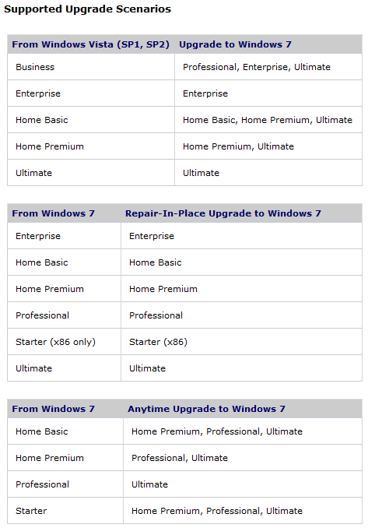
Upgrade Paths

Only possible from Vista or Win 7 to Win 7: you can go to any higher version

Repair-in-place Upgrade to same version

It will take a long time (3 hours when I did it)

See link Ch 2d

Multiboot Systems

Each Windows version must be installed in chronological order, because the boot loader changes with each version

Win XP

Win Vista

Win 7

If you install them out of order, you need to repair the boot sector (see page 49 in the textbook)

The boot menu options are controlled with the BCDEDIT command-line utility (you will do this in the projects)

Demonstration

Start, CMD, Enter

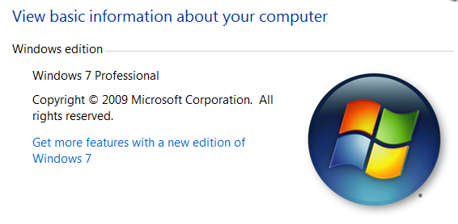
Normal Command Prompt--cannot start BCDEDIT

Start, CMD, Shift+Ctrl+Enter

Administrator Command Prompt--can start BCDEDIT

Windows Anytime Upgrade

Upgrades one Windows 7 version to a higher one

Start, right-click Computer, Properties

Click "Get more features with a new edition of Windows 7"

You need to buy a product key

Takes about ten minutes, does not require the DVD

Installing and Updating Drivers

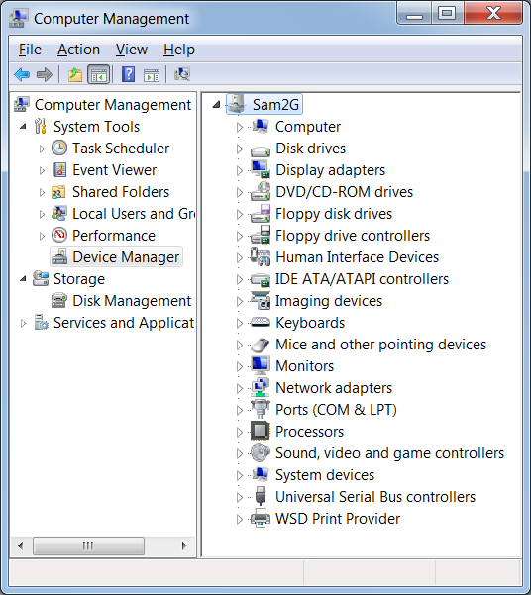
Device Manager

Start, right-click Computer, Manage

Device Manager

Check for any errors or warnings

Activating and Validating Windows 7

Activation

You will be prompted to enter a product key

Online activation will save a fingerprint of your system on Microsoft's servers

If the same key is used on a different machine, it will not activate

If your activation period expires and you have not entered a key, Windows will nag you, but it won't stop working

You can extend the 30-day trial period three times (see page 55 in the textbook)

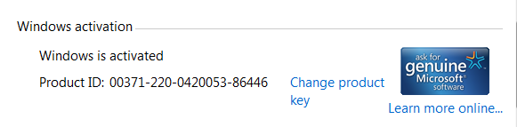
Activation Status

Start, right-click Computer, Properties

Activation status is at the bottom of this window

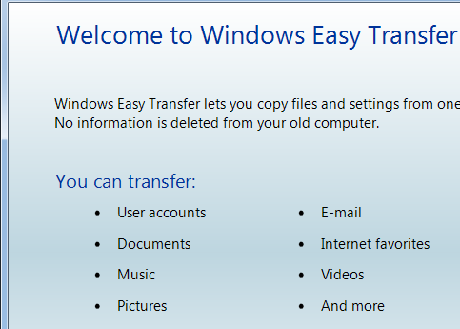
Transferring Files and Settings from Another Computer

Windows Easy Transfer

Start, TRANSFER

Look in Search results

Click "Windows Easy Transfer"

You'll do it in the Projects

Last modified 1-24-10

