Ch 3: Obtaining Help and Support

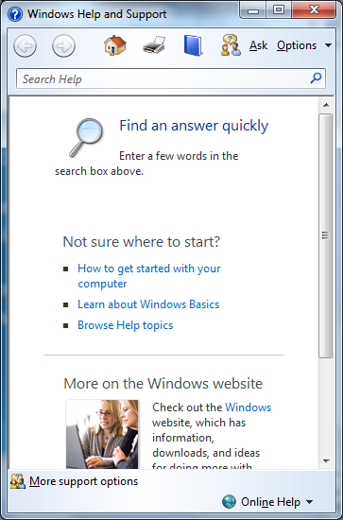
Editions

Help and Remote Assistance are the same in all editions

Help and Support

Start, Help and Support

Continually updated via the Internet

Convenient search box

Reality

It’s not in the book, and not on the certification test

But the way to really find answers is Google with this search parameter

Site:microsoft.com

Remote Assistance

View another computer’s screen over the Internet

Control another computer (with permission) to help fix it

Remote Assistance

Remote Assistance is for fixing a computer

Both users must be at their computers

Both users must agree to allow it

Included in all editions of:

Win 7, Vista, XP, Sever 2003, and Server 2008

Both users see the screen

Both users share a single login account, with its privileges

Connection can be made over the Internet, even through NAT

Remote Desktop Connection

Remote Desktop is for using a remote computer

Can be initiated from one computer when no one is at the remote target computer

Target computer must have Win 7 Professional, Enterprise, or Ultimate edition

You can initiate the connection from any Win 7 edition, or even through a Web browser

The screen of the target computer is hidden, showing a logon screen

Computers must be on the same LAN—does not work through NAT (but you can use a VPN)

See link Ch 3a

Remote Assistance

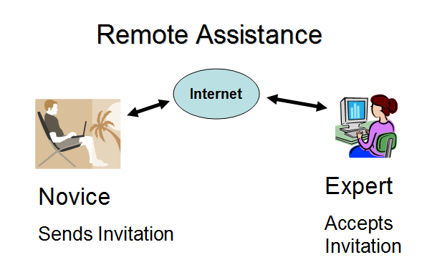
Connection Types

Remote Assistance tries all these connection types until one works:

IPv4

If both machines have public IPv4 addresses, or are on the same subnet

IPv6

If the routers and switches support IPv6

UPnP NAT Addresses

If you use a UPnP router (see link Ch 9a)

Connection Types

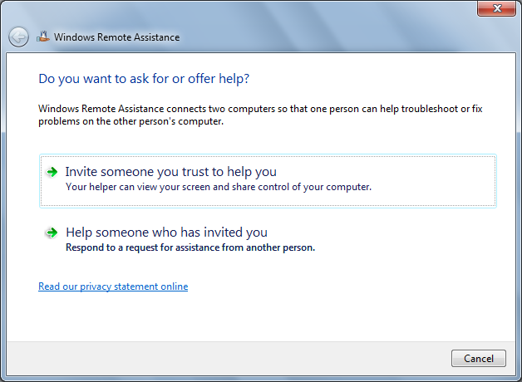
NAT traversal via Teredo

Uses a public Teredo server to determine port mapping

Connects using IPv6 encapsulated in IPv4 packets

See Link Ch 3b

Reality

It’s not in the book, and not on the certification test

But the way to really share a desktop is TeamViewer

teamviewer.com

Windows Firewall

Windows Firewall has an exception to allow Remote Assistance for private networks

By default, Remote Assistance is blocked in

Public networks

Corporate domains

Asking for Remote Assistance

Start, REMOTE, "Windows Remote Assistance"

"Invite someone you trust to help you"

If you both have Win 7, you can use Easy Connect

You can also use Windows Live Messenger

Asking for Remote Assistance

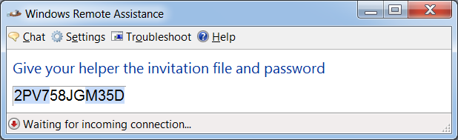
The session is password-protected

Asking for Remote Assistance

If one machine isn't Win 7:

Send an invitation file, via

E-mail

Shared folder

Physical media, such as a USB flash drive

You also need to give the expert the password to make the connection

Remote Assistance

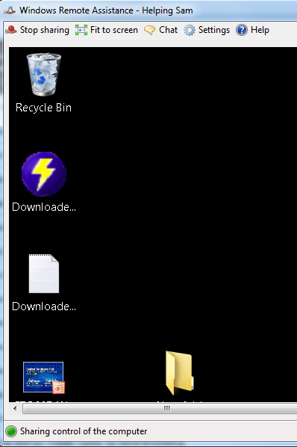
The expert can view the desktop, or request control

Novice and expert both see the desktop

Offering Assistance

With Windows Live Messenger

The expert can offer assistance via DCOM (Distributed Component Object Model)

That makes it easier for the novice

Requires prior adjustment of the novice’s computer

Intended for corporate machines on a domain

Remote Assistance with Earlier Windows Versions

Windows 7's Remote Assistance works with Windows Vista, XP, Server 2003 and Server 2008

No NAT traversal or Teredo

No voice chat

You can’t offer assistance to Win 7 from a computer running Win XP

Some invitation files are “Windows Vista or later only”

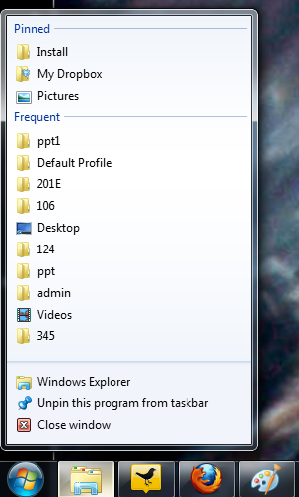
Security

Password required

Novice must accept each connection

Novice must approve sharing control

Invitation files expire after 6 hours, or when the Remote Assistance session is closed (you can adjust this duration)

Uses dynamic port assignment

Firewall only allows Remote Assistance on private networks

Traffic is encrypted (see link Ch 3e)
Ch 4: Personalizing Windows 7

Editions

Windows 7 Starter does not have

Aero graphics:

Transparent windows

Live taskbar previews

Flip 3-D

The ability to change the background image or colors

All the other editions have all the features discussed in this chapter
New Taskbar and Start Menu

Pinning Programs to the Taskbar

Drag them to dock them there

Open programs are added to the taskbar even if they are not pinned

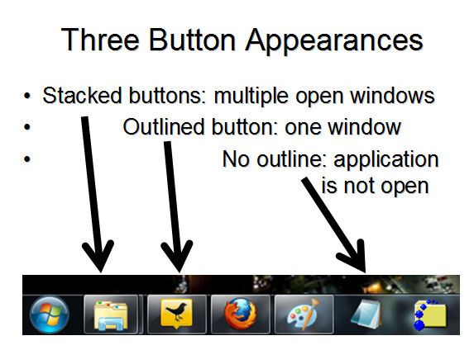
Drag documents and shortcuts to taskbar buttons to pin them

Opening Programs

To open a new program, click its taskbar button

To open an additional instance of the same program, Shift+Click its taskbar button

To open a program with administrative privileges, Ctrl+Shift+Click its taskbar button

Thumbnail Previews

Hover over a button to see thumbnail views of all its windows

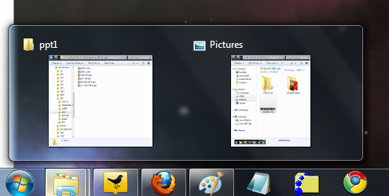
Hover over a thumbnail for a full-size preview "Aero Peek"

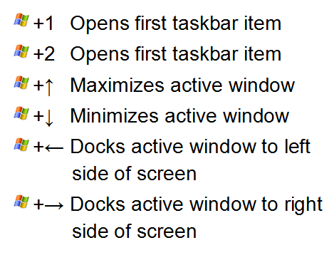
Shortcut Keys

Personalizing the Taskbar and Start Menu

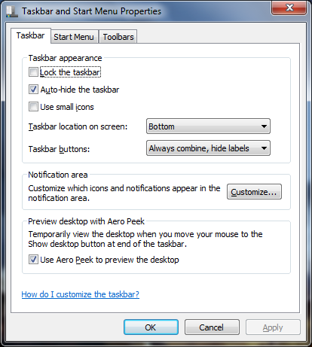
Taskbar Properties

Right-click an empty part of the taskbar, click Properties

Drag top of taskbar to make it higher

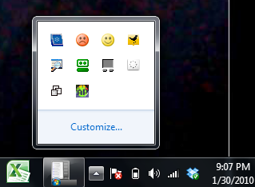
Reveal hidden taskbar with Logo key

Controlling Notifications

To see hidden icons, click the up-arrow

Click Customize to select which icons appear here

Customizing the Start Menu

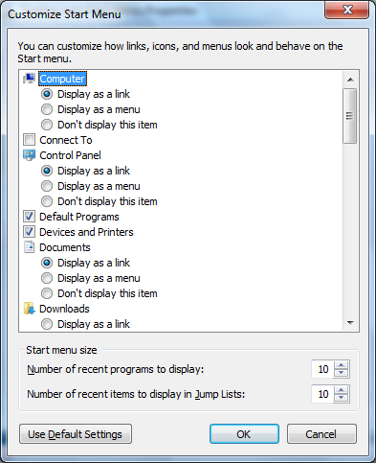
Right-click Start button, Properties, Customize

Here you can display Network, and many other items

Window Management

Aero Snap

Drag window to top to maximize it

Drag to side to make it half-screen

Drag top window border to top to maximize height but not width

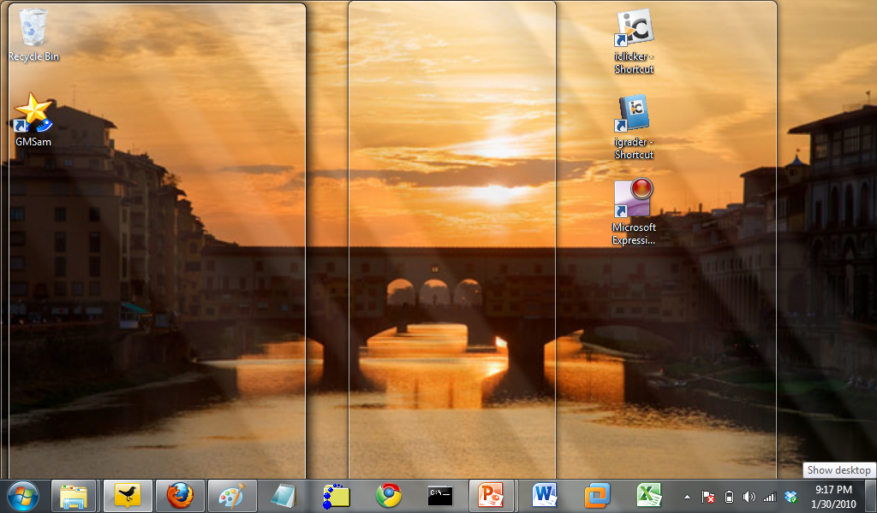
Aero Shake -- shake a window to minimize all other windows

View the Desktop and Gadgets

Hover the mouse over the lower-right corner

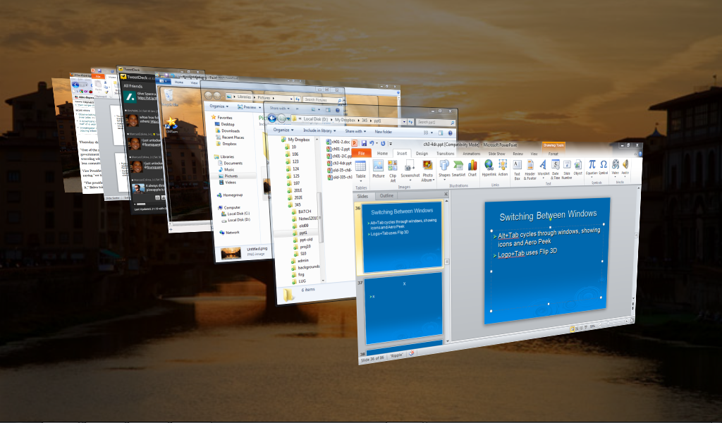

Switching Between Windows

Alt+Tab cycles through windows, showing icons and Aero Peek

Logo+Tab uses Flip 3D

Theme Elements: Visuals and Sounds

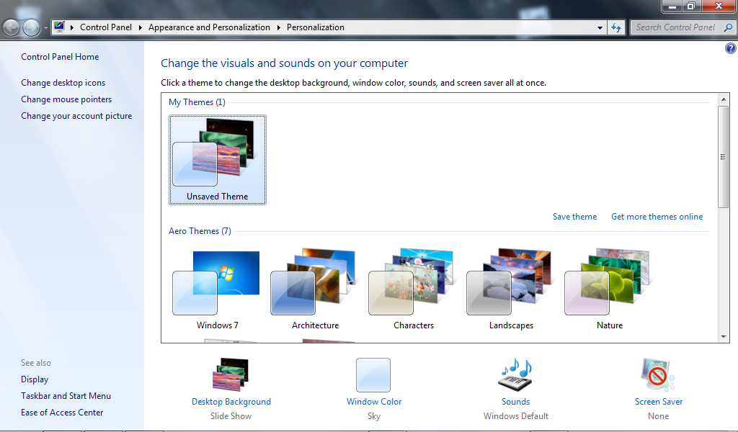
Personalization

Here you can set up a slide show, turn off Aero graphics, and much more

Slide Show From RSS Feed

Link Ch 3f

But you can't use Astronomy Photo of the Day

Configuring Your Display

Resolution and Multiple Monitors

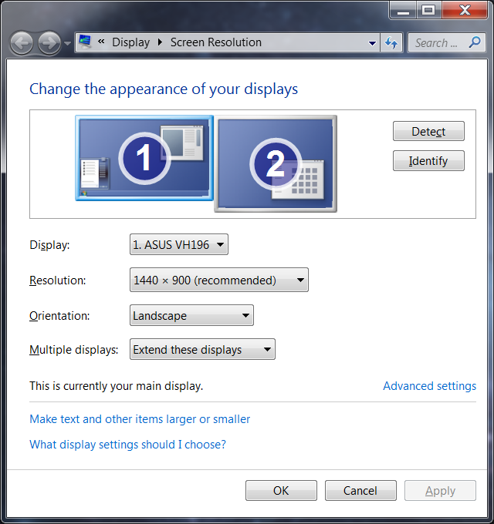
Right-click desktop and click Resolution

Power and Sleep Options

Choose What Closing the Lid Does

Start, POWER, "Power Options", "Choose what closing the lid does"
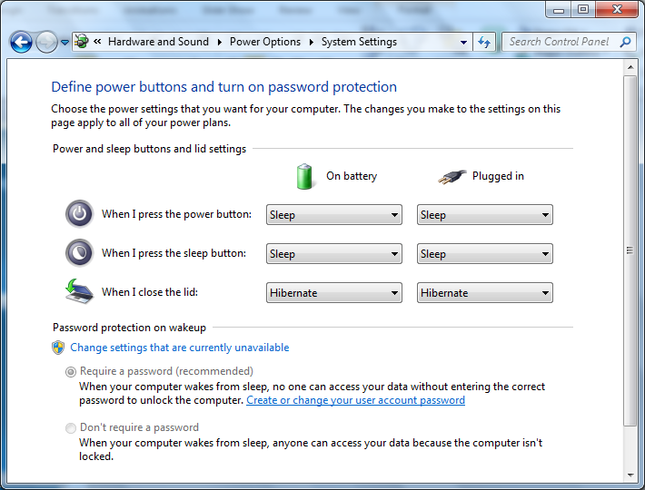

Last modified 8-28-10

