Ch 5: Adding, Removing, and Managing Programs

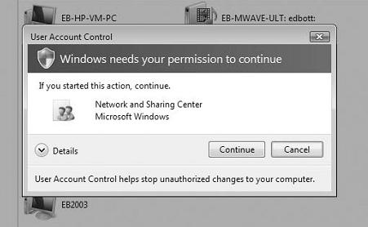
What's in Your Edition?

Everything in this chapter is the same in all editions, except Windows XP Mode

Windows XP Mode requires Windows 7 Professional, Enterprise, or Ultimate

Add or Remove Programs is Gone

No one ever used it to add programs anyway

Programs come with installers. You just have to deal with:

User Account Control (UAC)

Compatibility issues

User Account Control (UAC)

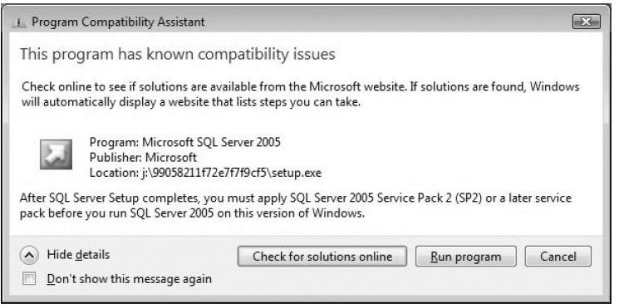
Installers change system files and registry settings

So you need to elevate privileges

Updates and uninstalls also require elevation

If the installer doesn’t automatically trigger UAC, you can right-click it and choose Run as Administrator

Compatibility Issues

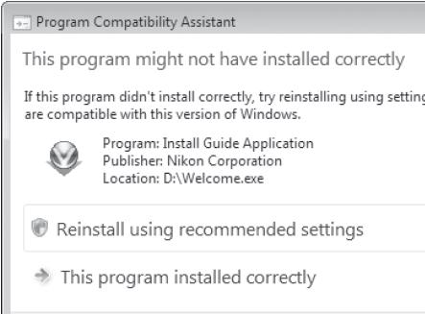
“Program Compatibility Assistant ” boxes warn you

Suggest solutions

Program Compatibility Troubleshooter

In Control Panel, open Programs

Under "Programs and Features", click "Run programs made for previous versions of Windows"

Compatibility Tab

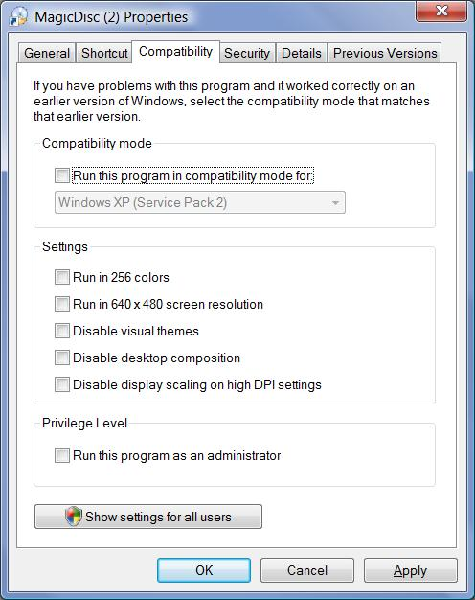
Right-click shortcut or EXE file, Properties

Windows XP Mode

Requirements for XP Mode

Runs a virtual machine with Windows XP seamlessly within Windows 7

Windows 7 Professional, Enterprise, or Ultimate

Processor must support hardware-assisted virtualization

The hardware virtualization must be enabled in the BIOS

Requirements for XP Mode

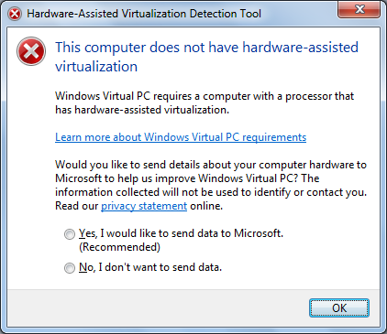
Microsoft provides a hardware-assisted virtualization detection tool (link Ch 5a)

If your hardware supports it, it's a free download

Installing Programs on 64-bit Versions of Windows

16-bit programs won’t install

32-bit programs install into the “Program Files (x86)” folder

64-bit programs install into the “Program Files” folder

Many programs, including IE, install both 32-bit and 64-bit versions on 64-bit Windows 7

By default, the 32-bit version runs, for compatibility

You can identify 32-bit programs in Task Manager

Startup Folder

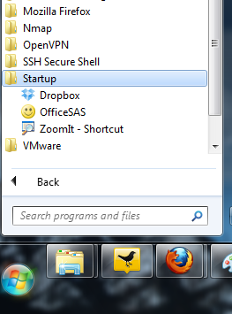
Start, All Programs, Startup

The simplest way to make programs launch at startup

Other Ways to Make a Program Run at Startup

Registry keys

Run or RunOnce or Policies\Explorer\Run

Load value

RunServices or RunServicesOnce

Winlogon or BootExecute

Scheduled Tasks

Win.ini

Group Policy

Shell service objects

Logon scripts

Using Msconfig to Control Startup Items

Start, MSCONFIG, Enter

Controlling Startup Programs with Windows Defender

This worked in Vista, but not in Windows 7
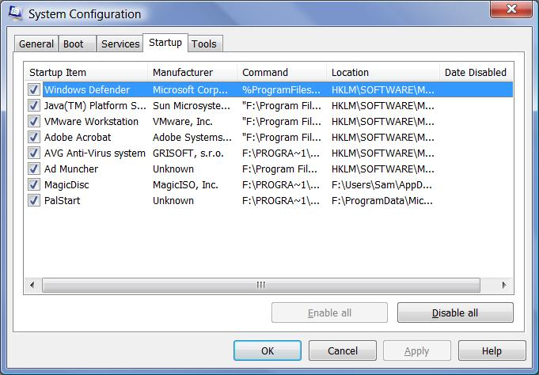

Controlling Startup Applications with Group Policy

To open the Group Policy console

Start, GPEDIT.MSC, Enter

These policies affect startup applications

Run These Programs At User Logon

Do Not Process The Run Once List

Do Not Process The Legacy Run List

Group Policy is not available in Windows 7 Home Premium or Starter
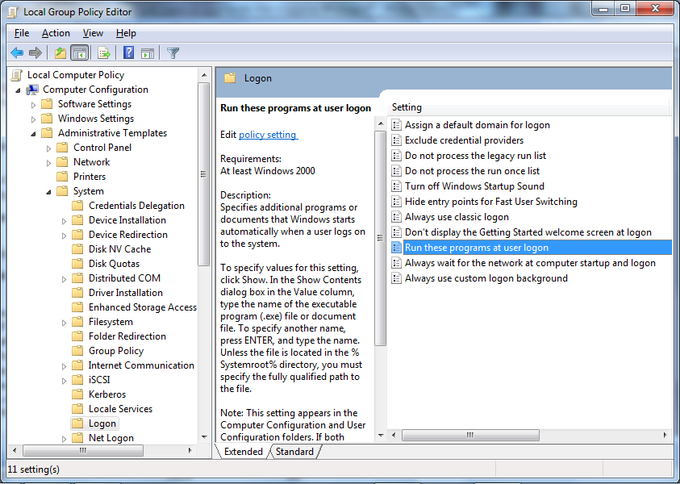

Task Manager

Ctrl+Shift+Escape

Task Manager Tabs

Applications

Shows running programs with status

Processes

Information about programs and services

“Show processes from all users” reveals processes running under system accounts

You can shut down processes here, but it can cause loss of data or a system crash

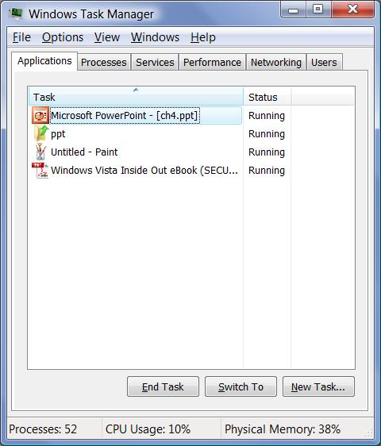
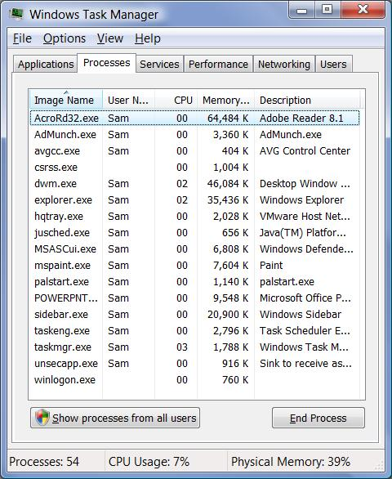
Running a Program as an Administrator

Right-click it and choose “Run as Administrator”

Launch it from the Administrator Command Prompt

Start, type in program name, press Ctrl+Shift+Enter

Uninstalling Programs

In Control Panel, under Programs, Uninstall a Program

When Programs Fail to Uninstall Properly

Remove Registry Keys Manually

See link Ch 5b
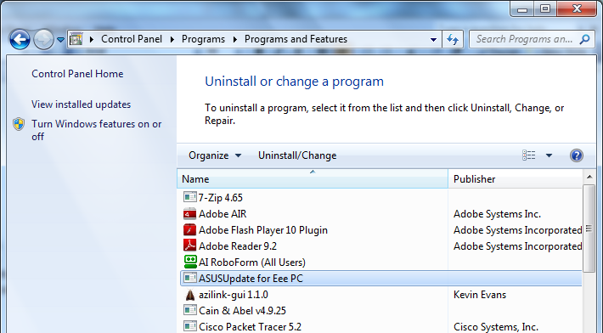

Default Programs and File Type Associations

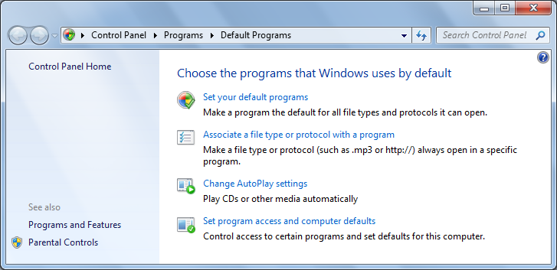
Default Programs Tool

Start, Default Programs

Set your Default Programs

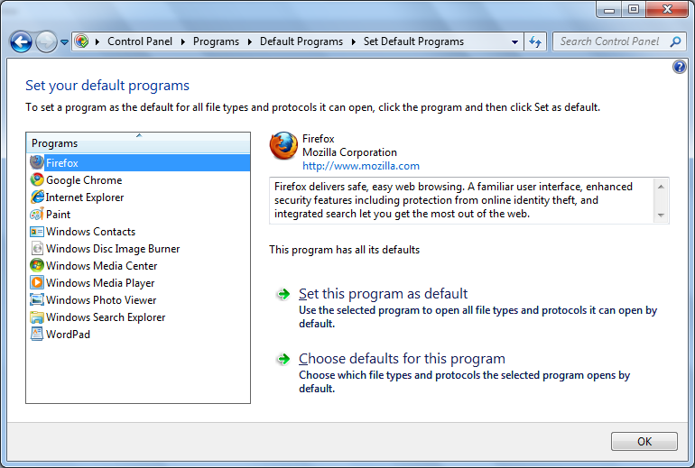

Changing File Type Associations
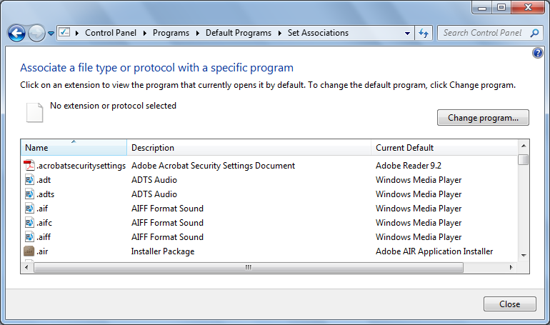

"Open With" Box

Click "Change Program" in the "Set Associations" box

Or right-click a file's icon and click "Open With", "Chose Default Program"
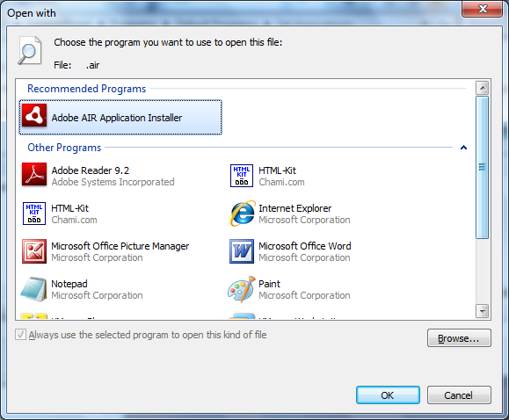

Set Program Access and Computer Defaults

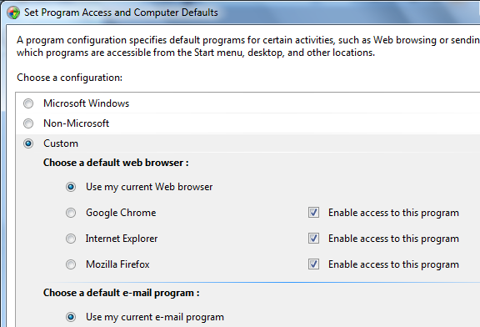
Start, Default Programs, "Set program access and computer defaults"

Added because of an antitrust lawsuit, to make it convenient to avoid Microsoft programs

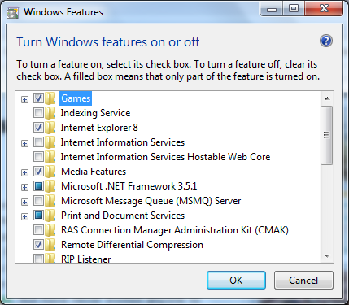

Turning Windows Features On or Off

Telnet client is not enabled by default in Windows 7

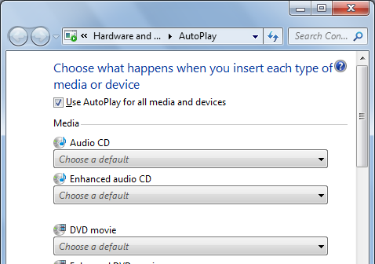

AutoPlay Options

AutoRun is now disabled on USB flash drives

Because of many powerful attacks that exploited it

Ch 6: Internet Explorer 8


What's in Your Edition?

Everything in this chapter is the same in all editions

Compatibility View

IE 8 is more compliant with W3C and IETF standards

Some pages may render better in Compatibility View, which renders them the way IE 7 did

Caret Browsing

Click Page, Caret Browsing

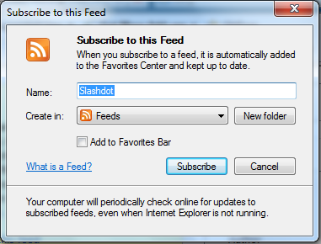
Adds a Microsoft-Word style "Caret" mark to the Web page so you can select text with the keyboard

Shift+Arrow-key selects text

Shift+Ctrl+Right-arrow selects a word at a time

Reopening Closed Tabs

Right-click a Tab, "ReOpen Closed Tab"

RSS Feeds

Pages that offer RSS feeds will be shown with the orange-and-white RSS icon on the command bar (upper right)

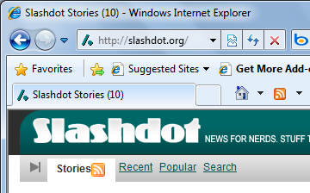
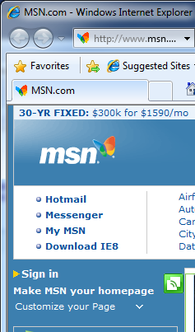
If you subscribe to a feed, it will automatically update

Web Slices

Shows as a green square symbol

Allows you to subscribe to that information like an RSS Feed

Intended for small items, like a weather forecast

Adding More Search Engines

Internet Explorer's Accelerators

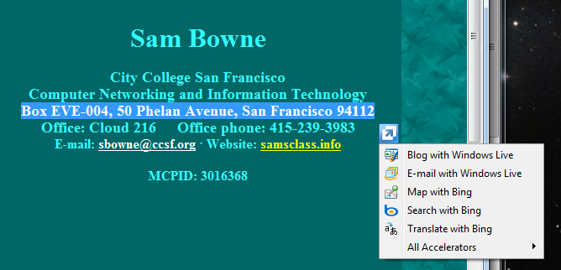
Highlight text on a page

A blue "Accelerator" button appears

Click it to see actions you can do with the text

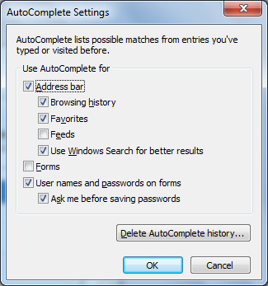

Using (or Refusing) AutoComplete

Tools, Internet Options, Content, "Options" in the AutoComplete section

Remembering passwords is convenient but dangerous

AutoComplete Password Storage

Encrypted, in the Registry

Safer than Windows XP’s storage

Security and Privacy Options

Protected Mode

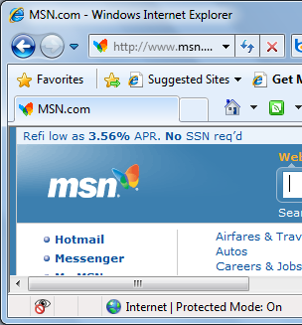
Indicated by "Protected Mode" in the Status bar at the bottom of the IE window

What Protected Mode Does

IE in Protected Mode runs with low privileges

Attempts to write to the Registry or system files are blocked and "virtualized"

Such changes are made in folders marked "Low"

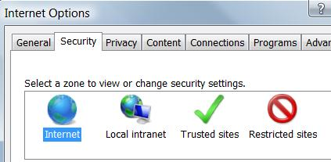

The Four Internet Security Zones

Internet

All sites that are not included in any other category

Local Intranet

Sites on your local network

Trusted Sites

(empty on a clean installation of Windows)

Restricted Sites

(empty on a clean installation of Windows)

Trusted Sites

"Medium" security level

Internet Explorer’s Protected Mode security is disabled

This allows some ActiveX controls to run

Adding Sites to the Trusted Zone

On the Security tab of the Internet Options dialog box. Click Trusted Sites

Click Sites

By default, sites must be secure (https)

Otherwise you don't really know if they are genuine

Restricted Sites

High security

Scripting disabled

This zone is the default for HTML-formatted e-mail you read using Microsoft Outlook or Windows Mail

Adding Sites to the Restricted Zone

On the Security tab of the Internet Options dialog box. Click Restricted Sites

Click Sites

No need for sites to be secure

Changing a Zone’s Security Settings

Use the slider to adjust the security level

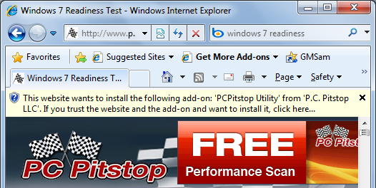
Custom level for detailed settings

Protecting Yourself from Unsafe and Unwanted Software

Authenticode

Microsoft's digital signing technology

Identifies publisher

Ensures that file has not been altered

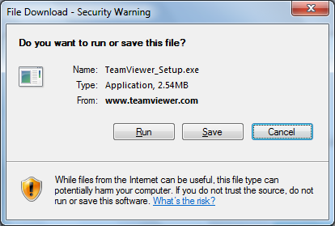
Signed controls will prompt warnings like this

Downloading Executable Files

You will see two warning boxes when running a file from the Internet
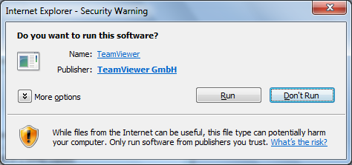

Controlling ActiveX

ActiveX controls are small programs that enhance the functionality of a Web site

They work only in IE, on Windows

Windows Update uses ActiveX

ActiveX controls are like executables that you run from the Start menu or a command line

They have full access to your computer's resources

ActiveX and Viruses

You cannot download an ActiveX control, scan it for viruses, and install it separately

ActiveX controls must be installed on the fly

You're protected from known viruses if you've configured your antivirus software to perform real-time scanning for hostile code

ActiveX Security Settings

Internet Options

Security tab

Internet

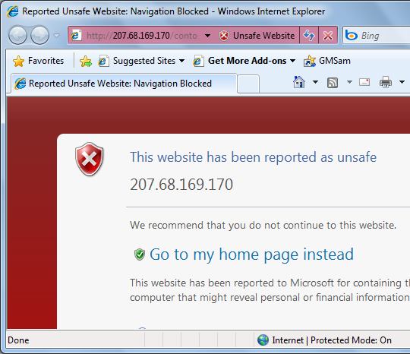
Custom Level

Using Scripts Wisely

Scripts are small programs

Written in a scripting language such as JavaScript or VBScript

Scripts run on the client computer

Using Scripts Wisely

Hostile scripts can be embedded in Web pages or in HTML-formatted e-mail messages

You can disable scripts in Internet Options, the same way you control ActiveX control security

Tip: For real safe browsing, use Firefox with the Noscript extension

Phishing Websites

IE 8 has the best warnings for phisihing websites, according to a recent test

Links Ch 6a, 6b

Managing Cookies

A cookie is a small text file

It enables a Web site to personalize its offerings in some way

Stored in %UserProfile%\AppData\Roaming\ Microsoft\Windows\Cookies

Cookies are used recording logon information, shopping preferences, etc.

Stored Cookies

The Cookies folder is a "Protected Operating System" file

Open it with Start, shell:cookies

Privacy Concerns

Cookies may contain information you typed into a Web page

This information can be read only by the site that created the cookie

BUT: Third-party cookies cheat and get around this rule (See link Ch 6c)

Platform for Privacy Preferences P3P

Internet Explorer 8 supports the Platform for Privacy Preferences (P3P) standard

You can choose to block certain kinds of cookies, while allowing the rest

Cookie Privacy Settings

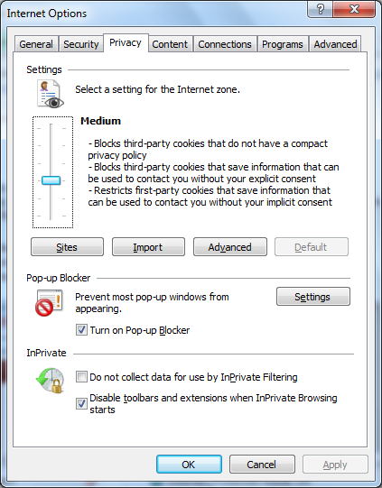
Tools, Internet Options, Privacy tab

Block All Cookies

High

Medium High

Medium

Low

Accept All Cookies

The default setting is Medium

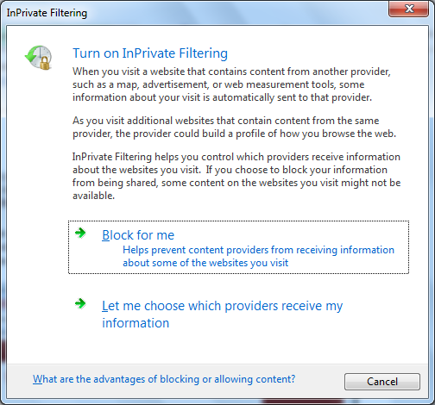

InPrivate Filtering

Click Safety, "InPrivate Filtering Settings"

Who's Been Spying On Me?

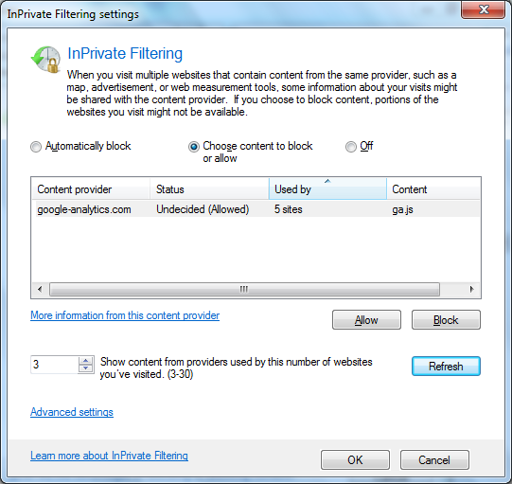
Click "Let me choose which providers access my information" to see

Clearing Personal Information

Safety, "Delete Browsing History"

InPrivate Browsing

Safety, InPrivate Browsing

Does not save history, cookies, temporary internet files

Disables toolbars and extensions

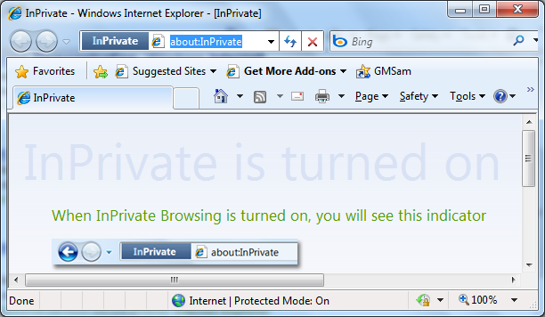

Last modified 2-8-10

