Ch 7: Adding Windows Live Programs and Services

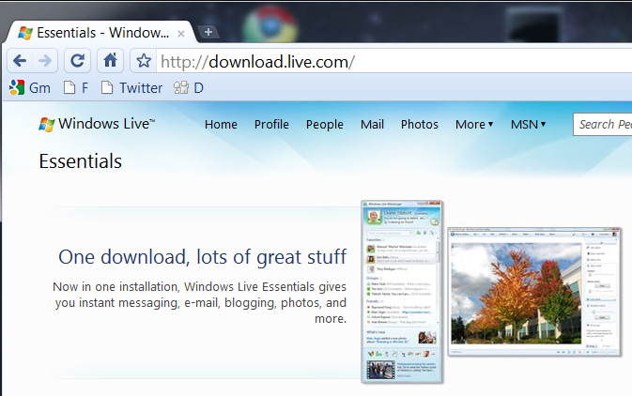
What's in Your Edition?

Everything in this chapter is the same in all editions

Windows Live Essentials

Free downloads that add functions to Windows 7

From download.live.com

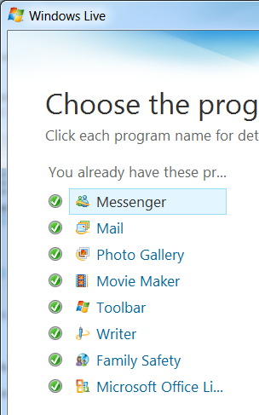

Downloading Windows Live Programs

After you click the Download button, the Windows Live Installer launches

Windows Live ID

Many Windows Live programs depend on personalized Web-based services and require a Windows Live ID

A hotmail address works

It's free

Windows Live Messenger

Instant messages, SMS text messages, games, and more
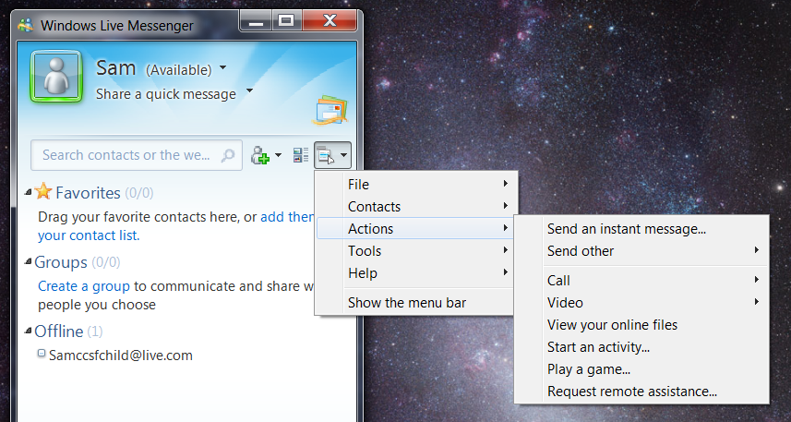

Windows Live Mail

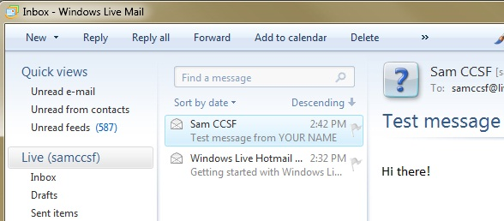
Email Client

The successor to Outlook Express

Automatically converts large images into thumbnails and links to a Windows Live server

Includes a Calendar

Other Windows Live Programs

Windows Live Writer

Used for blogs

Photo Gallery

Imports photos from cameras

Organizes them

Edit images

Upload and share photo albums

Movie Maker

Edit movie files

Family Safety

Restrict computer use of children

You'll use it in a Project

Windows Live Web Services

Social networking like MySpace

Share photos, calendar, and blog

Set your status and see what your contacts are doing

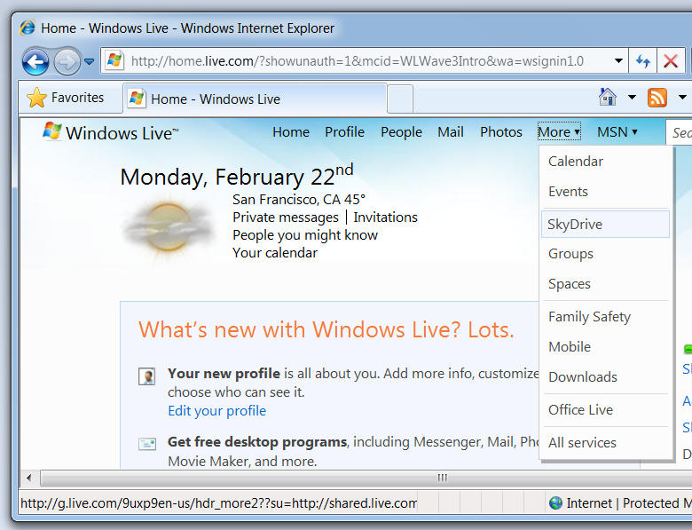
Office Live lets you collaborate on Microsoft Office documents

Sky Drive is a free online repository with a limit of 25 GB

Accessing Windows Live

In IE, go to windows.live.com, sign in

Ch 8: Finding and Organizing Files and Information

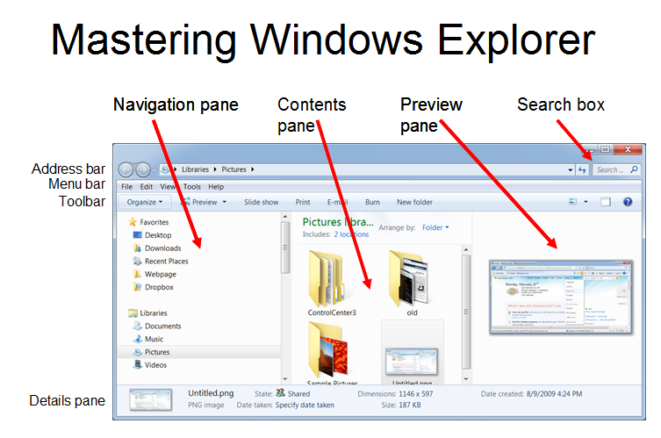
New Features in Windows Explorer

Windows Explorer now has live-icon previews

Integrated search

Versions

All the things in this chapter are available in all versions of Windows 7

Click the right side of the Address bar to see the traditional path

Organize, Layout to control panes

Press Alt to see Windows XP-style Menu bar

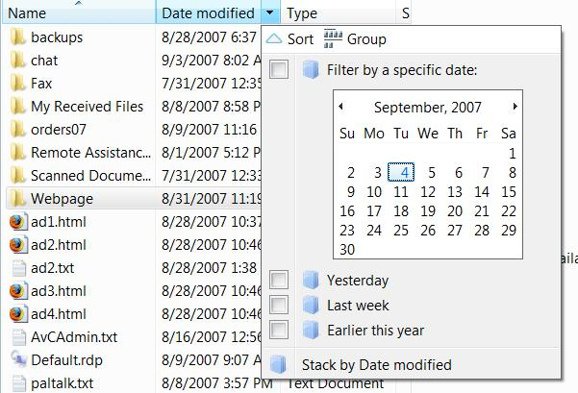
Using Headings

Click a heading to filter, sort, group, or stack (in Details view)

Adjusting Headings

Right-click a heading to change the visible headings

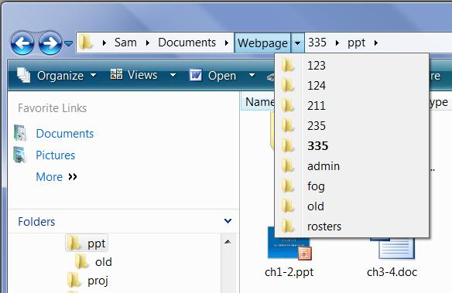
Navigating with Breadcrumbs

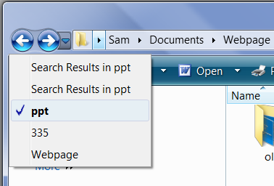

Recent Items

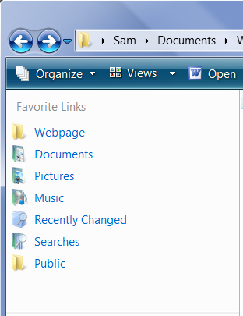

Favorite Links

Drag items to add them

Right-click to remove them
User Profiles

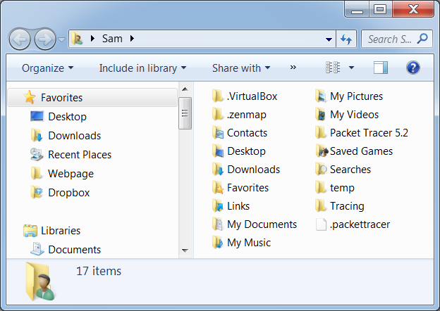
User Profile

Click Start, Your name

Personal Folders

Hidden and System files are not displayed

Favorites

Internet Explorer Favorites

Links

Shortcuts in the Favorites Links section of Windows Explorer

My Documents

There are two items in the Window Explorer profile folder named "My Documents"

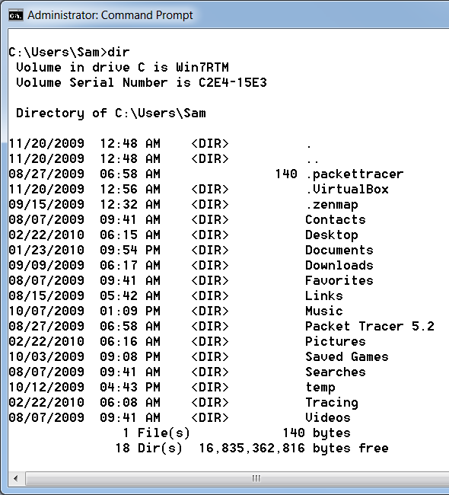
One is a junction, to be expained later

The other is an illusion, a custom display name for the Documents folder, specified in the Desktop.ini file

Real Names of Profile Folders

Use a Command Prompt to see the real names

Right-click, Rename in Windows Explorer to change the display names

Showing Hidden and System Files

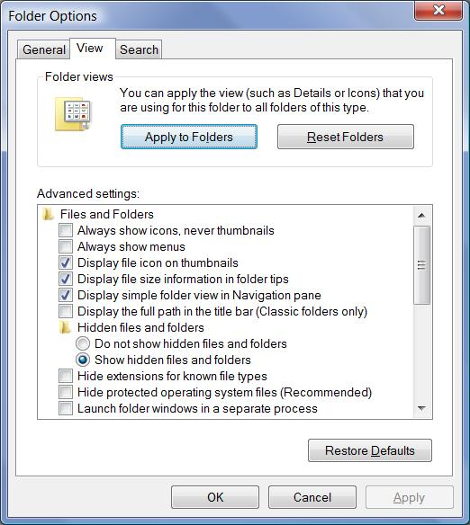
Organize, Folder and Search Options

View Tab

Check “Show hidden files and folders”

Clear “Hide protected operating system files (Recommended)”

User Profile

Click Start, Your name

This figure includes hidden and system files
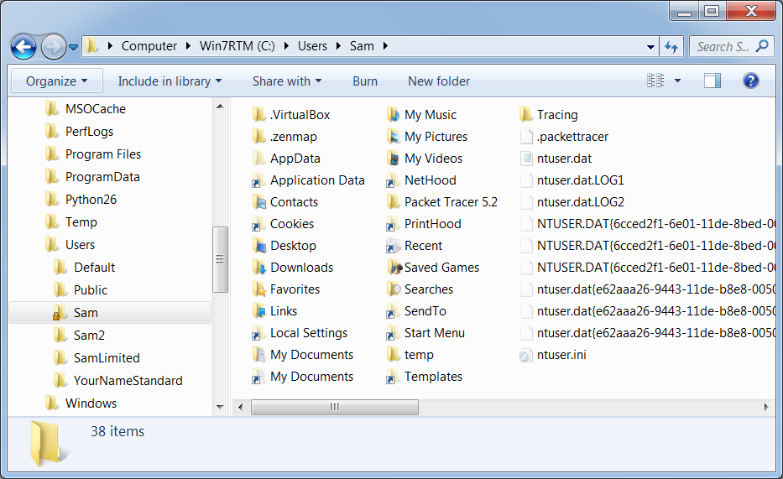

Items in a User Profile

User Profiles are Located in:

C:\Users\Username or %UserProfile%

Ntuser.dat and other registry files

Contain the HKEY_CURRENT_USER hive

NetHood, PrintHood, and SendTo for backward compatibility with Win XP

Application Data

AppData

Application-specific data in three subfolders:

AppData\Roaming

Data which can be placed on a server to form a Roaming Profile

AppData\Local

Data that should not roam, like Temporary Internet Files

AppData\LocalLow

Internet Explorer Protected Mode data

AppData\Roaming\Microsoft\Windows

Cookies

Libraries

Network Shortcuts (network shares that appear in the Computer folder)

Recent Items

SendTo

Start Menu

Templates

Junctions

Hidden Junctions that point to AppData subfolders

Application Data

Cookies

Local Settings

My Documents

NetHood

PrintHood

Recent

SendTo

StartMenu

Templates

Junctions

The Junctions, like “Application Data”, look like shortcuts but they aren’t

You can’t open them in Windows Explorer

“Everyone” is Denied Full Control

Leave them alone!

They are there to redirect data written by Windows XP legacy programs

Junctions in a Command Prompt

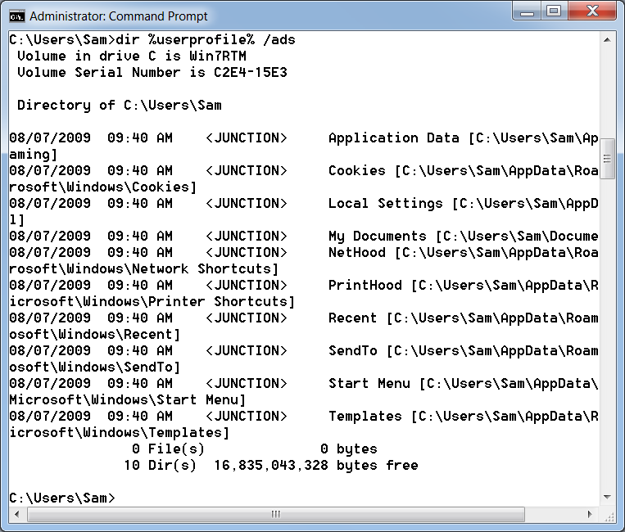
DIR %USERPROFILE% /ads

The VirtualStore Folder

Legacy applications often write to locations inaccessible to standard accounts, like C:\Program Files

User Account Control redirects such file and registry writes (and subsequent reads) to VirtualStore locations, such as

%LocalAppData%\VirtualStore

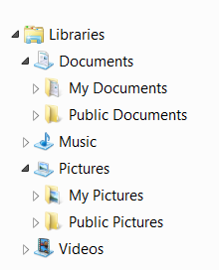
HLKM\Software\Classes\VirtualStore

Common Profiles

Public

The Public Desktop and Start Menu are merged with the current user’s profile to create the visible Desktop and Start menu

Corresponds with “All Users” profile in Windows XP

Default

New user profiles are copies of this folder

Libraries

Like "Search Folders" in earlier Windows versions

Collect several locations together in one location

Useful for large media collections, or files shared by several computers

You can create custom libraries

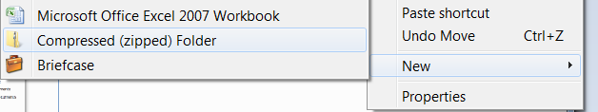
Compressed (Zipped) Folders

Right-click an empty portion of a folder

Click New, Compressed (Zipped) Folder

Drag files into the folder

Makes files much smaller, and acts like a normal folder to the user

Password protection for zipped folders is gone! (Use 7-zip)

Windows Explorer Keyboard Shortcuts

Ctrl+N open a new window

Ctrl+W close window

Alt+Up Arrow go up one level

Alt+Right Arrow go forward

Alt+Left Arrow go back

F4 move pointer to address bar and show history

File Properties and Metadata

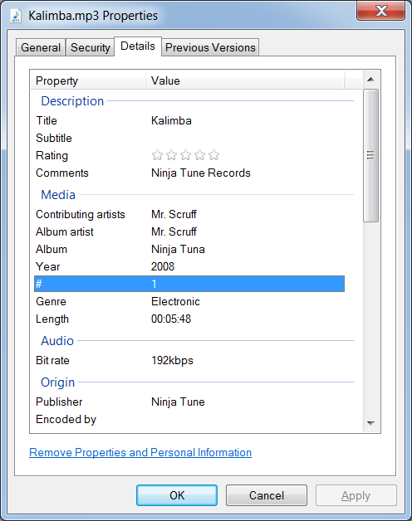
Can contain a lot of data, like the type of camera that took the photo, name of Microsoft Office user, etc.

Custom metadata is not available for PNG images

Last modified 2-22-10

