Ch 9: Using Windows Search

What's in Your Edition?

Everything in this chapter is the same in all editions

Configuring Search and Indexing Options

The Search Index is the heart of search

A database of files and folders, with names, properties, and contents

It is not intended to be directly accessed by the user

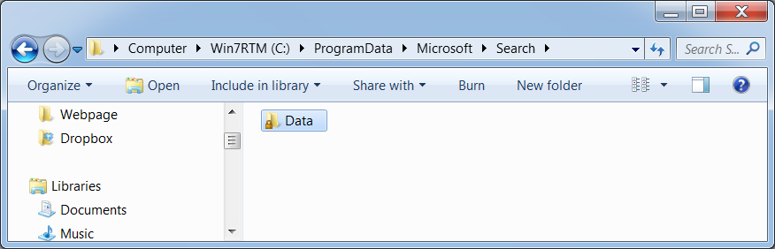
It does not index every folder

Indexed Searches

Indexed searches are fast but do not search every folder

Windows uses the Index if you search from these places

The start menu

The Search home folder

In libraries

In locations that are part of a homegroup

Non-indexed Searches

Non-indexed searches are slower but not restricted to indexed folders

Windows does not use the index for searches from places

The Computer Window

The root of a local drive

A local file folder

Building the Index

The Windows Search service crawls through indexed folders indexing files and folders

It also indexes contents of file types that have a protocol handler, such as Office documents

Protocol Handlers

Protocol handlers open files so the Indexer can read the contents

Windows 7 includes protocol handlers for Microsoft Office and Windows Live Mail files

Which Files and Folders are Indexed?

The Index includes these locations by default

Your profile (excluding AppData)

The Start menu

Internet Explorer favorites

Locally stored Email messages (if your mail client is supported)

Offline files

Folders included in Libraries

Indexing Options

Start, INDEX

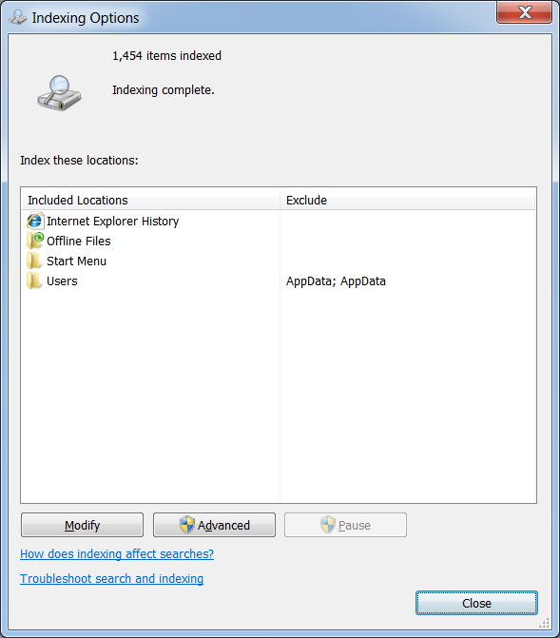
Adding folders here is clumsy and can be confusing, a better way to index them is to add them to a Library

File Formats that Support Content Indexing

HTML

MIME

Office

Plain Text

XML

Favorites, Journals, Rich Text, WordPad, XML Paper Specification

BUT no picture formats are included

Folders Excluded from Indexing

\Windows folder and its subfolders

\$RecycleBin

\Users\Default

\Program Files and \Program Files (x86)

\ProgramData (except the shared Start menu)

Indexer Status Gadget

From link Ch 9b

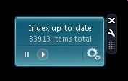
Not available at link Ch 9a when I tried it on 2-26-10

Basic Search Techniques

The Search box that appears in these places

Start menu

Upper right corner of any Windows Explorer window

Control Panel

A file dialog box (such as Save As)\

The Search option on the Start Menu is gone--Google forced Microsoft to remove it

Search Rules

Search text must appear at the beginning or end of a word, unless you use wildcards like *

Terms are case-insensitive

Searches ignore accents, umlauts, etc.

For an exact phrase, enclose search in quotation marks

Word Wheel

Search begins as soon as you type a character in the search box, and refines as you add more characters

This is really handy to find items on the Start menu

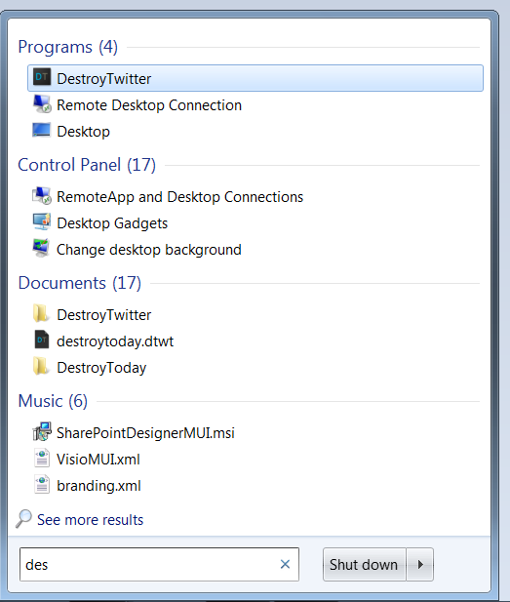
Categories

Search results from the Start menu appear in categories, with the number of items found

Click category headed, such as "Documents (17)" to see more results

Customizing Start Menu Searches

Right-click Start, Properties, Start Menu tab, Customize

Two items begin with Search
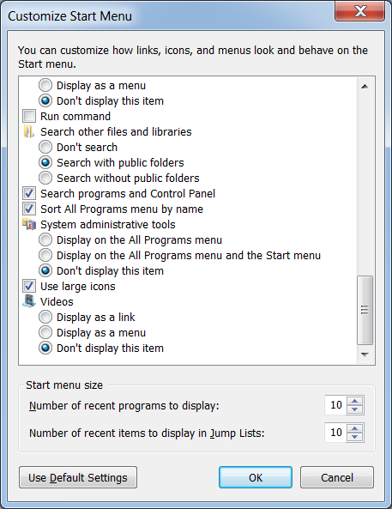

Other Programs

You can run programs like REGEDIT from the Start Menu search box, even though they are not not on the Start menu

The Start menu search looks in system folders that are not usually indexed

But the Word Wheel does not work in those folders--you must type the whole name

Search Filters

Appear below search box when you type letters in

Can also be typed into any search, like type:ppt
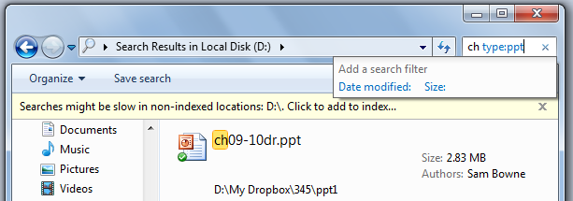

Searching Nonindexed Locations

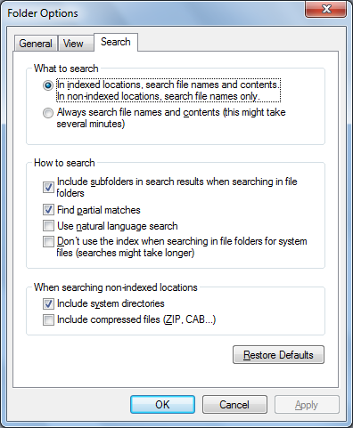
Click the information bar to add more locations to the Index

Searching in System Folders

In Folder Options

In "When searching non-indexed locations" section, check "Include system directories"

grep Searches

In the "How to search" section, check "Don't use the index…" to force "grep Searches"

grep stands for global | regular expression | print, the old-fashioned slow search that does not skip any folders
Ch 10: Advanced File Management

What's in Your Edition?

Offline Files and Encrypting File Systems are only available in Windows 7 Professional, Enterprise, or Ultimate editions

BitLocker Drive Encryption is only available in Enterprise and Ultimate editions

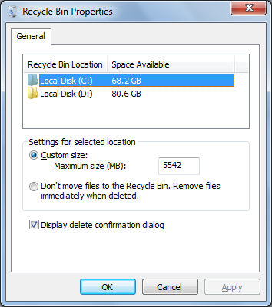
BitLocker To Go volumes can be locked and unlocked in any version of Windows 7, but can only be created in Enterprise and Ultimate editions
Recovering Lost, Damaged, and Deleted Files and Folders

Lost and Deleted Files

Lost Files

Use Windows Search

Accidental Deletions

Recovery Bin

Previous Versions

Backups

Files That Do Not Go Into the Recycle Bin

Files stored on removable disks

Files stored on network drives

Files deleted from a command prompt

Files deleted from compressed (zipped) folders

Files deleted with Shift+Delete

Changing Recycle Bin Settings

By default, 10% of each drive is used for the Recycle Bin

Restoring Files and Folders
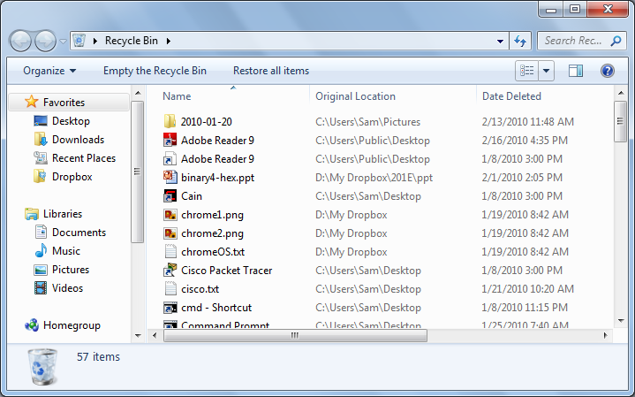

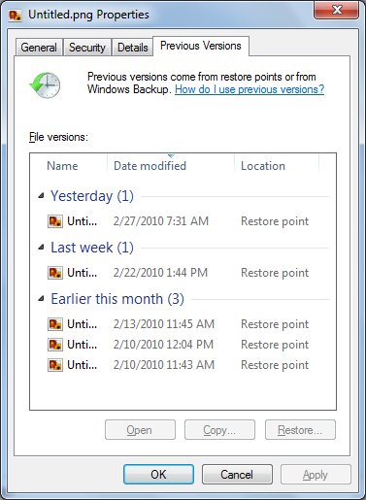
Previous Versions

Restore Points are created every day, with backups of your files

They appear in file Properties
Synchronizing Files Between Multiple Computers

Synchronizing Files

To keep files located on a server available, mark files or folders "Always Available Offline"

Requires Win 7 Professional or higher

Windows Live Mesh or Windows Live Sync

Available in all versions

Offline Files

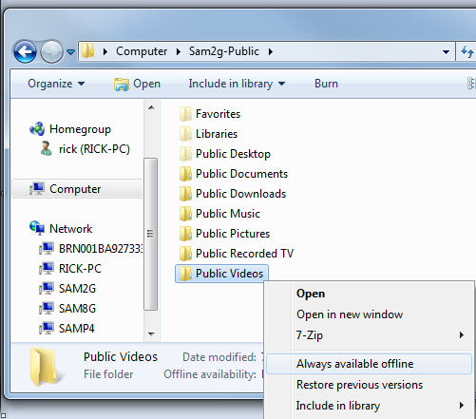
Windows caches the files on your computer

Files synchronize whenever you reconnect to the network

Also every six hours when you are connected

On demand--useful just before you disconnect to travel

Making a File or Folder Available for Offline Use

In Windows Explorer, right-click file or folder, click "Always available offline"

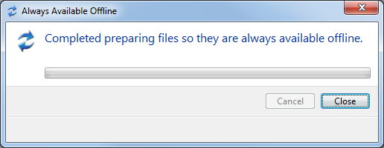

The "Always Available Offline" box appears as Windows synchronizes the file

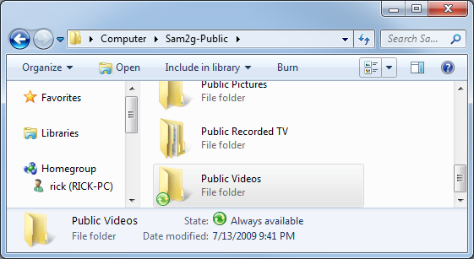

"Sync Center" icon

This green mark indicates objects that are available offline

Status at bottom shows "Always available"

Disabling Offline Files

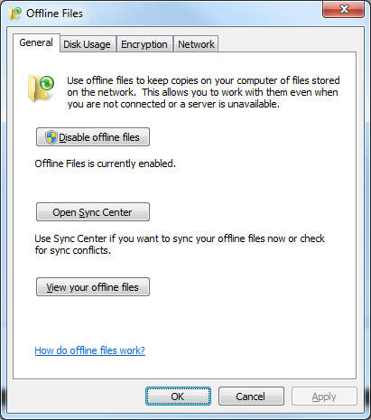
Start, OFFLINE, "Manage offline files"

Offline Files is enabled by default

Encrypting Offline Files

Logo, OFFLINE, "Encrypt your offline files"

Changing the Amount of Disk Space Used by Offline Files

In "Manage offline files"

You can also encrypt offline files here

Live Mesh

Live Mesh (Beta)

5 GB of free space

Automatically synchronizes on Windows 7, Vista, XP, or Mac OS X

Synchronizes on devices

Synchronize in a peer-to-peer fashion

Access devices in your mesh remotely

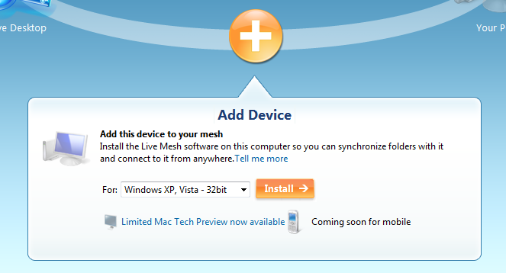
www.mesh.com

Log in with a Windows Live Account, click "Add Device", Select OS, Install

I used Vista for Win 7

Installing Live Mesh

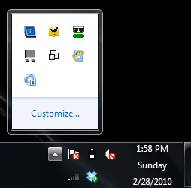
Live Mesh icon appears in Notification Area

Installation progress shown with alert box

After 15 minutes or so, it completes and asks you to sign in again
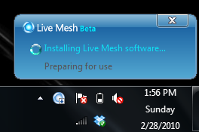

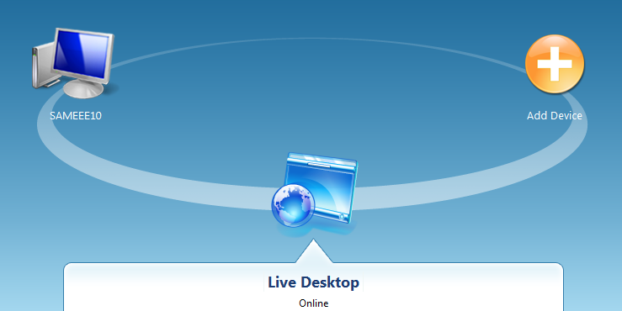

Device Installed

Your device appears on the mesh site

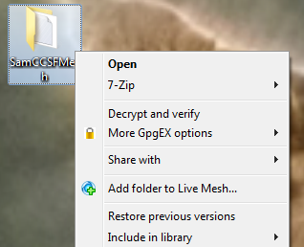
Adding Folders to Live Mesh

Right-click a folder or file to add it to Live Mesh

Folder icon turns blue
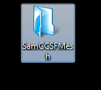

Mesh Bar

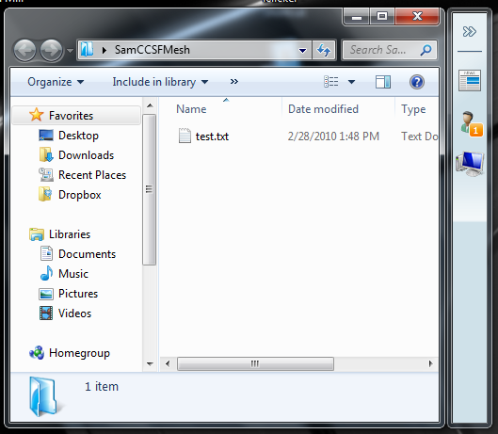
Live Mesh bar appears on the right side of the folder

You can see when the folder updated, what devices it is shared with, and who it is shared with

Remote Control with Live Mesh

Clicking a device in the Live Mesh page enables you to remotely control it!

You will need valid logon credentials

Works via Remote Desktop

See link Ch 10a
Windows Live Sync

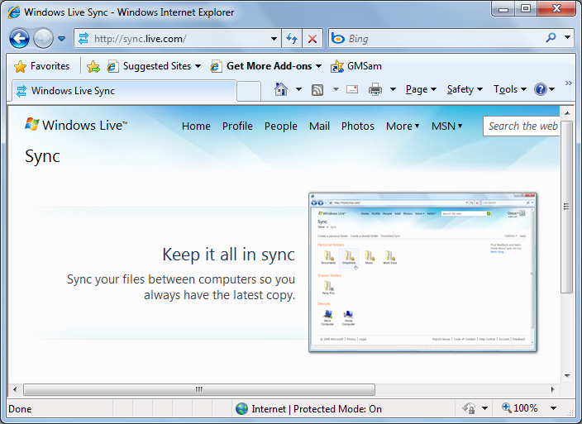
Sync.live.com

Download Live Sync software on each computer you want to use

Available for Win XP or later and Mac OS X

What Live Sync Does

Synchronize and share up to 20 folders

Create personal and shared folders

Folders can contain up to 20,000 files each

Files can't be larger than 4 GB

You can browse remote computers

You cannot remote-control other computers

SkyDrive

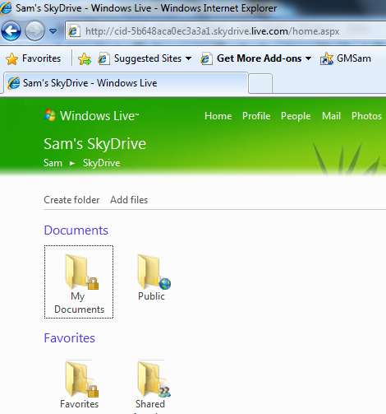
Click Skydrive to see your folders

25 GB of free storage

Social networking, blogging, friends, like MySpace

Relocating Personal Data Folders

Why Relocate Personal Folders?

Large collections of media files can fill the system drive

Separating system from data files makes it simpler to repair or reinstall the OS

Backups are simpler

New Alternative: Libraries

You could leave the default folders alone, like My Documents

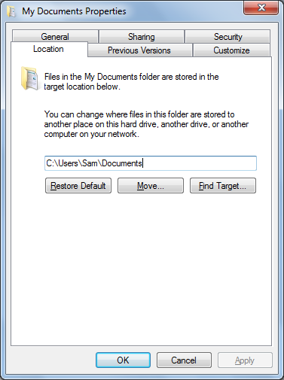
Create other folders for your data and add them to Libraries

Relocating Personal Folders

Start, click your name

Right-click My Documents, Properties

Location Tab

Works for the other folders too, such as My Pictures

Indexing Relocated Folders

The Windows Search Index won't automatically index relocated folders

You have to add them to the index list manually

Encrypting Information

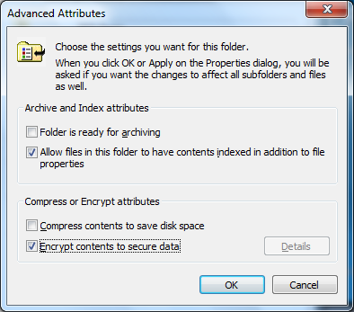
Encryption Options

Encrypting File System

Only available on NTFS drives

Tied to your logon password

BitLocker Drive Encryption

Encrypts whole disk volumes

Best with a Trusted Platform Module chip on the motherboard

BitLocker To Go

New in Windows 7

Encrypts USB flash drives

Encrypting File System (EFS)

In Folder Properties

Click Advanced button

Filenames turn green

Uses 256-bit AES (very secure)

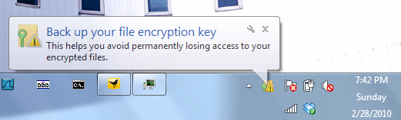
You need to back up your key or you might lose your files

Backing Up Your Key

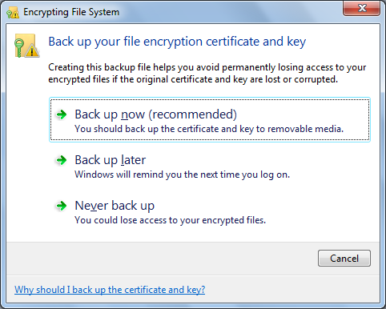

Click the alert to see this box

Green Letters

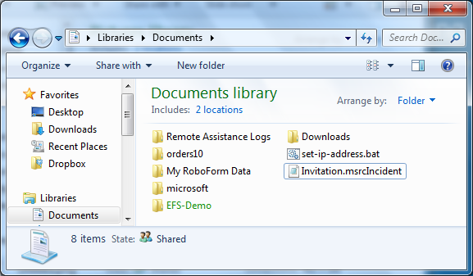
Indicate encrypted folders

BitLocker Drive Encryption

Encrypts entire NTFS volumes

Protects data even if the computer is stolen

Starting the computer requires a key which is on a USB stick, or in a Trusted Platform Module (a special chip on the motherboard)

Only available in Windows Enterprise or Ultimate

Details at links Ch 10b, 10c

BitLocker To Go

Encrypts removable devices, such as USB flash memory or hard drives

Don't encrypt my removable hard drive in the S214 lab--there are flash drives you can use

You can only create a BitLocker To Go encrypted drive with Windows Enterprise or Ultimate

But you can open it for reading in any version of XP, Vista, or Windows 7 (But you need to use a FAT filesystem, not NTFS)

RoboCopy

Allows copying all NTFS attributes

Can mirror entire folder hierarchies

Works on local volumes and over a network

Useful for backups

Link Ch 10d

Last modified 3-1-10

