Chapter 11 - Backup, Restore, and Recovery

Topics

Windows backups

System Protection

System Restore

Editions

All editions of Windows 7 include Windows Backup and can create and restore from both file backups and image backups

Backing up to a network drive is only allowed with the business editions: Professional, Ultimate, and Enterprise

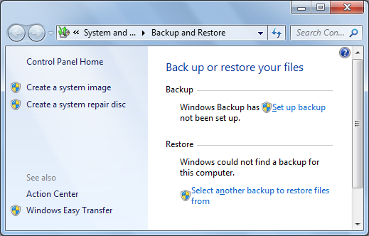
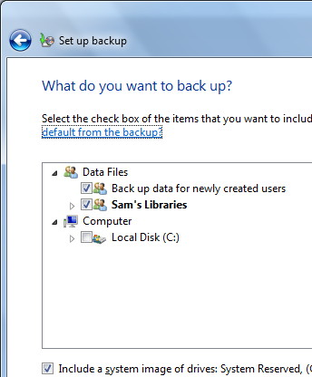
System Protection is the same in all editions

Backup

"Create a System Image" in the left pane makes a one-time image backup of your system,

"Set up backup" schedules backups on a periodic basis

By default, both file and image backup weekly

Two Kinds of Backups

File Backup

Backs up personal files, not programs or system files

Image Backup

Creates an image of your entire system drive and other drives you specify

This saves the OS, installed software, settings, profiles, etc.

Backup Destinations

An internal hard drive

It's recommended not to use another partition on the same hard drive 7 is installed on, because a disk failure will destroy the backups

An external hard drive

USB 2.0 or IEEE 1394 (FireWire)

A shared network location

Requires Win 7 Professional or better

Removable media, such as writable CDs or DVDs

The Backup program will prompt you to swap media as needed

Customizing a Backup

By default, everything in all user profiles and libraries are backed up

And an image of the system drive

So the easiest way to add folders to the backup is to add them to a library

Creating a System Image Backup

A complete image of the system partition, and any others you specify

Allows complete recovery from a disaster, such as a nasty malware infection

Images after the first one only include incremental changes, so they are faster and smaller

Network backups to the same location replace the old backup! It's safer to choose a different network folder for each backup.

Restoring Files

In "Backup and Restore", click "Restore My Files"

You can search through the backup to find the files you want

Restoring a System Image

Boot from Win 7 install DVD, or a System Repair Disc you made during the backup process

Select a system image from the list and start the restore

You can restore a whole system from an image on a USB hard drive in 20 minutes

You can also restore to a different computer to make a clone machine

Warning About Documents

Restoring a system image will also replace all your documents with old versions

Including emails, IE Favorites, desktop, etc.

BACK UP YOUR DOCUMENTS FIRST!

Restoring to Different Hardware

The target system must have as many hard drives as the original system

They must be at least as large, even if the first system was not full

It's OK if the drives use different controllers: SCSI, PATA (IDE), or SATA.

Different expansion cards, such as graphics cards, are OK too

Manage Space

In "Backup and Restore", click "Manage Space"

Manage Backup Files

This tool is the best place to control backup files
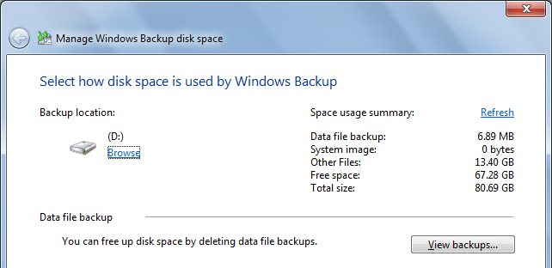

Viewing Backup Files

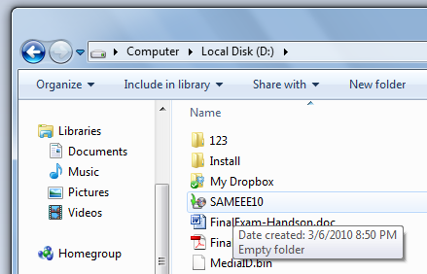
Backup folders will appear empty in Explorer, because only the System account has permission to read them

Viewing Backup Files

File backups are stored as normal Zip files

They can be opened on any system, not just Windows 7

To see them, you must give yourself NTFS permissions

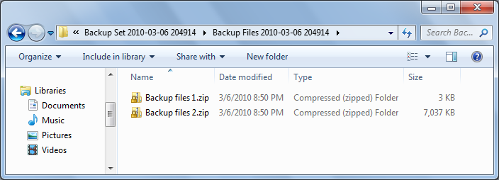

System Protection

System Protection uses these features

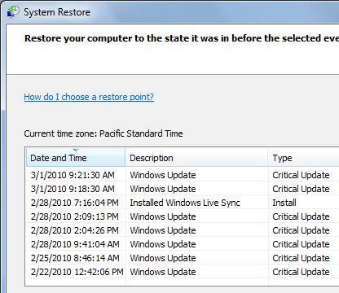
System Restore

Takes snapshots of local storage volumes

Now includes both system and data files

Shadow Copy Service

Can copy files even while they are in use

Previous Versions

Used to recover old versions of files

Restore Points

Win 7 creates a restore point every 7 days by default

XP and Vista did it every day

When Restore Points Are Created

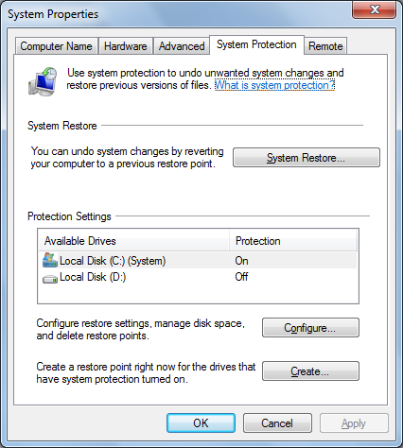
An application is installed with a compatible Vista or Win 7 installer

Windows Updates

System Restore is performed

A Restore Point is made first so the System Restore can be reversed

Windows Backup

A Restore Point is created as part of the backup process

System Restore Options

Start, right-click Computer, Properties

Advanced System Settings

By default, it only monitors the system drive

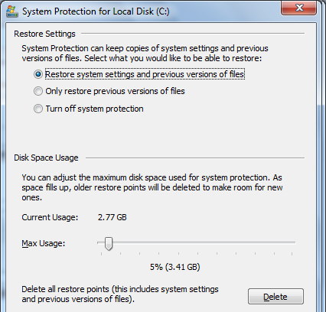

Restore Settings

Click Configure

Choose whether to monitor system settings or just files

"System Settings" includes the Registry and many other system file types

Disk Space

By default, System Protection uses 5% of the volume or 10 GB, whichever is less (for volumes 64 GB or larger)

On small volumes (less than 64 GB) it uses 3% or 300 MB, whichever is larger

System Restore Files

In C:\System Volume Information

You can't open this folder, or even take ownership of it

It's only intended for System access

Win XP and Restore Points

A Win 7 / Win XP dual-boot machine will have a problem

Booting into XP will erase all Win 7 restore points

This is caused by an incompatibility with NTFS journal versions

I don't know any way to prevent this

Link Ch 11a

Rolling Back with System Restore

Useful when

A newly installed program conflicts with software or drivers on your system

Updated drivers cause problems

Performance or stability problems appear for no apparent reason

System Restore can NOT save you from viruses or other malware

You need real antirvirus software

How to Use System Restore

Start, RESTORE, "Restore your computer to an earlier time"

"Open System Restore", Next

Choose a Restore Point

The restore process cannot be interrupted

The restore process is reversible

System Restore Do's and Don'ts

Newly created user accounts will stop working

System Restore does not uninstall programs, but it deletes most program files, leaving some junk behind

Changes made in the Windows Recovery Environment (booting from the install DVD) are not monitored

A System Restore can be performed in Safe Mode, but such a restore cannot be undone
Ch 12: Playing and Organizing Digital Media Files

Editions

Windows Media Player 12 is included in all versions of Windows 7

But the decoder needed for playing DVDs is not included in Starter or Home Basic

You need to upgrade to Home Premium (see link Ch 12a)

"Home Basic" is an obscure version not sold in the USA

File Formats and Codecs

Container formats define the way data is stored

Codecs are used to compress and decompress the data

To play a file, you need a supported container format and also the required codec

Supported File Formats

Windows Media Player 12 has built-in support for many popular audio and video formats—including 3GP, AAC, AVCHD, MPEG-4, WMV, and WMA. It also supports most AVI, DivX, MOV, and Xvid files.

This includes unprotected music from iTunes (AAC)

Link Ch 12b

Adding and Updating Codecs

Windows Media Player includes some codecs, including DivX and Xvid, but not all of them

You can download and install codecs from third-party sources, but they are risky

They can cause crashes, or even contain malware

Set a Restore Point before using third-party codecs

Advanced System Format (ASF)

A container format

Can contain audio, video, or both

Windows Media Audio (.wma)

ASF file compressed with WMA codec

Windows Media Video (.wmv)

ASF file compressed with WMV codec

ASF file (.asf)

Uses the ASF wrapper but has some other codec

Windows Media Metafiles

XML files containing plain text

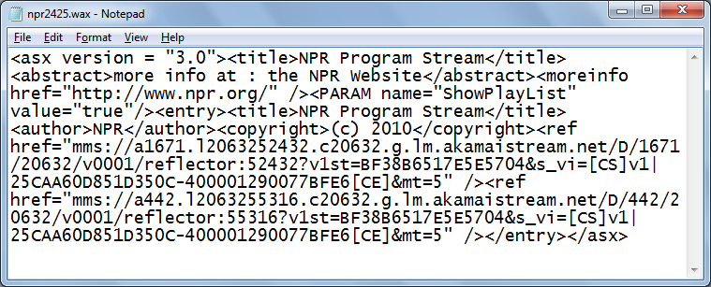
Redirect Windows Media Player to streaming media on Web servers

Filename extensions end in X

.asx, .wax, .wvx, .wmx

Example WAX File

From npr.org (link Ch 12c)

AVI and MOV

AVI and MOV are container formats used for video (with or without audio)

Audio Video Interweave (AVI) is from Microsoft

QuickTime (MOV) is from Apple

Windows Media Player support for MOV is incomplete

You may need Apple's QuickTime Player

MPEG

Moving Pictures Experts Group (MPEG)

An open standard

MP3 audio format--widely used and supported by almost every system (.mp3)

MPEG-2 videos are DVD quality

.mpeg, .mpg, .mpv, .m2v

MPEG

MPEG-4 audio

Also called AAC (Advanced Audio Encoding)

Higher quality and smaller sizes than MP3

Default format for iPod, iPhone, iTunes

Windows Media Player can play .m4a files

But .m4p files are DRM-protected and can only be played with an authorized copy of iTunes software

Recorded TV

Microsoft Digital Video Recording

.dvr-ms

Used by older versions of Windows Media Center

Windows TV

.wtv

New format for recording TV with Windows 7's Windows Media Player

TV recording requires a TV Tuner

CD Audio

If you open a music CD in Windows Explorer, you see each track listed as a CD Audio File, with a .cda extension

These are not really files

They cannot be copied to the Windows file system

Windows Media Player

Plays sound and video from local storage devices, including CD, DVD, hard disk, and flash drives

Stream the output across a network

Rip tracks from audio CDs to hard disk files

Create custom CDs and DVDs

Download songs to a portable music player, but not to a Zune or iPod

Using Windows Media Player

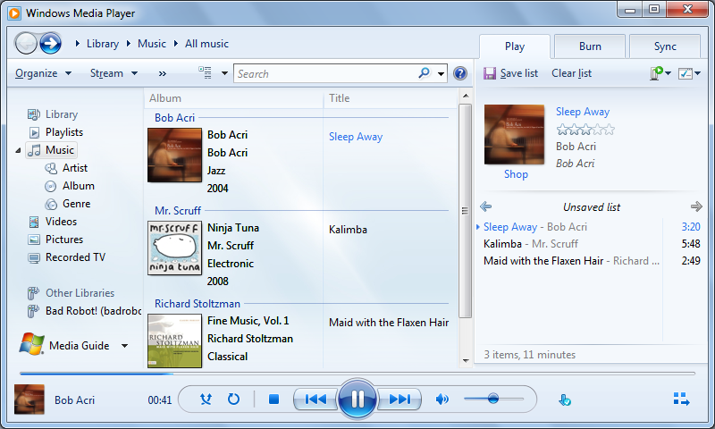
Straightforward--we'll skip pages 412-426

Ripping CDs

Ripping is copying music tracks from an audio CD to a hard disk file

The copies are unrestricted--no DRM!

You can play them anywhere, make more copies, etc.

Insert a CD, and in Windows Media Player, click "Rip CD"

Ripped files go to your Music folder

Compressing Music

Uncompressed music is huge--500 MB for an hour of music

Lossy compression degrades audio quality

This is the most popular choice

Usually the lost quality is not noticeable

Audio Format and Bit Rate

MP3 - most freedom, plays on almost every device

Windows Media Audio - default

Fixed bit rate is default setting

Variable bit rate improves quality for the same file size, but might not play in older players

Windows Media Lossless

Smaller than WAV

WAV (Lossless)

Uncompressed, huge files, easy to play on any device

This is essentially what raw music .cda tracks are

Windows Media Audio Pro

Intended for phones

Skip pages 432-438

Digital Rights Management

Files are encrypted to prevent copying

You can purchase DRM-Free files from iTunes and other retailers

You can also use pirate tools to remove DRM from files

That can be a serious offense under the Digital Millennium Copyright Act--fine is $750 per song per copy!

Last modified 3-8-10

