Chapter 13 - Sharing and Syncing Digital Media

Topics

Sharing Digital Media over a Network

Synchronizing Digital Media with Portable Devices

Burning Music and Other Media to CDs and DVDs

Creating and Sharing Picture and Video DVDs

Windows Media Player

Windows Media Player can

Play media on a single PC

Fetch media from another device on a network, even over the Internet

Sling media to another device on a network

Transfer your collection to a portable device (but not an Apple or Zune device)

Editions

Windows Media Player is included in all editions of Windows 7

Homegroups can only be created with Home Premium or better

Starter and Home Basic editions can join a homegroup that already exists

Windows DVD Maker is only available in Home Premium or better

Sharing Digital Media over a Network

Play media directly from another computer in your Homegroup

Play tunes from a shared music library

The shared library can be on a computer using any operating system

The music will be sent streaming

Send music from your computer to play on an other computer or device

Media Streaming Options

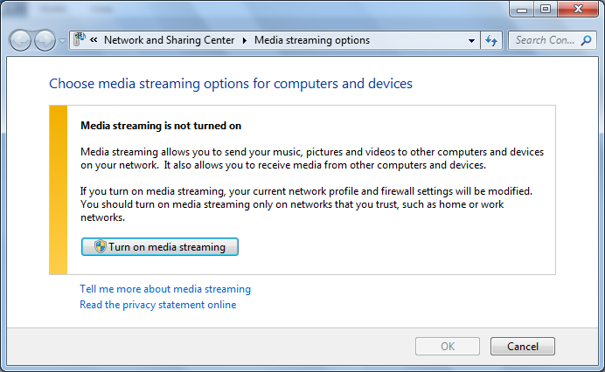
Start, "MEDIA STREAMING"

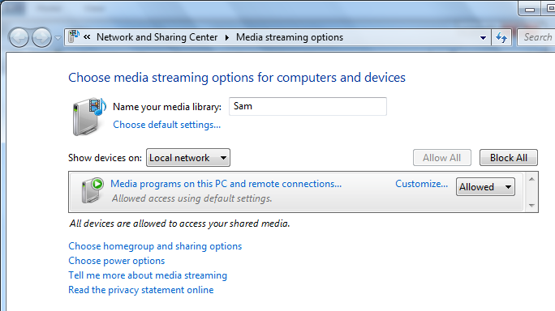

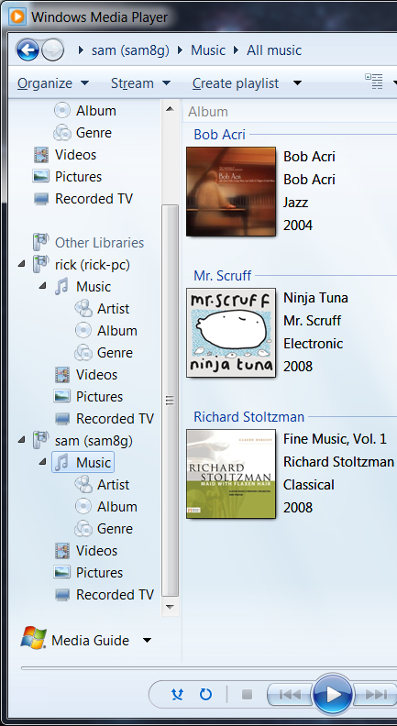
Other Libraries

In Windows Media Player

Restricting Shared Media

In Windows Media Player, click Stream, More Streaming Options

Click "Choose default settings…", or for a specific PC, click "Customize…"
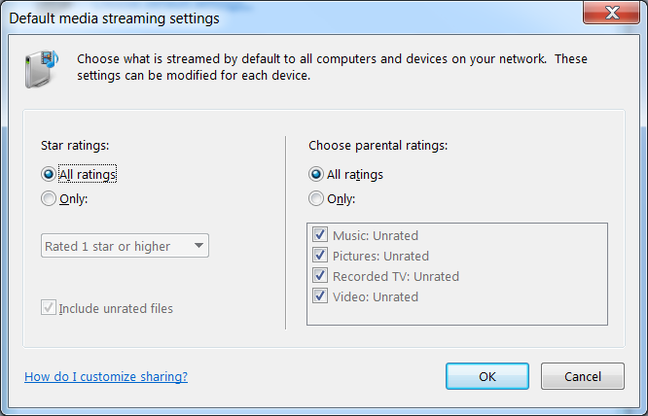

Streaming Music Properties

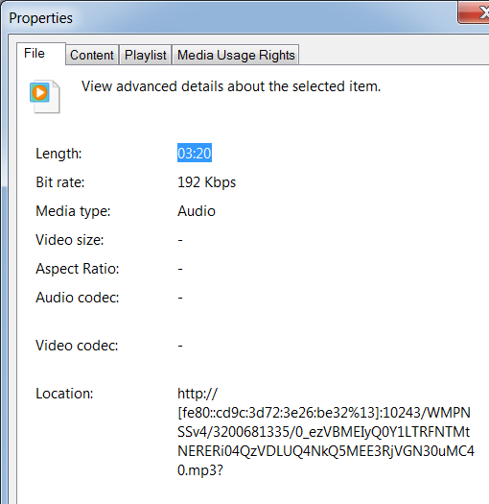
Play streaming media

In the lower left of Windows Media Player, right-click the album cover and click File, Properties

You see IP address, Port, and a complex file path

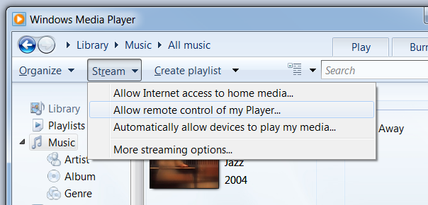

Streaming Digital Media to Other PCs or Devices

To allow this, on the target PC, in Windows Media Player, click Stream, "Allow remote control of my Player"

Only allowed on Home and Work networks

On controlling PC, in Windows Media Player, right-click a song and click "Play To" to send the music

This feature has bugs (see p. 445)
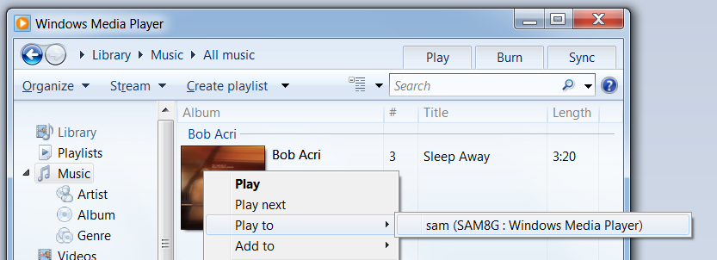

Remote Streaming over the Internet

Connect your Windows Live ID with your user account on both PCs

"Allow Internet Access To Home Media"

Synchronizing Digital Media with Portable Devices

Works with USB flash drives, flash memory cards, or phones that run Windows Mobile

Does not work with iPhones or Zunes, they require special software (iTunes and Zune)

Automatically transfers your library to the device, and adds new songs to the device

Does not work the other way--songs added ti the device are not automatically copied back to your PC

Burning Music and Other Media to CDs and DVDs

Windows Media Player can burn

Audio CD

Plays in any CD player

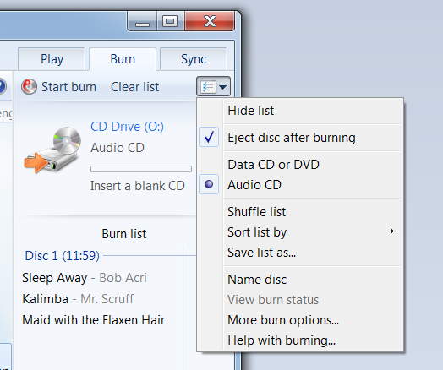
Does not display album and track information on a car CD player

Data CD

MP3 and WMA files

Plays back on any computer or MP3 or WMA player

Data DVD

Not the same as a video DVD

Holds data files, like a data CD

Burning

In Windows Media Player, click the "Burn" tab

Drag items to the Burn List in the lower right

Use the tiny "List Options" button on the top right to select burn type

Creating and Sharing Picture and Video DVDs

In Windows DVD Maker, you do two steps

Select pictures and videos

Add a title and create a menu that can be navigated with a remote control

Then you burn the DVD

Ch 14: Using Windows Media Center

What Is Windows Media Center

Windows Media Center

Serves as an alternative, simpler interface to Windows Media Player

Can record TV if you have a TV tuner

Editions

Windows Media Center is only included in Windows 7 Home Premium or better

Setting Up and Customizing Windows Media Center

Launching Windows Media Center

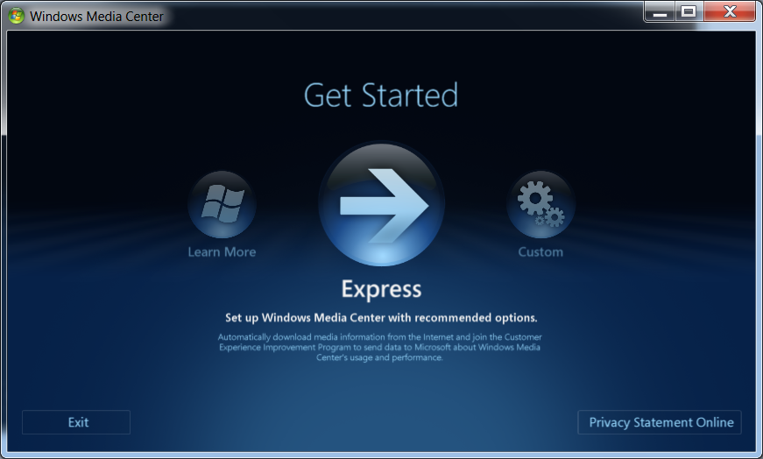
Start, Programs, Windows Media Center

Or the green button on a remote control that has been set up for use on a PC

Express

Express lets you start playing your media immediately

Using the Media Center Interface

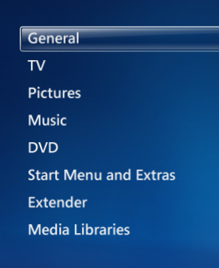
The interface is designed to be operated from ten feet away with a remote control

Lists are "strips" that wrap around

Hover over Media Center

Click the green circular button to go to the Start Page

Use the arrow keys to move up and down through menus

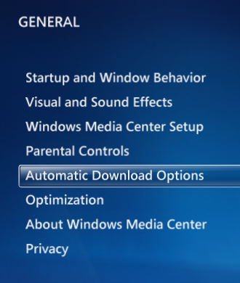
Find Tasks and use right and left arrows to select Settings, then press Enter

Settings Strip (on right)

General Options

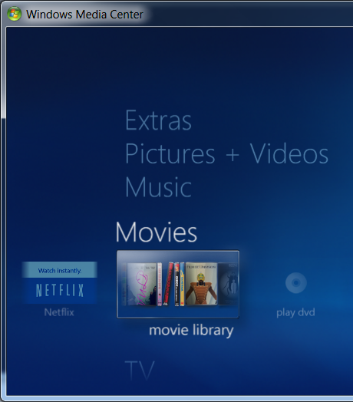
Start Menu

Pictures & Videos, Music, and Movies, lead to your galleries

Extras include games and online services

Tasks--customize settings and hardware

Third-party developers can add strips, such as Sports

Navigating with a Remote Control

Back - like a browser's Back button

Page Up/Page Down - move one screen at a time through galleries and the guide

Replay/Skip - jumps 7 seconds back or 30 seconds forward

Guide - opens a TV guide

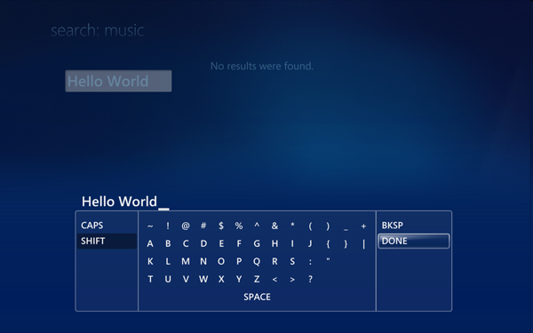

Entering Text with a Remote Control

Use On Screen Keyboard and select letters one by one with the arrow keys, press OK to select them

Image from link Ch 14a

Using Media Center with a Mouse or Keyboard

Move the mouse in the Media Center window

Mouse controls appear on lower right and upper left

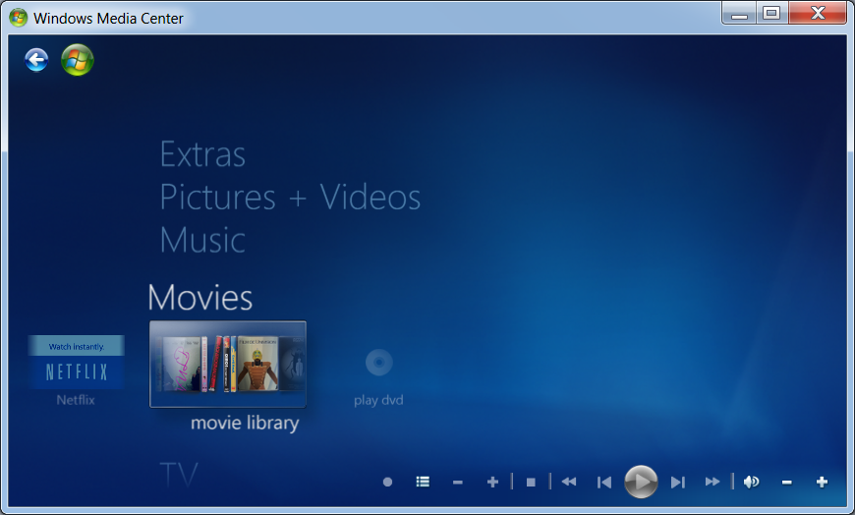
There are also keyboard commands (p. 475)

CDs, DVDs, and Devices

Adjust AutoPlay settings as desired

Without AutoPlay, the new CD appears in the top left slot in the Media Library but does not immediately play
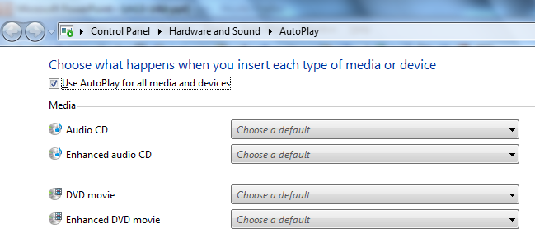

Recording and Watching TV

Media Center allows you to control; Media Player's TV features with a remote control

To record TV, you need a TV tuner (internal or USB) and a TV signal (such as Cable TV)

Media Center remote control also requires its infrared receiver which can be built-in to the computer or connected by USB

Over The Air (OTA) Broadcasts

OTA broadcasts are now all digital in the USA

They can be recorded in high-definition TV (HDTV) format

Premium Channels

You need a digital tuner that can decrypt the protected content

You can purchase special hardware to enable your computer to receive encrypted content, but you cannot move the card later

You can easily lose access to the content you've paid for

Recording TV Programs and Series

Using your remote control, you can easily program your computer to record TV shows

Files are saved in the Windows Recorded TV Show format

3 GB or more for an hour of TV

Enforces copy protection: you cannot play a protected file on a different device

The new PlayReady system should enable all devices in your HomeGroup to play the content

Watching and Managing Recorded TV

In Windows Media Center, go to the Start page and choose "Recorded TV" from the TV strip

Space Management

Media Center will delete old recordings to make room for new ones, when necessary

You can burn files to DVD for archiving (if they are not protected)

Connecting and Using a Media Center Extender

A hardware device that connects a home entertainment center through a network to your PC

Xbox 360 can act as an extender

Extenders work via Remote Desktop

Access is restricted by an eight-digit Setup Key

Issues with Media Extenders

Wireless networks may not have enough bandwidth to stream high-definition videos

There is a "Tune Network" option to detect and attempt to correct this problem

Extenders work with Windows Media codecs and MP3

But DVDs and Blu-ray discs won't stream

Last modified 3-15-10

