Ch 15: Security Essentials

Understanding Security Threats

Essential Security Measures

Firewall

Updates

Antivirus

Antispyware

Action Center

Editions

All the security software in this chapter is the same in all editions, except

Group Policy

Only present in Professional, Enterprise, and Ultimate versions

Security Threats

Virus

Code that attaches to another program

Spreads when the infected program runs

Worm

A independent program

Usually spreads through networks, by email or instant messaging, or blogs, etc.

Security Threats

Spyware

Software that is installed without user’s knowledge

Records personal information

Causes ads to display

Malware

Includes all these

Remote Access Trojan allows a criminal to control your machine remotely, so it becomes a bot in a botnet

What’s New in Windows 7

Windows Firewall

Now monitors outgoing traffic (but does not block it by default)

Firewall profiles

Advanced configuration console is much more complex than any previous Windows Firewall

User Account Control (UAC)

Helps to prevents installation of software without user’s consent

Much less annoying than it was in Vista

Windows Defender

Antispyware, simpler interface

Internet Explorer

Protected Mode

SmartScreen phishing filter

InPrivate browsing

Windows Biometric Service

Supports fingerprint scanners and other biometric devices

Data Encryption

BitLocker drive encryption (only in Enterprise and Ultimate editions)

BitLocker To Go removable device encryption (limited in editions below Enterprise and Ultimate)

Parental Controls

Lets parents block children's access to the Internet, games, and more

Data Redirection

Standard user accounts use virtualization to prevent changes to protected system folders and the Registry

Buffer Overrun Protection

Address Space Layout Randomization (ASLR)

Make it hard to take over computers with system calls

64-bit Windows 7

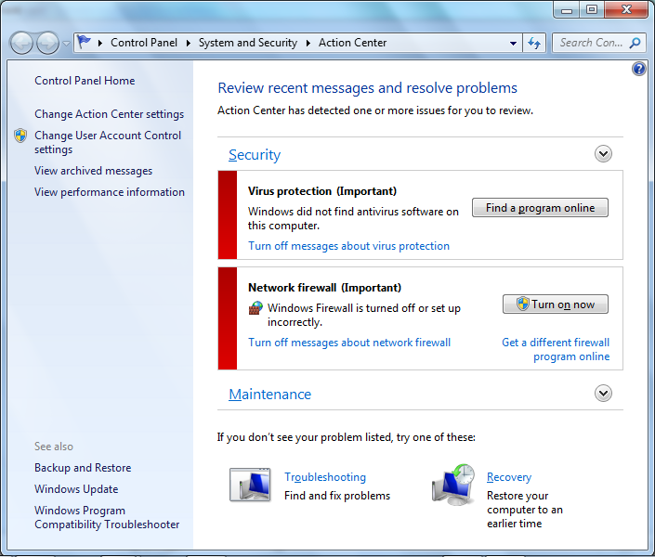
PatchGuard: only signed drivers are allowed

Restrictions on removable drives

USB flash drives and removable devices can be controlled with Group Policy

Monitoring Your Computer's Security

Action Center

Shows recommended actions

Works with third-party firewall, antivirus, and antispyware programs

And with Microsoft Security Essentials

Security Program Conflicts

Don't install two antivirus programs with real-time scanning

Your machine will slow to a crawl

Two firewalls is ok, but hard to manage

Now Microsoft recommends leaving Windows Firewall on in addition to third-party firewalls

Two or three antispyware programs is harmless and probably safer

Blocking Intruders with Windows Firewall

You should always run a personal firewall on your computer

Even when you work behind a corporate or home firewall

To protect you from your neighbors on the LAN

Laptops, USB flash memory sticks, etc. can bring infections inside your firewall

Windows Firewall

Filters incoming traffic only, by default

Stateful-inspection packet filtering

Remembers the requests you made recently

Allows incoming traffic only if you requested it

You can set exceptions to allow unsolicited incoming traffic

This is safer than stateless firewalls

They filter only by IP address, port, or protocol

New Windows Firewall Features

Can filter outgoing traffic

Windows Firewall With Advanced Security console allows many more settings

Exceptions can be configured for

Services

Active Directory accounts and groups, and more

Three separate profiles

Domain, Private non-domain, or Public

Firewall Profiles

Domain

Your computer is joined to an Active Directory domain

Firewall settings usually controlled by settings on the Domain Controller

Private

Your computer is connected to a Home or Work network in a workgroup configuration

Public

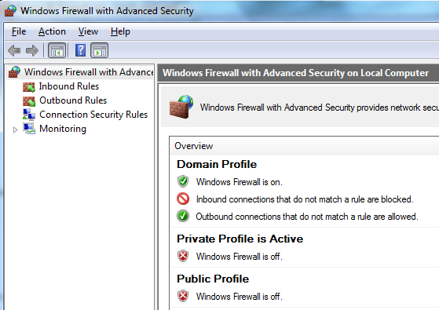
Airport, library, coffehouse, etc.

Using Windows Firewall in Different Network Locations

Domain

Private

Public

If you connect to two network types at once, each connection is filtered separately with the appropriate rule (unlike Vista)

Tools for Managing Windows Firewall

Windows Firewall, in Control Panel

Windows Firewall With Advanced Security

A snap-in for Microsoft Management Console (MMC)

Group Policy Object Editor

Available only in Business, Enterprise, and Ultimate editions

The Netsh utility

Command-line tool

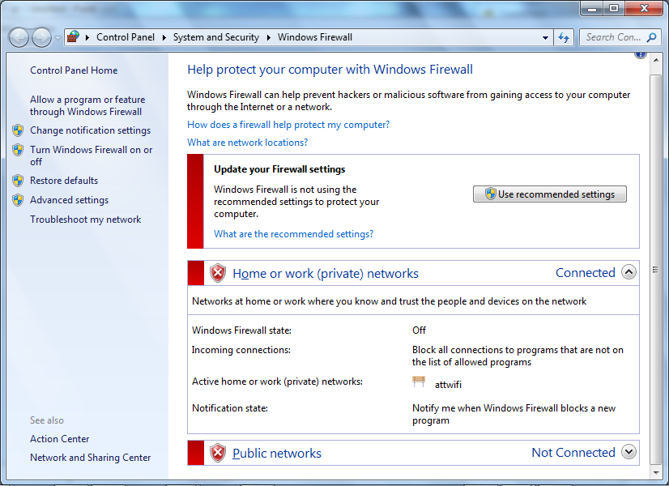
Windows Firewall

Shows current firewall status

Allows you to change settings

Click "Turn Windows Firewall on or off" to see next panel

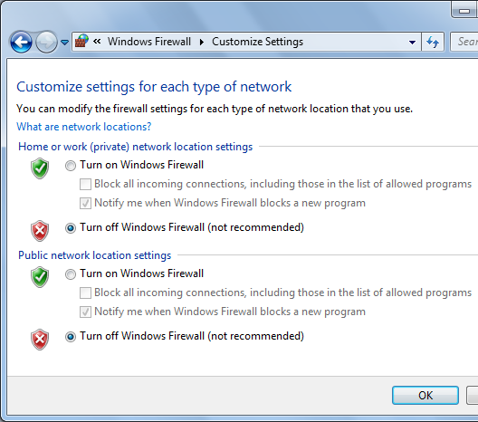
Customize Settings

Block all incoming connections means your computer cannot act as a server

It can still be a client

Allowing Connections Through the Firewall

You will need exceptions any time you want your computer to act as a server

Print server

File Server

Remote Desktop

Games

All these functions require your computer to accept unsolicited incoming traffic

Allowed Programs

In "Windows Firewall", click "Allow a program or feature through Windows Firewall"

Checking a box here lets a program through the firewall

If the item you need is not visible, use the "Add program…" or "Add port…" buttons

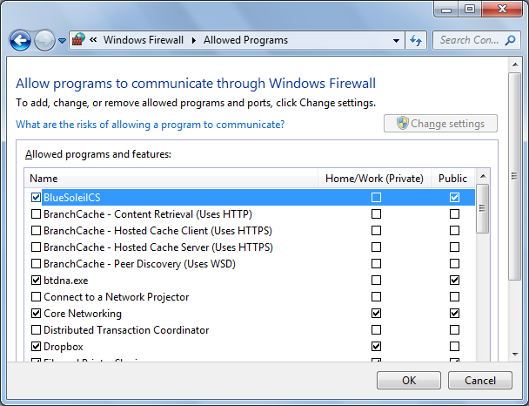

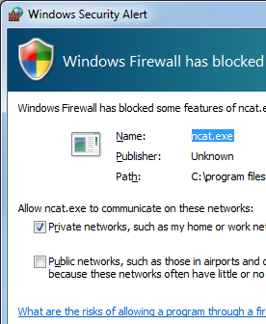

Firewall Alerts

Clicking "Unblock" on this alert does the same thing as checking the box in the "Allowed Programs" box

Windows Firewall with Advanced Security

Allows many advanced tasks, such as filtering outgoing traffic and logging
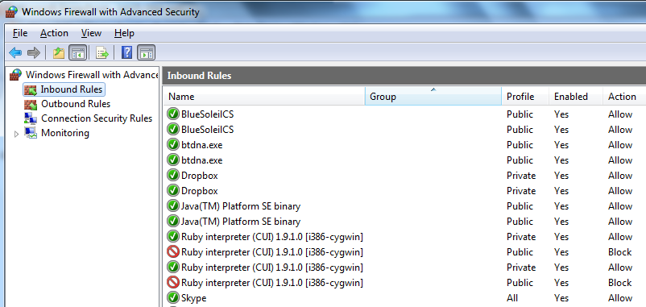

Windows Update
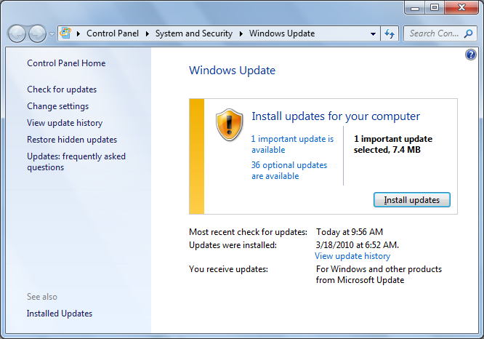

Antivirus Software

There are many vendors and many free and pay products

Microsoft Security Essentials is free, from Microsoft, and probably sufficient for most people

CCSF students get a free copy of Mcafee Enterprise (see my home page samsclass.info for instructions)

Removing Infections

Microsoft's Malicious Software Removal Tool (MSRT)

Automatically downloads and runs as part of Windows Update

McAfee Stinger

Another free tool to remove infections

The Ugly Truth

Many modern infections are very difficult to remove

Maintain image-based backups

Set a time limit for your efforts to remove an infection, after that just reformat and reinstall

Stopping Spyware with Windows Defender

Spyware causes things like:

Unexpected new toolbars, favorites, and links in your web browser

Changes to your browser’s home page and default search provider

Numerous pop-up ads

Sudden occurrence of computer crashes or slow performance

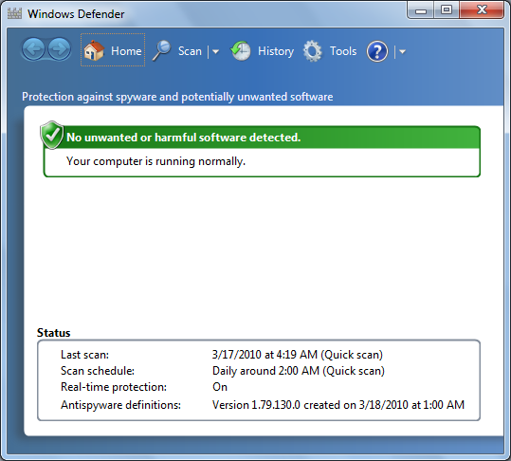
Windows Defender

Press Logo key, type in DEF

Provides real-time protection from spyware

Scans periodically for malware

Scans carefully avoid slowing your computer when it's in use

Real-Time Protection

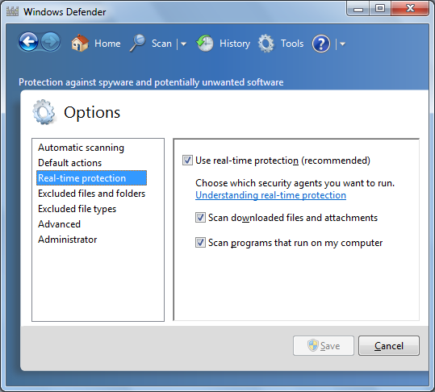
In Windows Defender, Tools, Options

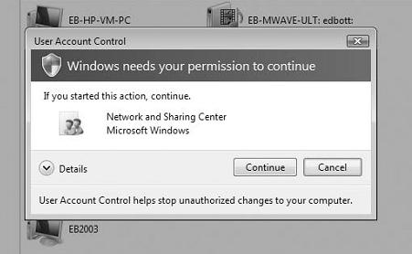
Preventing Unsafe Actions with User Account Control (UAC)

Administrator accounts have two tokens: one normal, one with administrator privileges

Elevating privileges requires clicking on a User Account Control box

What Triggers UAC Prompts

Installing and uninstalling applications

Installing device drivers

Unless they are included with Windows or from Windows Update

Installing ActiveX Controls

Changing settings for Windows Firewall

Changing UAC settings

What Triggers UAC Prompts

Configuring Windows Update

Adding or removing user accounts

Changing a user’s account type

Configuring Parental Controls

Running Task Scheduler

Restoring backed-up system files

Viewing or changing another user’s folders and files

Shield Icon

Indicates actions that will require privilege escalation for a Standard account

But not always for accounts in the Administrators group

If you are logged in as a Standard User

The “credentials prompt” will ask for administrator credentials
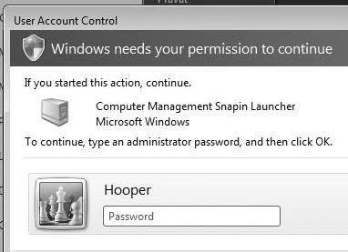

Auto-Elevation

UAC elevates privileges without showing a prompt for

Programs that are part of Windows, on a predefined list

Must be digitally signed by the publisher

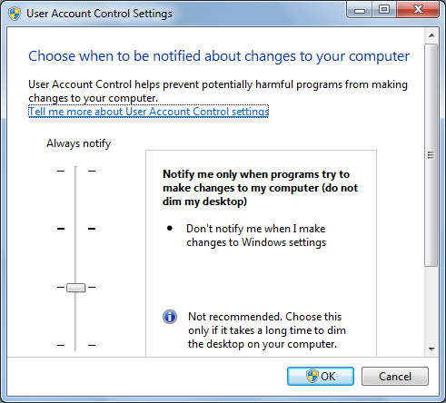
Must be stored in certain secure folders

This is less secure than Vista, but more convenient

Secure Desktop

The greyed-out desktop that forces you to respond only to the User Account Control box

Prevents other programs from running during this important process

Adjusting UAC Settings

Top setting is most secure, like Vista--constant UAC prompts

Default for Standard accounts

Second-highest is default for Win 7 accounts in the Administrators group

Second-lowest turns off Secure Desktop

Lowest is Off, like Win XP

Using Local Security Policy to Customize UAC

Start, SECPOL.MSC

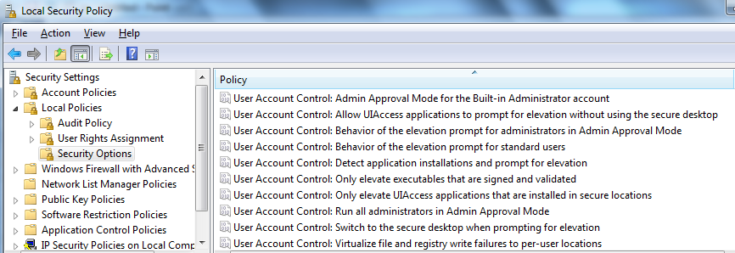

Working Around UAC Without Disabling It

Use an administrator Command Prompt window

No further elevation will be needed

Run as a standard user

Fewer elevated options will appear

Use a fingerprint reader instead of a password for more convenience

Use the “Administrator” account

Disabled by default

Not affected by User Account Control by default
Ch 16: Managing User Accounts, Passwords, and Logons

Editions

Only Professional or better editions can join a domain

Local Users and Groups is not available in Starter and Home Premium editions

Starter does not include Fast User Switching

Parental Controls are not available in a domain

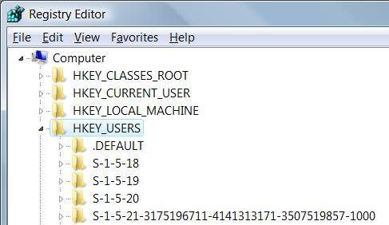
Introducing Windows Security

Windows 7 uses discretionary security

Each file, printer or other object has an owner

The owner decides who can use the object

Most security features require NTFS disk format, not FAT32

Security Identifiers (SIDs)

Each user account has a SID that uniquely identifies it

For well-known SIDs, see link Ch 16a

Tokens

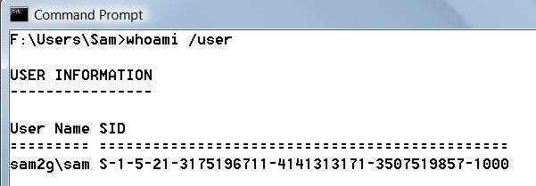
When you log on, you get a security access token

An electronic ID card

Includes your User Name, SID, and groups you belong to

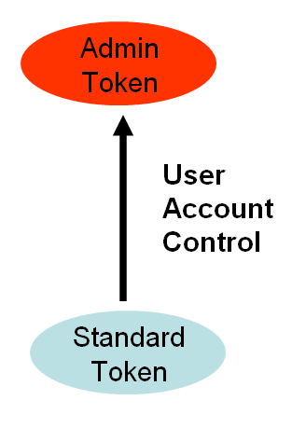
Each program you launch gets a copy of your security access token

Administrators Get Two Tokens

Each time you use a printer, file, or other limited-access object

Your token is compared to the access control list

User Account Control escalates the Standard Token to the Administrator Token

Access Control List

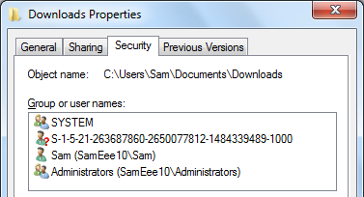

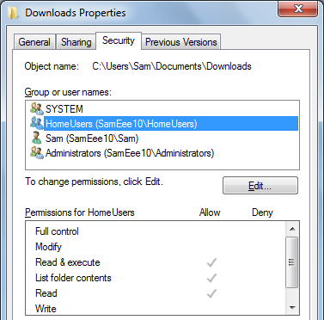

Permissions and Rights

Permission

The ability to access a particular object in some defined manner

for example, to write to an NTFS file or to modify a printer queue

Right

The ability to perform a particular systemwide action, such as logging on or resetting the clock

Owners and Administrators

The owner of a resource assigns permissions

To the resource via its properties dialog box

Administrators set rights

Via the Local Security Policy console

Available only in Business, Enterprise, and Ultimate editions of Windows 7

In the home editions, rights for various security groups are predefined and unchangeable.

Privileges

Serves as an informal term encompassing both permissions and rights

Account Types

Account Types are a convenience to describe memberships in the most frequently-user groups

Administrator accounts are in the Administrators group

Standard accounts are in the Users group

Guest accounts are in the Guests group

Tasks Only Administrators Can Perform

Create, change, and delete user accounts and groups

Install and uninstall programs

Configure automatic updating or install Windows updates manually

Install an ActiveX control

Install or remove hardware device drivers

Share folders

Set permissions

Access all files, including those in another user’s folder

Take ownership of files

Copy or move files into the %ProgramFiles% or %SystemRoot% folders

Restore backed-up system files

Grant rights to other user accounts and to themselves

Configure Parental Controls

Configure Windows Firewall

Tasks Available to Standard Users

Change the password and picture for their own user account

Use programs that have been installed on the computer

Install system and driver updates using Windows Update

Install approved ActiveX controls

Refresh a network adapter's IP address

View permissions

Create, change, and delete files in their document folders and in shared document folders

Restore their own backed-up files

View the system clock and calendar, and change the time zone

Configure power options

Log on in Safe Mode

Guests

Guests have privileges similar to Standard accounts

Guests cannot create a password

The Administrator Account

Disabled by default as a security measure

If you enable it and use it, you won't see any UAC prompts

Other Groups

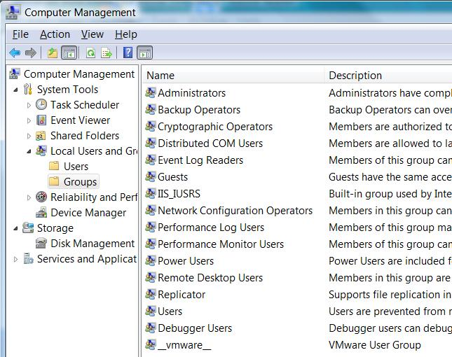
In Computer Management, in Local Users and Groups

Shows many other groups

Accounts in them won't appear in Control Panel's User Accounts

Permissions and Rights are Cumulative

If a user account belongs to more than one group

That accounts gets all the privileges from all the groups

Local Accounts and Groups vs Domain Accounts and Groups

Local Accounts are set up on each computer independently

In a Workgroup—a network without a domain

Recommended for networks with less than ten computers

Domain Accounts are set up on the domain controller

A server running Windows NT Server, Server 2000, Server 2003, or Server 2008

Working with User Accounts
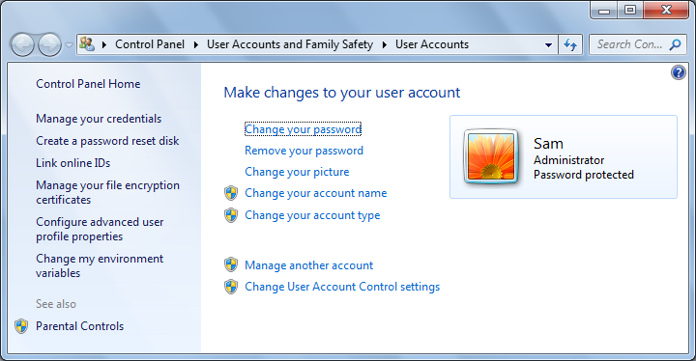

Working with User Accounts

Manage your credentials

Stored network passwords

Password reset disk

Link Online IDs

Used to allow sharing of items through a Windows Live account

Manage Your File Encryption certificates

For EFS

Configure Advanced User Profile Properties

Switch from a Local Profile to a Roaming Profile on a domain

Roaming Profiles can be used on any domain computer

Change My Environment Variables

For programmers

Manage Your Fingerprint Data

Only appears if you have a fingerprint reader installed

Deleting an Account

When you delete an account, you get this choice

That user's SID is gone forever

Effects of Deleting an Account

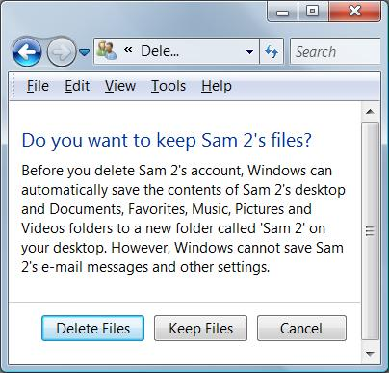
If there are files only that user has NTFS permissions to use

The Administrator can Take Ownership to gain access

If that user had encrypted files with Encrypting File System

Those files are lost forever, unless a Recovery Agent had been configured previously

Using Other Account Management Tools

User Accounts

Simplest way to perform common tasks

Advanced User Accounts

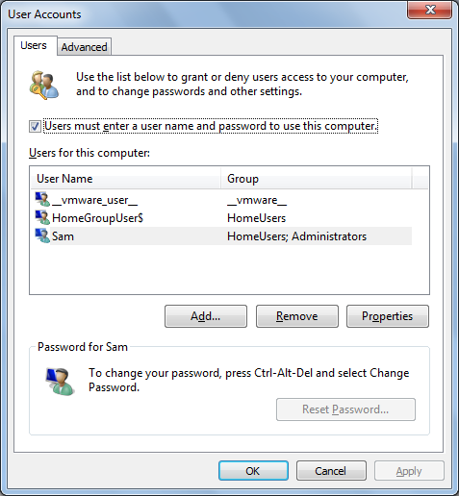
At a Command Prompt, enter NETPLWIZ

Here you can configure automatic logon

You can remove the Ctrl+Alt+Delete requirement for domain member logons

Local Users and Groups

Right-click Computer, Manage

Only available in Professional, Ultimate, and Enterprise versions
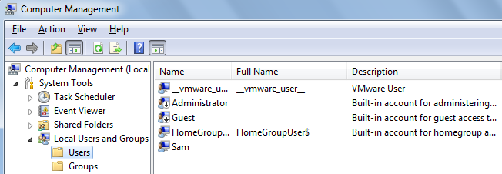

Command-line Tools

NET USER

NET LOCALGROUP

Changing a Password

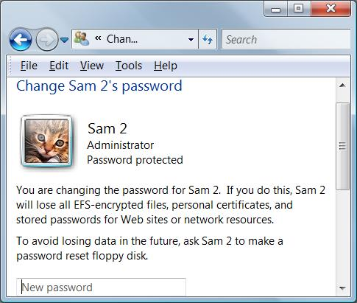
Changing your own password is easy

In User Accounts

Administrators can change passwords for other accounts

EFS-encrypted files will be lost

Recovering From a Lost Password

Windows offers two options

Password Hint

Created when you configure a password in User Accounts

Password Reset Disk

You can make this in User Accounts

Non-Microsoft Options (Hacking)

Ultimate Boot CD

Linux Boot Disk

Kon-Boot

Ophcrack

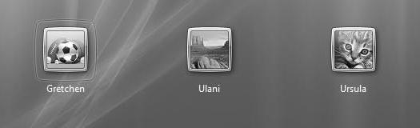
Many other tools (see CNIT 123: Ethical Hacking)

Managing the Logon Process

In a workgroup, a computer shows several login icons

In a domain, you must first press Ctrl+Alt+Delete

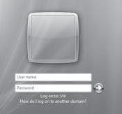
Then you see one icon, with a Switch User button

Bypassing the Logon Screen

If your computer has only one account

aside from built-in accounts, such as Administrator and Guest

And if that account doesn’t have a password

Windows 7 automatically logs on as that user during startup

Logging Off, Switching Users, or Locking Your Computer

Log off

All your programs close

Switch users

Your programs continue to run

Your account is still logged on

Lock your computer

Your programs continue to run

The logon screen appears so that no one can see your desktop or use the computer

Click Start, click the arrow next to the "Shut down" button, and click Lock

Parental Controls

Parental Controls is included in Windows 7

Set hours of use for children

Restrict programs and games

To filter Web sites or monitor activity

Download "Family Safety" from Windows Live Essentials

Last modified 3-22-10

