Ch 17: Setting Up a Small Office or Home Network

Workgroup

This chapter is discussing a workgroup, not a domain

Recommended for 10 or fewer computers

No domain controller required

Editions

Everything in this chapter is the same in all editions except

Computers running Windows 7 Starter Edition cannot create a HomeGroup, although they can join one that already exists

Capabilities of a Small Network

Shared storage

Shared printers

Shared media

Shared internet connection

Not often used, it's usually better to use a hardware router

What’s New in Windows 7

HomeGroups

Easy sharing on Home Networks

Password-protected

Wi-Fi Protected Setup (WPS)

Simple and secure configuration of wireless devices

Mobile broadband support

For connections to 3G networks

What’s New in Windows 7

DirectAccess

Connects to an enterprise server remotely, like a Virtual Private Network (VPN)

Requires a Windows Server 2008 R2 domain controller

Requires Windows 7 Enterprise or Ultimate

Link Ch 17a

BranchCache

Local copies of network files in branch offices

What’s New in Windows 7

Next Generation TCP/IP stack

Improvements in security, performance, and convenience that are largely invisible to ordinary users

Windows Filtering Platform can filter at all levels of the TCP/IP protocol stack

Receive Window Auto-Tuning improves performance

IPv4 and IPv6 are incorporated in a single Windows driver and both enabled by default

This was new in Vista

Using Network And Sharing Center

To open it:

Start, NETWORK

Control Panel, Network And Internet, Network And Sharing Center.

In the notification area, click the Network icon and then click Network And Sharing Center.

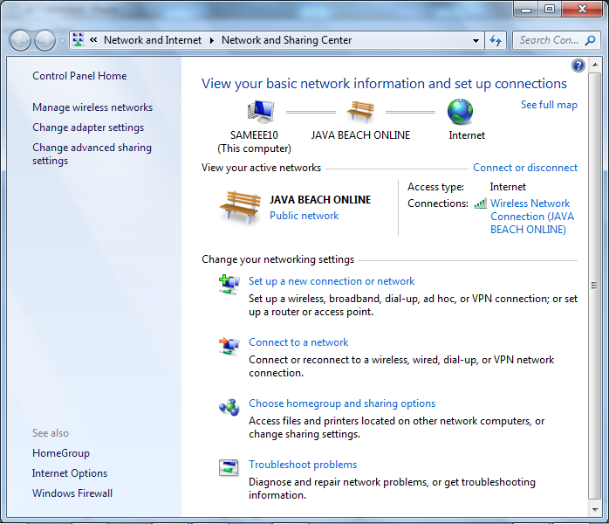

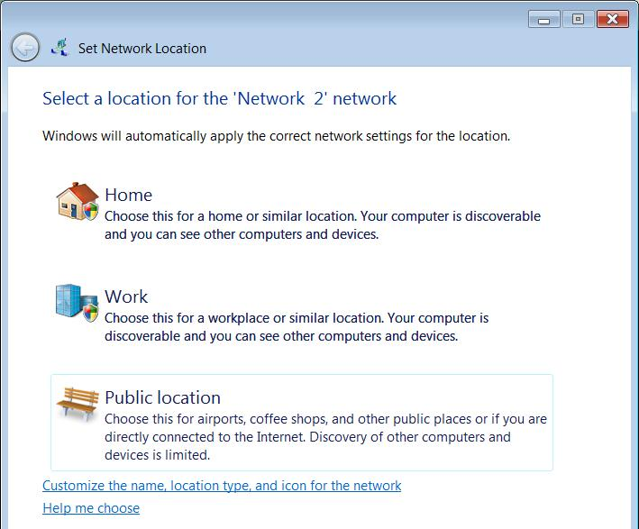
Understanding Location Types

When you first connect to a network, this box appears

Location Types

Home

Your trusted network

Should be protected by a residential gateway

Enables HomeGroup sharing

Work

A trusted network

Turns on Network Discovery

Public Location

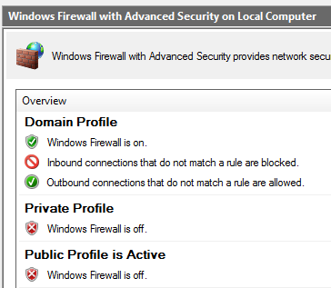
Such as wireless hotspots in coffee shops

Turns off Network Discovery

Firewall Profiles

Private Profile

Home or Work locations

Public Profile

Public location

Domain Profile

Joined to a domain controller

Configuring Your Network Hardware

Network adapters

Each computer needs an adapter (also called a network interface card, or NIC)

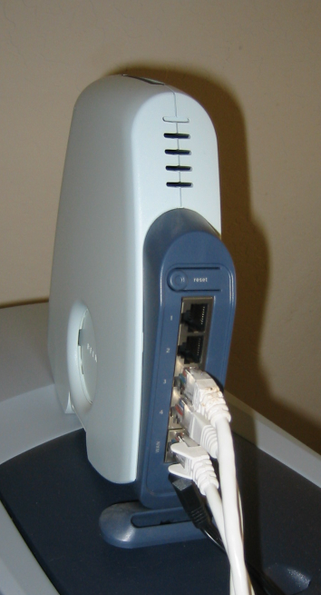
Network adapters can be internal (usually installed in a PCI slot) or external (typically connected to a USB port)

Ethernet is the most popular by far

Pic from Network+ Guide to Networks, Second Edition by Tamara Dean

Hubs

A hub or switch can be used to connect the computers in an Ethernet network

To connect two computers, you can use a crossover cable and no hub

Router

You can also use a router or residential gateway, which typically adds network address translation (NAT) capabilities and security features

Wireless Network Access Point

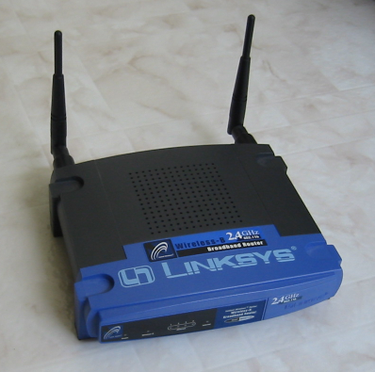
On wireless networks, a wireless access point handles these duties

Cables

On an Ethernet network, eight-wire Category 5 patch cable with RJ-45 connectors on each end

Installing and Configuring Network Adapters

Happens automatically for Plug and Play adapters

Ethernet and Wireless

Three popular technologies, all supported by Windows 7

Ethernet/Fast Ethernet/Gigabit Ethernet

10, 100 or 1000 Megabits per second

Wireless

IEEE 802.11b, also known as Wi-Fi -- 11 megabits per second

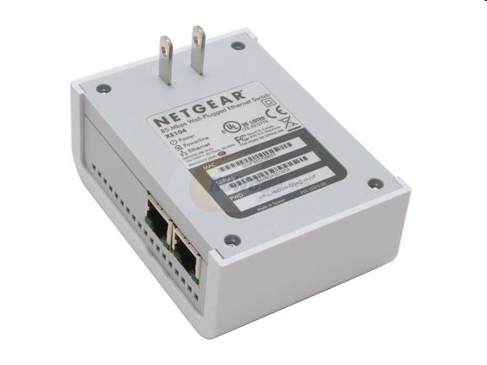
IEEE 802.11g or 802.1a -- 54 Mbps

IEEE 802.11n – 300 Mbps claimed

Phone Line and Power Line

Phone Line

Uses normal phone lines

10 or 128 Mbps

Power Line

Connects to power outlets

200 Mbps

Image from newegg

Making Connections

Place the router in a central location

If you plan to use Internet Connection Sharing and you have an external DSL or cable modem, you’ll need to install two network adapters in the computer with the shared Internet connection

Typical Network

The gateway often includes the switch and the wireless access point
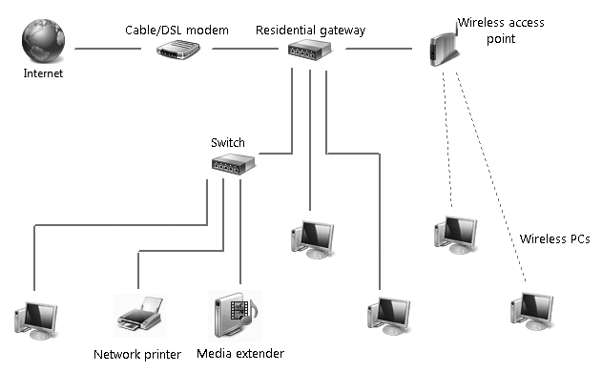

Understanding Security for Wireless Networks

Risks:

Theft of service

Denial of service

Overwhelming your connection with traffic

Privacy violations

Listening to traffic through your connection

Theft or destruction of data

Entering shared folders

Network takeover

Installing a Trojan to allow remote control of your systems

Max Butler

Took over the world’s market in stolen credit cards in 2006

From a San Francisco apartment in the Tenderloin

Using his neighbor’s unsecured wireless access points

Link Ch 17b

Wireless Security Options

Wired Equivalent Privacy (WEP)

Old and broken, has mathematical flaws

Hackers can break into a WEP network easily

Wi-Fi Protected Access (WPA)

Much safer than WEP

Uses a pre-shared key from 8 to 63 bytes long

Wi-Fi Protected Access 2 (WPA2)

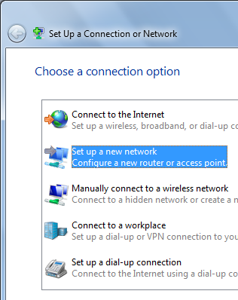
Strongest protection

Open Wi-Fi Network

If you just buy Wi-Fi devices and turn them on, you usually get an "open" network

Completely insecure

Anyone nearby can use it

Convenient, but risky

Wi-Fi Protected Setup

In Network and Sharing Center

Click "Set up a New Connection or Network"

Click "Set up a New Network"

Only works with newer routers

Security at the Wi-Fi Access Point

Change the administrator password to a non-default value

Use a non-default network name (SSID)

Disable remote administration

Upgrade the firmware

Use virtual private networks for wireless connections

RADIUS

On larger networks with one or more domain servers available

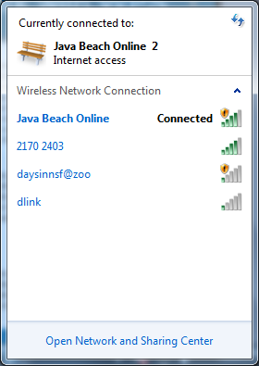
Set up a Remote Authentication Dial-In User Service (RADIUS) server

This allows the most secure option of all: 802 1x authentication

In addition, consider enabling Internet Protocol Security (IPsec)

Connecting to a Network

Click the Network icon in the Notification area

A caution shield icon marks unprotected Wi-Fi networks

Connecting to Network with WPS

There are four methods of transferring the security settings

PIN #

Buttons (as shown)

RFID

USB flash drive

Links Ch 17c & Ch 17d
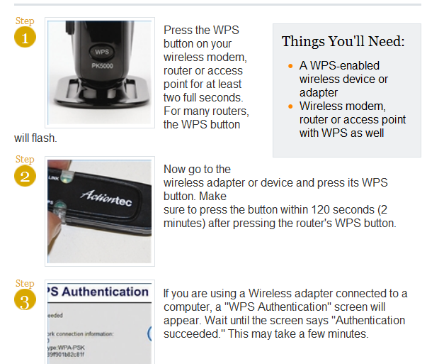

HomeGroups

Only available in Windows 7

Cannot be used with Vista or XP

Ch 18: Sharing and Managing Network Resources

Editions

Sharing is the samein all editions except

Computers running Windows 7 Starter Edition cannot create a HomeGroup, although they can join one that already exists

The computer hosting Remote Desktop connections must have Win 7 Pro, Enterprise, or Ultimate

The client machine can use any version of Windows 7, or even earlier Windows versions

HomeGroups

Intended for home users on a trusted network

Can be used on machines with no logon password

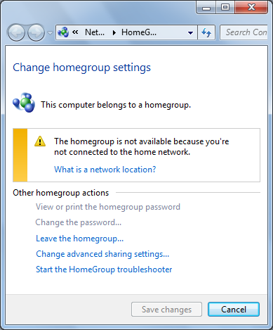
HomeGroup Benefits

Easy sharing of libraries and files

Easy access to shared media libraries

Can stream media to other devices

Easy sharing of USB-connected printers

HomeGroup Requirements

At least one computer on the network must use Windows 7 Home Premium or better, to create the HomeGroup

All computers must use Windows 7

The network location must be Home on all computers

HomeGroup in a Domain

A domain-joined computer can see and access shared resources on other machines in its HomeGroup

But other machines cannot see anything on the domain-joined computer

This protects corporate documents from other computers at your home

Leaving a HomeGroup

In "HomeGroup", click "Leave the homegroup"

This makes it possible to join a different homegroup

Disabling HomeGroup

Change network location to "Work"

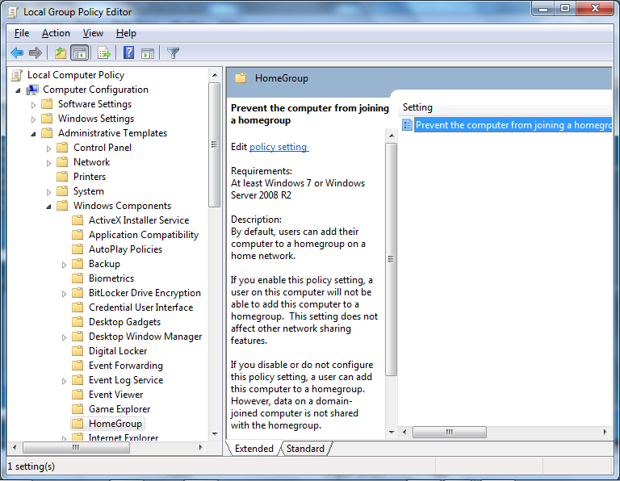
Or disable it in Group Policy

Sharing Resources with Older Windows Versions

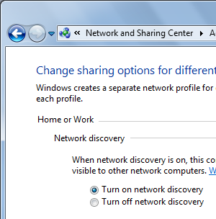
Public folder sharing

Configurable in Network and Sharing Center

"Any folder" sharing

Share any folder you choose, with any permissions you like

Configuring Your Network for Sharing

1. Ensure that all computers have the same workgroup name

Optional for Vista and Windows 7

2, Set network location to Home or Work

3, Ensure that Network Discovery is turned on

4. Select sharing options

File and Printer Sharing must be turned on to share any files (other than streaming media)

Password Protected Sharing

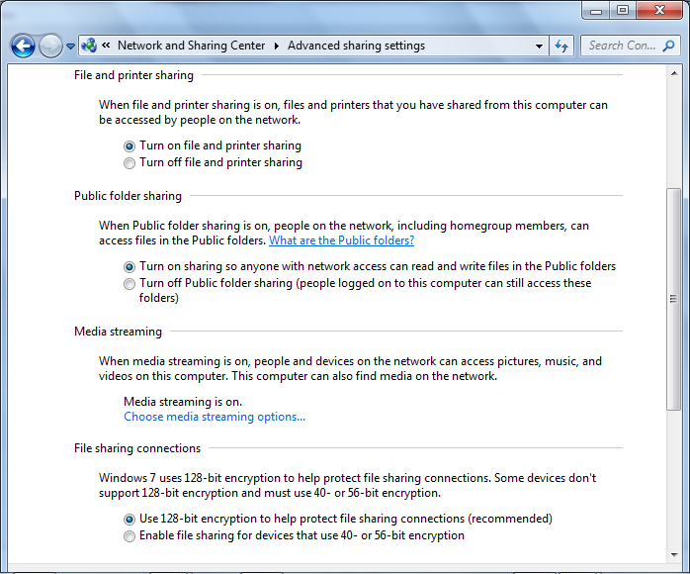
Requires an account on your computer for each person connecting to a share

5. Set up user accounts

If you are using password protected sharing

One easier way is to make a single account named "Share" that they all use

You could also share with Everybody and no password, for maximum convenience, minimum security

A third-party utility: DropBox

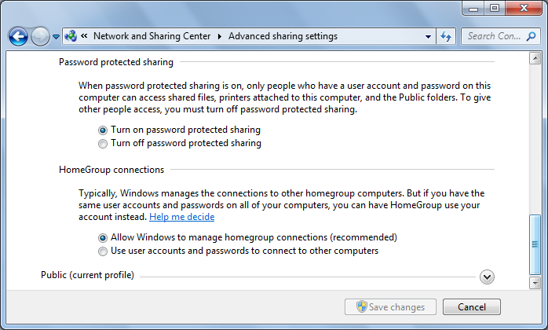
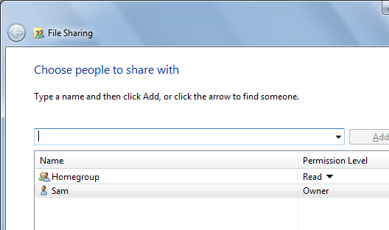
Sharing from Any Folder

Make sure the Sharing Wizard is enabled in Folder Options

In Windows Explorer, select the folder(s) you want to share

From the menu bar, click Share With, Specific People

This wizard sets both sharing and NTFS permissions

Advanced Sharing Properties

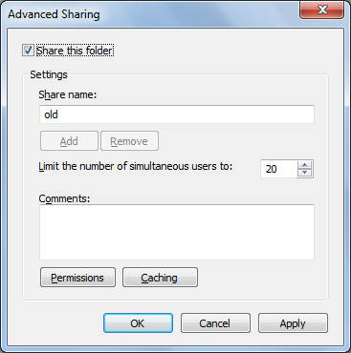
Right-click a folder, Properties, Sharing Tab

Advanced sharing

Share Permissions

Click "Permissions"

Share Permissions and NTFS Permissions

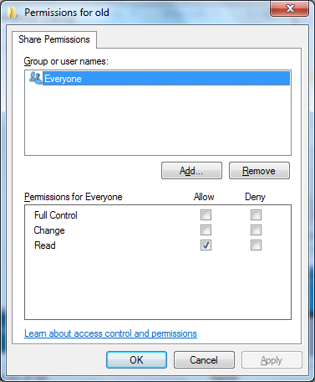
Share permissions allow network access to a resource

NTFS permissions limit all access to the resource, networked or local

Network sharing requires both share and NTFS permissions

If either access is blocked, network users can't use the resource

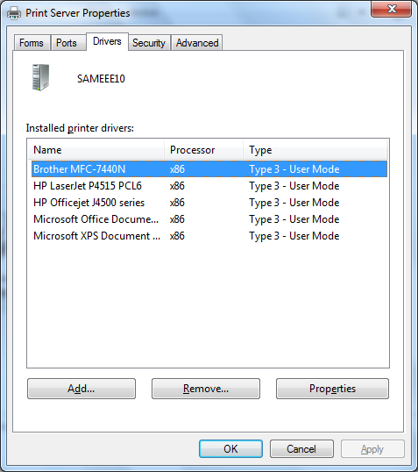
Sharing a Printer

In "Devices and Printers", open Printer Properties

Printer Permissions:

Print - use the printer and manage your own documents in the queue

Manage Printers - share a printer, change printer properties

Manage Documents - pause, restart, move, and remove documents

Default Permissions

Everyone - Print

Administrators - Print, Manage Printers, and Manage Documents

Print Server Properties

In "Devices and Printers", click "Print Server Properties"

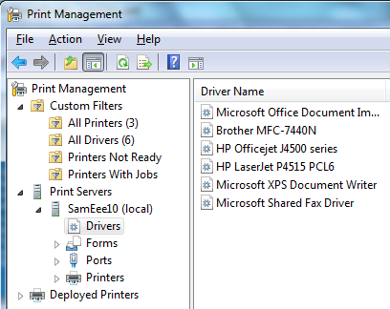
Here you can control forms, ports, drivers, spool files, and notifications

Print Management

Only available in Professional, Enterprise, and Ultimate editions

Manages printers, drivers, queues, and shares

Finding and Using Shared Resources on a Windows Network

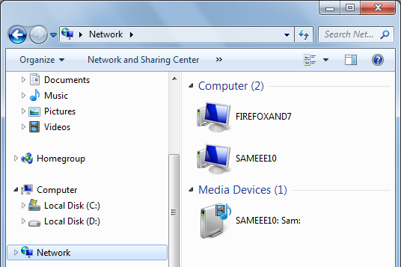
Network

In Windows Explorer, the Network folder shows an icon for each computer on your network

Double-click a computer to open shared resources

But it is often inaccurate--Start \\SERVER-NAME will often open machines even when they are not visible in the Network folder

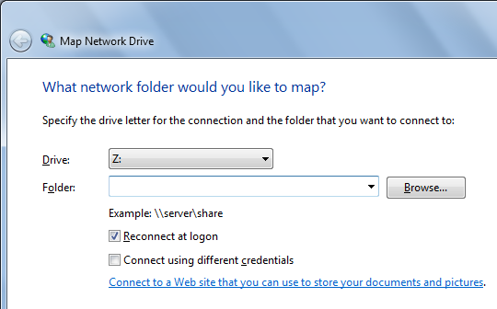
Mapped Folders

In Computer, click "Map Network Drive"

Assigns a drive letter to a network drive, so it works as if it were a local hard drive

Remote Desktop

Remote Desktop Features

Control a computer remotely, as if you were at its keyboard

Bidirectional audio support--play videos and other media remotely

Perform remote management, such as installing updates

Use a low-powered computer to control a more powerful one--a "thin client"

Traffic is encrypted for security

Remote and Client Computers

The computer being controlled is the remote computer

The computer being used to control the remote computer is the client computer

Remote Computer Requirements

Windows 7 Professional, Enterprise, or Ultimate

Or Vista Business or better

Or Win XP Pro or better

A network connection that can reach the client computer (via LAN or the Internet)

Client Computer Requirements

Windows 7 (any version), Vista SP1, or Xp SP3

Or any older version of Windows, back to Win 95, if you download the Remote Desktop Client

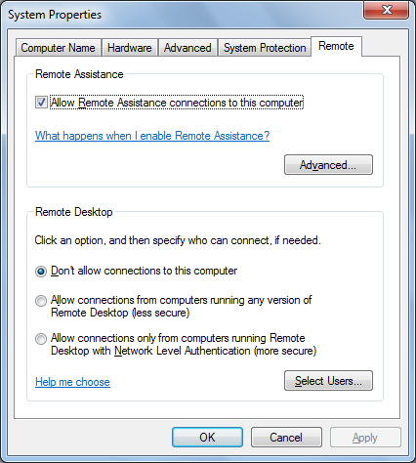
Or a Mac with the appropriate client software

Or Linux with the appropriate client software

Third-Party Alternatives

Laplink Gold

UltraVNC

TeamViewer

LogMeIn

GoToMyPC

Laplink Everywhere

Remote Desktop Networking

The remote computer listens on port TCP 3389, and Windows Firewall automatically opens that port

The port can be changed (link Ch 18a)

Configuring a Router for Remote Desktop

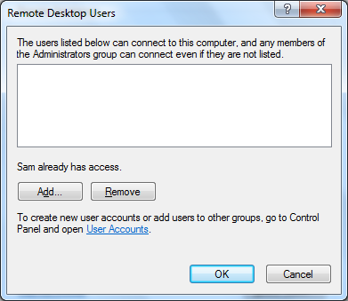
If the remote computer is behind a router with Network Address Translation, you will need to configure "port forwarding" on the router

Or use a Windows Home Server

Or use a Windows Server 2008 Terminal Services Gateway

Or use a VPN

Enabling Inbound Remote Desktop Connections

Logo+Break, "Advanced System Settings"

On the Remote tab, in the "Remote Desktop" section, click one of the "Allow connections…" buttons

Remote Desktop Users

By default, members of the Administrators group can connect remotely

Click "Select Users" to add more users

NOTE: Remote desktop users must have a non-blank password

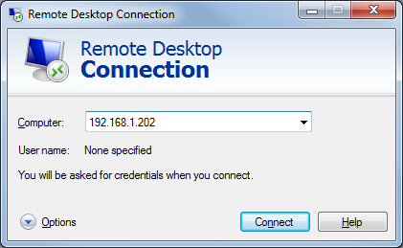
Using Remote Desktop Connection

Start, REMOTE, "Remote Desktop Connection"

Enter remote machine's name or IP address

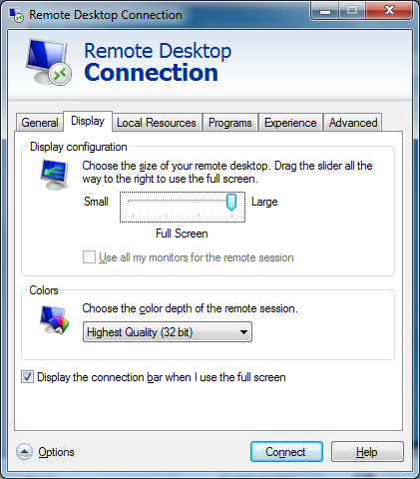

Changing Screen Resolution and Display Settings

Click "Options" to adjust the settings so the remote desktop window fits on your screen

You can also use multiple monitors

Local Resources

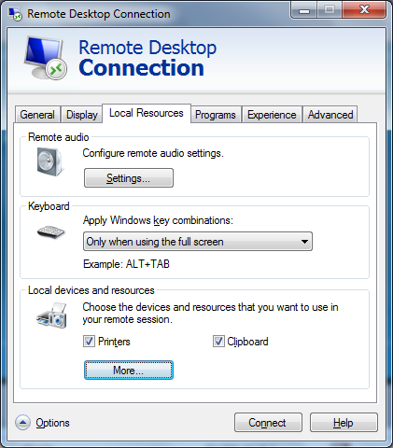
Clipboard lets you move data from the local to the remote machine, and vice versa

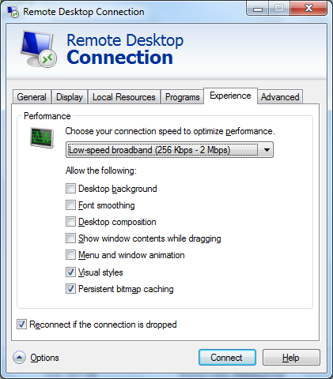

Performance Options

Adjust "Experience" tab settings to balance features with network speed

"Desktop Composition" is required for Aero effects

Ending a Remote Session

In the remote session, click Start and click the arrow to see three options

Lock - locks the screen

Disconnect - ends remote session but leaves your programs running

Log off - closes your programs and disconnects

Last modified 4-5-10

