Chapter 19 - Fixing and Tweaking Your Network

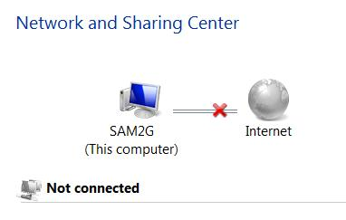
Editions

The networking features in this chapter work identically in all Windows 7 editions

Viewing Status in Network And Sharing Center

Click the X or ! To launch Network Diagnostics

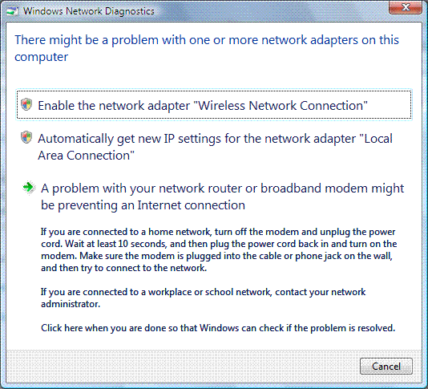
Windows Network Diagnostics

Tries to diagnose and correct network problems

Pops up boxes like this one

Diagnosing Problems Using Network Map

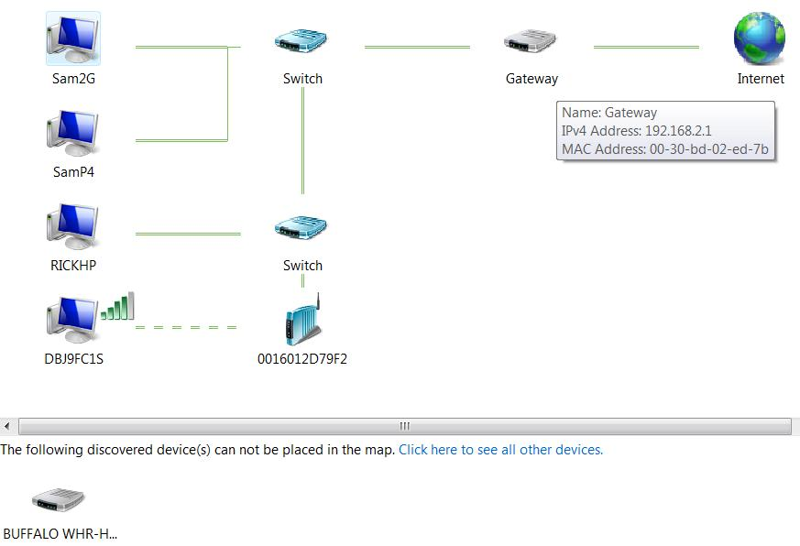
Hover over a device to see its address information

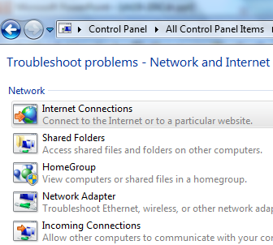

Devices in the Network Map

Devices that don't support Link Layer Topology Discovery (LLTD) appear at the bottom, including:

Win XP machines (unless you install the KB 922120 update – see link Ch 19a; if you have XPSP3, you need the hotfix at link Ch 19b)

Devices that support Universal Plug and Play (UPnP) but not LLTD may only provide limited information

Devices without network discovery turned on

Troubleshooting Network Problems

The Windows Diagnostic Framework automatically detects and fixes many problems

If that doesn't happen, try the troubleshooters

In Network and Sharing Center, click "Troubleshoot Problems"

The HomeGroup troubleshooter is especially useful

HomeGroup Issues

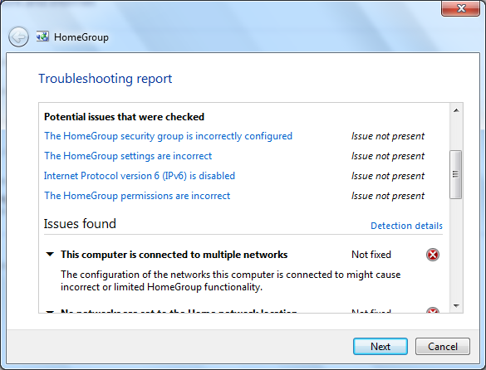
Run the wizard and click "View Detailed Information" on the last page

Network Troubleshooting Tools
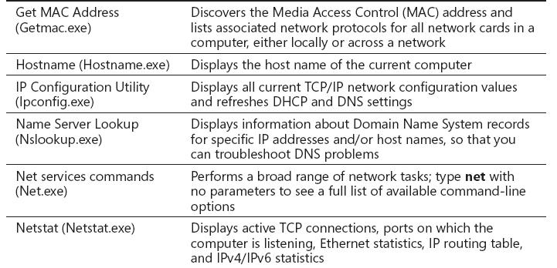

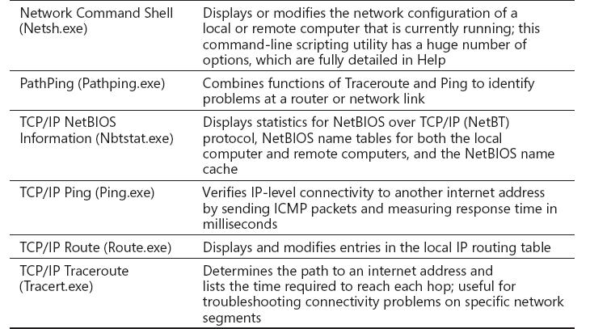

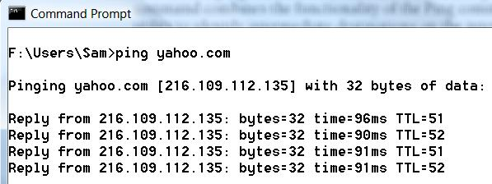
PING

PING an IP Address or DNS name to test connectivity

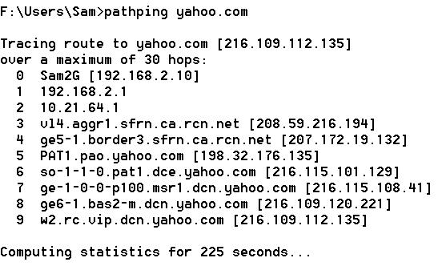
But most Windows machines have firewalls that block pings by default—you'll need to turn the firewalls off or allow the PINGs through first

PATHPING

Finds intermediate routers

Calculates statistics

TRACERT

Sends three packets to each router on the path

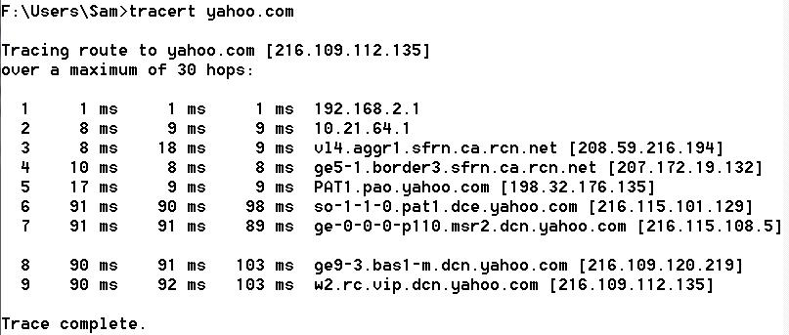
Similar to PATHPING
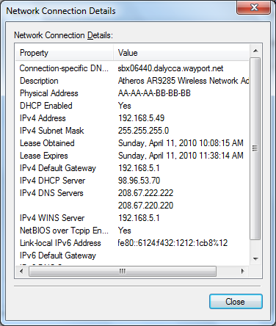

Diagnosing IP Address Problems

To see your IP configuration

In Network And Sharing Center, click "Change Adapter Settings"

Double-click the icon for your connection

Click Details

Or use the
IPCONFIG /ALL command at a Command Prompt

Important IP Addresses to Know

169.254.x.y

Automatic Private IP Address (APIPA)

The computer tried to use Dynamic Host Configuration Protocol (DHCP) but could not contact a DHCP Server

Make sure you are connected to the DHCP server (usually a router) and restart the machine

The IPCONFIG /RENEW command at a Command prompt works too

Important IP Addresses to Know

10.x.y.z or 192.168.x.y or 172.16.x.y to 172.31.x.y

Reserved private IP address

Normal for a computer behind a Network Address Translation (NAT) server, such as a router

But the router needs a public address on its Wide Area Network (WAN) side

You cannot connect directly to the Internet with a private address

Important IP Addresses to Know

0.0.0.0

Cable disconnected, or

IP address conflict

No networking is possible with this address

Subnet Mask

The subnet mask must be the same for all computers on your local network segment

Usually the subnet mask is one of these three

255.0.0.0

255.255.0.0

255.255.255.0

Intermediate values like 255.255.240.0 are sometimes used in large networks

Default Gateway

Traditionally uses an address ending with 1 like 192.168.0.1

All devices on a network should have the same default gateway

Unless you have a complex network with more than one router

Repairing Your TCP/IP Configuration

Automated Repair

Right-click the connection icon in Network Connections and click Diagnose

Renew your IP address

In a Command Prompt window, use

IPCONFIG /RENEW

or

IPCONFIG /RENEW6

For IPv6

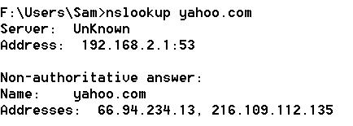
Resolving DNS Issues

Test DNS with the NSLOOKUP command

Your DNS address should be

Your router, or your ISP's DNS server

Open DNS - Free DNS Service for everyone

208.67.222.222

208.67.220.220

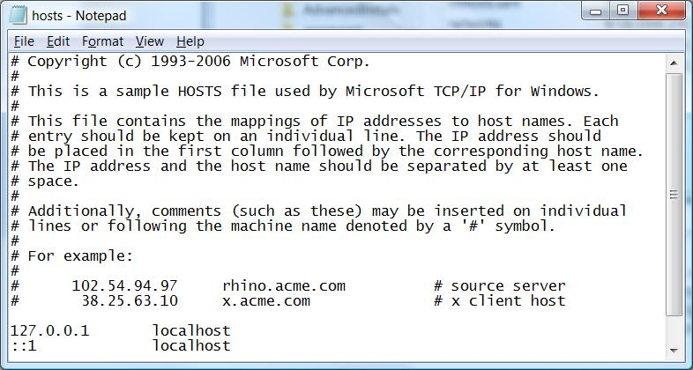
Hosts File

Malware sometimes changes the Hosts file to block websites

C:\Windows\System32\drivers\etc\hosts

DNS Cache

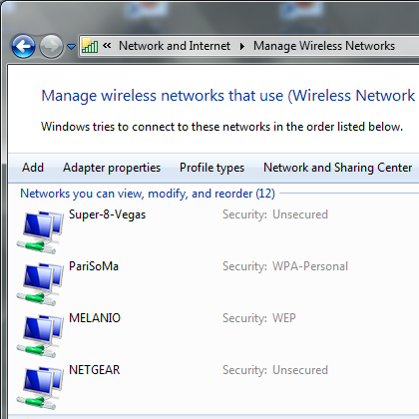
Windows maintains a temporary list of DNS names and IP addresses

You can clear it with this command at a Command Prompt

IPCONFIG /FLUSHDNS

Preferred Wi-Fi Networks

The WLAN AutoConfig service attempts to connect to each remembered network in turn

To control this, in Network and Sharing Center, click "Manage Wireless Networks"

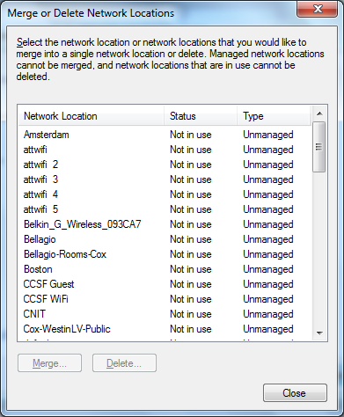

Merge or Delete Network Locations

In Network and Sharing Center, click your network's icon

In the next box, click "Merge or Delete Network Locations"

Setting the Workgroup Name

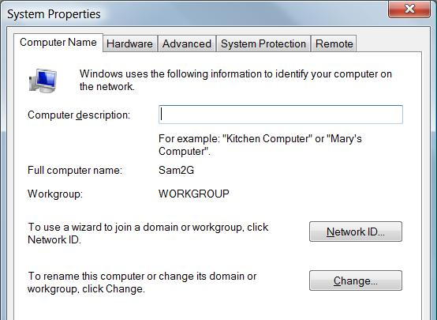
Start, right-click Computer, Properties, "Change settings"

However, the workgroup name is unimportant in Windows 7

Managing Network Connections

In "Network and Sharing Center"

Click "Change Adapter Settings"

Right-click a connection, Properties

Network Connection Components

Client For Microsoft Networks

Allows you to connect to Windows computers

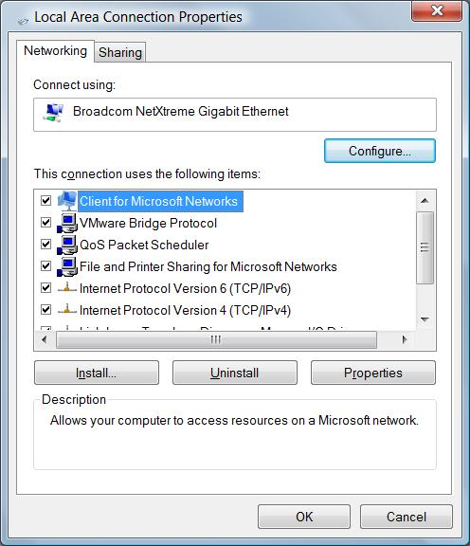
QoS Packet Scheduler

Quality Of Service – will be important when we switch to Internet Protocol version 6 (IPv6)

File And Printer Sharing For Microsoft Networks

Allows your computer to be a file or print server

Internet Protocol Version 6 (TCP/IPv6)

The new Internet protocol, not widely used in the USA yet

Internet Protocol Version 4 (TCP/IPv4)

The primary Internet protocol in current use

Link-Layer Topology Discovery Mapper I/O Driver

Used to create the network map

Link-Layer Topology Discovery Responder

Also used to create the network map

IP Addresses

On a TCP/IPv4 network, every computer has a unique IP address

Four 8-bit numbers

(In decimal format, a number between 0 and 255)

Separated by periods

Example: 147.144.1.2

TCP/IP configuration has three additional settings:

Subnet Mask

Default Gateway

DNS Server

Subnet Mask, Default Gateway, DNS Server

Subnet mask

Tells the network how to distinguish between IP addresses that are part of the same network and those that belong to other networks.

Default Gateway

A computer that can send packets outside the local network

Domain Name System (DNS) Servers

Computers that translate domain names (such as www.microsoft.com) into IP addresses

Methods For Assigning IP Addresses

Dynamic Host Configuration Protocol (DHCP)

The most common method

IP configuration is set automatically by the server

Automatic Private IP Addressing (APIPA)

If DHCP fails, the machines make up their own addresses starting with 169.254.

Static IP Addressing

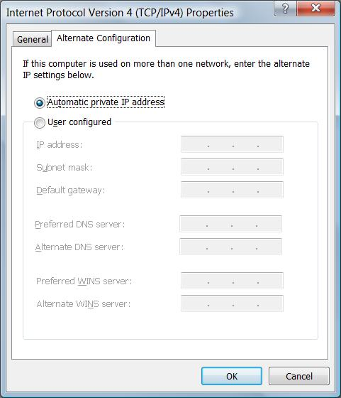
Administrator must manually type in the IP address for each machine

Servers typically use static IP addresses

Requires more administrative effort and not commonly used for workstations anymore

Alternate IP Configuration

You set the address used if DHCP fails

Useful for a laptop that travels between two different LANs

In "Network and Sharing Center"

Click "Change Adapter Settings"

Right-click a connection, Properties

Click "Internet Protocol Version 4 (TCP/IPv4)", Properties

Public IP Addresses

Like public telephone numbers

Every computer that is directly connected to the Internet needs one

Your Internet service provider assigns you a public IP address

Dynamic IP Address

Common for dial-up connections

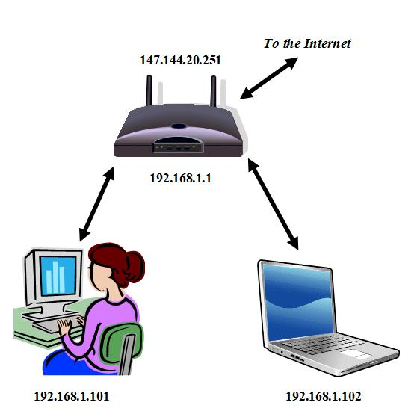
Each time you connect, your ISP assigns a different IP address to your computer

Static IP Address

Common for cable or DSL connections

Your IP address never changes

Private IP Addresses

A whole network can share a single Public IP Address

Better Security

Lower Cost

Each of the computers on the local network has a Private IP Address that is not reachable from the outside world.

Router uses network address translation (NAT) to pass packets back and forth between the single public IP address and the many private IP addresses on the network

Reserved Private IP Addresses

The Internet Assigned Numbers Authority (IANA) has reserved these ranges for Private IP Addresses:

10.0.0.0 – 10.255.255.255

172.16.0.0 – 172.31.255.255

192.168.0.0 – 192.168.255.255

Understanding IPv6

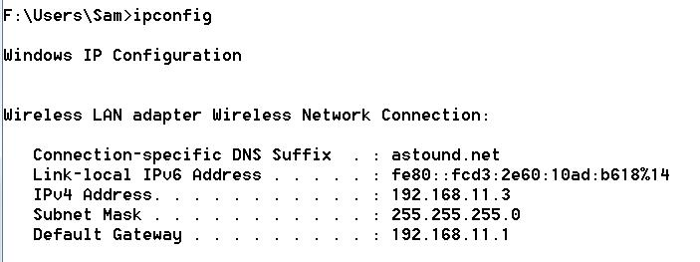
IPv6 addresses are 128 bits rather than 32

The :: indicates a lot of zeroes omitted

Windows 7 prefers IPv6 and uses IPv4 only when necessary

Which is almost all the time, in the USA

See link Ch 12b
Chapter 20 - Tuning Up and Monitoring Performance

Editions

All of the tools described in this chapter are available in all editions of Windows 7

What Causes Poor Performance?

Defective hardware

Run Windows Memory Diagnostic

Hard disk diagnostics from the manufacturer

Outdated or flawed device drivers

Inadequate hardware resources

Active background tasks

Out-of-control processes or services

Malware

Establishing a Performance Baseline

Windows Experience Index

Command-line version: WINSAT.EXE

System Health Report

Also called System Diagnostics

Resource Monitor

Windows Experience Index

Logo+Break to open System

Click "Windows Experience Index"

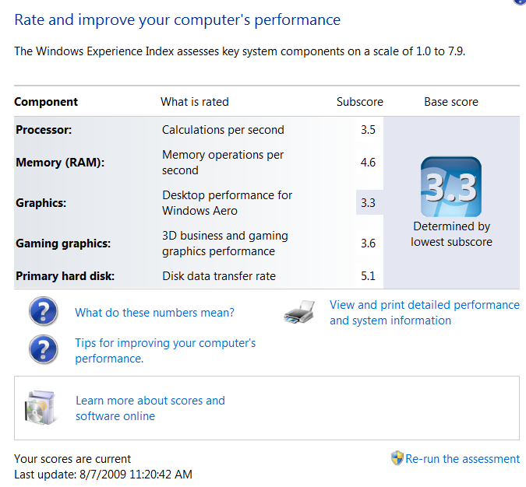
Scores go from 1 to 7.9

System Health Report

Logo+Break to open System

Click "Windows Experience Index"

"Advanced Tools"

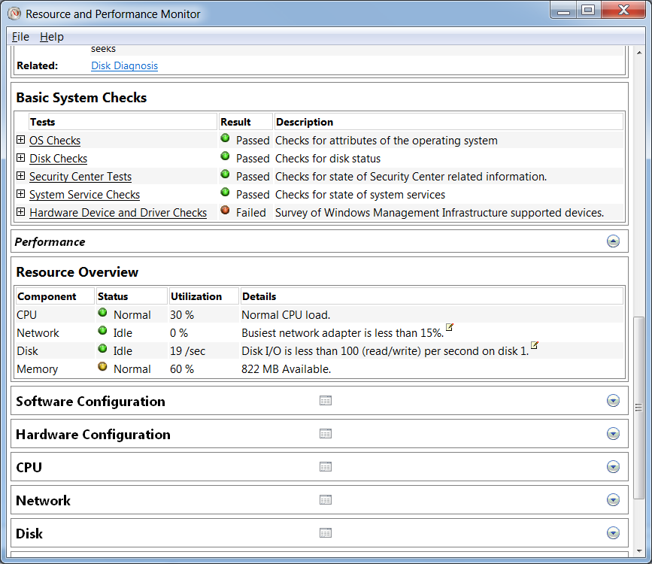
"Generate a System Health Report"

Monitoring Performance in Real Time

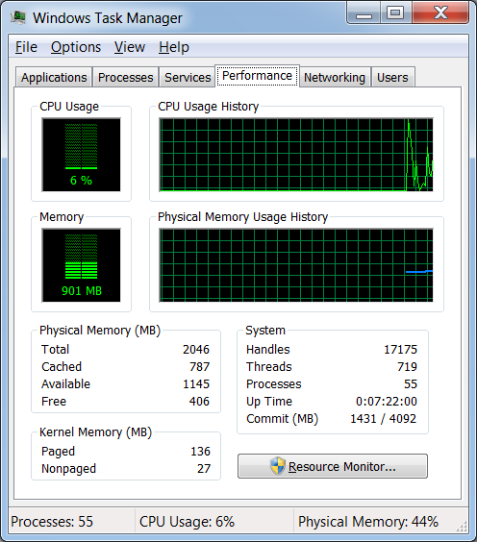
Windows Task Manager

Resource Monitor

Windows Task Manager

Ctrl+Shift+Esc

Performance tab shows CPU and memory usage

Options, Always on Top to control window's placement

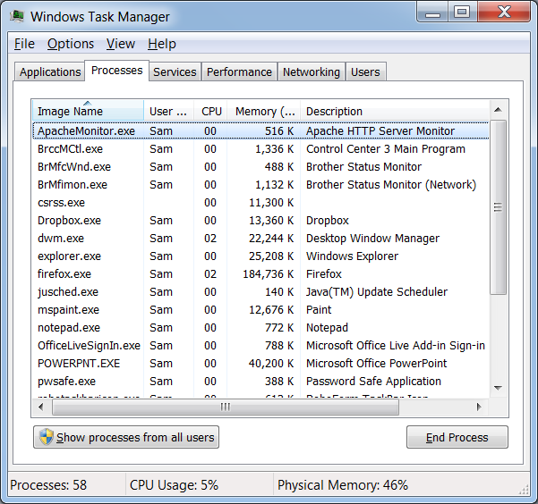

Processes Tab

By default, only the processes directly accessible to the user are shown

"Show processes from all users" to see them all

Process Information

For each process, Windows Task Manager shows:

Image Name (the name of the process)

User Name (which user started the process)

CPU (% currently using)

Memory (Private Working Set)

The amount of memory the process requires to perform its regular functions

Description

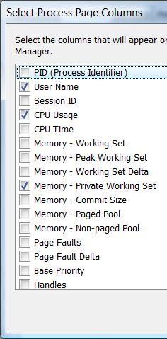
Select Columns

View, Select Columns to customize Task Manager

Process Identifier (PID) helps to correlate processes with Services

Using Resource Monitor

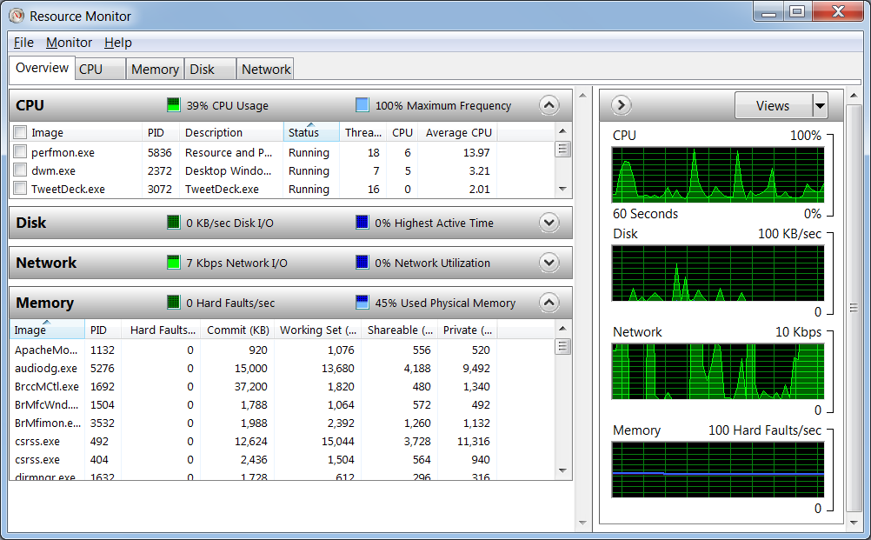
Logo, Resource

Basic Strategies for Improving Performance

Ensuring that you have adequate RAM

Ensuring that you have an adequate virtual-memory configuration

Tuning and troubleshooting SuperFetch

Using ReadyBoost to compensate for a slow hard disk

Managing startup programs

Keeping your disks defragmented

Maintaining adequate free space on your disks

Avoiding tweaks of dubious value

Adequate RAM

For 32-bit Windows 7, minimum RAM is 1 GB

For 64-bit Windows 7, you need 2 GB

Double that RAM for better performance

Physical Memory Limitations

All 32-bit versions are limited to 4 GB max. RAM, and usually only 3.5 GB or less of that is usable

64-bit Starter & Home Basic: max. RAM 8 GB

64-bit Home Premium max. RAM 16 GB

64-bit Pro & higher max. RAM 192 GB

Memory Terms

Physical memory

RAM chips

Virtual memory

Stored on the hard disk in the page file

Kernel memory

Used by the Windows OS

Cached memory

Holds data or code that is not in use now, but which may be used again

Free memory

RAM with nothing in it, immediately available

Working Set

Memory used by a process

"Private Working Set" cannot be given up to be used by other processes

Commit Charge

Total amount of virtual memory that a program has touched (committed)

Commit Charge Limit

Total physical and virtual RAM available

Hard faults

A block of memory needed by the operating system has to be fetched from the page file on the hard disk

A high number of hard faults means that virtual memory is being used a lot, which slows performance drastically

Solution: get more RAM

Virtual Memory

A file on disk that is used to store data when RAM is full

Also called the "page file" or "swap file"

On the root of the system volume

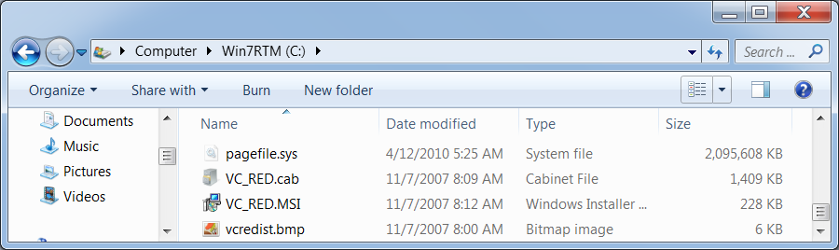

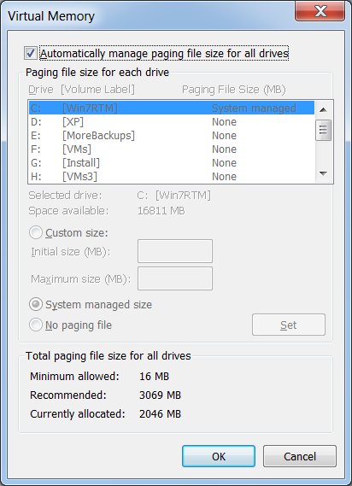
Virtual Memory Settings

Start, right-click Computer, Properties

Advanced System Settings

In System Properties, on the Advanced tab, in the Performance section, click Settings

In Performance Options, click the Advanced tab

Click "Change"

Page File Management

If you have a second disk drive, you may get better performance by putting some page file space there

Don't bother if you have two partitions on the same physical hard drive

Leave some page file on the system drive for crash dumps

Performance-enhancing Technologies

SuperFetch

Adjusts caching to match the way you use your computer (automatic, no adjustment needed)

ReadyBoost

Uses a USB 2.0 flash memory stick or other external memory to cache (may help with netbooks)

Managing Startup Programs

Too many startup programs slow a machine

Find them with MSCONFIG

Or download Autoruns from Microsoft

Link Ch 20a

Keeping Your Disks Defragmented

By default, Windows 7 defragments your disk automatically each week

You shouldn't need to do anything further

Maintaining Adequate Free Space on Your Disks

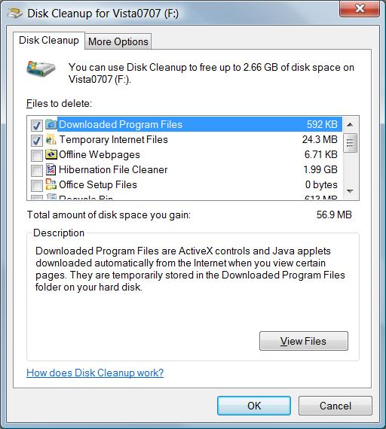
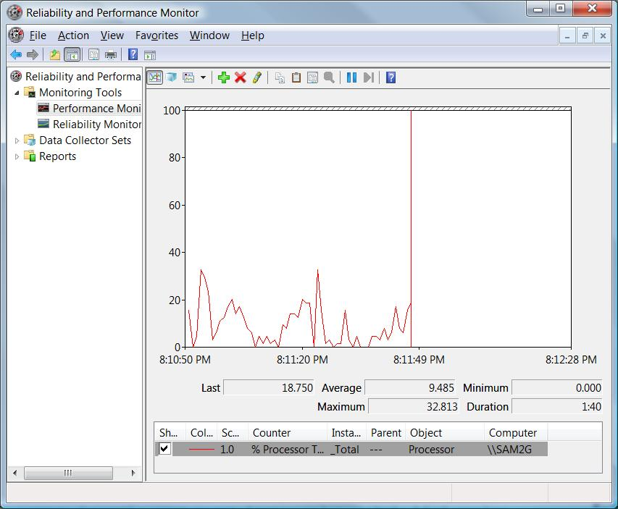
Disk Cleanup can help

Page File Myths

With 1 GB or more RAM, you should eliminate the swap file

Windows wasn't designed to run without a swap file

Creating a swap file of a fixed size improves performance

This was true on 1990s-vintage hardware, but not any more

Prefetch Folder

The Prefetch folder contains an index to segments of frequently used files

This speeds up performance

Don't turn it off

It doesn't need to be manually cleared—it does that automatically

Shutting Down Services

Shutting down services can make Windows look like an older version, and run somewhat faster

Windows Search, System Restore, Automatic Updates

You also lose features

Not sensible for people who want to understand how Windows works as designed

Performance Monitor

For Advanced System Analysis

Last modified 4-12-10

