Chapter 21 - Performing Routine Maintenance

Editions

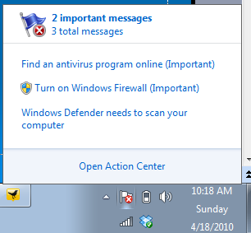
Everything in this chapter is the same for all editions

Maintenance

Update Windows and drivers

Check your disks for errors

Defragment your hard disks

Perform regular backups (covered in chapter 11)
Action Center

Action Center

Shows a red X on the flag when there is a problem

Action Center

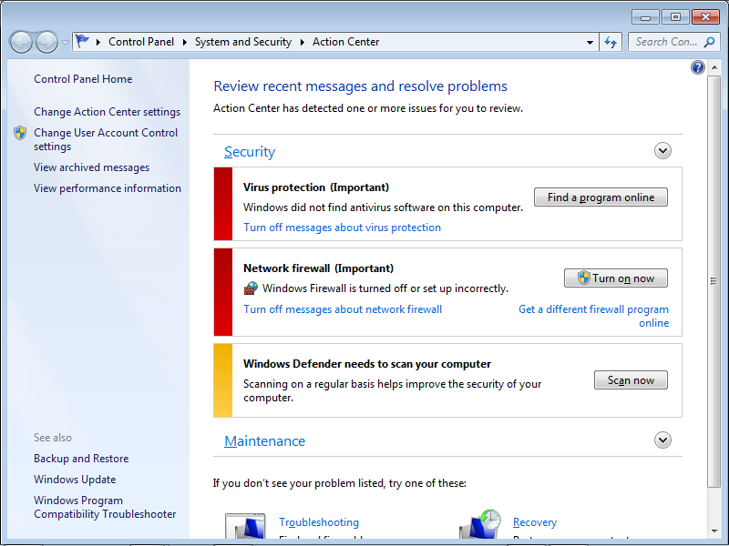

Updates

Windows Update

Can be set to update all Microsoft products, not just Windows

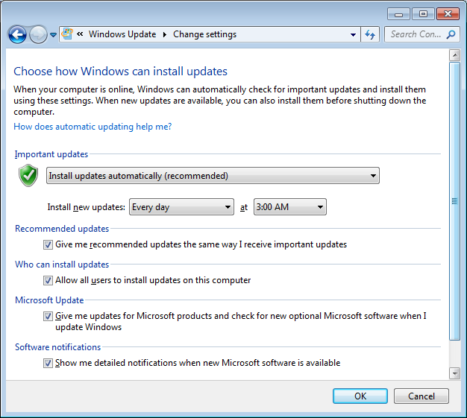
Update Settings

Updating Device Drivers

Some drivers are included in Windows Updates, but many are not

You will need to visit your device vendor's website, or your computer vendor's website, to find updates

Updating Many Computers

Microsoft Update Catalog (link Ch 21a)

Download installable versions of updates

WSUS (Windows Server Update Services)

Manages and deploys updates from a server running Windows Server 2003 or 2008

Link Ch 21b

Checking Disks for Errors

Checking Disks for Errors

Disk errors can prevent files from opening, or cause blue-screen errors

Windows can recover automatically from many disk errors, especially on drives formatted with NTFS

Windows Check Disk utility, chkdsk.exe, does a more thorough test

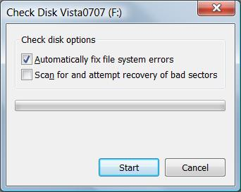
Two versions of this utility

Graphical version that performs basic disk-checking functions

Command-line version that provides more options

To Check for Errors

Open Computer

Right-click the drive

Properties

Tools tab

Check Now

To Check for Errors

Automatically Fix File System Errors

Equivalent to Chkdsk /F

Scan For And Attempt Recovery Of Bad Sectors

Automatically repairs file system errors too, even if other box is not checked

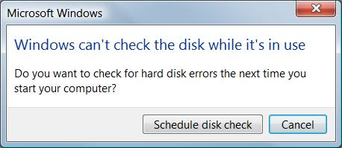
Equivalent to Chkdsk /R

If you simply want a report of file system errors without making changes, leave both boxes unchecked

Checking System Volumes

If you selected the Automatically Fix File System Errors

On a drive with open files

The disk check occurs the next time you start Windows

It Can Take a Long Time

Once started, the Check Disk operation cannot be stopped except by pressing your computer’s power switch

On very large drives (hundreds of GB and larger), the full disk check can takes hours or even days to complete.

Automatic Checking

Check Disk runs automatically after an abnormal shutdown if the file system is "dirty"— data was not properly read or written

NTFS disks don’t get dirty as much as FAT32 ones

To see if your disk is dirty, use this command

chkntfs d:

Command-line Check Disk

At an Administrator Command Prompt

Chkdsk d:

Scans disk d: in read-only mode, displaying drive status but not making any changes

Switches

/F fix any errors

/V verbose

/R Identifies bad sectors and recovers information from those sectors if possible

Chkdsk in the Windows Recovery Environment

Only two switches are available for Chkdsk in the Windows Recovery Environment

/P Performs an exhaustive check of the current disk.

/R Repairs damage on the current disk.
Defragmenting Disks

Defragmenting Disks for Better Performance

Files are stored in 4 KB clusters

It takes 50,000 clusters to store a 200 MB file

On a freshly formatted hard disk, Windows writes a file in contiguous clusters (in order)

Reading and writing go faster with contiguous clusters

Defragmenting Disks for Better Performance

As you delete files and save new ones, the files get fragmented

Scattered them over the hard disk into many noncontiguous pieces

Disk Defragmenter rearranges files so that they’re stored in contiguous clusters

Automatic Defragmentaion

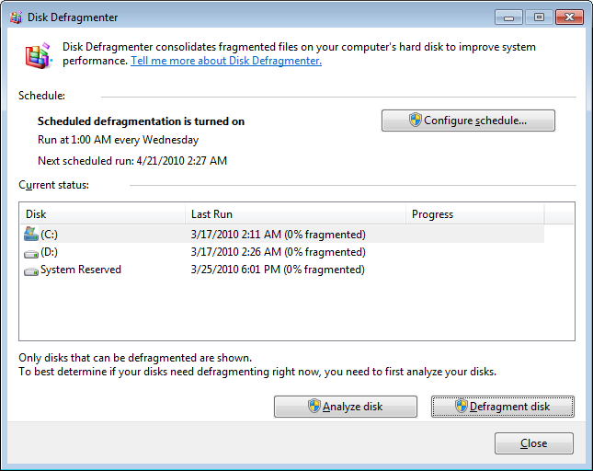
On the Tools tab in a drive's Properties sheet

Click "Defragment Now"

Runs once a week automatically in Windows 7, with low priority

Command-Line Version: Defrag

defrag d:

where d is the drive letter

Disk Defragmenter Limitations

Must have at least 15 percent free for complete defragmentation

You cannot defragment a volume that has errors

First run

chkdsk d: /f

The Disk Defragmenter does not defragment files in the Recycle Bin, and certain system files, such as the page file

Empty the Recycle Bin before defragmenting

Defragmenting Solid-State Media

Does not happen automatically

Generally unnecessary, and may even shorten devce life

Manual defragmentation is possible, however
Managing Disk Space

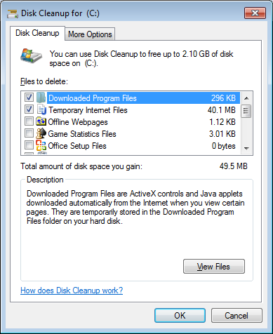
Managing Disk Space

Clear out temporary files that you no longer need

Uninstall programs you don’t need

Uninstall Windows components you don’t need

Delete documents you don’t need

On NTFS volumes, use real-time file compression

Disk Cleanup

If you click a "low disk space" warning, this tool opens automatically

To start it manually

Start, "Cleanup"

"Downloaded Program Files" includes ActiveX and Java add-ins, which you may want to keep

Clean Up System Files

This button appears if you are running as a non-administrator with User Account Control turned on

More Disk Cleanup Options

Deleting System Restore points and backups can save space, but it's dangerous

You may also have a windows.old file you can delete

Chapter 22 - Using Advanced System Management Tools

Editions

Everything in this chapter is the same for all editions
Viewing System Information

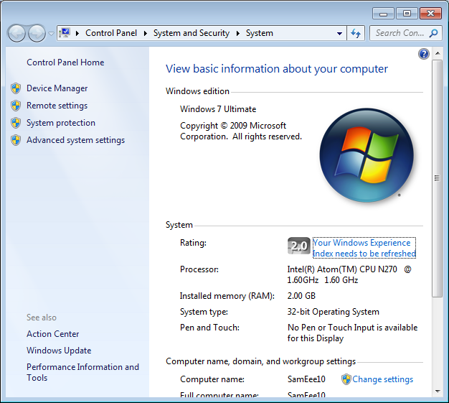
System Properties

Start, right-click My Computer, Properties

Device Manager

Windows Experience Index

Systeminfo

Command-line utility
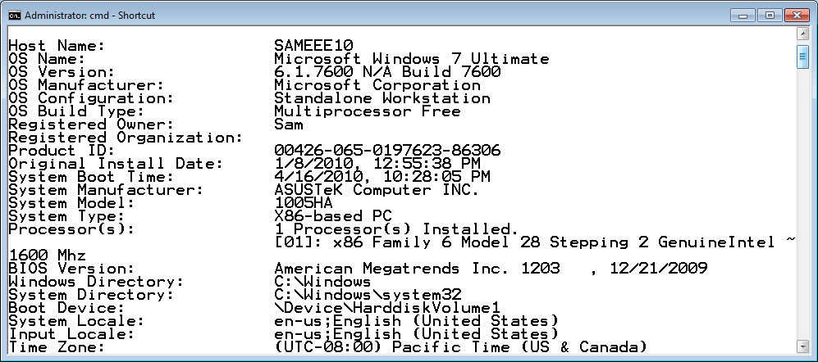

Windows Management Instrumentation Command-Line Utility (WMIC)

Used to get an overwhelming amount of information

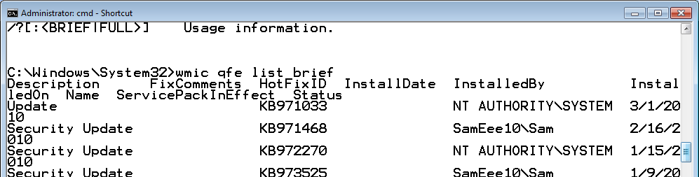
Many command-line switches

System Information (MSINFO32)

Start, MSINFO32
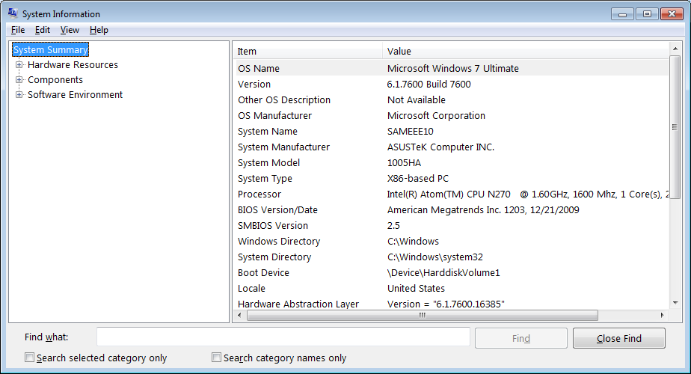

Microsoft Management Console (MMC)

Microsoft Management Console (MMC)

Microsoft Management Console

Start, MMC, Enter

It’s an empty container at first

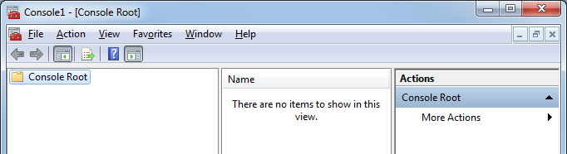
Add Snap-ins to use it

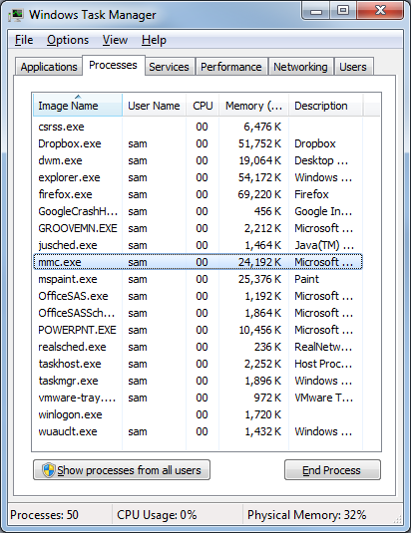
Snap-ins

Microsoft Common Console Documents

.msc files

Demo

Start, gpedit.msc

Open Task Manager

On Applications tab, right-click “Local Group Policy Editor”, and click “Go To Process”

The Process is mmc

Snap-ins

Many familiar tools are snap-ins

Computer Management

Compmgmt.msc

Device Manager

Devmgmt.msc

Event Viewer

Eventvwr.msc

Performance Monitor

Perfmon.msc

Demonstration: Custom Snap-in

Add snap-ins

Save the console in C:\Windows\System32

It now appears in the Start button's Search menu

See project 10

Task Scheduler

New Features in Task Scheduler

Implemented as a Microsoft Management Console (MMC) snap-in

More information about tasks

Integrated with the Event Viewer

Events can trigger tasks

More extensive triggering and scheduling options

Launch when computer is idle

Launch when a specific user logs on

Launching Task Scheduler

Start, search for "Task Scheduler"
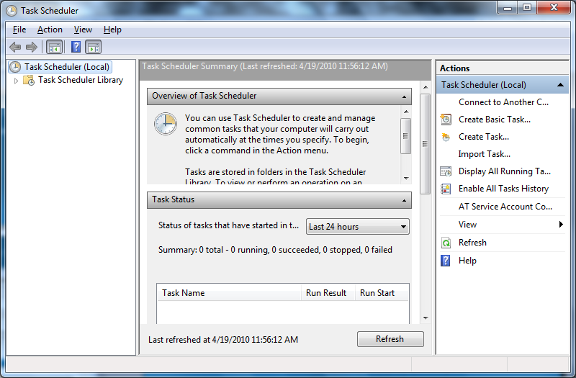

Active Tasks

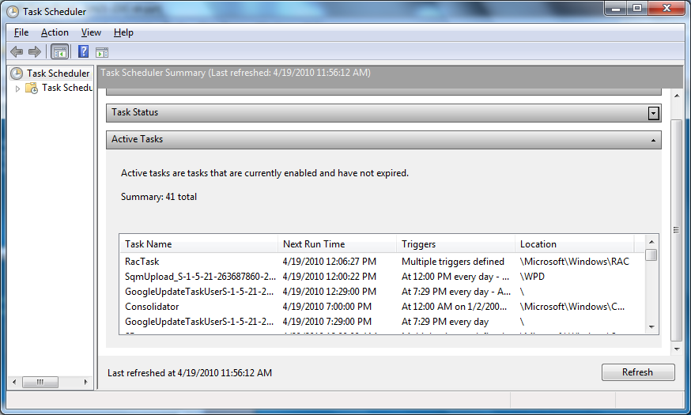
Minimize top two sections

Task Details

Browse to task in folder tree to see read-only details in lower pane

To modify them, right-click task name in the top pane and click Properties
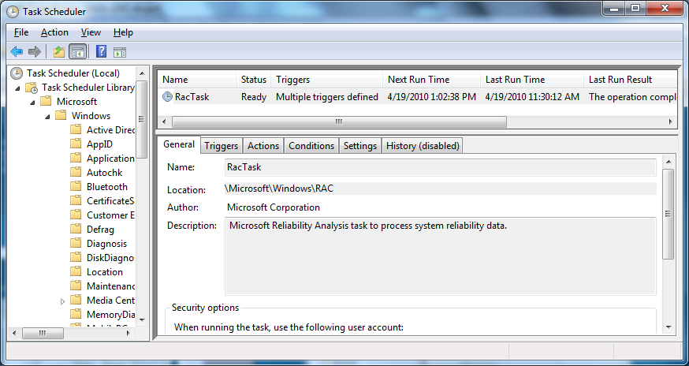

Task Scheduler Terminology

Trigger

The time or the event that causes a task to run

Action

What the task does

Condition

An additional requirement that, along with the trigger, must be met for the task to run

Setting

A property that affects the behavior of a task

Scheduling Tasks with the Schtasks Command

Schtasks /Create

Schtasks /Change

Schtasks /Delete

Schtasks /End

Schtasks /Query

Schtasks /Run
Services

Services

A service is a specialized program that performs a function to support other programs

Many services operate at a very low level

Interacting directly with hardware

Need to run even when no user is logged on

Run with the System account (which has elevated privileges)

Using the Services Console

A MMC snap-in

In Computer Management

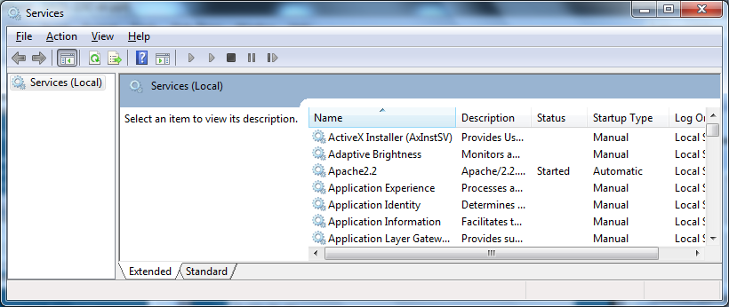
Or SERVICES.MSC at a command prompt

Actions on Services

Start, stop, pause, resume, or restart

Pausing and resuming is less drastic than stopping and restarting

May avoid cancelling jobs in process

Essential services start automatically

Some others must be manually started or stopped

Usually because of an error

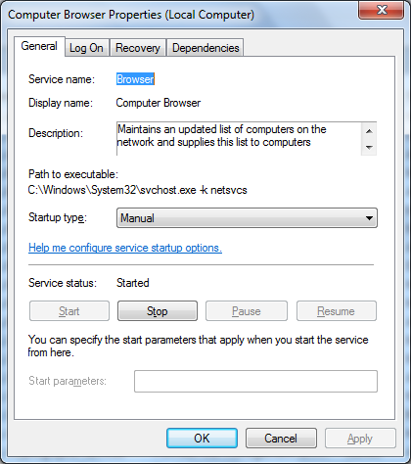
Service General Properties

Startup Types

Automatic (Delayed Start)

Starts shortly after the computer starts

Automatic

Starts when the computer starts

Manual

Doesn't start automatically at startup, starts when needed

Disabled

Can't be started

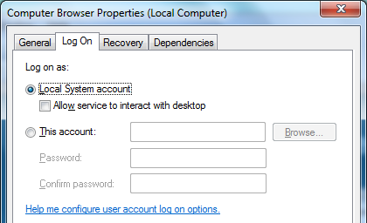
Service Log On Properties

The logon account must have the "Log On As A Service" right

Local Security Policy

Security Settings

Local Policies

User Rights Assignment

Service Recovery Properties

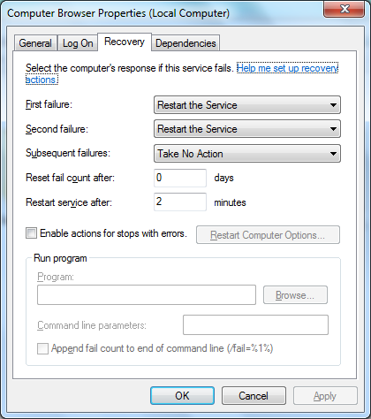
When it fails

Take No Action

Restart The Service

Run A Program

Restart The Computer

Dependencies

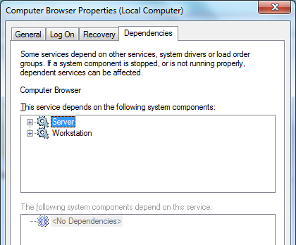
If you attempt to start a service that depends on other services, Windows first starts the others

If you stop a service upon which others are dependent, Windows also stops those services

Determining the Name of a Service

Each service has three names

Service name

Used in command-line and Registry

Display name

Appears in the Services console

Executable file name

Many are Svchost.exe

Managing Services from Task Manager

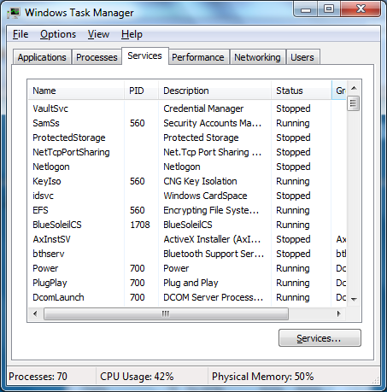
Right-click a service to start or stop it

Right-click service "Go to process" to see its process

"Show processes from all users" to see them all

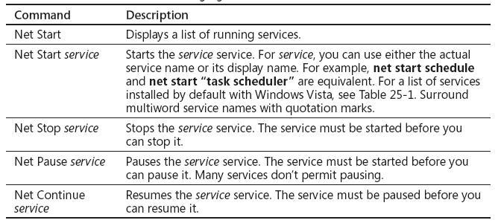
Managing Services from a Command Prompt

Editing the Registry

Editing the Registry is Dangerous

A bad manual change can crash your system

Normally you use Control Panel to update the registry to avoid such disasters

Understanding the Structure of the Registry

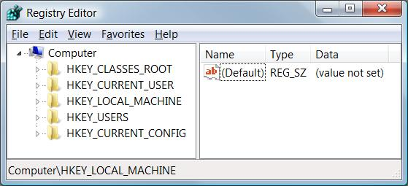
The registry consists of five root keys

HKey_Classes_Root

HKey_Current_User

HKey_Local_Machine

HKey_Users

HKey_Current_Config

Or HKCR, HKCU, HKLM, HKU, and HKCC

Subkeys

Root keys (sometimes called predefined keys), contain subkeys

Subkeys look like folders in Regedit

HKCU has these top-level subkeys: AppEvents, Console, Control Panel, …

A root key and its subkeys form a path

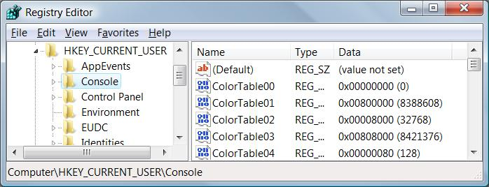
HKCU\Console

Values

Every Subkey contains at least one value

But it may show (value not set)

The default value (often undefined)

Values have name, data type, and data

Hives

A key with all its subkeys and values is called a hive

The registry is stored on disk as several separate hive files

Hive files are read into memory when the operating system starts (or when a new user logs on)

HiveList

HKLM\System\CurrentControlSet\Control\HiveList
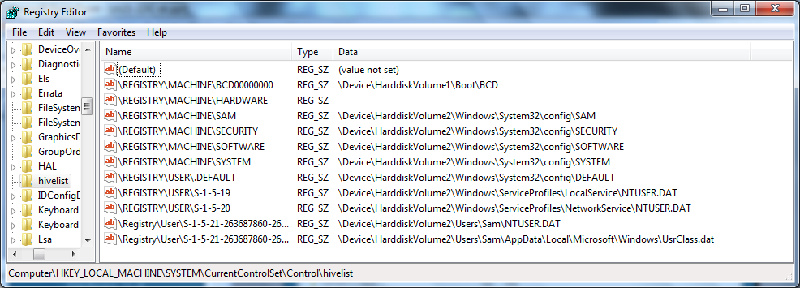

Hardware Hive

\Registry\Machine\Hardware has no associated disk file

Windows 7 creates it fresh each time you turn your system on

HKCR and HKCU

These keys are links to items contained in other root keys

HKey_Classes_Root (HKCR)

Merged from keys within HKLM\Software\Classes and HKU\sid_Classes

sid is the security identifier of the currently logged on user

HKey_Current_User (HKCU)

HKU\sid

Avoiding Registry Mishaps

Registry Editor changes the registry immediately

No Undo command

No File, Save command

Backing Up Before You Edit

Registry Editor's File, Export

Registry Hive format is recommended for backups

Because it restores the entire hive exactly

BUT if you restore it to the wrong key, it does a lot of damage

.reg Files

You can export a registry key in Registration Files format

Creates a .reg file

Can be edited in notepad

Right-click, Merge to insert values into registry
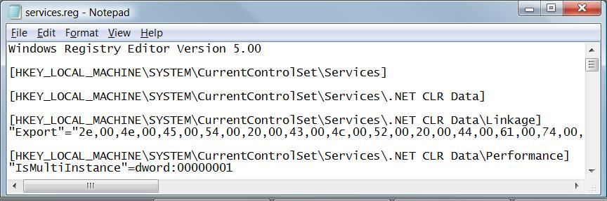

HKLM\System\CurrentControlSet

This hive is so important, Windows backs it up

To restore this hive, press F8 during bootup and use "Last Known Good Configuration"

Last modified 3-22-10

