Chapter 23 – Recovering From an Computer Crash

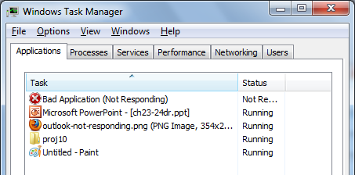
Editions

The troubleshooting tools described in this chapter are available in all editions

"Not Responding"

This indicates that Windows Error Reporting is starting

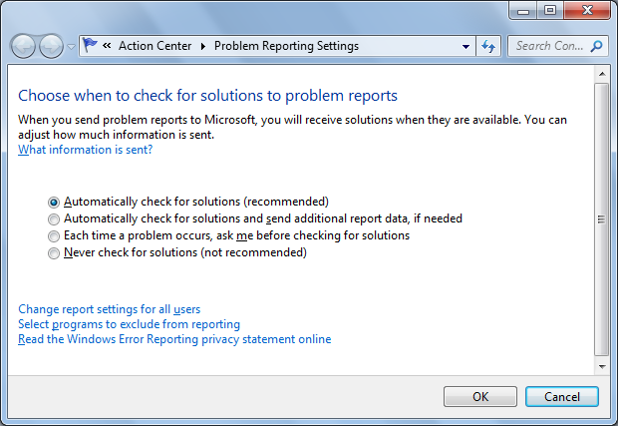
It sends data to Microsoft, and gives application developers tools to recover gracefully

Problem Reporting Settings

Solutions

In Action Center, in the Maintenance section, click "Check for solutions"

Not always available

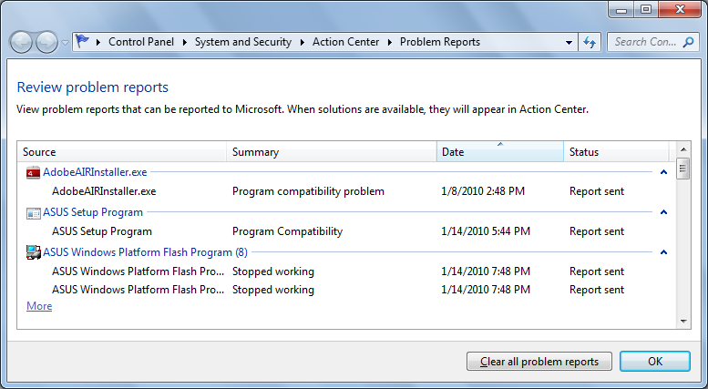
Problem Reports

Troubleshooters
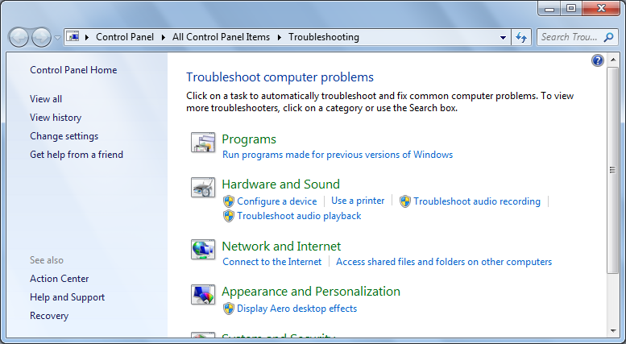

Problem Steps Recorder


Start, "problem steps"

Creates a single-file Web page containing every step you recorded

It's a ZIP file containing a MHT page

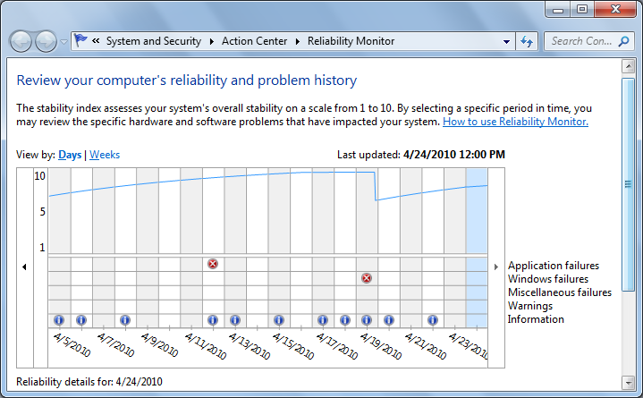
Reliability Monitor

Analyze Wait Chain

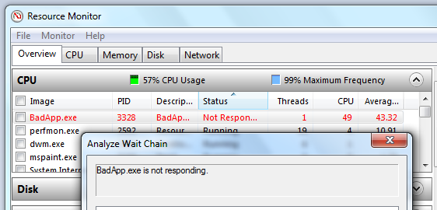
In Resource Monitor, on the Overview tab, under CPU, right-click a "Not Responding" program and click "Analyze Wait Chain"

That sometimes tells you what it's waiting for, although not in the case shown

Event Viewer

Event Log Service

Records noteworthy occurrences in these log files

Application

Security

Setup

System

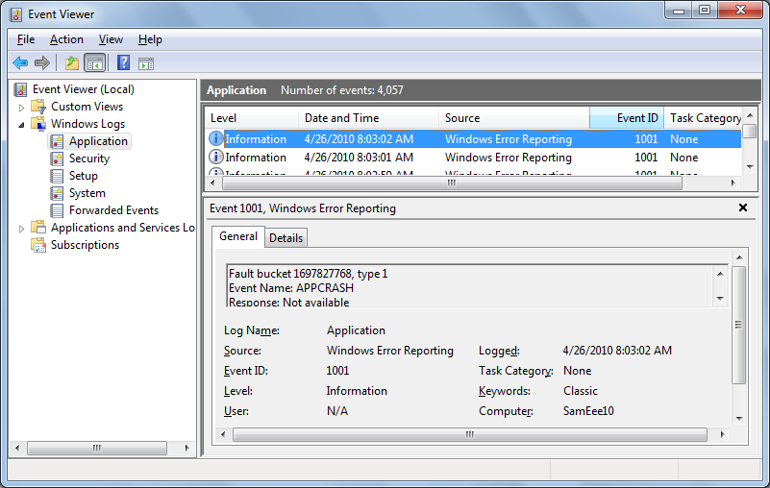
Forwarded Events

Event Viewer: New Features

View events from multiple logs simultaneously

Create and save filtered selections as custom views

Create a task to run automatically when a particular event occurs

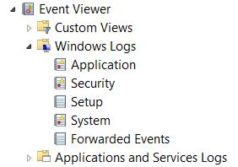
Create a subscription to specified events on other networked computers

Types of Events

Application

Generated by programs, selected by the developer

Security

Logon attempts

Attempts to use secured resources, such as an attempt to create, modify, or delete a file

Setup

Application installation

System

Generated by Windows itself

For example, a driver fails to load when you start Windows

Forwarded Events

Events gathered from other computers

Applications And Services

Logs for individual applications

Analytic And Debug Logs

View, Show Analytic And Debug Logs

Rarely used

Event Levels

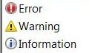
Error

Possible loss of data or functionality

Such as a malfunctioning network adapter

Warning

Less significant then errors

Such as a nearly full disk

Information

Other events

Such as someone using a printer

Event Logs Summary

Click Event Viewer in the left pane

For details, click an Event Type, then click "View all instances" in right pane
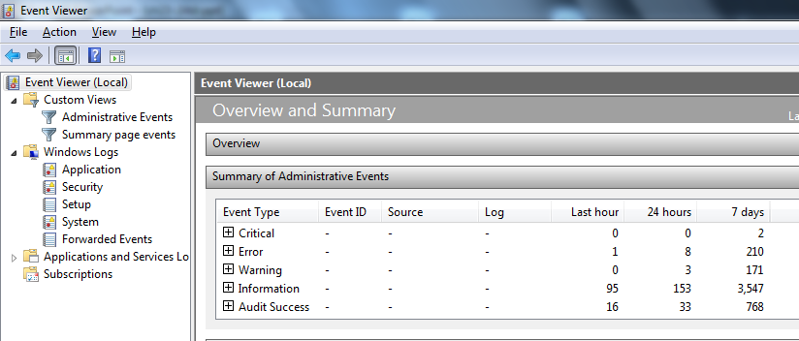

Viewing Individual Logs and Events


Level

Information, Warning, or Error

Date And Time

Source

The application or system component that generated the event

Event ID

A very important number to define the event

Task Category

May give further information about the event

Event Details

Right-click an event, click "Event Properties"

Link at the bottom gives you Microsoft's Web info

Eventid.net gives you much better information
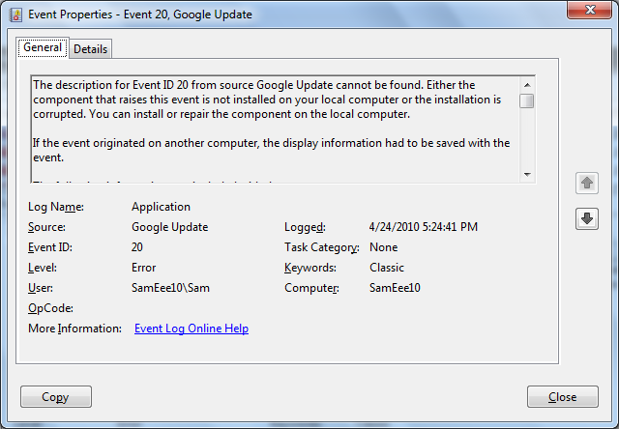

Creating a Task to Run When a Specific Event Occurs

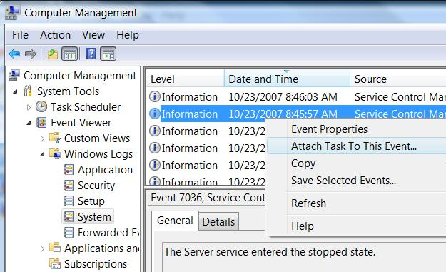
Connects Task Scheduler to Events

Dealing with Stop Errors

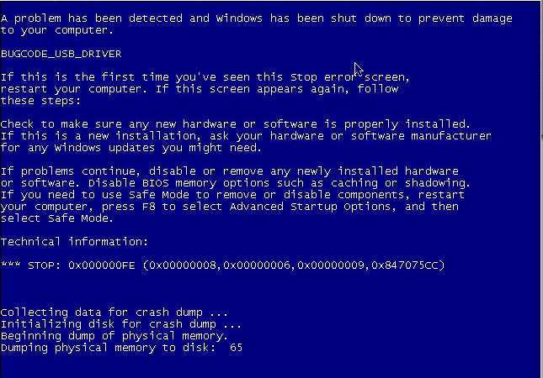
Blue Screen of Death (BSOD)

How Windows Handles Stop Errors

Displays a STOP error (BSOD)

Writes debugging information to the page file

When the system restarts, this information is saved as a crash dump file

By default, the system restarts

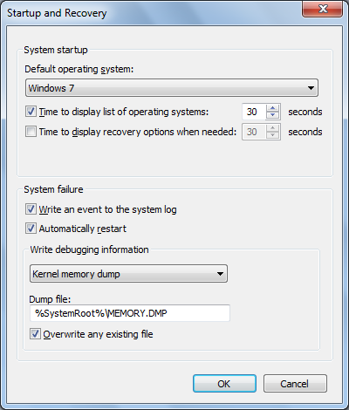

Customizing STOP

Error Behavior

Start

Right-click Computer, Properties

Advanced System Settings

Advanced tab

In "Startup and Recovery" section, click Settings

How to Read a Stop Error

Symbolic error name

At the top – here it is BUGCODE_USB_DRIVER

Troubleshooting recommendations

Error number and parameters

After the word STOP

Advice for Dealing with Stop Errors

Look for a driver name

Don’t rule out hardware problems

Check your memory

Logo, MEM for Memory Diagnostics

Ask yourself, “What’s new?”

Search the Knowledge Base

Check your system BIOS for updates

Are you low on system resources?

Check RAM and disk space

Try starting in Safe Mode

If that works, it's probably a driver problem

Try an alternative driver

Even one made for a different hardware model in the same family
Recovering from a Crash

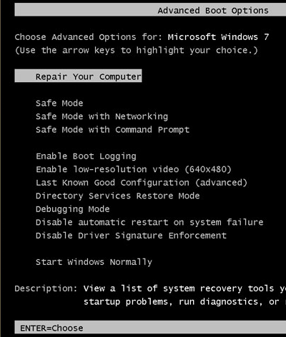
Recovery Tools

Advanced Boot Options

Press F8 during startup

Safe Mode

The Windows Recovery Environment (WinRE)

Boot from DVD

Replaces Windows XP's Recovery Console

Advanced Boot Options

Press F8 during startup

Windows Error Recovery

If you shut down and restart with the power switch, you see this screen
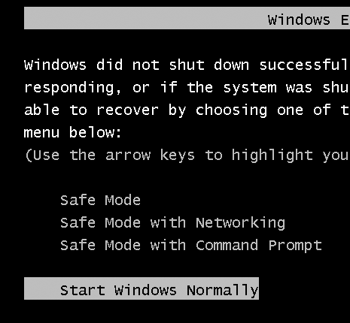

Safe Mode

Uses only those services and drivers that are absolutely required to start your system

Generic video driver at 800 x 600 resolution

USB flash drives, hard disks, keyboard, and mouse will be supported

No audio devices

No Startup folder programs

These configuration tools are available

Device Manager

System Restore

Registry Editor

Help And Support

Online help (if you use Safe Mode with Networking)

Backup and Restore Center is not available

To restore a Complete PC Backup, use the Windows Recovery Environment, not Safe Mode

Other Safe Mode Options

Safe Mode With Networking

Safe Mode plus drivers and services required to start Windows networking

Safe Mode With Command Prompt

Safe Mode with no graphics

Uses Cmd.exe only

Last Known Good Configuration

Every time Windows starts in normal mode

It makes a record of all currently installed drivers and the contents of the registry key

HKLM\SYSTEM\CurrentControlSet

Last Known Good Configuration (Advanced) restores the previous, working registry key

If you just installed a driver that makes the system hang, this is an easy fix

System Restore is more reliable

Enable Boot Logging

Lists the names and status of all drivers loaded

%SystemRoot%\Ntbtlog.txt

Enable Low-Resolution Video

640 x 480

Directory Services Restore Mode

Ignore it, it only applies to domain controllers

Debugging Mode

Kernel debug mode—rarely used

Disable Automatic Restart On System Failure

Stops an endless cycle of restarting

Disable Driver Signature Enforcement

Use this option if Windows is refusing to start because of an unsigned driver

Windows Recovery Environment

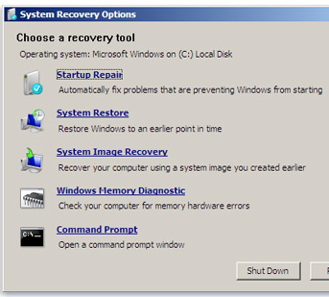
Press F8 during bootup, select "Repair Your Computer"

Or Boot from install DVD

Select Keyboard Input Method, click Next

Logon

Startup Repair

Easy and automatic

Fixes boot files, including BCD (Boot Configuration Data) store

System Restore

Runs as usual, but cannot create a restore point first

So there's no way to undo a System Restore made from Windows Recovery Environment

System Image Recovery

You must have previously used Windows Backup to create an image backup of your system disk

Formats your disk and completely replaces it with the backup copy

You will lose recent documents on the System disk

Copy them to a USB drive with the Command Prompt first

Windows Memory Diagnostic Tool

Checks your RAM

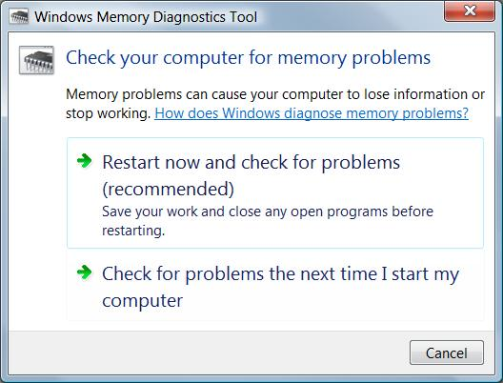
You can also run it with Windows 7 running

Shows results at next restart

Working at the Command Prompt

The Command Prompt option in Windows RE

You can run all commands, including

DISKPART to manage disk partitions

Networking is not available unless you run the WPEINIT command

You run with the System account

So anyone who can boot from DVD can completely control your computer

Unless you use encryption
Ch 24: Setting Up and Configuring Hardware

Editions

The tools described in this chapter are available in all editions

Installing and Configuring a New Device

Almost all devices are Plug and Play

When you plug in a device

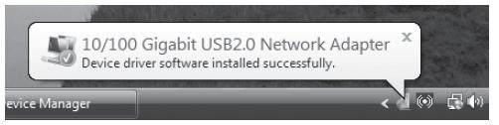
Windows 7 looks in the Driver Store for a matching driver

Messages like this one show the Plug and Play process

Found New Hardware Wizard

If Windows 7 can’t find a signed driver

The Found New Hardware wizard appears

Run Setup Software First

If the device comes with a setup CD, run it before plugging in the device for the first time

Unless the device documents say otherwise

Devices and Printers

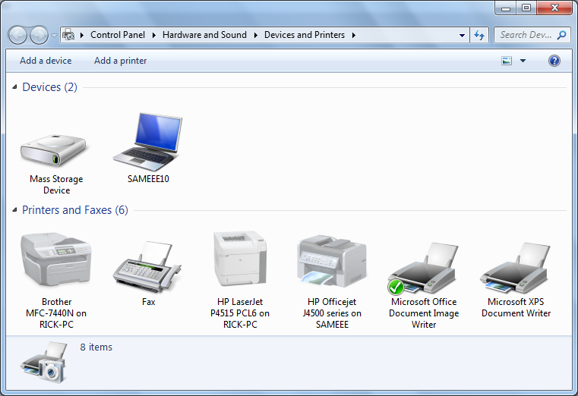
Right-click devices here to configure them

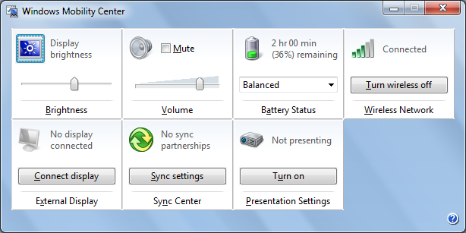

Mobility Center

Handy place to adjust settings for portable computers

Device Manager

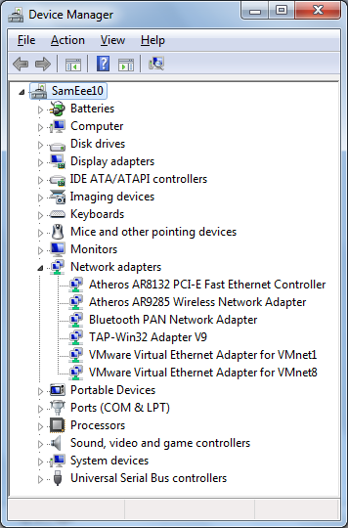
Starting point for all hardware and driver troubleshooting

Device Properties

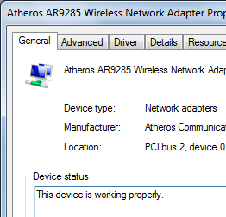
Double-click icon in Device Manager

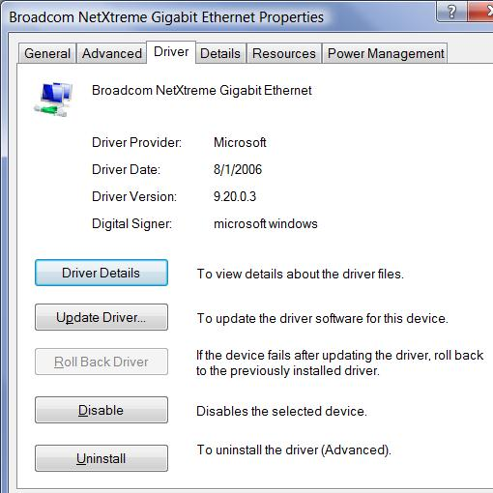

Driver Tab

Shows version, and who signed the driver

Roll back option – returns to the previous driver version

Error Icons in Device Manager

Question mark and

Yellow exclamation point

Indicate a missing driver or other configuration problem

A Crash Course in Device Drivers

Each hardware device needs a driver

A compact control program

Windows 7 has a library of drivers called the Driver Store

In C:\Windows\System32\DriverStore

Using the Driver Store

Any user can read and execute files in the Driver Store

No Administrator credentials are required

The Driver Store is created when Windows 7 is installed

Windows Update can add drivers to it

Installers can add to it, with Administrator credentials

Administrators can add other drivers to the store, even ones that are not Microsoft approved or signed

INF Files

Each driver has Setup Information file (.inf)

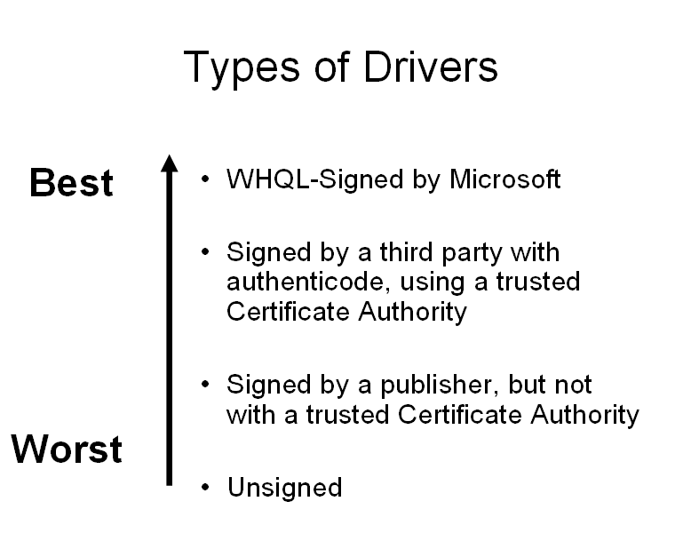
Contains instructions Windows uses to install the driver files

Driver Store drivers have INF files in

%systemroot%\inf

Usually C:\Windows\inf

WHQL-Signed Drivers

Windows Logo Program

Signed by Microsoft’s Windows Hardware Quality Lab (WHQL)

Proves the driver has not been altered

Also proves the driver has been thoroughly tested so it won’t crash Windows

The most trustworthy drivers

Can be installed by any user with no warnings

Drivers Signed by a Third Party

Signed with digital certificates called “Authenticode Signatures”

Proves the driver has not been altered

Not tested by Microsoft, may cause Windows to crash

Unsigned Drivers

No guarantee that the driver has not been altered

No guarantee that anyone has tested it

Driver may cause a system crash or contain a trojan

Can be installed only by Administrators

Can not be used at all on 64-bit Windows 7

Driver Verifier

If your computer has blue-screens, lockups, or other strange behavior

Driver Verifier will thoroughly test all drivers at startup, and stop if it finds any problems

Then you can fix the problem, and turn Driver Verifier off again

Open an Administrator Command Prompt

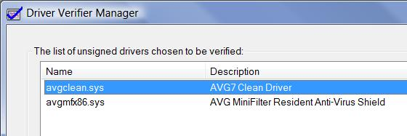
VERIFIER

Last modified 4-26-10

