Chapter 25 - Managing Disks and Drives

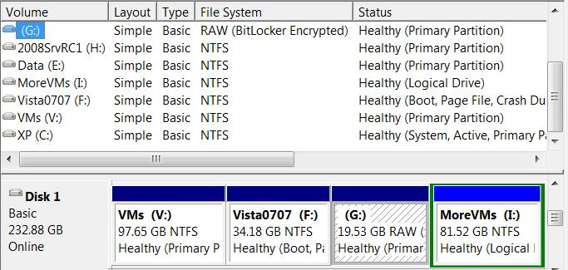
Editions

Disk management is the same in all editions of Windows 7

Disk Management Tools

Disk Management console in Computer Management

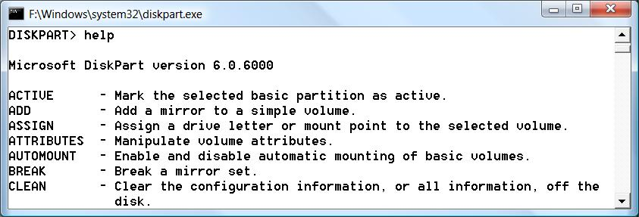

Command-line program DISKPART

New Features in Win 7 and Vista

Can now shrink partitions as well as expand them

Universal Disk Format (UDF) support for writeable CDs and DVDs

Dynamic disk for USB, IEEE 1394 , and eSATA removable hard drives

Running Disk Management

At any command prompt, enter DISKMGMT.MSC, or

Right-click the My Computer icon on the Start menu, choose Manage

And then select Disk Management on the left side of the Computer Management window

Control Panel, System and Maintenance

Under "Administrative Tools", choose "Create And Format Hard Disk Partitions"

Disk Management Lets You

Check the size, file system, status, and other properties of disks and volumes

Create, format, and delete partitions, logical drives, and dynamic volumes

Assign drive letters

Create mounted drives

Disk Management Lets You

Convert basic disks to dynamic disks, and vice versa

Create spanned volumes and striped volumes

Extend or shrink partitions

Managing Disks from the Command Prompt

Enter DISKPART at a Command Prompt

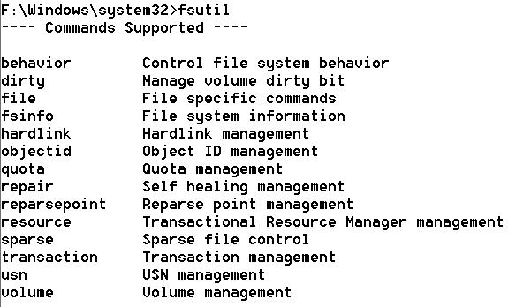
Now enter further commands at the DISKPART> prompt

FSUTIL allows more esoteric disk management tasks

Why Use the Command Prompt?

To automate disk management tasks with scripts

To manage disks from the Windows Recovery Environment

Disk Management is not available there

(Also to manage disks in Windows 2008 Server Core, which has no Graphical User Interface (GUI))

Disk Management Terminology

Volume

A disk or subdivision of a disk that is formatted and available for storage

Usually assigned a drive letter, like C:

Mounted drive

A volume mapped to an empty folder on an NTFS-formatted disk

Has no drive letter

Format

To prepare a disk for storage

Using a particular file system, such as NTFS

File System

A method for organizing folders (directories) and files on a storage medium

Windows 7 supports

FAT (File Allocation Table)

NTFS (NT File System)

CDFS (Compact Disc File System) (also called ISO-9660)

UDF (Universal Disk Format)

Basic Disk and Dynamic Disk

A hard disk in Windows 7 is either basic disk or a dynamic disk

Basic Disk

Subdivided into partitions

Usually a maximum of 4 partitions

The first three partitions are primary partitions

The last partition is an extended partition

The extended partition can be subdivided into logical disks

Dynamic Disk allows these disk structures

Simple volume

A volume contained entirely on a single physical disk

On a basic disk, a simple volume is also known as a partition

Spanned volume

Combines space from physically separate disks

Only available on dynamic disks

Striped volume

Data is stored in 64 KB strips across physically separate disks in order to improve performance

Only available on dynamic disks

MBR and GPT Disks

MBR (Master Boot Record) and GPT (GUID Partition Table) are alternative ways of maintaining information about a disk's subdivisions

GPT supports larger disks (up to 18 Exabytes or 18 million Terabytes) and more partitions (up to 128 on a basic disk)

Active Partition

The active partition on a basic disk is the one from which an x86-based computer boots

The Master Boot Record on the physical disk containing the active partition is used to begin startup

The active partition is usually on the first physical hard disk (Disk 0)

System and Boot Partitions

The system partition

Contains the bootstrap files that Windows XP uses to start your system and display the boot menu

The boot partition

The partition where the Windows system files are located

Setting Up a New Hard Disk

Installing Windows on a New Disk

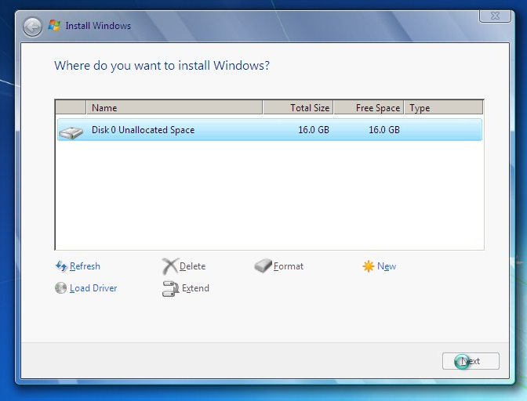
You can choose Unallocated Space when installing Windows 7

Windows 7 will automatically format it and partition it, using all free space, unless you click "Drive Options (Advanced)"

Image from link Ch 25a

Creating a New Simple Volume

In Computer Management, right-click the Unallocated Space and select "New Simple Volume"

In the New Simple Volume Wizard, choose

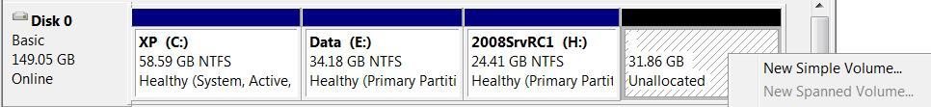
Size, Drive Letter, and Format

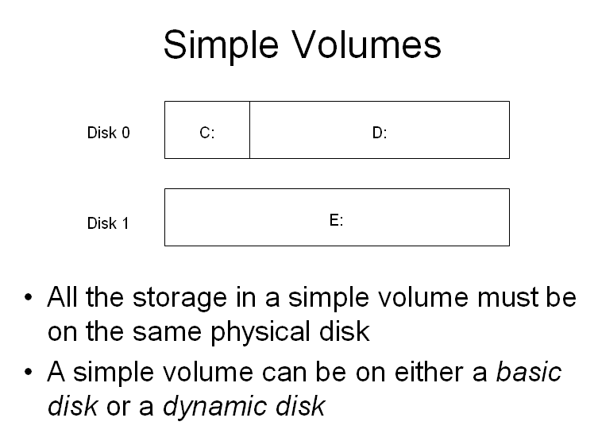
Simple Volumes

All the storage in a simple volume must be on the same physical disk

A simple volume can be on either a basic disk or a dynamic disk

Formatting Disks

Right-click a volume in Explorer or Disk Management, Format

File System

FAT, FAT32, or NTFS

Only NTFS allowed for volumes larger than 4 GB

Allocation Unit Size

Leave at Default

Quick Format

Skips Disk Check

Formatting Doesn't Erase Data

It just makes it inaccessible

It can still be recovered with third-party utilities like "Recover My Files"

Link Ch 25c

To really erase data, use

FORMAT /P:x

x is the number of passes, or

CIPHER /W

Choosing a File System

Usually you want NTFS for hard disks

FAT and FAT32 are old and limited

The only reason for FAT and FAT32 is for machines that multiboot with Win 9x

Removable devices like floppies and USB flash drives often use FAT

Choosing the Right UDF Version for Optical Media

Universal Disk Format (UDF)

Version 1.5

Can be read on systems running Windows 2000, Windows XP, Vista, and Windows Server 2003

Version 2.00 or 2.01

Cannot be read on Windows 2000. Can be read on Windows XP, Vista, and Windows Server 2003

Version 2.50

Can only be read on Windows Vista, Windows 7, and Windows Server 2008

Advantages of NTFS over FAT and FAT32

Security

NTFS Permissions

EFS (Encrypting File System)

Reliability

Recovers from disk errors better, because it is a journaling file system

Expandability

Volumes can be expanded

Advantages of NTFS over FAT and FAT32

Efficiency

More efficient than FAT32 for partitions larger than 8 GB

Windows 7 cannot create a FAT32 partition larger than 32 GB

Optimized Storage of Small Files

Small files are stored more efficiently
Managing Existing Disks and Volumes

Extending a Volume

An NTFS volume can be extended, as long as there is space available

In Disk Management, right-click the volume, "Extend Volume"

If you extend a volume using space on another disk, or noncontiguous space on the same disk, the disk(s) will be converted to Dynamic Disk

Volume Extension Limitations

Only NTFS-formatted volumes can be extended

A logical drive can be extended only within the extended partition that contains it

The system and boot partitions can be extended only into contiguous unallocated space

You cannot extend a striped volume.

Shrinking a Volume

You can shrink an NTFS volume, as long as it's not full of files

In Disk Management, right-click the volume, "Shrink Volume"

Disk Management defragments the disk, and then performs the shrink

Force Windows to Shrink a Volume

Windows will often refuse to shrink a volume as much as it should

These steps may help

Disable System Restore on the volume (you will lose Restore Points)

Configure the volume to use no page file

Use a third-party defragmenter

Most drastic solution

Make an image backup of the volume, delete and recreate the partition, and restore it

Converting a FAT32 Disk to NTFS

At a Command Prompt

convert d: /fs:ntfs

d: is the drive you want to convert

Assigning or Changing a Volume Label

Labels are just a convenience for the user

In "Computer", right-click a volume, "Rename"

Assigning and Changing Drive Letters

In Computer Management

Right-click, "Change Drive Letter and Paths…"

But not for these volumes

Boot volume

System volume

Any volume containing the page file
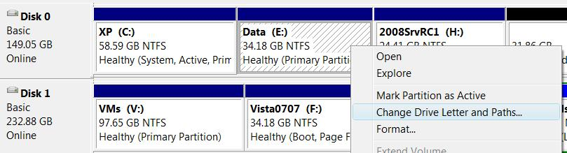

Mapping a Volume to an NTFS Folder

Suppose C: is full, but you don't want to bother moving the system to a new drive

You could add a drive and map it to C:\Programs

In Computer Management

Right-click, "Change Drive Letter and Paths…", Add, "Mount In The Following Empty NTFS Folder"

Make a Bootable USB or Flash Install Disk

You can install Windows 7 from a USB or flash disk

Instructions at link Ch 25b

Properties and Status of Disks and Volumes

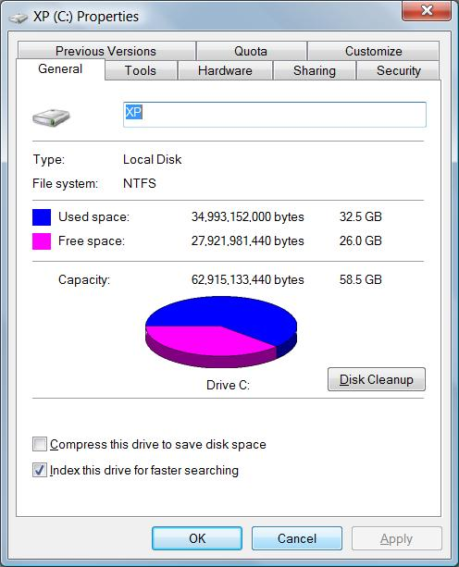
Using Windows Explorer

Start, Computer

Right-click volume, Properties

Properties and Status of Disks and Volumes

Computer Management shows status of volumes in top pane, and status of disks on the lower left side

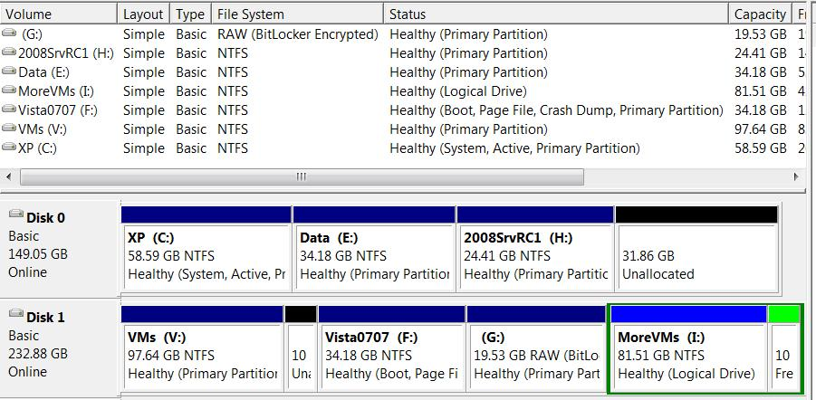

Disk Status

Online

No problems

Offline (Errors)

A dynamic disk with read or write errors

Offline

A dynamic disk that is unavailable, possibly unplugged

Foreign

A dynamic disk moved in from another computer

Unreadable

Physical damage, or a corrupt dynamic database

Missing

Corrupted, disconnected,

or not powered on

Not Initialized

Disk is brand new, or from a non-Microsoft system such as Linux

No Media

Removable media is not inserted (only for drives with removable media, such as CD and DVD drives)

Volume Status

Healthy

No problems

Healthy (At Risk)

Read or write errors on this dynamic disk

Healthy (Unknown Partition)

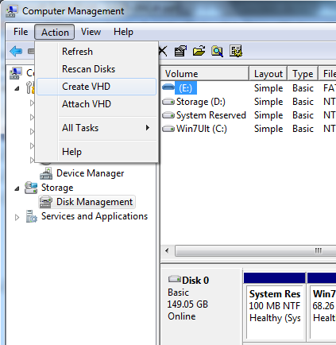
Windows does not recognize the partition; it may be from Linux, or a manufacturer's recovery partition

Initializing

Disk management is preparing a dynamic disk for use

Failed

The dynamic disk is damaged or the file system is corrupted

Unknown

Corrupt boot sector--could be caused by a boot-sector virus

Working with Virtual Hard Disks

Creating a Virtual Hard Disk

In Disk Management, Action, "Create VHD"

New in Win 7

Ch 26: Using Pen, Touch, and Voice Input

Editions

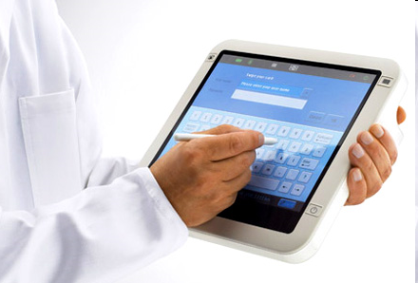
Speech recognition is available in all editions of Windows 7

Pen and touch features require custom hardware and are supported in Home Premium, Professional, Enterprise, and Ultimate editions

Tablet PC

Touch-sensitive screen and a stylus, like a smart phone

Understands handwriting and converts it to text

Image from link Ch 26a

Touch-Enabled PCs

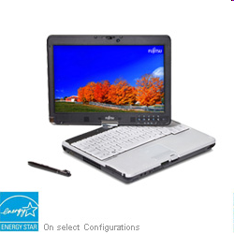
Notebook computers with both a keyboard and a touch-sensitive screen

Convertible designs have a rotating hinge so they can be used either as a tablet or a normal laptop

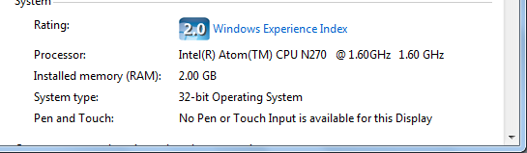

System Properties

"Pen and Touch" line shows whether your system has this capability

Pen and Touch

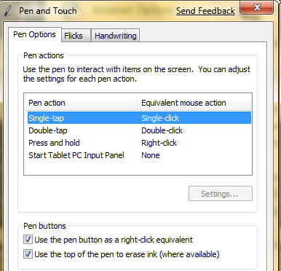
In Control Panel

If your hardware supports it, you can also enable multi-touch and gestures

Image from link Ch 26b

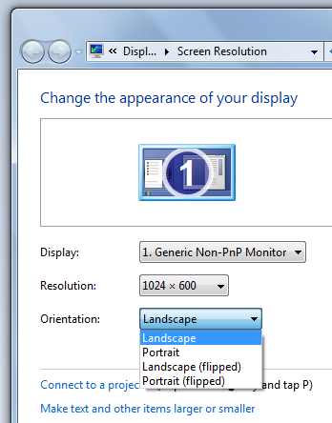

Changing Orientation

Right-click desktop, "Screen Resolution"

Or Ctrl+Alt+Arrow

Multitouch and Gestures

Video at link Ch 26c

Writing Pad and Touch Keyboard

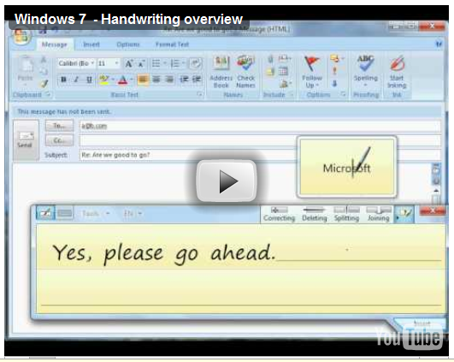
Touch Keyboard works like a cell-phone

"Input Panel" is a small box

Video at link Ch 26d

Speech Recognition and Voice Commands

Microphone

You will need a high-quality microphone

Microsoft recommends a USB headset

Go through the tutorial so Windows 7 can learn to recognize your voice

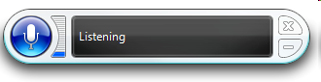
Microphone Icon

Indicates whether Windows 7 is listening for commands

Click it or say "Stop Listening" to stop

"Start Listening" to re-activate it

Speech Recognition Voice Training

You read text out loud so Windows 7 can learn your voice

It takes practice to use voice recognition effectively

Last modified 5-3-10

