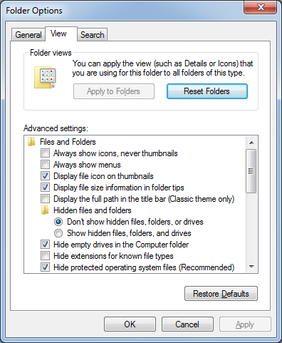
Choosing a Computer to Use
- This project could be dangerous! You will be editing the Registry, which can seriously harm your operating system if you make mistakes. If you are not comfortable exposing your Windows 7 machine to these risks, use the lab.
- Log onto any Windows 7 machine with an account that has Administrator privileges.

Displaying File Extensions
- Click Start, and type FOLD into the Search box.
- Click "Folder Options". In the Folder Options window, click the View tab. Make sure the "Hide extensions for known file types" box is cleared, as shown to the right on this page.

Creating a Restore Point on the Windows 7 Machine
- On the Windows 7 machine, Click Start, and type RESTORE into the Search box.
- Click "Create a Restore Point".
- In the "System Properties" box, click "Create".
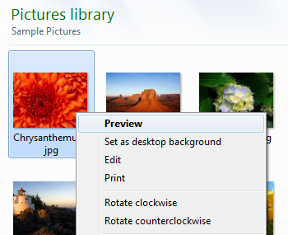
- In the "Create a restore point" box, enter a name of "Your Name - Before registry edits" and click the Create button. Wait while the restore point is created.
- A box appears saying "The restore point was created successfully". Click Close.
- Close "System Properties".

Creating a New Action for Images
- Click Start, Pictures. Open the "Sample Pictures" folder and right-click one of the .jpg images. The Context Menu opens, as shown to the right on this page. Notice the items here, Preview, "Set as desktop background", and others.
- Click Start, and type REGEDIT into the Search box. Press the Enter key. In the "User Account Control" box, click Yes.
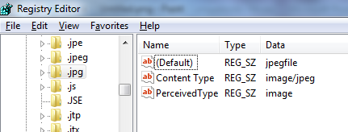
- In the left pane of "Registry Editor", expand the HKEY_CLASSES_ROOT key. Scroll down until you find the .jpg file extension, as shown to the right on this page.
- Click the .jpg subkey in the left pane. Find the Default value in the right pane: it is jpegfile. This is the name of the extension's associated file type subkey in the second section of HKEY_CLASSES_ROOT.
- In the left pane of "Registry Editor", scroll down past the whole alphabet, until it starts over again at A. Then scroll down further until you find the jpegfile subkey. In the left pane, expand the subkeys within jpegfile, as shown below on this page.
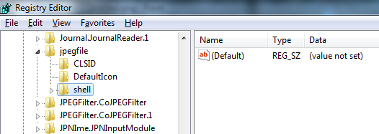

- In the left pane of "Registry Editor", click shell to select it. From the Menu bar, click Edit, New, Key. A new subkey appears with its name highlighted. Type in the name:
Open in Firefox
and then press the Enter key.
- From the Menu bar, click Edit, New, Key. A new subkey appears with its name highlighted. Type in the name:
command
and then press the Enter key.

- In the right pane, double-click (Default). In the "" box, type this line exactly, as shown below, then click OK:
"C:\Program Files\Mozilla Firefox\firefox.exe" "%1"

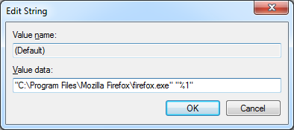
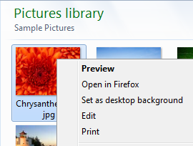
- Click Start, Pictures. Open the "Sample Pictures" folder and right-click one of the .jpg images. The Context Menu should now show an "Open in Firefox" item, as shown to the right on this page.

Saving a Screen Image
- Make sure the "Open in Firefox" item is visible.
- Press PrintScrn to copy the whole desktop to the clipboard.
- Click Start and type in PAINT. Click Paint. In the untitled - Paint window, click Edit, Paste. The image appears in the Paint window.
- In the untitled - Paint window, click File, Save. Save the document with the filename Your Name Proj 4a, using a File Type of PNG or JPG.

Customizing the "New" Menu
- On the Desktop, right-click, and click New, "Text Document". Double-click the newly created document to open it in Notepad, and verify that it is empty. Close Notepad.
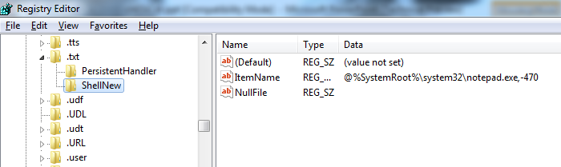
- Click Start, and type REGEDIT into the Search box. Press the Enter key. In the "User Account Control" box, click Yes.
- In the left pane of "Registry Editor", expand the HKEY_CLASSES_ROOT key. Scroll down until you find the .txt file extension, as shown below on this page.

- In the left pane of "Registry Editor", expand the .txt subkey. Click the ShellNew key to select it.
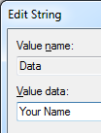
- In the right pane, right-click NullFile and click Delete. In the "Confirm Value Delete" box, click Yes.
- From the Registry Editor menu bar, click Edit, New, "String Value". Type in the name Data and press the Enter key.
- In the right pane, double-click the Data value. Type in your name, as shown to the right on this page. Don't use the literal string "Your Name"--use your own name. Then click OK.
- You should see the item Data in the right pane, with the value Your Name, as shown below on this page.

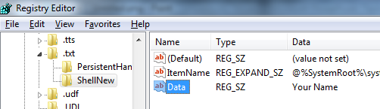
Saving a Screen Image
- Make sure the "Your Name" value is visible.
- Press PrintScrn to copy the whole desktop to the clipboard.
- Click Start and type in PAINT. Click Paint. In the untitled - Paint window, click Edit, Paste. The image appears in the Paint window.
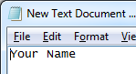
- In the untitled - Paint window, click File, Save. Save the document with the filename Your Name Proj 4b, using a File Type of PNG or JPG.
- On the Desktop, right-click, and click New, "Text Document". Double-click the newly created document to open it in Notepad. You should see your name automatically entered into it, as shown to the right on this page.

Using System Restore to Undo Registry Changes
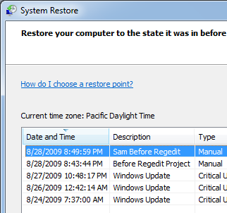
- Press the Windows logo key, next to the Ctrl key at the lower left of your keyboard. Don't touch the mouse. Type this into the Search box:
rest
- "System Restore" should appear in the Programs list. If it's not already highlighted, press the down-arrow as needed to highlight it. Then press the Enter key.
- In the "Restore system files and settings" box, click Next.
- In the "Restore system files and settings" box, make sure that the restore point with your name on it is highlighted, as shown to the right on this page.

Saving a Screen Image
- Make sure the "Your Name Before Registry Edits" line is visible.
- Press PrintScrn to copy the whole desktop to the clipboard.
- Click Start and type in PAINT. Click Paint. In the untitled - Paint window, click Edit, Paste. The image appears in the Paint window.
- In the untitled - Paint window, click File, Save. Save the document with the filename Your Name Proj 4c, using a File Type of PNG or JPG.

Completing the System Restore
- Close all other windows. The System Restore will reboot your system rudely, and could cause you to lose data if you are editing documents.
- In the "System Restore" box, click Next.
- In the "Confirm your restore point" box, click Finish.
- Another box pops up, as shown below on this page, saying "System Restore cannot be interrupted". This is really rude—what it means is that System Restore is about to close all your applications and restart, trashing the files you are editing, but it doesn't say that. Close any other programs you have open, then click Yes.
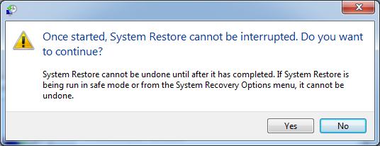

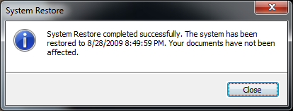
- The restore completes, and your machine restarts. Log in as before. You should see a message saying "System Restore completed successfully", as shown to the right on this page.
- Your Windows 7 machine should be back to its normal condition:
  - No "Open in Firefox" item when right-clicking a .jpg image
  - New text files should start empty

Turning in your Project
- Email the JPEG images to me as attachments to one e-mail message. Send the message to: cnit.345@gmail.com with a subject line of Proj 4 From Your Name, replacing Your Name with your own first and last name. Send a Cc to yourself.

Last revised 8-28-09

