Choosing a Computer to Use
- This project should be harmless to do on any Windows 7 computer.
- Log onto any Windows 7 machine with an account that has Administrator privileges.

Installing ActivePython

- We’ll use a simple Python application just to see how it uses RAM. Python isn’t installed on Windows by default, so we’ll use ActivePython.
- Open a browser and go to activestate.com/activepython
- Click the “DOWNLOAD NOW” button to get ActivePython 2.6, as shown to the right on this page. Save the installer file.
- Run the installer and install the software with the default options.

Downloading the WasteMemory.py Script
- Open a browser and go to samsclass.info
- Click the “CNIT 345” link. On the next page, click the Projects link.
- On the "Proj 5" line, point to the "WasteMemory.Python Script" link, as shown below on this page. Right-click and save the file on your desktop.
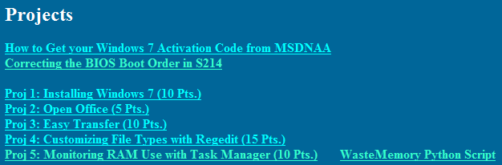
- The file you downloaded was a Zip archive. To extract it, on your desktop, right-click WasteMemory and click "Extract All…". In the "Extract Compressed (Zipped) Folders" box, click Extract.
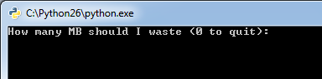
- A window appears with the WasteMemory.py file in it. Double-click the WasteMemory.py file.
- A box pops up asking "How many MB should I waste (0 to quit):", as shown to the right on this page.

Viewing Memory Usage with Task Manager
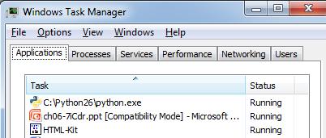
- On your keyboard, press Shift+Ctrl+Esc.
- Task Manager opens. Click the Applications tab. You should .see a Task named C:\Python26\python.exe as shown to the right on this page.
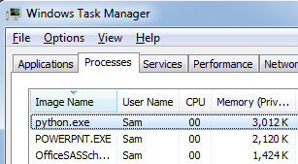
- Right-click the C:\Python26\python.exe task and click "Go To Process".
- Task manager switches to the Processes pane, and highlights the python.exe process, as shown to the right on this page.
- Notice the "Memory (Priv…" column—this shows the amount of memory each process is using now. The Python process should be using approximately 3,000 K of RAM now, which means 3 MB.

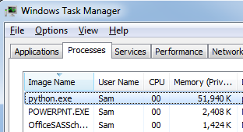
Using More RAM
- Find the Python window showing the "How many MB should I waste (0 to quit):" message. Click in that window. Type 50 and then press the Enter key.
- The Memory usage of the python.exe process should increase to approximately 52,000 K, as shown to the right on this page.

Saving a Screen Image
- Make sure the python.exe process is visible, using approximately 52,000 K of Memory.
- Press PrintScrn to copy the whole desktop to the clipboard.
- Click Start and type in PAINT. Click Paint. In the untitled - Paint window, click Edit, Paste. The image appears in the Paint window.
- In the untitled - Paint window, click File, Save. Save the document with the filename Your Name Proj 5a, using a File Type of PNG or JPG.

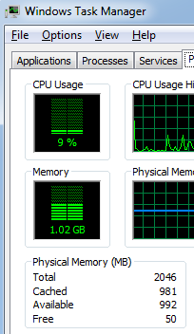
Using Task Manager's Performance Tab
- In Task Manager, click the Performance tab. Find the Available Memory and write it down in the box below on this page.
Available RAM
with 50 MB Wasted: _______________

- Find the Python window showing the "How many MB should I waste (0 to quit):" message. Click in that window. Type 1 and then press the Enter key.
- The Available memory shown in Task Manager should increase by approximately 50 MB immediately.

Turning in your Project
- Email the JPEG image to me as an attachment to an e-mail message. Send the message to: cnit.345@gmail.com with a subject line of Proj 5 From Your Name, replacing Your Name with your own first and last name. Send a Cc to yourself.

Last revised 9-11-09

