Choosing a Computer to Use
- This project should be harmless to do on any Windows 7 computer.
- Log onto any Windows 7 machine with an account that has Administrator privileges.

Installing ActivePython
- You should already have ActivePython installed. If you don't, do project 5 first.

Downloading the WasteMemory.py Script
- You should already have downloaded the WasteMemory script. If you haven't, do project 5 first.
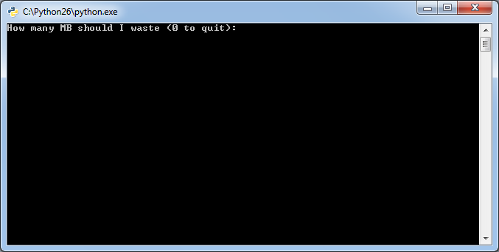
- Double-click the WasteMemory.py file.
- A box pops up asking "How many MB should I waste (0 to quit):", as shown to the right on this page.

Viewing Memory Usage with Resource Monitor
- Click Start. Type in RESOURCE. Find "Resource Monitor" in the results list and click it.
- Resource Monitor opens. Click the Overview tab. Expand the Memory section by clicking the down-arrow on the right side of its line. You should .see an Image named python.exe as shown below on this page.
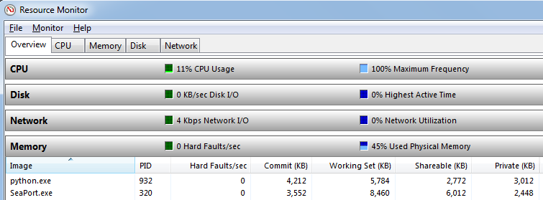

- All the Memory values should be small now. Resize the column headers so you can read them. The value on the right "Private (KB)" should be about 3,000, as shown in the figure above on this page.

Using More RAM
- Find the Python window showing the "How many MB should I waste (0 to quit):" message. Click in that window. Type 50 and then press the Enter key.
- The "Private (KB)" memory usage of the python.exe process should increase to approximately 52,000 K, as shown to on the next page.

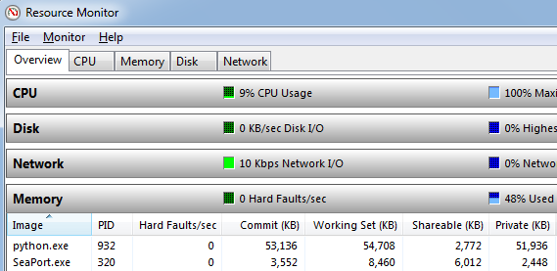

Saving a Screen Image
- Make sure the python.exe process is visible, using approximately 52,000 of "Private (KB)" memory usage.
- Press PrintScrn to copy the whole desktop to the clipboard.
- Click Start and type in PAINT. Click Paint. In the untitled - Paint window, click Edit, Paste. The image appears in the Paint window.
- In the untitled - Paint window, click File, Save. Save the document with the filename Your Name Proj 6a, using a File Type of PNG or JPG.

Using Resource Monitor's Memory Tab
- In Resource Monitor , click the Memory tab, as shown below on this page. Look at the bottom section with the colored bar. The right part of the bar, colored blue, shows "Standby" available memory.
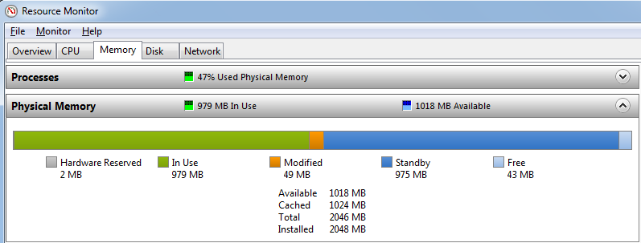

- Find the Python window showing the "How many MB should I waste (0 to quit):" message. Click in that window. Type 1 and then press the Enter key.
- You should be able to see the size of the blue bar change immediately. Try going back and forth from 0 to 50 a couple of times to see how convenient this tool is,

Turning in your Project
- Email the JPEG image to me as an attachment to an e-mail message. Send the message to: cnit.345@gmail.com with a subject line of Proj 6 From Your Name, replacing Your Name with your own first and last name. Send a Cc to yourself.

Last revised 9-11-09

