Choosing a Computer to Use
- It would be best to do this on your own Windows 7 computer, if you have one, so you can fix a real problem it has. But if you prefer to use the lab, log onto any Windows 7 machine with any account that has Administrator privileges.

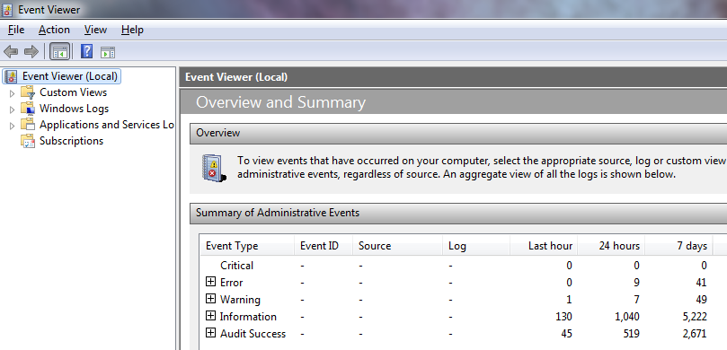
Opening Event Viewer
- Click Start. Type EVENT into the Search box. In the results list, click "Event Viewer".
- Event Viewer opens, showing the "Overview and Summary" as shown below on this page.

Selecting an Event to Research
- Unless you are extremely fortunate, your machine will have some Error events. As you can see above, mine has 41 Errors in the last 7 days. (If you really have zero Errors, research a Warning event instead.)
- Click the + icon on the left of the Error lineFind an Error event that seems interesting and double-click it.

- The lower pane shows details of the event, as shown below on this page. Findthe Event ID number and the Source and write them in the box below.
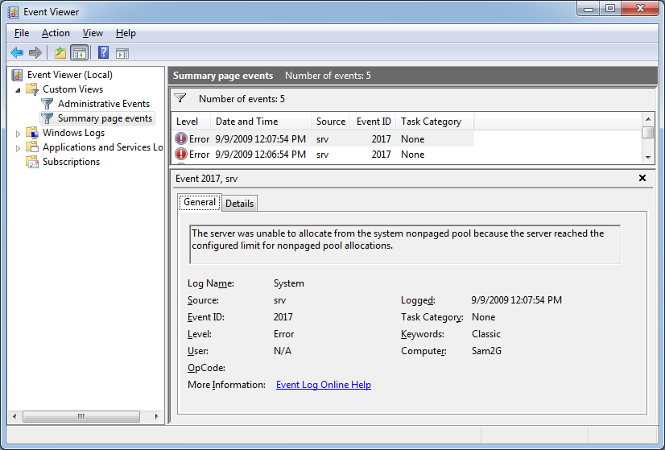

Event ID: ______________

Source: ______________

Saving a Screen Image
- Make sure the Event ID number and the Source are visible.
- Press PrintScrn to copy the whole desktop to the clipboard.
- Click Start and type in PAINT. Click Paint. In the untitled - Paint window, click Edit, Paste. The image appears in the Paint window.
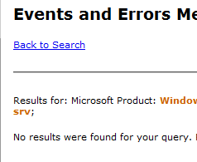
- In the untitled - Paint window, click File, Save. Save the document with the filename Your Name Proj 7a.

Using Microsoft Help to Learn about Events
- Click the blue "More Information" link in the lower pane of Event Viewer. An "Event Viewer" box opens, saying "Event Viewer will send the following information across the Internet. Is this OK? " Click Yes.
- A Microsoft Web page opens, offering you the guidance Microsoft has for you. It is usually worthless, as shown to the right on this page. If it has any information, read it and learn as much as you can about your event.

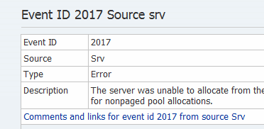
Using Eventid.net
- Open a browser and go to eventid.net. Enter your Event ID and Event Source in the appropriate boxes and click the Search button.
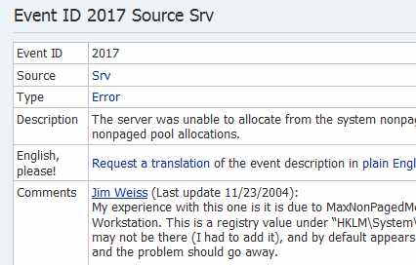
- You should see a page with some information about your event, as shown to the right on this page. Click the blue "Comments and links" link at the bottom of this box.
- You should see a page with Comments about your event, as shown to the right on this page.

Saving a Screen Image
- Make sure comments about your event are visible.
- Press PrintScrn to copy the whole desktop to the clipboard.
- Click Start and type in PAINT. Click Paint. In the untitled - Paint window, click Edit, Paste. The image appears in the Paint window.
- In the untitled - Paint window, click File, Save. Save the document with the filename Your Name Proj 7b.

Describe The Problem And Solution In Your Own Words
- Based on what you have read, compose a description of the problem and how to solve it, in your own words. If you did not get any help from the sources above, try typing the Event ID into Google. If that doesn't work, start over with a different Event.

Turning in your Project
- Email the JPEG images to me as attachments to one e-mail message. Put your description of the problem and how to solve it, in your own words in the body of the email message. Send the message to: cnit.345@gmail.com with a subject line of CNIT 235 Proj 7 From Your Name, replacing Your Name with your own first and last name. Send a Cc to yourself.

Last modified 9-12-09

