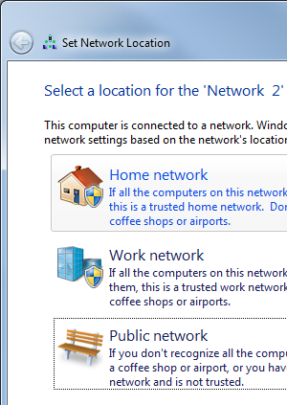
Finding Computers to Use
- You need two Windows 7 computers networked together. Choose one of them to be Computer A and the other to be Computer B.

Isolating Computers in S214
- If you are working in S214, there will be a problem: there can only be one HomeGroup on the network. You will need to isolate your two computers from the rest of the network.
- To do that, remove the blue Ethernet cables from both of your Windows 7 machines.
- Use two patch cords from the closet to connect your two Windows 7 computers to a a switch or router from the closet. The two machines will be able to network with each other, but not connect to the Internet for the duration of this project.

Setting the Network Type to Home
- When you connect the cables, a "Set Network Location" box should pop up, as shown to the right on this page. Click "Home network".

Checking HomeGroup Settings--Do This on Both Computers A and B
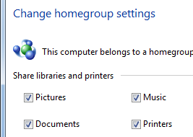
- On Computer A, click Start. Type HOME into the Search box. In the results list, click HomeGroup.
- If you see the message “This computer belongs to a homegroup”, as shown to the right on this page, do this:
  - Click "Leave the homegroup…".
  - Click "Leave the homegroup" again.
  - Click Finish.
- Repeat the process on Computer B.

Verifying That There is No HomeGroup
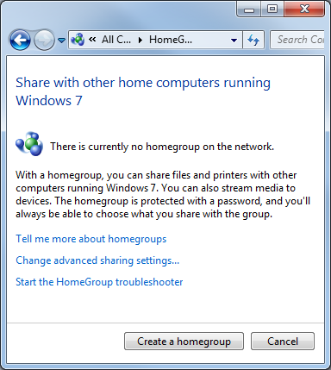
- On Computer A, the HomeGroup box should now show the message "There is currently no homegroup on the network", as shown to the right on this page.

Saving a Screen Image
- Make sure the "There is currently no homegroup on the network" message isvisible.
- Press PrintScrn to copy the whole desktop to the clipboard.
- Click Start and type in PAINT. Click Paint. In the untitled - Paint window, click Edit, Paste. The image appears in the Paint window.
- In the untitled - Paint window, click File, Save. Save the document with the filename Your Name Proj 8a.

Creating a HomeGroup: Do This on Computer A
- On Computer A, in the HomeGroup box, click the "Create a homegroup" button.
- In the "Create a homegroup" box, click Next.
- A HomeGroup password appears. Write that password down below:

Password: ________________________________________

Joining a HomeGroup: Do This on Computer B
- On Computer B, the HomeGroup box should show a message saying something like"Student on S214-01 has created a homegroup on the network". Click the "Join now" button.
- In the "Create a homegroup" box, click Next.
- In the next page, type in the password you wrote above on this page. Click Next.
- A message should appear saying "You have joined the Homegroup".

Viewing the HomeGroup: Do This on Computer A
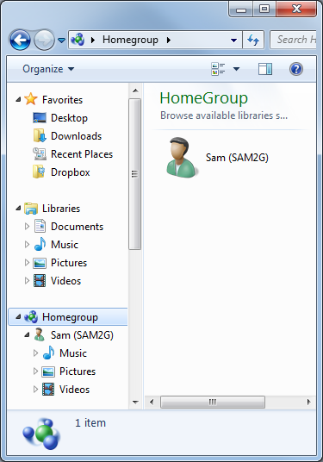
- On Computer A, click Start, Computer. In the left pane, click Homegroup.
- In the right pane, you should see a computer's icon in your HomeGroup, as shown to the right on this page.

Saving a Screen Image
- Make sure a computer's icon is visible in your Homegroup.
- Press PrintScrn to copy the whole desktop to the clipboard.
- Click Start and type in PAINT. Click Paint. In the untitled - Paint window, click Edit, Paste. The image appears in the Paint window.
- In the untitled - Paint window, click File, Save. Save the document with the filename Your Name Proj 8b.

Restoring Normal Networking
- Disconnect the patch cords and the router, and put them back in the closet.
- Plug the blue cables attached to the all back into the computers.
- Test both computers A and B and make sure they can reach the Internet.

Turning in your Project
- Email the JPEG images to me as attachments to one e-mail message. Send the message to: cnit.345@gmail.com with a subject line of CNIT 235 Proj 8 From Your Name, replacing Your Name with your own first and last name. Send a Cc to yourself.

Last modified 9-18-09

