Choosing a Computer to Use
- This project could be dangerous! You will be editing the Registry, which can seriously harm your operating system if you make mistakes. If you are not comfortable exposing your Windows 7 machine to these risks, use the lab.
- Log onto any Windows 7 machine with an account that has Administrator privileges.

Creating a Restore Point
- Click Start, and type RESTORE into the Search box.
- Click "Create a Restore Point".
- In the "System Properties" box, click "Create".
- In the "Create a restore point" box, enter a name of "Your Name - Before registry edits" and click the Create button. Wait while the restore point is created.
- A box appears saying "The restore point was created successfully". Click Close.
- Close "System Properties".

Disabling SMBv2
- Background: disabling SMBv2 is a recommended workaround to protect vulnerable versions of Windows Vista and Server 2008 from an exploit using a malformed SMBv2 packet. Windows 7 RTM is not vuilnerable, but Windows 7 RC is. Doing this project on Windows 7 RTM is just a way to practice using Regedit--it has no direct value.
- Click Start, and type REGEDIT into the Search box. Press the Enter key. In the "User Account Control" box, click Yes.
- In the left pane of "Registry Editor", expand these containers:
  - HKEY_LOCAL_MACHINE
  - System
  - CurrentControlSet
  - Services
  - LanmanServer (you will have to scroll down to find it)
- In the left pane, right-click the Parameters subkey. In the context menu, click "New ► DWORD (32 bit) Value".

- In the right pane, a new value appears with its name "New Value #1" highlighted. Type in the new name smb2 and press the Enter key. The value should appear in the right pane, as shown below on this page.
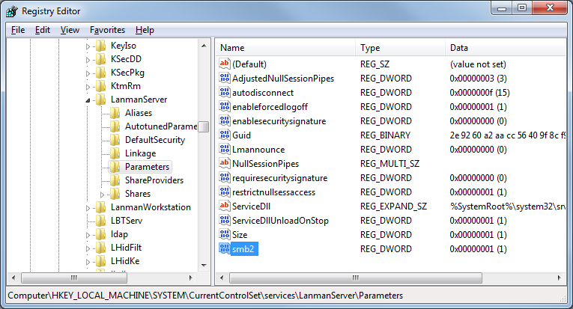

Saving a Screen Image
- Make sure the smb2 item is visible, showing a value of (1).
- Press PrintScrn to copy the whole desktop to the clipboard.
- Click Start and type in PAINT. Click Paint. In the untitled - Paint window, click Edit, Paste. The image appears in the Paint window.
- In the untitled - Paint window, click File, Save. Save the document with the filename Your Name Proj 11a, using a File Type of PNG or JPG.

Exporting the "Parameters" Subkey
- In the left pane of Registry Editor, right-click Parameters and click Export. Save the file on your Desktop as SMB.reg.
- On your Desktop, right-click the SMB.reg file and click Edit. The file opens in Notepad. You should see the smb2 value near the bottom with the value 00000001 as shown below on this page.
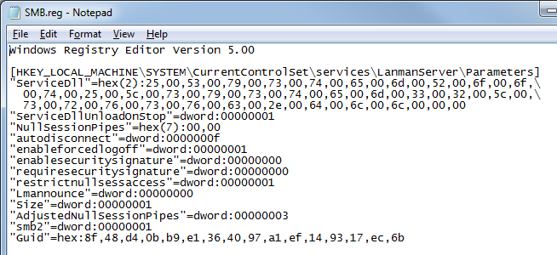

Saving a Screen Image
- Make sure the smb2 item is visible, showing a value of (1).
- Press PrintScrn to copy the whole desktop to the clipboard.
- Click Start and type in PAINT. Click Paint. In the untitled - Paint window, click Edit, Paste. The image appears in the Paint window.
- In the untitled - Paint window, click File, Save. Save the document with the filename Your Name Proj 11b, using a File Type of PNG or JPG.

Stopping the "HomeGroup Listener" Service
- The SMB change doesn't take effect until you restart the Server service. But you can't do that until the "HomeGroup Listener" service is stopped.
- Click Start, and type SERV into the Search box. In the results, click Services.
- In the Services console, scroll down and click "HomeGroup Listener". In the central portion of the console, click Stop. The "HomeGroup Listener" line should now show a blank Status, as shown below on this page.
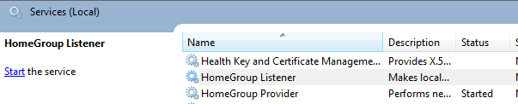

Restarting the "Server" Service
- In the Services console, scroll down and click "Server". In the central portion of the console, click Restart.

Starting the "HomeGroup Listener" Service
- In the Services console, scroll down and click "HomeGroup Listener". In the central portion of the console, click Start.

Using System Restore to Undo Registry Changes
- Press the Windows logo key, next to the Ctrl key at the lower left of your keyboard. Don't touch the mouse. Type this into the Search box:
rest
- "System Restore" should appear in the Programs list. If it's not already highlighted, press the down-arrow as needed to highlight it. Then press the Enter key.
- In the "Restore system files and settings" box, click Next.
- In the "Restore system files and settings" box, make sure that the restore point with your name on it is highlighted.

Completing the System Restore
- Close all other windows. The System Restore will reboot your system rudely, and could cause you to lose data if you are editing documents.
- In the "System Restore" box, click Next.
- In the "Confirm your restore point" box, click Finish.
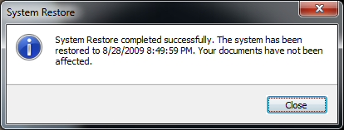
- Another box pops up, saying "System Restore cannot be interrupted". Click Yes.
- The restore completes, and your machine restarts. Log in as before. You should see a message saying "System Restore completed successfully", as shown to the right on this page.

Saving a Screen Image
- Make sure the "System Restore completed successfully" line is visible.
- Press PrintScrn to copy the whole desktop to the clipboard.
- Click Start and type in PAINT. Click Paint. In the untitled - Paint window, click Edit, Paste. The image appears in the Paint window.
- In the untitled - Paint window, click File, Save. Save the document with the filename Your Name Proj 11c, using a File Type of PNG or JPG.

Turning in your Project
- Email the JPEG images to me as attachments to one e-mail message. Send the message to: cnit.345@gmail.com with a subject line of Proj 11 From Your Name, replacing Your Name with your own first and last name. Send a Cc to yourself.

Last revised 9-25-09

