Choosing a Computer to Use
- This project could be dangerous! You will be editing the PATH environment variable, which might cause some programs to fail, if you make mistakes. If you are not comfortable exposing your Windows 7 machine to these risks, use the lab.
- Log onto any Windows 7 machine with an account that has Administrator privileges.

Creating a Restore Point
- Click Start, and type RESTORE into the Search box.
- Click "Create a Restore Point".
- In the "System Properties" box, click "Create".
- In the "Create a restore point" box, enter a name of "Your Name - Before changing PATH" and click the Create button. Wait while the restore point is created.
- A box appears saying "The restore point was created successfully". Click Close.
- Close "System Properties".

Launching a Command Prompt
- Click Start, and type CMD into the Search box. Press the Enter key.
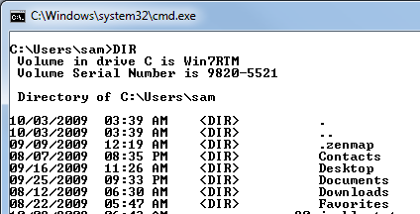
- You should see a "Command Prompt" window, with a prompt that shows your profile home folder: C:\Users\YourName, as shown below on this page. If you opened an Administrator Command Prompt instead, close it and open a normal Command Prompt instead.

Creating a Folder
- In the Command Prompt window, type this command and then press the Enter key:
DIR
- You see a list of files and folders in the current directory. There shouldn't be anything named BATCH.
- In the Command Prompt window, type this command and then press the Enter key:
MKDIR BATCH
- This command creates a folder named BATCH. But because you are using the command line, you can't see any results. So you need to issue another DIR command. This is a typical Command Line pattern: do a DIR to see what you have, run a command, and do another DIR to see the results.
- In the Command Prompt window, type this command and then press the Enter key:
DIR

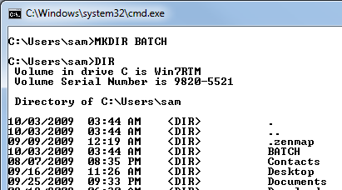
- You should see the BATCH folder, as shown to the right on this page.

Changing the Working Directory
- In the Command Prompt window, type this command and then press the Enter key:
CD BATCH
- This changes the working directory to the BATCH folder. You can see the change because the prompt changes from C:\Users\YourName to C:\Users\YourName\BATCH.

Creating the TESTPATH.BAT File
- In the Command Prompt window, type this command and then press the Enter key:
NOTEPAD TESTPATH.BAT
- A Notepad box pops up asking if you want to create a new file. Click Yes.
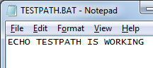
- In the Notepad window, enter this command, as shown to the right on this page:
ECHO TESTPATH IS WORKING
- In the Notepad window, click File, Save. Close Notepad.

Using Relative Paths
- In the Command Prompt window, the prompt should be C:\Users\YourName\BATCH. Type this command and then press the Enter key:
TESTPATH
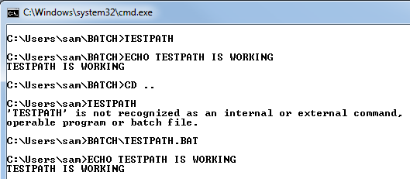
- You should see the message "TESTPATH IS WORKING" twice, as shown below on this page.

- In the Command Prompt window, type this command and then press the Enter key:
CD ..
- This command moves the working directory to the parent of the current directory. The prompt changes to C:\Users\YourName.
- In the Command Prompt window, type this command and then press the Enter key:
TESTPATH
- You should see an error message saying "'TESTPATH' is not recognized", as shown on the previous page of these instructions. This happens because Windows cannot find the file.
- In the Command Prompt window, type this command and then press the Enter key:
BATCH\TESTPATH
- You should see the message "TESTPATH IS WORKING", because now you told Windows where to find the file: in a subdirectory of the current working directory named BATCH.

Viewing the PATH Environment Variable
- In the Command Prompt window, type this command and then press the Enter key:
SET
- A list of all the Environment Variables appears, ending with windir. This list is confusing--we'll make it simpler.
- In the Command Prompt window, type this command and then press the Enter key:
SET PATH
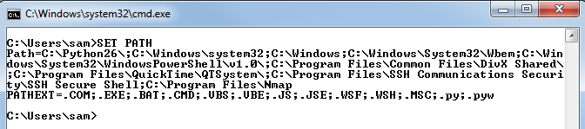
- This shows only the environment variables starting with PATH. The one we care about is the first one named PATH. The value in the PATH variable depends on what you have installed on your computer, but it's usually several lines long, as shown below on this page. PATH contains a list of directories Windows uses to find files when they are referenced by only the filename, not the full path. Right now the PATH does not include the BATCH folder, as shown below on this page.

Saving a Screen Image
- Make sure the PATH is visible, and the BATCH folder is not included in it.
- Press PrintScrn to copy the whole desktop to the clipboard.
- Click Start and type in PAINT. Click Paint. In the untitled - Paint window, click Edit, Paste. The image appears in the Paint window.
- In the untitled - Paint window, click File, Save. Save the document with the filename Your Name Proj 12a, using a File Type of PNG or JPG.

Changing the PATH
- In the Command Prompt window, type this command and then press the Enter key:
SET PATH=%PATH%;C:\USERS\YOURNAME\BATCH
Replace YOURNAME with your logon name.
- This command adds the BATCH folder to the PATH. To see the result, in the Command Prompt window, type this command and then press the Enter key:
SET PATH
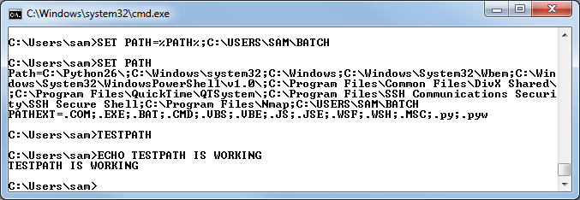
- You should see C:\USERS\YOURNAME\BATCH at the end of the PATH now, as shown below on this page.

- In the Command Prompt window, the prompt should be C:\Users\YourName. Type this command and then press the Enter key:
TESTPATH
- You should see the message "TESTPATH IS WORKING", because Windows can find the file now that the BATCH folder is in the PATH. If you don't see that message, check carefully to see if you can find an error in the PATH. If you do, you need to restore the correct PATH before trying again to change it correctly. To restore the path, either use System Restore, or do the steps below to return the PATH to normal with the Command Line.

Returning the PATH to Normal from the Command Line
- In the Command Prompt window, type this command and then press the Enter key:
SET PATH
- Use the mouse to point inside the Command Prompt window and right-click. In the Context menu, click Mark. Point to the first letter in Path, hold down the left mouse button, and drag carefully through all the lines containing the value of the PATH, as shown below on this page. Once you have the correct text highlighted, press the Enter key to copy it to the clipboard.
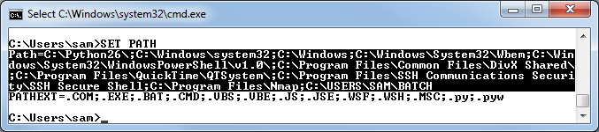
- Open Notepad. From the Notepad menu bar, click Edit, Paste. The copied lines appear, starting with Path=.
- The Path is spread across several lines, broken with carriage returns. It can't be used that way in the command line, so we need to get rid of the carriage returns.
- In Notepad, click in the first line of text. Press the End key to move to the end of this line. Press the Delete key once to delete the carriage return and merge the line below onto the first line.
- Press End and then Delete again.
- Press End and then Delete again.
- The Notepad file should now be one single long line, showing the entire path, with the cursor at the right end of that line. Carefully backspace through the part you added to the path, removing this text, including the semicolon:
;C:\USERS\YOURNAME\BATCH
- Your Notepad window should now contain the original path value, as shown below on this page.
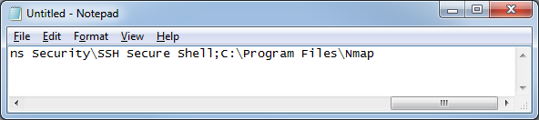

- In the Notepad window, press Ctrl+A to select all the text, and Ctrl+C to copy it.
- In the Command Prompt window, type this command (but don't press the Enter key yet)
SET

- In the Command Prompt window, point to the right of the word SET and right-click. In the Context menu, click Paste. The original Path should paste in, as shown below on this page. Press the Enter key.

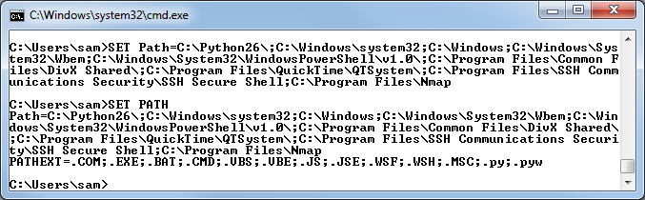

- In the Command Prompt window, type this command and then press the Enter key:
SET PATH
- You should see the original path shown, as shown above on this page.

Saving a Screen Image
- Make sure the Path is visible, showing that it has returned to its original value.
- Press PrintScrn to copy the whole desktop to the clipboard.
- Click Start and type in PAINT. Click Paint. In the untitled - Paint window, click Edit, Paste. The image appears in the Paint window.
- In the untitled - Paint window, click File, Save. Save the document with the filename Your Name Proj 12b, using a File Type of PNG or JPG.

Using System Restore to Undo Changes
- If you did everything correctly, the machine is back to its normal state now. But just to make sure it's back to normal for the next student, do the System Restore, with these steps:
- Press the Windows logo key, next to the Ctrl key at the lower left of your keyboard. Don't touch the mouse. Type this into the Search box:
rest
- "System Restore" should appear in the Programs list. If it's not already highlighted, press the down-arrow as needed to highlight it. Then press the Enter key.
- In the "Restore system files and settings" box, click Next.
- In the "Restore system files and settings" box, make sure that the restore point with your name on it is highlighted.

Completing the System Restore
- Close all other windows. The System Restore will reboot your system rudely, and could cause you to lose data if you are editing documents.
- In the "System Restore" box, click Next.
- In the "Confirm your restore point" box, click Finish.
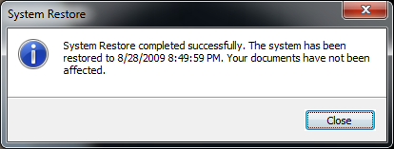
- Another box pops up, saying "System Restore cannot be interrupted". Click Yes.
- The restore completes, and your machine restarts. Log in as before. You should see a message saying "System Restore completed successfully", as shown to the right on this page.

Saving a Screen Image
- Make sure the "System Restore completed successfully" line is visible.
- Press PrintScrn to copy the whole desktop to the clipboard.
- Click Start and type in PAINT. Click Paint. In the untitled - Paint window, click Edit, Paste. The image appears in the Paint window.
- In the untitled - Paint window, click File, Save. Save the document with the filename Your Name Proj 12c, using a File Type of PNG or JPG.

Turning in your Project
- Email the JPEG images to me as attachments to one e-mail message. Send the message to: cnit.345@gmail.com with a subject line of Proj 12 From Your Name, replacing Your Name with your own first and last name. Send a Cc to yourself.

Last revised 10-3-09

