Warning! This project may break your computer! If done correctly, it should not do any harm, but if you leave Driver Verifier turned on, a machine may show blue-screen errors at startup. If you are not comfortable doing this on your home machine, do it on the machines in S214.

Starting Your Computer
- Start your computer. Boot to your installation of Windows 7. Log in with your personal account.

Selecting Drivers to Verify
- Press the Windows Logo key on the bottom left of your keyboard, between the Ctrl and Alt keys. Type in this command, and then press Shift+Ctrl+Enter:
CMD
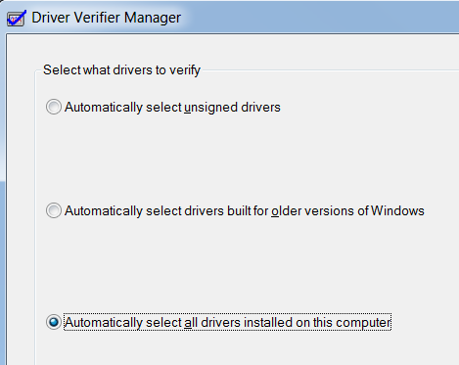
- In the Administrator Command Prompt window, type in this command, and then press Enter:
VERIFIER
- In the "Select a task" screen, accept the default selection of "Create standard settings" and click Next.
- In the "Select what drivers to verify" screen, accept the default selection of "Automatically select all drivers installed on this computer" and click Next.
- A box pops up saying "You must restart this computer for the changes to take effect". Click OK.

Restarting Your Computer
- Close all windows and restart your computer. Boot to your installation of Windows 7. One of these two things will happen:
- If your machine starts normally:
  - Skip to step 10.
- If your machine stops with a blue screen error:
  - Write down the name of the driver and the error code.
  - Restart your machine again, and press the F8 key during startup. Start the machine in Safe Mode. Log in normally. Then proceed to step 10.

Viewing the Verified Drivers
- Press the Windows Logo key on the bottom left of your keyboard, between the Ctrl and Alt keys. Type in this command, and then press Shift+Ctrl+Enter:
CMD

- In the Administrator Command Prompt window, type in this command, and then press Enter:
VERIFIER
- In the "Select a task" screen, click "Display information about the currently verified drivers" and click Next.
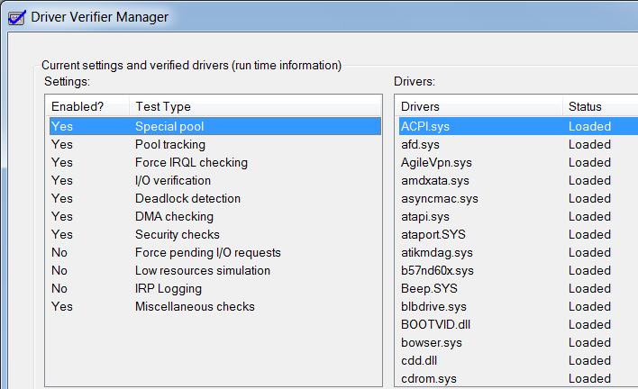
- The next screen shows information about the drivers that have been verified, as shown to the right on this page.

Capturing an Image of the Verified Drivers
- Press the PrintScrn key. Paste the image into Paint. Save it with the filename Your Name Proj 20.

Viewing the Rest of the Verification Results
- In the "Driver Verifier Manager" window click Next.
- In the "Global counters" screen, details about the drivers tests are shown. Glance through them and click Next.
- In the "Counters specific to each of the verified drivers" screen, more details about the drivers tests are shown. Glance through them and click Finish.

Disabling Driver Verifier
- This is a very important part of the project—if you leave Driver Verifier on, it might cause blue-screen errors! It's best to turn it off when you have finished using it.
- In the Administrator Command Prompt window, type in this command, and then press Enter:
VERIFIER
- In the "Select a task" screen, click "Delete existing settings" and click Next. Click Finish.
Turning in your Project
- Email the JPEG image to me as an attachment to one e-mail message. Send the message to: cnit.345@gmail.com with a subject line of Proj 20 From Your Name, replacing Your Name with your own first and last name. Send a Cc to yourself.
Revised 11-7-09

