Requirements
You will need a machine with Windows 7 and a USB flash drive,. BitLocker To Go is not available in the Vista.
Starting Your Windows 7 Ultimate Machine
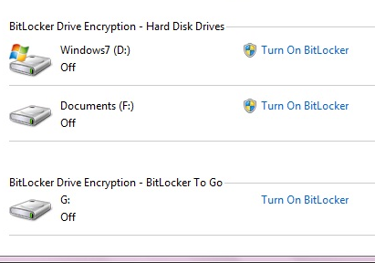
- Start the machine and boot to Windows 7 Ultimate. Log in with any account that has Administrator privileges, such as the Student account. If a password is required, try P@ssw0rd
Starting BitLocker
- Press the Logo key, and type in
BIT
When “BitLocker Drive Encryption” is highlighted, press Enter.
- Insert a USB flash drive. When it appears in the “BitLocker Drive Encryption” window, in the “BitLocker Drive Encryption – BitLocker To Go” section, as shown to the right on this page, click “Turn on BitLocker”.
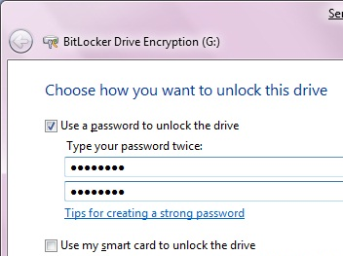
- In the “Choose how you want to unlock this dive” box, check “Use a password to unlock this device”, as shown to the right on this page. Enter a password of P@ssw0rd in both fields and click Next.
- In the “How do you want to store your recovery key?” box, click “Save the recovery key to a file”. Click Save to save the key in the default location of Documents with the default name, which is just a long string of letters and numbers. Then click Next.
- In the next box, click “Start encrypting”.

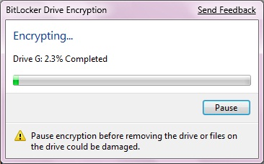
- You will see a progress bar moving, as shown to the right on this page.

Saving the Screen Image
- Press the PrintScrn key in the upper-right portion of the keyboard. That will copy the whole desktop to the clipboard.
- Click Start, All Programs, Accessories, Paint. In the untitled - Paint window, select Edit, Paste from the menu bar. The window image appears in the Paint window.
- In the untitled - Paint window, click File, Save. Save the document with the filename Your Name Proj 21a. Select a Save as type of JPEG.

Viewing the Recovery Key File
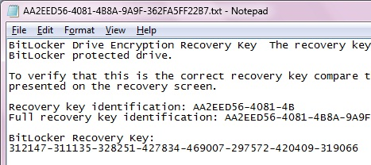
- Open the Documents folder. Double-click the recovery key file—its filename is a long string of letters and numbers. You should see the Recovery key, as shown to the right on this page.

Saving the Screen Image
- Press the PrintScrn key in the upper-right portion of the keyboard. That will copy the whole desktop to the clipboard.
- Click Start, All Programs, Accessories, Paint. In the untitled - Paint window, select Edit, Paste from the menu bar. The window image appears in the Paint window.
- In the untitled - Paint window, click File, Save. Save the document with the filename Your Name Proj 16xb. Select a Save as type of JPEG.

Turning in your Project
- Email the JPEG images to me as attachments to a single email message. Send the message to: cnit.345@gmail.com with a subject line of "Proj 21b From Your Name", replacing Your Name with your own first and last name. Send a Cc to yourself.

Let the Encryption Process Finish
- If you are using a borrowed USB memory stick in the S214 lab, please let the encryption process finish.
Last Modified 11-7-09

