What you Need for this Project
You need two computers with wireless NICs. At least one of them must be running Windows 7. The instructions assume you are using Windows 7 in S214.

Choose Two Computers
- Choose one computer to be the Internet Connection Server. The other computer will be the Client.
- Start both machines and boot to Windows 7. Log in with an administrative account, such as Student.
- Insert USB wireless NICs into each computer and wait until the drivers load.

Creating an Ad Hoc Wireless Network--Do This on the Internet Connection Server
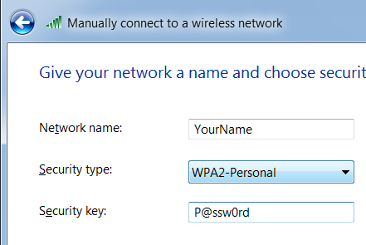
- On the Internet Connection Server computer, click Start. Type in NET and then click "Network and Sharing Center". On the left side, click "Manage Wireless Networks".
- In the "Manage Wireless Networks" box, on the top left, click Add.
- In the "Manually connect to a wireless network" box, click "Create an ad hoc network".
- In the "Set up a wireless ad hoc network" box, click Next.
- In the "Manually connect to a wireless network" box, give the network your name and type in a security key of P@ssw0rd, as shown to the right on this page. Click Next.
- In the "The YourName network is ready to use" box, click "Turn on Internet connection sharing".
- When you see the message saying "Internet connection sharing is enabled", click Close.

Connecting the Client Computer to the Ad Hoc Network
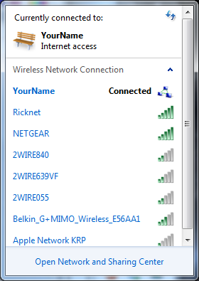
- On the Client computer, click Start and type in CONNECT
- Click "Connect to a network". You should see your Ad Hoc network in the list, with an icon that shows three tiny computers connected, as shown to the right on this page.
- Click your network, and click Connect.
- In the "Type your network security key" box, type P@ssw0rd and then click OK.
- If a "Set Network Location" box appears, click Public.

Saving the Screen Image
- Make sure the Ad Hoc network with your name on it is visible, showing a status of Connected. Press the PrintScrn key in the upper-right portion of the keyboard.
- Click Start, All Programs, Accessories, Paint. Click in the untitled - Paint window, and press Ctrl+V to paste the image. Save the image with the filename Your Name Proj 22a. Select a Save as type of PNG or JPEG.

Disabling the Wired Network--Do This on the Client Computer
- On the Client computer, click Start and type in CONNECTIONS
- Click "View network connections". Right-click "Local Area Connection" and click Disble.

Testing the Internet Connection--Do This on the Client Computer
- On the Client computer, click Start and type in CMD and then press Enter.
- In the Command Prompt window, type this command and then press Enter:
ping google.com
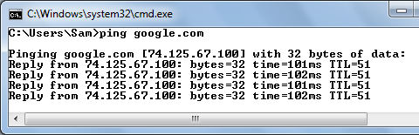
- You should see replies, as shown to the right on this page.

Saving the Screen Image
- Make sure the Reply lines are visible, showing a working network connection. Press the PrintScrn key in the upper-right portion of the keyboard.
- Click Start, All Programs, Accessories, Paint. Click in the untitled - Paint window, and press Ctrl+V to paste the image. Save the image with the filename Your Name Proj 22b. Select a Save as type of PNG or JPEG.

Turning in your Project
- Email the images to me as attachments to an email message. Send the message to: cnit.345@gmail.com with a subject line of "Proj 22 From Your Name", replacing Your Name with your own first and last name. Send a Cc to yourself.

Last Modified: 11-20-09

