Choosing a Computer to Use
- This project could be dangerous! You might make strange changes that will be confusing later. However, if you use System Restore properly, all the changes will be removed by the end. If you are not comfortable exposing your Windows 7 machine to these risks, use the lab.
- Log onto any Windows 7 machine with an account that has Administrator privileges.

Creating a Restore Point on the Windows 7 Machine
- On the Windows 7 machine, Click Start, and type RESTORE into the Search box.
- Click "Create a Restore Point".
- In the "System Properties" box, click "Create".
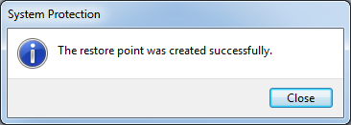
- In the "Create a restore point" box, enter a name of "Your Name - Before policy changes" and click the Create button. Wait while the restore point is created.
- A box appears saying "The restore point was created successfully", as shown to the right on this page. Click Close.
- Close "System Properties".

Customizing the Windows Security Window
- The procedure is the same as you used in "Project 9: Limiting Control Panel with Group Policy". The specific changes to make are explained in the textbook on pages 189-191.
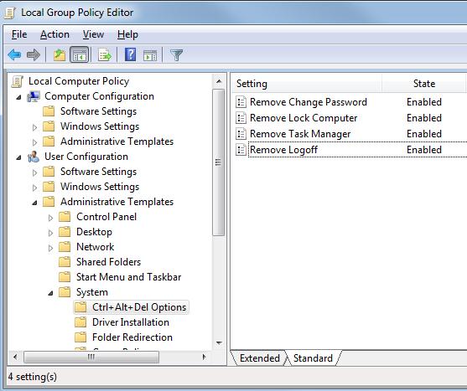

Saving a Screen Image
- Make sure the "Local Group Policy Editor" window is visible, showing the correct four items Enabled, as shown on the previous page.
- Press PrintScrn to copy the whole desktop to the clipboard.
- Click Start and type in PAINT. Click Paint. In the untitled - Paint window, click Edit, Paste. The image appears in the Paint window.
- In the untitled - Paint window, click File, Save. Save the document with the filename Your Name Proj 2xa, using a File Type of PNG or JPG.

Testing the Policy
- Press Ctrl+Alt+Delete. Only "Switch User" and "Cancel" should remain. Click "Cancel".

Enabling Shutdown Event Tracker
- The specific change to make is explained in the textbook on pages 194-195.

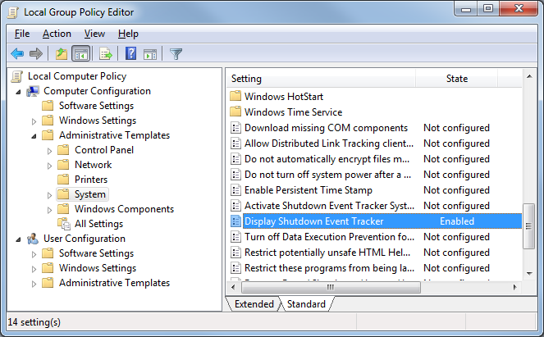
Saving a Screen Image
- Make sure the "Local Group Policy Editor" window is visible, showing the correct item Enabled, as shown above on this page.
- Press PrintScrn to copy the whole desktop to the clipboard.
- Click Start and type in PAINT. Click Paint. In the untitled - Paint window, click Edit, Paste. The image appears in the Paint window.
- In the untitled - Paint window, click File, Save. Save the document with the filename Your Name Proj 2xb, using a File Type of PNG or JPG.

Testing the Policy
- Close all windows. Shut down your machine. You should see the "Shutdown Event Tracker" as shown on page 195 of your textbook.

Using System Restore to Undo all the Changes
- Press the Windows logo key, next to the Ctrl key at the lower left of your keyboard. Don't touch the mouse. Type this into the Search box:
rest
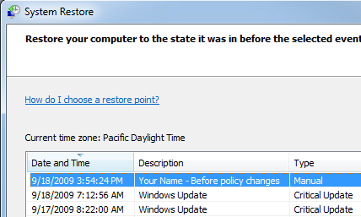
- "System Restore" should appear in the Programs list. If it's not already highlighted, press the down-arrow as needed to highlight it. Then press the Enter key.
- In the "Restore system files and settings" box, click Next.
- In the "Restore system files and settings" box, make sure that the restore point with your name on it is highlighted, as shown to the right on this page.

Saving a Screen Image
- Make sure the "Your Name Before policy changes" line is visible.
- Press PrintScrn to copy the whole desktop to the clipboard.
- Click Start and type in PAINT. Click Paint. In the untitled - Paint window, click Edit, Paste. The image appears in the Paint window.
- In the untitled - Paint window, click File, Save. Save the document with the filename Your Name Proj 4c, using a File Type of PNG or JPG.

Completing the System Restore
- Close all other windows. The System Restore will reboot your system rudely, and could cause you to lose data if you are editing documents.
- In the "System Restore" box, click Next.
- In the "Confirm your restore point" box, click Finish.
- Another box pops up, as shown below on this page, saying "System Restore cannot be interrupted". This is really rude—what it means is that System Restore is about to close all your applications and restart, trashing the files you are editing, but it doesn't say that. Close any other programs you have open, then click Yes.
- The restore completes, and your machine restarts. Log in as before. You should see a message saying "System Restore completed successfully", as shown to the right on this page.
- Your Windows 7 machine should be back to its normal condition:

Turning in your Project
- Email the JPEG images to me as attachments to one e-mail message. Send the message to: cnit.345@gmail.com with a subject line of Proj 4 From Your Name, replacing Your Name with your own first and last name. Send a Cc to yourself.

Last revised 9-18-09

