What You Need for This Project
- Two computers running Windows 7 on a LAN, with Internet access. You need administrator privileges. I've only tested this with a real machine, but a virtual machine would probably work too. This project does not require doing anything very dangerous to your machines. The most dangerous part is turning off your firewall temporarily.
Choosing Two Computers
- Choose one computer to be the Scanner. The other one will be the Target.
Downloading and Installing the Nmap Security Scanner--Do This on Both the Scanner and Target Computers
- Nmap is a port scanner. It sends packets to the target and monitors the responses to discover what network services are listening on that computer. It is a favorite tool for security professionals worldwide.
- On the Scanner computer, open a Web browser and go to nmap.org
- In the upper center of the window, click Download.
- In the next screen , scroll down to the "Windows (NT/ME/2K/XP/Vista) binaries" section.
- In the "Latest release self-installer:" line, click " nmap-5.00-setup.exe ". The version number may be larger.
- Save the installer file. Run it and install the software with the default selections.
- Repeat the process to install Nmap on the Target computer.
Setting the Firewall to On, Allowing Exceptions--Do This on the on Both the Scanner and Target Computers
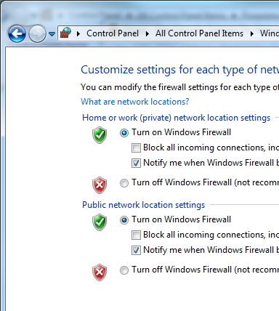
- On the Scanner computer, click Start and type in FIRE. In the Search results, click "Windows Firewall".
- In the Windows Firewall window, on the left side, click "Turn Windows Firewall on or off".
- In the "Customize Settings" window, make sure both the "Turn on Windows Firewall" buttons are selected, and both the "Block all incoming connections…" boxes are clear, as shown to the right on this page. Click OK.
- Repeat the process to configure the same firewall settings on the Target computer.
Finding the IP Address--Do This on the on Both the Scanner and Target Computers
- On the Scanner computer, click Start and type in CMD. Press Enter.

Scanner IP: __________________________

Target IP: __________________________
- In the Command Prompt window, type this command and then press the Enter key:
IPCONFIG | MORE
- Find the IP address that starts 192.168.1 and write it in the box as shown to the right on this page.
- Repeat the process to find the IP address of the Target computer.
Running a Nmap Port Scan--Do This on the Scanner Computer
- On the Scanner computer, click Start and type in NMAP. In the Search results, click "Nmap - Zenmap GUI".
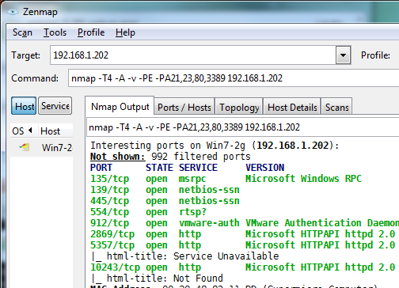
- In the Zenmap window, in the Target box, type in the Target IP you wrote in the box above on this page. Click the Scan button.
- In the results, scroll up and look for green text. You should see some open ports, as shown to the right on this page. If you all ports filtered, check your firewall settings.
Saving the Screen Image
- Press the PrntScn key to copy the desktop to the clipboard. Open Paint and press Ctrl+V. Save the image with the filename Your Name Proj 13a. Select a Save as type of PNG or JPEG.
Leave Zenmap Open
- Don't close the Zenmap window.
Setting the Firewall to On, Allowing Exceptions--Do This on the Target Computer
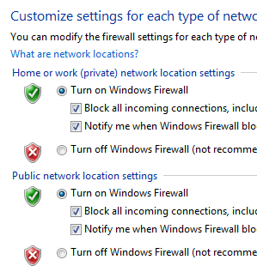
- On the Target computer, click Start and type in FIRE. In the Search results, click "Windows Firewall".
- In the Windows Firewall window, on the left side, click "Turn Windows Firewall on or off".
- In the "Customize Settings" window, make sure both the "Turn on Windows Firewall" buttons are selected. Check both the "Block all incoming connections…", as shown to the right on this page. Click OK.
Running a Nmap Port Scan--Do This on the Scanner Computer
- On the Scanner computer, Zenmap should still be open, with the Target IP in the Target box. Click the Scan button.
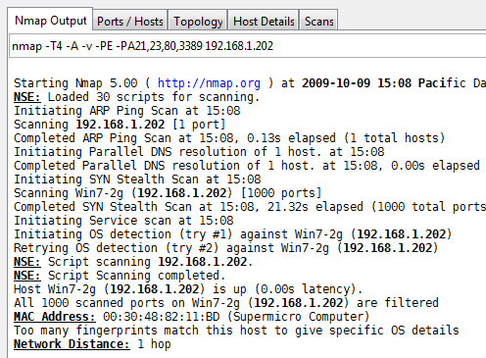
- You should see the message "All 1000 scanned ports are filtered", as shown to the right on this page.

Saving the Screen Image
- Press the PrntScn key to copy the desktop to the clipboard. Open Paint and pres s Ctrl+V. Save the image with the filename Your Name Proj 13b. Select a Save as type of PNG or JPEG.
Leave Zenmap Open
- Don't close the Zenmap window.
Setting the Firewall to On, Allowing Exceptions--Do This on the Target Computer
- On the Target computer, click Start and type in FIRE. In the Search results, click "Windows Firewall".
- In the Windows Firewall window, on the left side, click "Turn Windows Firewall on or off".
- In the "Customize Settings" window, make sure both the "Turn on Windows Firewall" buttons are selected, and both the "Block all incoming connections…" boxes are clear, as shown to the right on this page.
- Make sure both the "Notify me…" boxes are checked, as shown to the right on this page.
- Click OK.
Starting a Ncat Listener--Do This on the Target Computer
- On the Target computer, click Start and type in CMD. Press the Enter key.
- In the Command Prompt window, type this command and then press the Enter key:
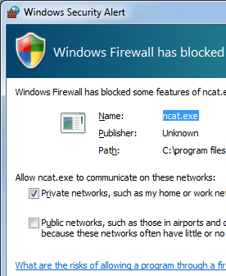
NCAT -l 2222
Note: the argument -l is a lowercase L, not the numeral 1
- This starts the Ncat utility (part of Nmap) listening on TCP port 2222. Windows Firewall detects this and pops up a "Windows Security Alert" box, as shown to the right on this page.
  - Troubleshooting: If the "Windows Security Alert" box does not appear, it is possible that ncat has been used previously on that machine so it's not a new program anymore. To fix that, click Start, type in FIRE, and click "Allow a program through Windows Firewall". In the "Allowed Programs" box, click the "Change settings" button. Find ncat in the list and remove it.
- In the "Windows Security Alert" box, click "Allow access".
Running a Nmap Port Scan--Do This on the Scanner Computer
- On the Scanner computer, Zenmap should still be open, with the Target IP in the Target box.
- In the Command: box, add these characters after the word nmap:
-p 2220-2229
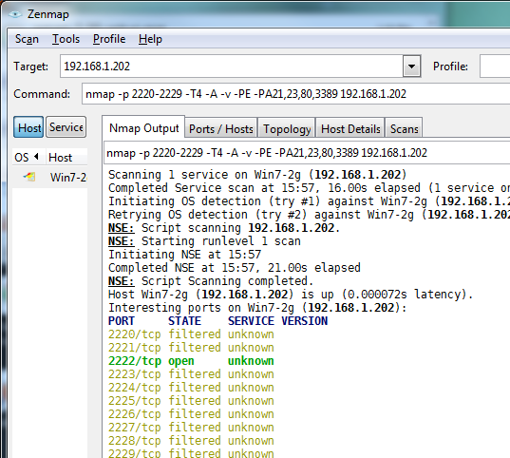
- This tells nmap to only scan ports from 2220-2229. Leave the rest of the command intact, as shown to the right on this page.
- Click the Scan button. You should see green text saying "2222/tcp open", as shown to the right on this page.

Saving the Screen Image
- Press the PrntScn key to copy the desktop to the clipboard. Open Paint and pres s Ctrl+V. Save the image with the filename Your Name Proj 13b. Select a Save as type of PNG or JPEG. .
Turning in your Project
- Email the images to me as attachments to one e-mail message to cnit.345@gmail.com with a subject line of Proj 13 From Your Name. Send a Cc to yourself.
Last modified 10-9-09

