What You Need for This Project

LEGAL WARNING!
Use only machines you own, or machines you have permission to hack into. Accessing computers without permission from the owners is a crime! Don’t do it! If you do illegal things, you may be arrested and go to jail, and I will be unable to save you. These instructions are intended to train computer security professionals, not to help criminals.
- A computer running Windows (any version). This can be either a real or virtual machine.
- You don’t need administrator privileges—you don’t need any login account at all on the Windows XP machine.
- You need physical access to the Windows machine, and the ability to boot from a CD.

Getting the Ultimate Boot CD Image
- You need the Ultimate Boot CD. Your instructor provided them in class.

Booting from the Ultimate Boot CD Image
- Start the computer. Insert the UBCD disk into the tray.
- Restart the machine. If a message appears on the screen, saying "Press any key to boot from CD", press the Enter key.
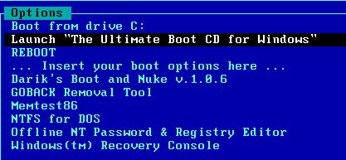
- If the machine does not boot from the CD, you will need to press F2 during the text phase of startup and change the BIOS boot order to put the CD-ROM above the hard disk. Your instructor or a lab assistant should be able to show you how to do this.
- When you see the screen shown to the right on this page, accept the default selection of Launch "The Ultimate Boot CD for Windows", and press the Enter key.
- When you see a box saying "Select shell to start, click to accept the default.
- When you see a box saying "Network support is not started yet. Do you want to start network support now?" click No.

Using Password Renew to Create a New Administrator User
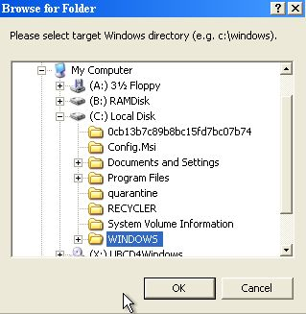
- When you see the desktop, click Start, Programs, "Password Tools", "Password Renew".
- In the "Password Renew for NT's v. 1.1 BETA" box, in the lower right, click the"Select a target" button. In the "Browse for folders" box, expand"(C:) Local Disk," click the WINDOWS folder, and click OK, as shown to the right on this page.
  - NOTE: in the S214 lab there are a lot of operating systems on the machine, so the one you are trying to hack into may be D:, or E:, or F:, etc. It can be confusing. The name of the drive may be helpful, and you may need to try several times to make an account on the OS you want to.
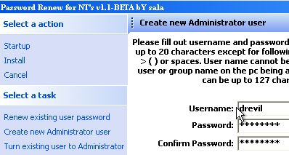
- In the "Password Renew for NT's v. 1.1 BETA" box, in the left pane, click "Create a new Administrator user".
- In the right pane, enter a user name of drevil
- Leave the password blank. The image to the right shows a password entered, but that is not recommended in the lab, because other students won't know the password.
- In the left pane, click "Install". A box should pop up saying "Password Renew for NTs is successfully done!" as shown to the right on this page.

Testing the New Account
- From the desktop, click Start, "Turn off computer." In the "Shut down windows" box, select "Restart and Eject" and click OK. Remove the disk when the tray opens.Let Windows start up normally.
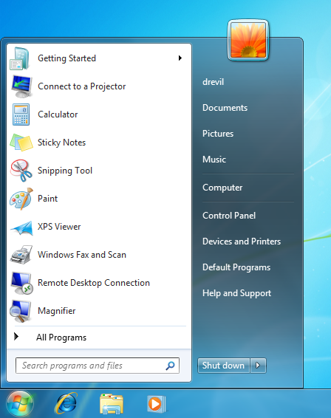
- Log in as drevil with no password.
- When the desktop loads, click the Start button. Your login name appears at the top of the menu, as shown to the right on this page.

Saving a Screen Image
- Make sure the "drevil" account name is visible.
- Press the PrintScrn key to copy the whole desktop to the clipboard.
- Click Start, "All Programs", Accessories, Paint. In the untitled - Paint window, select Edit, Paste from the menu bar. The desktop appears in the Paint window, with only a corner of it visible.
- In the untitled - Paint window, click File, Save. Save the document with the filename Your Name Proj 1x. Select a Save as type of JPEG.

Turning in Your Project
- Email the JPEG image to me as an attachment. Send it to: cnit.345@gmail.com with a subject line of Proj 1x From Your Name, replacing Your Name with your own first and last name. Send a Cc to yourself.

Last Modified: 10-4-12

