What You Need for This Project
- A Windows 7 Ultimate installation DVD. You can get one from your instructor.
- A computer with an empty partition at least 20 GB in size to install the OS on.
- If you install the OS incorrectly, you could lose all the data on your computer. If you aren't comfortable doing this project at home, use the S214 lab.

Installng Win 7 Ultimate
- Follow the process in Project 1: Installing Windows 7, but use the Windows 7 Ultimate DVD instead.
- You will end up with a 30-day trial version. We don't have product keys for the Ultimate edition, so it will expire after 30 days and start complaining that "You may be the victim of software piracy". But you should still be able to do projects on it anyway.

Saving the First Screen Image: System Properties
- Once your Windows 7 Ultimate is installed, click Start. Right-click Computer and click Properties. You should see a System window showing that your Windows edition is "Windows 7 Ultimate", as shown below on this page.
- Press the Print Scrn key. Paste the image into Paint. Save the image with the filename Your Name Proj 5xa. Select a Save as type of JPEG or PNG.
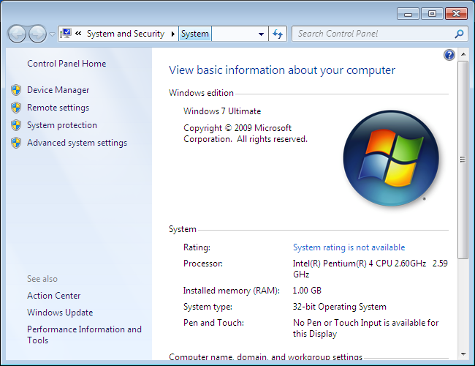

Saving the Second Screen Image: Student Account
- If you are working at home, you don't need the second image, but you must state in your email message that you did the project at home.
- If you are working in the S214 lab, you need the second image to show that you have created a Student account for the other students to use, as shown below on this page. The steps to create this image are in Project 1.
- Press the Print Scrn key. Paste the image into Paint. Save the image with the filename Your Name Proj 5xb. Select a Save as type of JPEG or PNG.
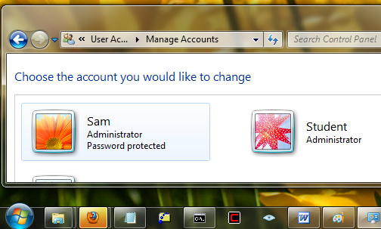

Turning in Your Project
- Email the images to me as attachments to an e-mail message. Send it to: cnit.345@gmail.com with a subject line of Proj 5x From Your Name, replacing Your Name with your own first and last name. Send a Cc to yourself.
Last Modified: 10-293-09

