Starting Your Computer
- Start your computer. Boot to your installation of Windows 7. Log in with your personal account.

Note to Students Working at Home
- The instructions below assume you are working in the S214 lab. If you are working at home, all you need to do is add any Office product to your Windows 7 computer. If you want to get the specific product described below, download OpenOffice from openoffice.org.

Getting the Installer Files from the Server
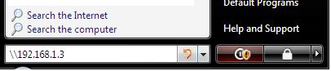
- Click the Start button (the Windows Logo button in the lower left corner). In the search box, type in \\192.168.1.3 as shown to the right on this page. Press the Enter key.
- If you are prompted to enter a login name and password, enter a name of CNIT and leave the password blank.
- In the Network ► 192.168.1.3 window, double-click cnit335.

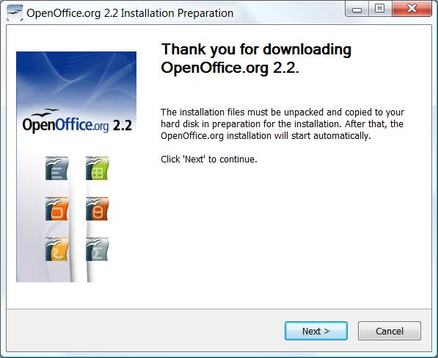
Installing OpenOffice
- Double-click the OpenOffice folder on your desktop. Double click the installer file, which should have a name like this OOo_2.2.1_Win32Intel_install_wJRE_en-US.exe (you might have a later version).
- Follow the on-screen prompts to complete the installation, using the default or recommended settings.

Opening OpenOffice Writer
- Click Start, "All Programs", "OpenOffice.org 2.2", "OpenOffice.org Writer".
- In the "Welcome to OpenOffice.org 2.2" box, click Next.
- Scroll to the bottom of the license agreement and click Accept.
- At the "Provide your full name and initials below" screen, click Next.
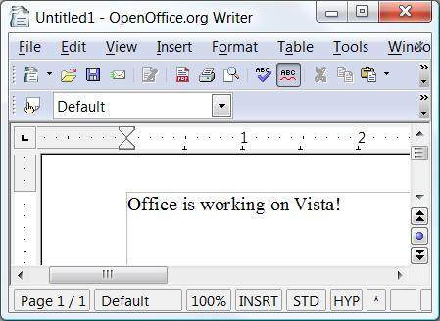
- At the "Online Update " screen, clear the "Check for updates automatically" box and click Next.
- At the " OpenOffice.org Registration" screen, click "I do not want to register" and click Finish. OpenOffice.org Writer opens, as shown to the right on this page.

Saving the Screen Image
- Click on the "OpenOffice.org Writer " window to make sure it is the active window.
- Hold down the Alt key and press the PrintScrn key in the upper-right portion of the keyboard. That will copy the active window to the clipboard.
- Click Start, All Programs, Accessories, Paint. In the untitled - Paint window, select Edit, Paste from the menu bar. The window image appears in the Paint window.
- In the untitled - Paint window, click File, Save. Save the document in the My Pictures folder (or any other place you wish, such as a floppy disk) with the filename Your Name Proj 2b. Select a Save as type of JPEG.

Turning in your Project
- Open Firefox, and use it to email the JPEG image to me as attachments to one e-mail message. Send the message to: cnit.345@gmail.com with a subject line of "Proj 2 From Your Name", replacing Your Name with your own first and last name. Send a Cc to yourself.

Last Modified: 8-22-09

